METHODS
Architecture: The network consists of 150 nodes, organized into 10 layers of 15 nodes each. Each node can be in an active or inactive state, and these are randomly initialized in the first time step with a value a_{x,y} = {0, 1}, such that a given percentage of nodes are in the active state. A node can change state following the dynamics described below. The nodes of layer i are sequentially and fully connected to those of layer i+1. The last layer is also fully connected to the first layer in a unidirectional ring network (Figure 1A). The connections are defined by a connectivity matrix $W_{i,j}^{k}$ where k determines the input layer, and i,j are the indices of the nodes at the layer k and k+1.

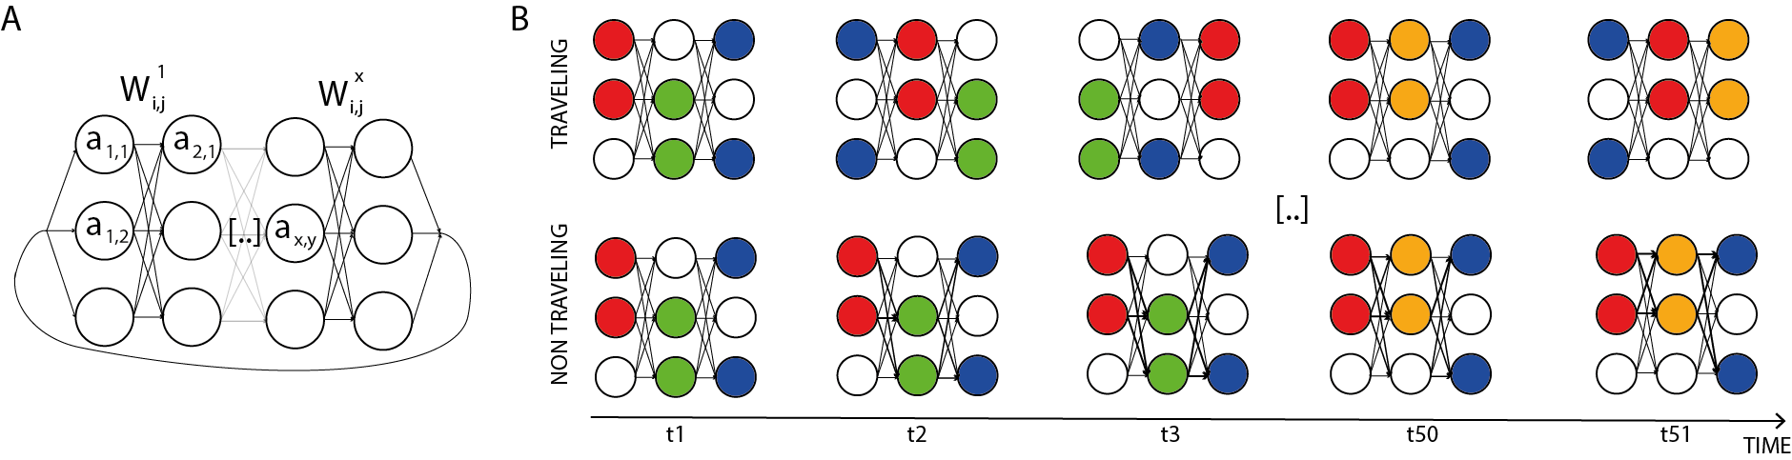
Figure 1 : A) the network B) the two conditions
Network dynamics: The network is initialized to have 25% of the nodes in the active state at the first timestep. Over timesteps, each state a_{x,y} of each node x at the layer y is updated according to the following formula:
$$a_{x,y}\left(t+1\right)= γ_{m}a_{x,y}^{m}\left(t\right)+ a_{x,y}^{w}\left(t\right)$$
The term $a_{x,y}^{m}\left(t\right)$ represents the activity that maintains the relevant information in each node, and $γ_{m}$ is a decay term we set to 0.9. We consider a ‘traveling’ and a ‘static’ condition, defined as:
$$\left\{\begin{aligned}{ a}_{x,y}^{m} \left(t+1\right)= a_{x,y}^{m}\left(t\right) in the static condition \\ { a}_{x,y+1}^{m} \left(t+1\right)= a_{x,y}^{m}\left(t\right) in the traveling condition\end{aligned}\right.$$
In the traveling condition, the $a_{x,y}^{m}\left(t\right)$term propagates from layer y to layer y+1, but not in the ‘static’ condition. The second term $a_{x,y}^{w}\left(t\right)$ determines the effect of the weights $W_{i,j}^{k}$, and it is defined as the product between the activity of the layer y-1 and the weights $W_{i,j}^{y-1}$between layer y-1 and layer y:
$$a_{x,y}^{w}\left(t\right)= Θ(a_{x,y-1}\left(t\right)* W_{i,j}^{y-1}\left(t\right))$$
Where $Θ\left(x\right)$ is defined as
$$Θ\left(x\right)= \left\{\begin{aligned}1, x≥ε \\ 0, x<ε\end{aligned}\right.$$
Note that a node can change its state over timesteps either by decaying to 0 over time, or in the traveling condition, as schematically shown in Figure 1b. Importantly, a node can switch from inactive to active due to the effect of the connectivity matrix, if $a_{x,y}^{w}\left(t\right)$ is larger than the threshold ε, which was set to 0.8.
Weights update: The connectivity matrix $W_{i,j}^{k}$ was updated at every timestep following the equation: $W_{i,j}^{x}\left(t+1\right)= γ_{w} W_{i,j}^{x}\left(t\right)+ ΔW_{i,j}$
Where $γ_{w}$ is a decay term we set to 0.9, and $ΔW_{i,j}$ followed an Hebbian like behavior defined as :
$$ΔW_{i,j}= \left\{\begin{aligned}δ, if a_{i}=a_{j}=1 \\ 0, otherwise\end{aligned}\right.$$
Where δ was set to 0.05 or 0.1 to investigate the behavior of the network with different learning strengths.
Procedure: At first, we initialized the network such that 25% of the nodes were in the active state. The weights $W_{i,j}^{k}$ were initialized randomly from a Uniform distribution U(0,0.01). We run the network for 200 timesteps. Importantly, after 100 timesteps, we modified the activity of five layers, setting the states to new, random values, thus mimicking the update of the encoding of some items with new ones. We quantified the encoding of activity in the layer over timesteps by measuring the Hamming and cosine distances between the expected activity (i.e., if there were no interference from synaptic connections) and the network activity. We also quantified the changes in the synaptic weights over time steps in the two conditions by assessing their distribution at each timestep. We repeated the procedure thirty times with random initializations.
RESULTS
Results with a high learning rate. We first investigate the results of the network when the parameter governing the amount of weight update, namely δ, was set to 0.1. We calculated the Hamming and Cosine distances over timesteps between the network activation pattern and the ground-truth one. Figure 2 shows that, over time, the distance increases in the static case but not in the traveling condition. This pattern was regularly observed over the 30 different initializations in the static case, but happens rarely in the traveling case. This shows that a traveling pattern, compared to a static one, is more robust to interference caused by the synaptic plasticity.
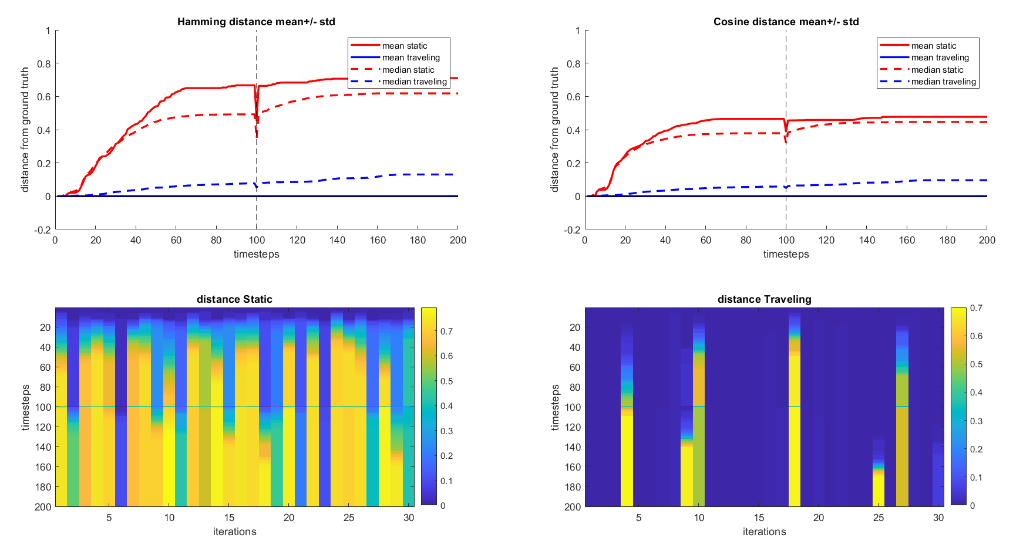
Figure 2: Upper panels show the Hamming (left) and Cosine (right) distance over timesteps between the ground truth and the real activation pattern, for both the static (red) and traveling (blue) conditions. Solid line represents the median, while dashed line the mean over the thirty iterations. The lower panels show the Hamming distance over timesteps (y axis) for the static (left) and traveling (right) conditions over all the 30 iterations (x axis).
We next investigate how the weights change over timesteps in the two conditions. Figure 3 reveals that the weights have a very low distribution in the traveling case: as the pattern moves across the area, the traveling pattern prevents the Hebbian rule from generating strong weight connections. On the other hand, in the static case, most of the weights converge to a higher value (i.e., 1, as shown in Figure 3, which is due to the decay term $γ_{w}$ and the weight update $ΔW_{i,j}$). At the 100th time step, due to the change in the items’ encoding, different combinations of weights are strengthened further, bringing all connections to higher value. This is not the case for the traveling condition.
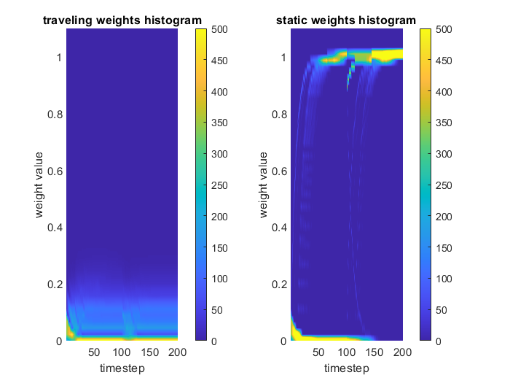
Figure 3: Histogram of the weights $W_{i,j}^{k}$ for traveling (left) and static (right) conditions over timesteps (x axis). The y-axis represents the weight values, while the color represents the amount of each value in the network.
Results with a lower learning rate. We then rerun the simulations with a smaller weights update, that is $ΔW_{i,j}$=0.05. We observe a similar pattern of results, even though to a lesser extent. Figure 4 shows that, while the traveling wave case is immune from the perturbations due to the connectivity term $a_{x,y}^{w}\left(t\right)$, in the static case we observed an increase in the distance from the groundtruth, especially after the updating of the items at the 100th timestep. Figure 5 confirms that the weights distribution is following a similar pattern as in the case with a larger $ΔW_{i,j}$: in the traveling case, the weights are closer to values around 0, whereas in the static case some increase to 0.5 (as before, this upper limit is determined by the decay term $γ_{w}$ and the weight update $ΔW_{i,j}$).

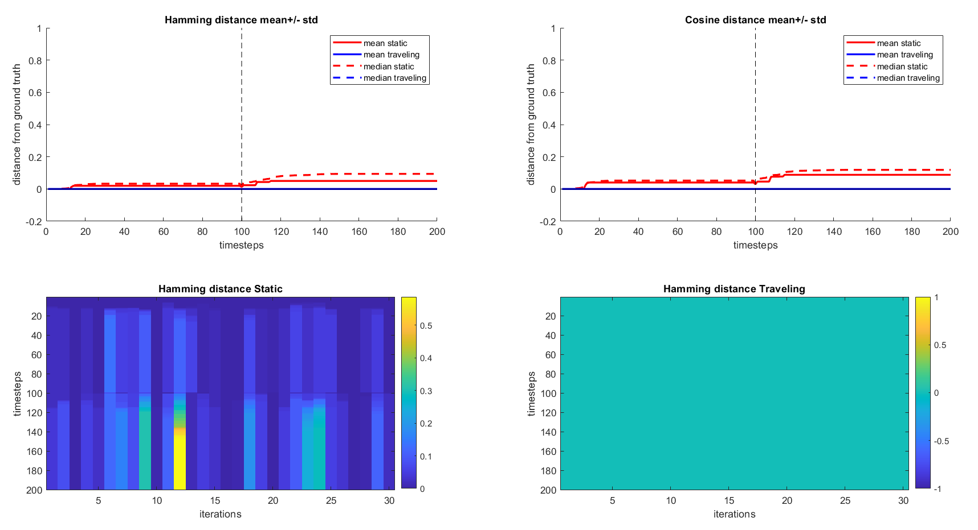
Figure 4: As in Figure 2, the upper panels show the Hamming (left) and Cosine (right) distance over timesteps between the ground truth and the real activation pattern, for both the static (red) and traveling (blue) conditions. The solid line represents the median, while the dashed line represents the mean over the thirty iterations. The lower panels show the Hamming distance over timesteps (y axis) for the static (left) and traveling (right) conditions over all 30 iterations (x axis).

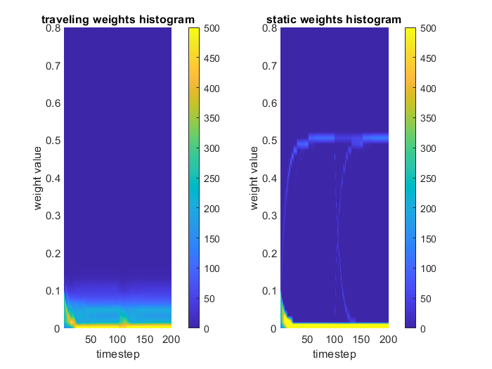
Figure 5: As in Figure 3, histogram of the weights $W_{i,j}^{k}$ for traveling (left) and static (right) conditions over timesteps (x axis). The y-axis represents the weight values, while the color represents the amount of each value in the network.

Some points to discuss / keep in mind:
- Terminology – here I talked vaguely about nodes. If we talk about neurons, we should probably model the whole neuronal dynamics (with some LIF model or using Izhikevich implementation). It would probably work, but it would be a bit longer to put into place. I guess here the point is to have a proof of principle, but then we should be careful with the wordings.
- Biological plausibility I: how much our simulations are informative? It all relies on the assumption that there is some plasticity in the modeled brain region. Trivially, the easier solution to implement working memory (within this simple framework), would be to have zero plasticity (or zero connections between items), as this is what causes the interference here. Yet, we consider that there is Hebbian plasticity in the brain and some connectivity between the items, which causes the interference in the static case.
- Biological plausibility II: why is there connectivity between the items? Anatomical constraints? If there were no connections between items (i.e., columns in the model), the static case would work just fine.
- The proposed pattern can go beyond the working memory framework, and can be proposed as a more general mechanism that shields encoded information from ‘synaptic’ (yes, I know, there are not neurons!) interference.

