# GOOD GAME GUILD
● STELLAR TESTNET
Proof
of Deliverables
Epic 2 / Deliverable 2 • Reviewer-ready package
TESTNET  NETWORK | 9  EVIDENCE CAPTURES | 72  CONTRACT TESTS

GGG • INSTAWARDS • TESTNET EVIDENCE

Exact identity
Field | Value
Network | Stellar Testnet — Test SDF Network ; September 2015
Source revision | d590b36
Verified Testnet code WASM hash | 2dcfb4c3ed77863269a347308156021de08427f5e6aa77ba15a08d9476c03f77
Verified code-upload transaction | Verified code-upload transaction
Contract ID | CBQSPLAPABKXKNKLG7DZKWFRAPD5UEUCIGEM3JJ5OX5PGNJNDVZZYNMB
Single deploy-and-initialize transaction | 1db90c4a30856b46a2815ec5911c59acd7e4c255e22ac27fada045bb086fa5cd

Required evidence

Single deploy-and-initialize transaction
VERIFIED on Testnet. The successful one-operation createContractV2 deployment created contract CBQSPLAPABKXKNKLG7DZKWFRAPD5UEUCIGEM3JJ5OX5PGNJNDVZZYNMB. The opt-in test checks one operation, six constructor arguments, one organizer signature, confirmed deployment, stored deadline, and immediate joins:
RUN_STELLAR_IT=1 pnpm --filter web test:integration --
src/lib/stellar/builders.integration.test.ts
The captured single-deploy-initialize-testnet.png output records the deployment transaction, resulting contract ID, Explorer URLs, and immediate join transaction.
Screenshot slot docs/evidence/issue-266/single-deploy-initialize-testnet.png
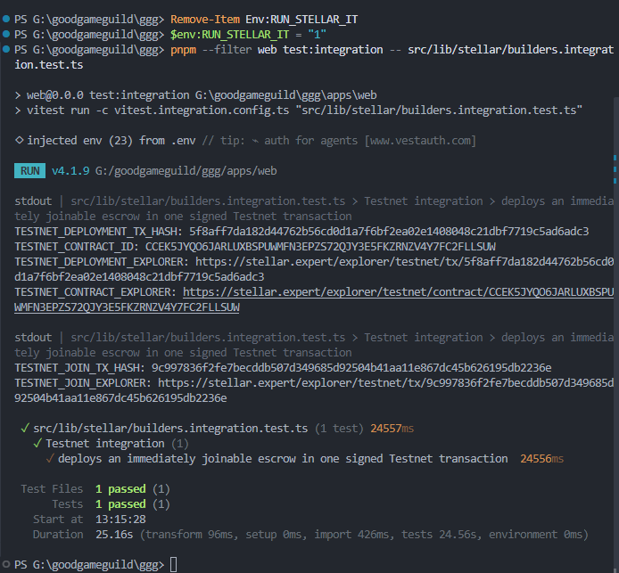

N-winner payout
VERIFIED on Testnet and by reproducible contract test. finalize_results is exercised by five_winner_payout_distributes_pool_and_dust and the successful five-winner Testnet finalization.
Caption: Five entries of 1,000,003 base units create 5,000,015. The 40% / 25% / 15% / 10% / 10% distribution pays 2,000,008, 1,250,003, 750,002, 500,001, and 500,001; two rounding units go to rank one. The full pool is paid and the escrow balance is zero.
cd contracts/escrow
cargo test five_winner_payout_distributes_pool_and_dust
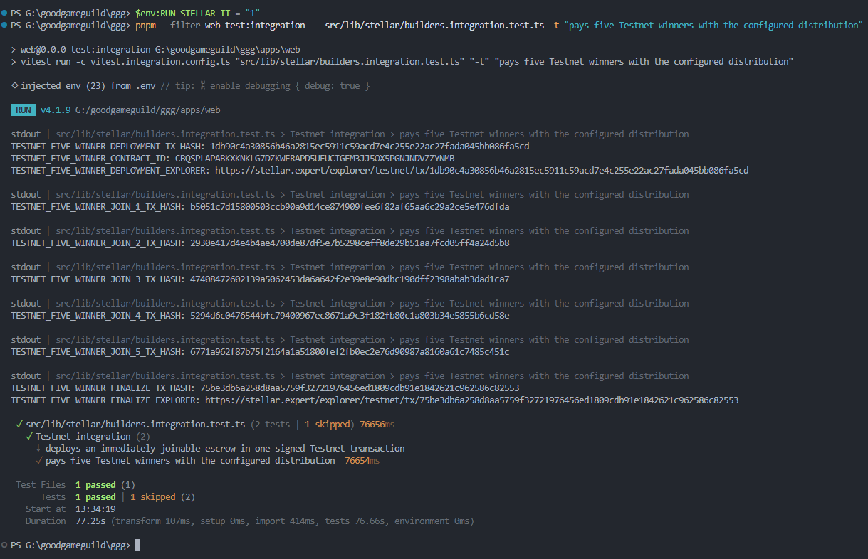
https://stellar.expert/explorer/testnet/tx/75be3db6a258d8aa5759f32721976456ed1809cdb91e1842621c962586c82553

Live five-winner Testnet command
The opt-in integration test deploys a new five-winner escrow, funds and joins five temporary Testnet players, finalizes them in rank order, verifies all payouts and a zero pool, then prints Explorer URLs. It creates one deployment, five join, and one finalization transaction.
$env:RUN_STELLAR_IT = "1"
pnpm --filter web test:integration --
src/lib/stellar/builders.integration.test.ts -t
"pays five Testnet winners with the configured distribution"
Remove-Item Env:RUN_STELLAR_IT
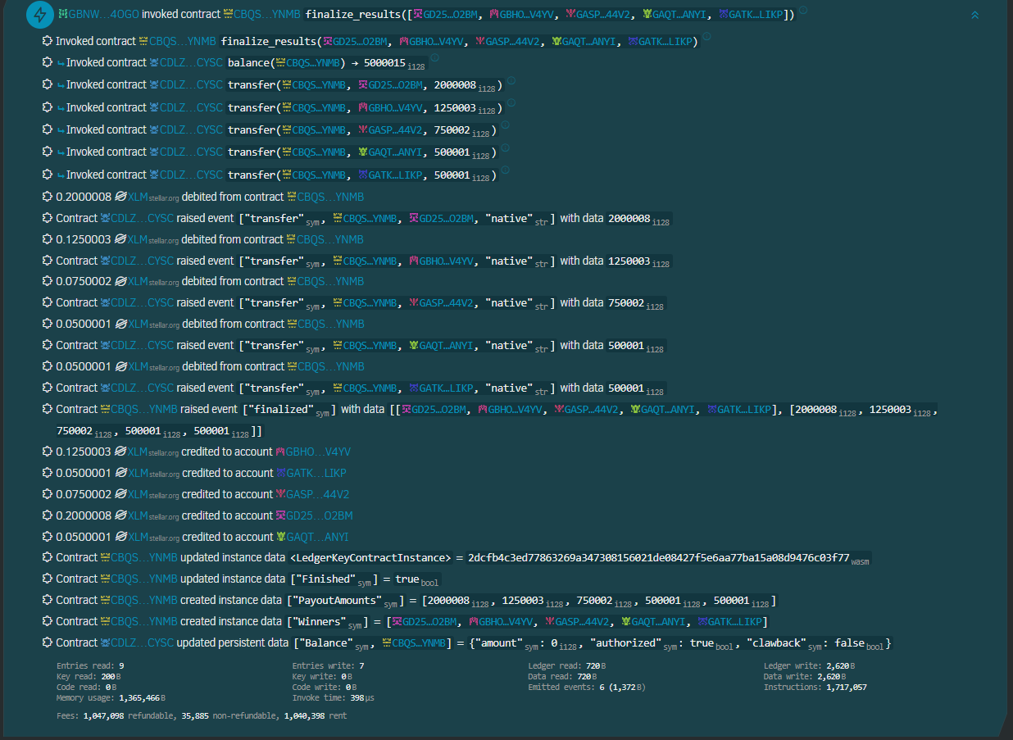

TTL and read helpers
VERIFIED by reproducible tests; not a live-instance observation. lifecycle evidence documents the no-op-at-90-days threshold, extension below it, rollback behavior, terminal operations, and near-archive read. regression evidence maps get_players() and get_tournament() coverage.
Caption: mutations retain storage as required, failed calls do not extend TTL, and the two read helpers inspect near-archival state without mutating its lifecycle.
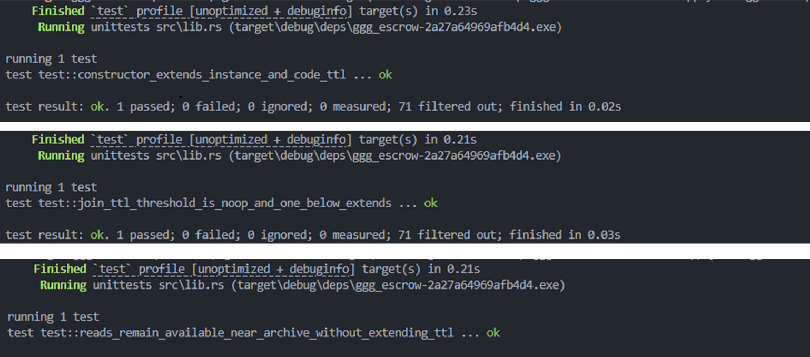

30+ passing contract tests
VERIFIED local/CI-reproducible result; public CI link pending. Recorded result is cargo test: 72 passed, including TTL and both helper methods.
cd contracts/escrow
cargo test

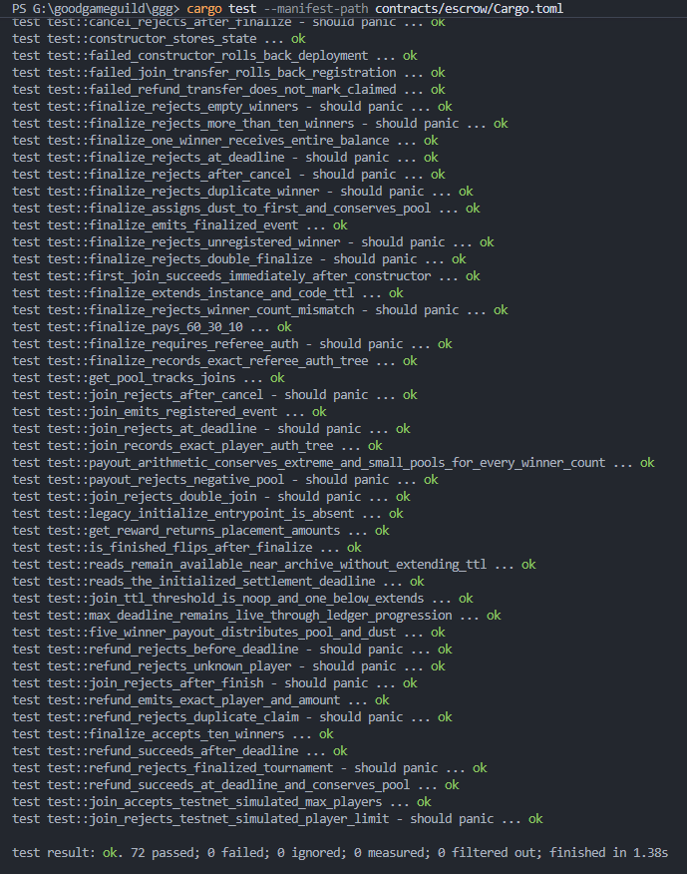

Evidence image appendix
Full-resolution evidence captures, in the order referenced above.

Verified Testnet ContractCode upload
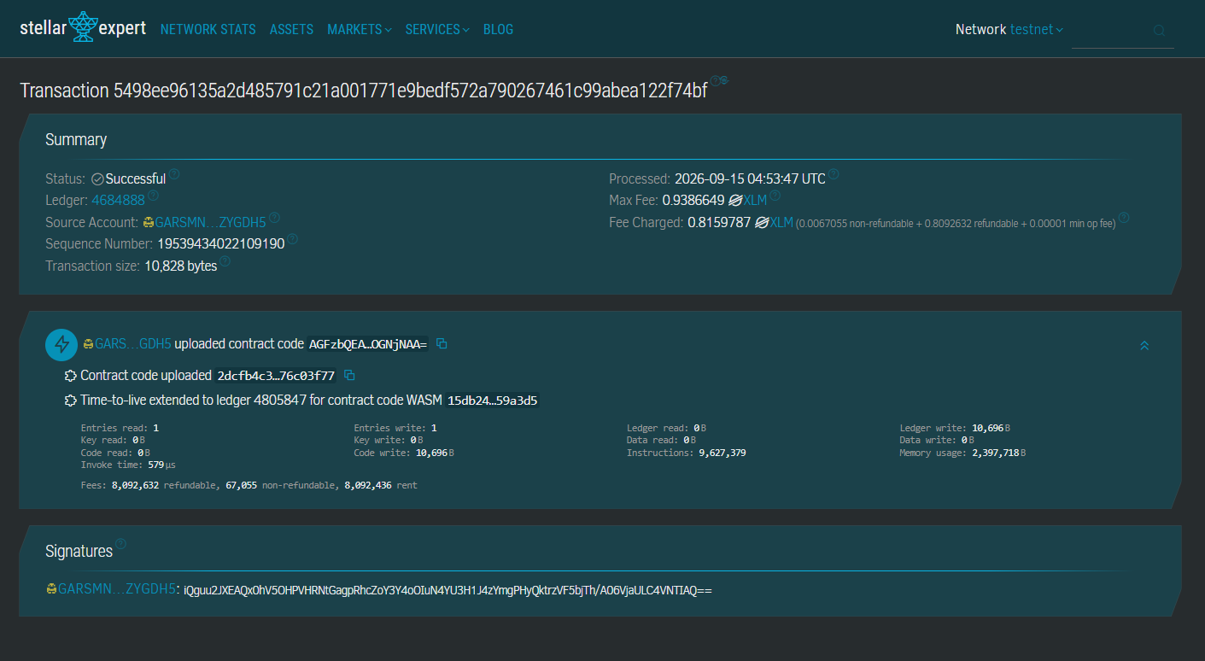
Verified Testnet ContractCode upload

Single deploy-and-initialize Testnet integration
Single deploy-and-initialize Testnet integration

Focused five-winner contract-test result
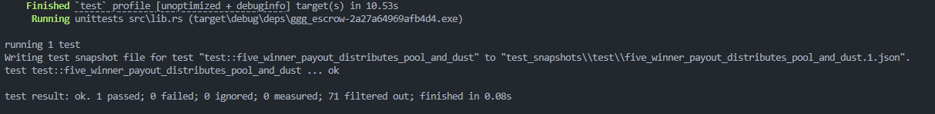
Focused five-winner contract-test result

Five-winner distribution and expected payout amounts
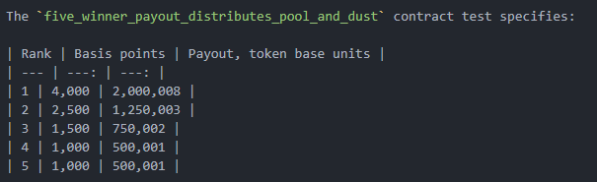
Five-winner distribution and expected payout amounts

TTL and read-helper contract-test evidence
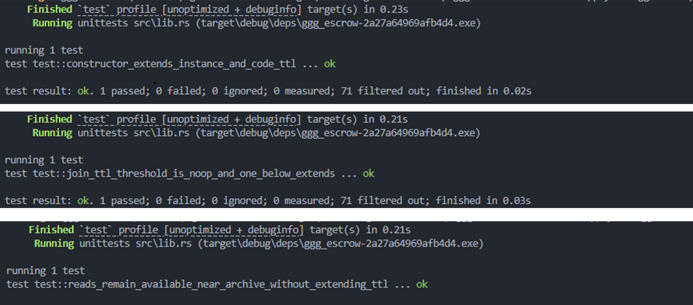
TTL and read-helper contract-test evidence

Contract-suite result
Contract-suite result

Payout-conservation matrix
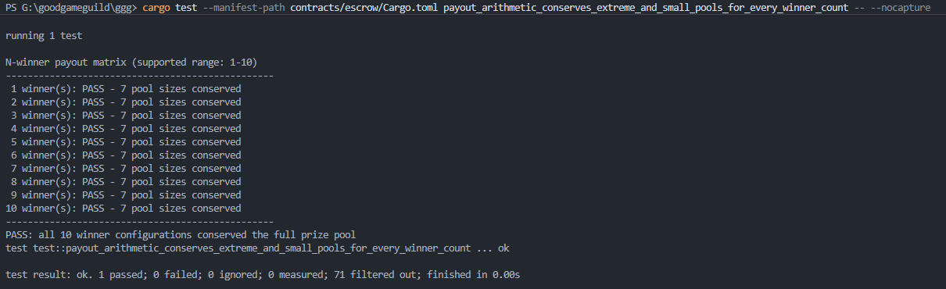
Payout-conservation matrix

Five-winner Testnet integration result
Five-winner Testnet integration result

Live five-winner Testnet finalization and payout
Live five-winner Testnet finalization and payout

