Real-Time Competitor Strategy Tracker - Project Documentation

# Project Overview

This project is a **Development for Real Time Competitor Strategy Tracker for E-commerce.** It monitors competitor prices, inventory, and reviews, providing actionable insights to optimize strategy.

# Key Features Implemented

• **Data Collection**  
Competitor prices, inventory, and reviews are collected using Python scripts and APIs. This step ensures that all relevant data is captured in real-time.

• **Data Processing**  
The collected data is cleaned, structured, and stored in a database. Duplicate or incorrect entries are removed to maintain accuracy.

• **Analysis & Alerts**  
Price changes and review sentiment are analyzed. Alerts are generated for significant price drops or negative review trends to help businesses react quickly.

• **Visualization**  
Data is displayed in an interactive dashboard built with Streamlit. Users can filter, sort, and view charts for trends and competitor comparison.

• **Historical Tracking**  
All changes are tracked over time (30/60/90 days) to identify trends and patterns, enabling strategic decisions.

# User Stories Implemented

• As a Product Manager, added competitor SKUs and set up automatic tracking.  
• As a Merchant, implemented real-time alerts for significant price drops.  
• As an Analyst, developed a comprehensive dashboard showing all competitor data.  
• As a User, created historical trend charts to detect pricing and review patterns.  
• As a Business User, integrated review sentiment analysis to display positive and negative trends clearly.

# Real-Time Competitor Strategy Tracker - Project Documentation

## Project Overview

This project is a Real-Time Competitor Strategy Tracker for e-commerce businesses. It monitors competitor prices, inventory, and reviews, providing actionable insights to optimize strategy and decision-making.

## Key Features Implemented

## • Real-Time Competitor Data Tracking Continuously monitors competitor pricing, inventory, and promotions through automated web scraping and data integration.

## • Predictive Analysis for Pricing Strategies Uses machine learning models to forecast future price trends and recommend optimal pricing decisions.

## • Sentiment Analysis Using LLMs Analyzes customer and competitor reviews through advanced language models to gauge market perception.

## • Interactive Streamlit Dashboard Provides an intuitive, data-driven interface for visualizing analytics, trends, and insights in real time.

## • Automated Email Alerts and Notifications Sends instant updates on significant competitor movements or pricing changes to support timely decision-making.

## Project Workflow

The workflow of the Real-Time Competitor Strategy Tracker includes the following stages:

1. **Data Collection:** Competitor prices, inventory, and reviews are collected via Python scripts and APIs.
2. **Data Processing:** Collected data is cleaned, structured, and stored in a database.
3. **Analysis & Alerts:** Price changes and review sentiment are analyzed; notifications are generated for significant changes.
4. **Visualization:** Data is displayed on an interactive Streamlit dashboard for easy interpretation.
5. **Historical Tracking:** All changes are tracked over time to identify trends and support strategic decision-making.

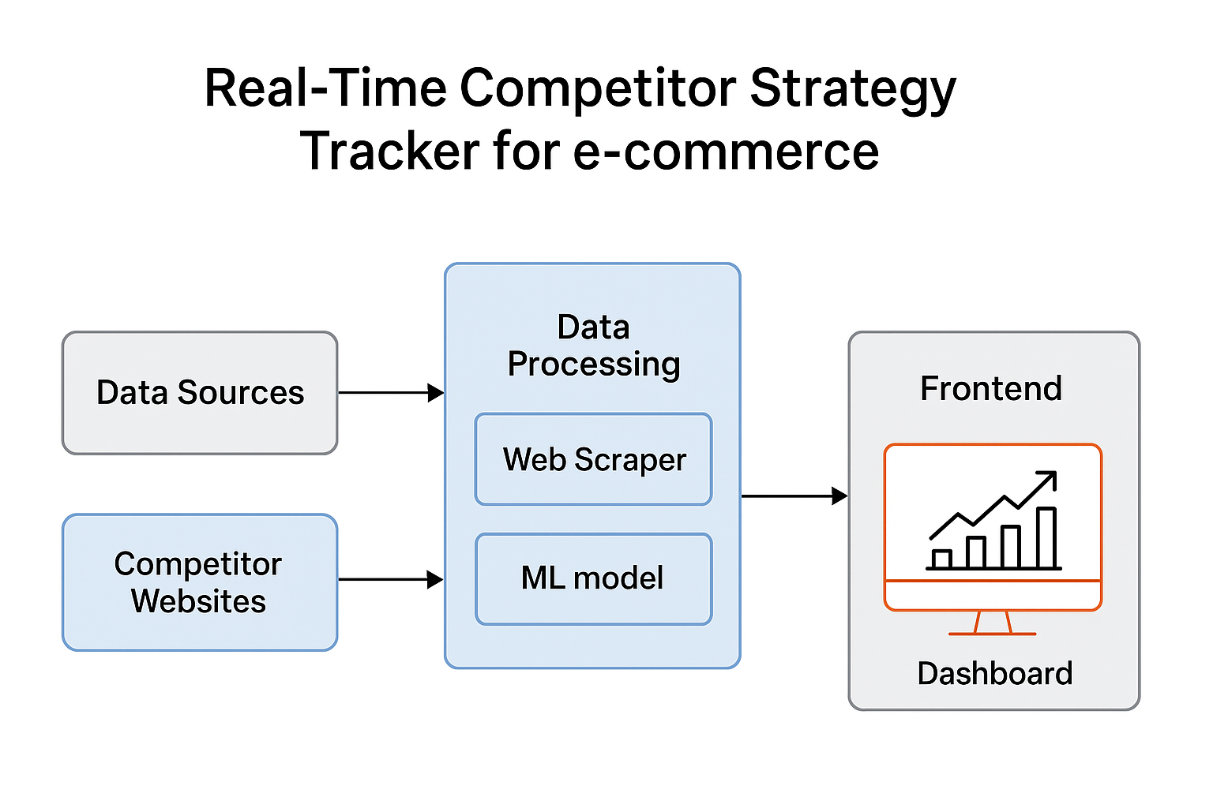

**Objectives:**

**Automate Competitor Data Collection from Multiple E-commerce Platforms**  
Implement web scraping and API integrations to continuously gather real-time competitor pricing and product information.

**• Analyze Competitor Strategies through Aggregation and Sentiment Modeling**  
Use data aggregation and NLP-based sentiment analysis to identify patterns in competitor behavior and customer perception.

**• Predict Future Competitor Pricing or Promotional Actions Using ML Models**  
Leverage machine learning techniques to forecast pricing trends and anticipate market movements for strategic planning.

**• Build an Interactive Streamlit Dashboard with Alert Features**  
Develop a dynamic dashboard for visualization, monitoring, and automated notifications on significant competitor changes

**Future Improvements:**

**• Integration with More E-commerce APIs for Direct Data Fetching**  
Enable seamless and real-time competitor data retrieval by connecting with multiple e-commerce platforms through APIs.

**• Enhanced Visualization with Time-Series Insights**  
Incorporate advanced trend analytics and historical comparisons for deeper understanding of pricing and sentiment patterns.

**• Incorporate Advanced Deep Learning Models for Better Prediction Accuracy**  
Use neural networks and transformer-based models to improve forecasting precision and strategic recommendations.

**• Develop Mobile-Responsive Dashboard Interface**  
Optimize the Streamlit dashboard for smartphones and tablets to ensure accessibility and monitoring on the go.