* What stuff in android
-----------------------------------------------------------------------------

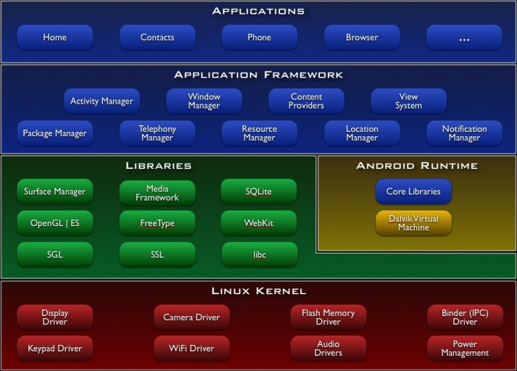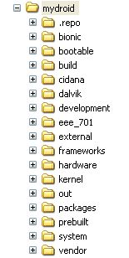

* how to get the entire source tree

http://android.git.kernel.org/ (Android source tree git respo)
http://source.android.com/download (source code download tutorial)

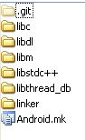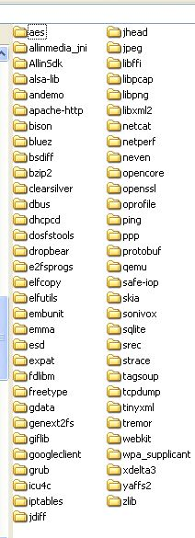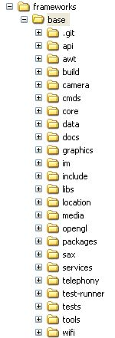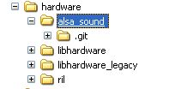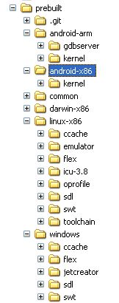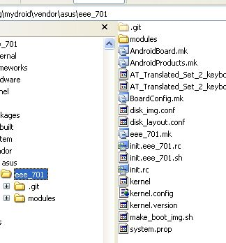

* Build system
-----------------------------------------------------------------------------
mydroid\external\skia
Android.mk
LOCAL_SRC_FILES:= \
src/core/Sk64.cpp \
src/core/SkBuffer.cpp \
src/core/SkChunkAlloc.cpp \
src/core/SkCordic.cpp \
…
LOCAL_SHARED_LIBRARIES := \
libcutils \
libutils

LOCAL_C_INCLUDES += \
$(LOCAL_PATH)/include/core
LOCAL_MODULE:= libsgl
include $(BUILD_SHARED_LIBRARY)

include $(CLEAR_VARS)

make libsgl

out/target/product/generic/system/lib/libsgl.so

target SharedLib: libsgl (out/target/product/generic/obj/SHARED_LIBRARIES/libsgl_intermediates/LINKED/libsgl.so)
target Prelink: libsgl (out/target/product/generic/symbols/system/lib/libsgl.so)
target Strip: libsgl (out/target/product/generic/obj/lib/libsgl.so)
Install: out/target/product/generic/system/lib/libsgl.so

make clean-libsgl

Build system doc
mydroid/build/core/build-system.html

* How can I run this one I compiled
-----------------------------------------------------------------------------
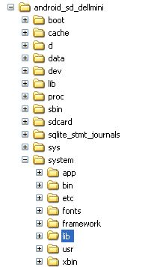

* what's the different between bionic libs(come with android) and GNU/Linux libs
-----------------------------------------------------------------------------
bionic has no STL support.

off_t in bionic is 64-bit.

pthread_mutex_t, pthread_cond_t are only 4 bytes each.

bionic does not support thread_cancel()

bionic does not provide support for System-V IPCs like
(semget(), shmget(), msgget())

...

* references
-----------------------------------------------------------------------------
Android main site
http://source.android.com/
http://developer.android.com

Android source tree (source code download tutorial)
http://android.git.kernel.org/
http://source.android.com/download

Android sdk/ndk
Android 1.5 SDK, Release 2 ,May 2009
Android 1.5 NDK, Release 1 ,June 2009
http://developer.android.com/sdk/1.5_r2/index.html

Build system doc
mydroid/build/core/build-system.html

vmware image made by xi'an gavinwang (customized for dellmini)
\\Fileserver\RD\Engineer\android_xa

* current projects
-----------------------------------------------------------------------------
dell mini
yuhua gphone

