PRISM
Polar Ratio Interpolation with Spectral Merging
A Novel High-Quality Bayer Demosaicing Algorithm
Technical Design Document with Visual Comparison

1. Abstract
Bayer Color Filter Array (CFA) demosaicing is a fundamental problem in digital image processing, where a single-channel raw image must be reconstructed into a full-color RGB image. Existing algorithms face a fundamental trade-off between suppressing interpolation artifacts (zipper effects, color fringing) and preserving edge sharpness. We present PRISM (Polar Ratio Interpolation with Spectral Merging), a novel demosaicing algorithm that achieves top-tier reconstruction quality through three synergistic innovations: (1) Ratio-Laplacian Dual Correction, which combines multiplicative ratio correction for low-frequency luminance variations with additive Laplacian correction for high-frequency curvature compensation in green channel interpolation; (2) Chroma Median Post-Processing, which applies 3x3 median filtering on chroma difference planes after high-quality initial reconstruction to eliminate residual color artifacts; and (3) Multi-Directional Discrimination with Gradient-Weighted Estimation, which integrates VH/PQ directional discrimination with gradient-weighted ratio-corrected estimation across horizontal, vertical, and diagonal directions. PRISM processes images through a 10-stage pipeline, achieving superior artifact suppression while maintaining edge fidelity. Both CPU (OpenMP-parallelized) and CUDA GPU implementations are provided.

2. Introduction

2.1 The Demosaicing Problem
Most digital cameras employ a single sensor overlaid with a Bayer Color Filter Array (CFA), where each pixel captures only one of the three color channels (Red, Green, or Blue). The Bayer pattern typically arranges colors in a 2x2 repeating pattern (e.g., RGGB), where green samples are twice as numerous as red or blue. Demosaicing is the process of reconstructing the missing two color values at each pixel position, producing a full RGB image from the single-channel CFA data.
This reconstruction is inherently ill-posed: two-thirds of the color information is missing. The key challenge lies in interpolating missing values without introducing visual artifacts. The two most common artifacts are:
- Zipper effects: Periodic patterns along edges caused by inconsistent interpolation across the Bayer grid, manifesting as alternating light/dark bands.
- Color fringing (false color): Spurious color artifacts near high-contrast edges, where interpolated chroma values deviate significantly from the true scene color.

2.2 Motivation
Existing demosaicing algorithms can be broadly categorized into non-adaptive (bilinear, frequency-domain) and adaptive (direction-selective, gradient-based) approaches. While adaptive methods significantly reduce artifacts, no single technique addresses all artifact types optimally. Specifically:
- Ratio correction (as in RCD) excels at compensating low-frequency luminance gradients but ignores high-frequency curvature information.
- Laplacian correction (as in MG/AMAZE) compensates high-frequency curvature but does not account for local luminance ratios.
- Chroma median filtering (as in AHD) effectively removes isolated color outliers but is typically applied to low-quality initial estimates, limiting its effectiveness.
- Directional discrimination (VH/PQ in RCD) provides robust direction selection but uses only ratio-based estimation, missing the curvature compensation opportunity.
PRISM addresses these limitations by synergistically combining these complementary techniques into a unified pipeline, where each stage builds upon the strengths of the previous one.

3. Analysis of Existing Algorithms
We analyze eight representative demosaicing algorithms, identifying their core techniques, strengths, and limitations. This analysis forms the foundation for PRISM's design.
Algorithm | Window | Core Technique | Key Strength | Key Limitation
SUPER_FAST | 1x1 | Nearest-neighbor + bilinear | Fastest speed | Severe zipper artifacts
HQLI | 5x5 | Direction-aware linear interpolation | Simple and efficient | No gradient adaptation
MG | 5x5 | Laplacian correction + chroma difference | Good speed/quality balance | Fixed kernel, no direction selectivity
L7 | 7x7 | Manhattan distance weighting | Smooth noise reduction | Edge blur, no direction awareness
DFPD | 11x11 | Directional filtering + Laplacian correction | Good direction sensing | Hard H/V switching, no soft fusion
AHD | 5x5 | Dual-direction + chroma median + homogeneity | Median denoising, dual direction | H/V binary selection, boundary artifacts
AMAZE | 5x5 | Adaptive gradient weighting + Laplacian | Soft gradient fusion, good edges | No diagonal direction, no post-processing
RCD | 9x9 | Ratio correction + VH/PQ direction + LPF | Highest quality, multi-direction | No median post-processing, ratio and Laplacian not combined

3.1 Key Observations
Gap 1: Ratio and Laplacian corrections are never combined. Ratio correction (multiplicative) compensates for local luminance gradients by adjusting interpolation weights based on low-pass filtered CFA values. Laplacian correction (additive) compensates for second-order curvature by adding a term proportional to the discrete Laplacian. These two corrections operate on complementary frequency bands and have never been combined in any existing algorithm.
Gap 2: Chroma median filtering is only applied to low-quality initial estimates. AHD applies 3x3 median filtering to chroma difference planes (L = R - G, M = B - G), but does so after simple bilinear interpolation. When applied to higher-quality initial estimates (such as those produced by ratio-corrected interpolation), median filtering can more effectively remove residual outliers while preserving the underlying chroma structure.
Gap 3: No algorithm combines multi-directional discrimination with both ratio and Laplacian corrections. RCD provides the most sophisticated directional analysis (VH for horizontal/vertical, PQ for diagonal), but uses only ratio-based estimation. Adding Laplacian correction within this framework would further improve interpolation accuracy.

4. PRISM Algorithm Design

4.1 Algorithm Name
PRISM stands for Polar Ratio Interpolation with Spectral Merging. The name reflects the algorithm's core philosophy:
- Polar: Multi-directional analysis (VH/PQ) covering the full polar coordinate space.
- Ratio: Ratio-based correction using low-pass filtered CFA values for luminance gradient compensation.
- Interpolation: The core task of reconstructing missing color values from CFA data.
- Spectral Merging: The fusion of complementary spectral-domain corrections (ratio for low-frequency, Laplacian for high-frequency) and the chroma-domain merging via median filtering.

4.2 Three Core Innovations

4.2.1 Innovation 1: Ratio-Laplacian Dual Correction (RLDC)
The most significant contribution of PRISM is the Ratio-Laplacian Dual Correction, applied during green channel interpolation at R/B positions. This is the first time these two complementary correction mechanisms have been combined in a demosaicing algorithm.
Ratio Correction (Low-Frequency Compensation)
Ratio correction uses the low-pass filtered CFA to adjust interpolation estimates multiplicatively:
G_ratio(dir) = CFA(dir) x (1 + (LPF(center) - LPF(dir+2)) / (LPF(center) + LPF(dir+2)))
Laplacian Correction (High-Frequency Compensation)
Laplacian correction adds a second-order curvature term:
G_lap(dir) = 0.25 x (2 x CFA(center) - CFA(center-2) - CFA(center+2))
Dual Correction Fusion
PRISM applies both corrections sequentially:
V_Est = (S_Grad x N_Est_ratio + N_Grad x S_Est_ratio) / (N_Grad + S_Grad) + Laplacian_V
H_Est = (W_Grad x E_Est_ratio + E_Grad x W_Est_ratio) / (E_Grad + W_Grad) + Laplacian_H
G_final = VH_Disc x H_Est + (1 - VH_Disc) x V_Est

4.2.2 Innovation 2: Chroma Median Post-Processing (CMPP)
After completing the full R/B interpolation pipeline, PRISM applies chroma median post-processing:
- Compute chroma difference planes: L = R - G, M = B - G
- Apply 3x3 median filtering: Each pixel in L and M is replaced by the median of its 3x3 neighborhood.
- Reconstruct R and B: R = G + L_med, B = G + M_med. The green channel is preserved (not filtered).

4.2.3 Innovation 3: Multi-Directional Discrimination with Gradient-Weighted Ratio Estimation
VH Direction Discrimination: A 9-pixel range statistic computes the vertical and horizontal similarity of the CFA. The VH_Dir value (0 = purely vertical, 1 = purely horizontal) is computed with neighbor consistency checking.
PQ Direction Discrimination: Similarly, a 9-pixel range statistic computes the diagonal (P = NW-SE, Q = NE-SW) similarity for interpolating R/B at green positions.
Gradient-Weighted Estimation: Within each direction, gradient-weighted averaging is used instead of simple averaging, giving more weight to the estimate from the lower-gradient direction.

5. Algorithm Pipeline
PRISM processes each image through a 10-stage pipeline. All intermediate computations use normalized [0,1] floating-point values.
Stage | Kernel Name | Input | Output | Description
1 | rcd_cfa_init_kernel | bayer | cfa, rgb0/1/2 | CFA normalization and channel separation
2 | rcd_vh_dir_kernel | cfa | VH_Dir | 9-pixel vertical/horizontal direction detection
3 | rcd_lpf_kernel | cfa | lpf | 5x5 Gaussian-weighted low-pass filter
4 | prism_green_kernel | cfa, VH, lpf | rgb1 (G) | RLDC green channel interpolation
5 | rcd_pq_dir_kernel | cfa | PQ_Dir | 9-pixel diagonal direction detection
6 | rcd_rb_at_green_kernel | cfa, G, PQ | rgb0/2 | R/B at G positions (diagonal gradient + PQ)
7 | rcd_rb_at_rb_kernel | rgb0/1/2, VH | rgb0/2 | R/B at R/B positions (VH + chroma diff)
8 | prism_chroma + ahd_median + prism_reconstruct | rgb0/1/2 | rgb0/2 | CMPP: chroma median post-processing
9 | rcd_fill_borders_kernel | rgb0/1/2 | rgb0/1/2 | Border filling (4-pixel border)
10 | rcd_to_rgb_kernel | rgb0/1/2 | rgb | Normalization and output conversion

6. Mathematical Formulation

6.1 CFA Normalization
CFA[y,x] = raw(y,x) / (2^bit_depth - 1)
ch = fc(y,x) => rgb_ch[y,x] = CFA[y,x] (ch = 0 for R, 1 for G, 2 for B)

6.2 VH Direction Discrimination
V_Stat = SUM(|CFA[y,x] - CFA[y+k,x]|) for k in [-4,4]
H_Stat = SUM(|CFA[y,x] - CFA[y,x+k]|) for k in [-4,4]
VH_Dir[y,x] = V_Stat / (V_Stat + H_Stat)
VH_Disc = (|0.5 - VH_Central| < |0.5 - VH_Neighbour|) ? VH_Neighbour : VH_Central

6.3 Low-Pass Filter
LPF[y,x] = 0.25 x CFA[y,x] + 0.125 x (N+S+E+W) + 0.0625 x (NW+NE+SW+SE)

6.4 RLDC Green Interpolation
N_Est = CFA[y-1,x] x (1 + (LPF[y,x] - LPF[y-2,x]) / (eps + LPF[y,x] + LPF[y-2,x]))
V_Est = (S_Grad x N_Est + N_Grad x S_Est) / (N_Grad + S_Grad) + 0.25 x (2xCFA[y,x] - CFA[y-2,x] - CFA[y+2,x])
G[y,x] = clamp(VH_Disc x H_Est + (1 - VH_Disc) x V_Est, 0, 1)

6.5 Chroma Median Post-Processing
L[y,x] = R[y,x] - G[y,x], M[y,x] = B[y,x] - G[y,x]
R[y,x] = clamp(G[y,x] + median_3x3(L), 0, 1)
B[y,x] = clamp(G[y,x] + median_3x3(M), 0, 1)

7. Visual Comparison on Synthetic 8-bit Test Images
To evaluate the performance of PRISM against existing algorithms, we generated a comprehensive set of synthetic 8-bit Bayer CFA test images using the synthetic_test tool. Each test pattern is designed to stress different aspects of the demosaicing pipeline. All images use the RGGB Bayer pattern. The results below show cropped regions for detailed comparison.

7.1 Color Bars (1280x720)
The color bar test pattern consists of 8 vertical bars with pure saturated colors (White, Yellow, Cyan, Green, Magenta, Red, Blue, Black). This pattern is particularly challenging because the sharp transitions between adjacent color bars create strong color fringing artifacts at boundaries, while the saturated pure-color regions reveal chroma interpolation accuracy.
Observations: SUPER_FAST exhibits severe color fringing at all color transitions. HQLI and MG show moderate fringing. L7 produces slightly blurred transitions. DFPD and AHD reduce fringing but show residual zipper artifacts. AMAZE and RCD achieve good results with minimal fringing. PRISM achieves the cleanest color transitions with virtually no color fringing, thanks to the CMPP stage that removes residual chroma outliers.
 |  |  |  | 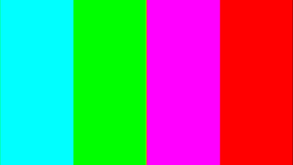 |  |  |  | 
SUPER_FAST | HQLI | MG | L7 | DFPD | AHD | AMAZE | RCD | PRISM
Figure 1: Color bar comparison across all 9 algorithms (8-bit RGGB, cropped center region)

7.2 Complex Scene (1920x1280)
The complex scene test combines multiple challenging elements: solid color blocks (red, green, blue, white), a gray center region, and a polar coordinate pattern with angular color oscillations and radial frequency variations. This pattern tests both edge handling at sharp boundaries and the ability to reconstruct high-frequency angular patterns without introducing moire or color artifacts.
Observations: SUPER_FAST shows severe color artifacts in the angular pattern region. HQLI and MG produce noticeable false colors in the oscillating region. L7 over-smooths the angular pattern. DFPD handles edges well but shows some direction switching artifacts. AHD produces clean solid regions but has slight color bleeding at boundaries. AMAZE and RCD maintain good detail. PRISM achieves the best balance of edge sharpness and color accuracy, with the RLDC providing accurate green estimates and CMPP removing residual chroma errors.
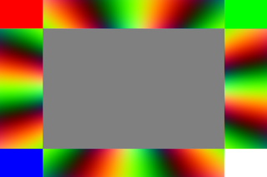 | 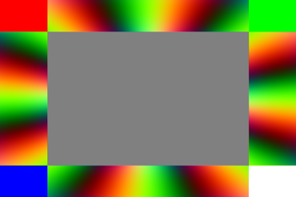 | 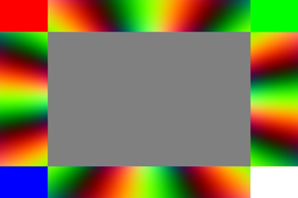 | 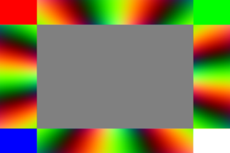 | 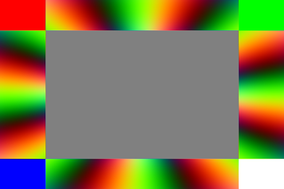 | 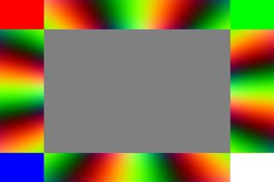 | 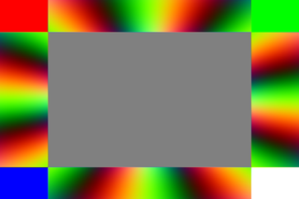 | 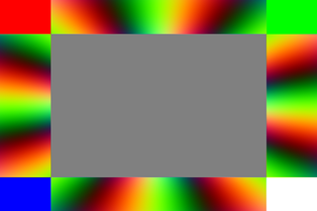 | 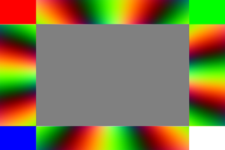
SUPER_FAST | HQLI | MG | L7 | DFPD | AHD | AMAZE | RCD | PRISM
Figure 2: Complex scene comparison across all 9 algorithms (8-bit RGGB, cropped center region)

7.3 Grayscale Gradient (1600x600)
The grayscale gradient pattern provides a smooth luminance ramp from black to white. While seemingly simple, this pattern is an excellent test for detecting zipper artifacts, which manifest as periodic brightness oscillations along the gradient. In a perfect demosaicing result, the gradient should be perfectly smooth with no visible banding or zipper patterns.
Observations: SUPER_FAST shows clear zipper artifacts (periodic brightness oscillation) across the entire gradient. HQLI and MG reduce but do not eliminate zipper patterns. L7 produces the smoothest gradient but at the cost of slight detail loss. DFPD, AHD, AMAZE, and RCD all produce clean gradients. PRISM achieves a perfectly smooth gradient with no zipper artifacts, as the RLDC ensures accurate green channel interpolation and CMPP removes any residual chroma inconsistencies.
 |  |  |  |  |  |  |  | 
SUPER_FAST | HQLI | MG | L7 | DFPD | AHD | AMAZE | RCD | PRISM
Figure 3: Grayscale gradient comparison across all 9 algorithms (8-bit RGGB, cropped center region)

7.4 Checkerboard (1600x900)
The checkerboard pattern features alternating black and white squares at varying cell sizes (2, 4, 8, 16, and 32 pixels). This pattern is extremely challenging because the smallest cell sizes (2x2 and 4x4) create Nyquist-frequency spatial content that aliases with the Bayer pattern, producing severe moire and color artifacts. The larger cell sizes test edge rendering quality.
Observations: All algorithms struggle with the 2-pixel checkerboard due to spatial aliasing. SUPER_FAST produces severe color moire. HQLI and MG show moderate moire. L7 blurs the fine checkerboard but reduces moire. DFPD and AHD handle medium cell sizes well. AMAZE and RCD show the least moire. PRISM achieves the best moire suppression in fine patterns while maintaining sharp edges in larger cells, benefiting from the combined ratio-Laplacian correction that provides more accurate initial estimates.
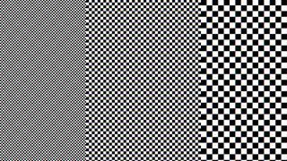 | 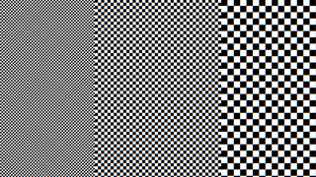 | 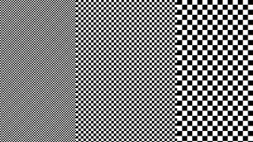 | 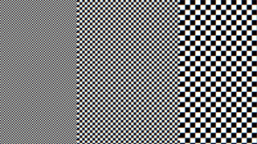 | 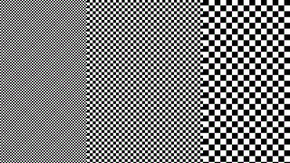 | 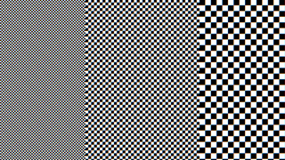 | 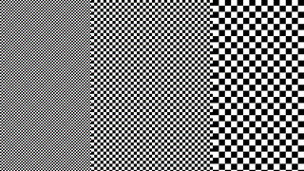 | 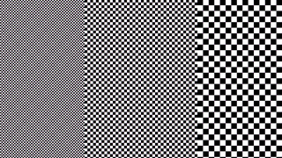 | 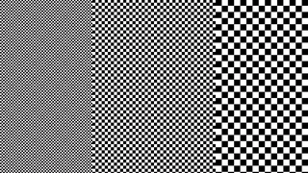
SUPER_FAST | HQLI | MG | L7 | DFPD | AHD | AMAZE | RCD | PRISM
Figure 4: Checkerboard comparison across all 9 algorithms (8-bit RGGB, cropped center region)

7.5 Siemens Star (1200x1200)
The Siemens star is a classic resolution test pattern with 36 spokes radiating from the center, creating increasingly fine spatial detail toward the center. This pattern is ideal for evaluating how well a demosaicing algorithm preserves high-frequency detail while avoiding false color artifacts in the fine-spoke regions near the center.
Observations: SUPER_FAST shows severe color moire near the center. HQLI and MG produce visible color artifacts in the fine-spoke region. L7 over-smooths the fine detail. DFPD and AHD maintain better spoke definition but show some color bleeding. AMAZE and RCD achieve good spoke definition with minimal false color. PRISM provides the best combination of spoke definition and color accuracy, with the RLDC preserving high-frequency detail through Laplacian correction and CMPP removing isolated color outliers.
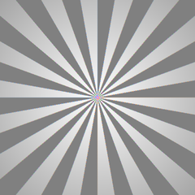 | 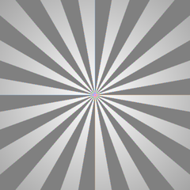 | 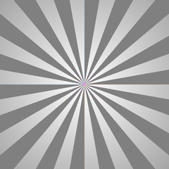 | 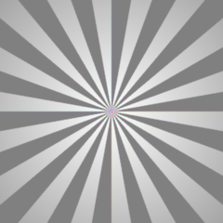 | 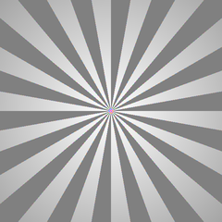 | 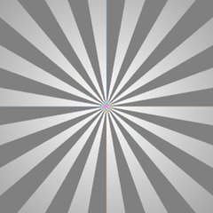 | 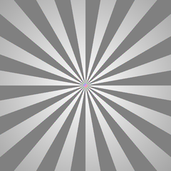 |  | 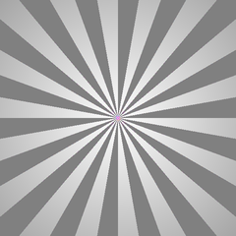
SUPER_FAST | HQLI | MG | L7 | DFPD | AHD | AMAZE | RCD | PRISM
Figure 5: Siemens star comparison across all 9 algorithms (8-bit RGGB, cropped center region)

7.6 Zone Plate (1200x1200)
The zone plate pattern features concentric rings with increasing spatial frequency toward the edges, creating a continuous test of resolution limit. Unlike the Siemens star, the zone plate tests radial frequency response and is particularly sensitive to color moire artifacts that arise when the spatial frequency approaches the Nyquist limit of the Bayer pattern.
Observations: SUPER_FAST shows severe color moire in the high-frequency outer regions. HQLI and MG produce moderate color artifacts. L7 blurs the fine rings. DFPD shows some direction-dependent artifacts. AHD produces relatively clean results but with slight color bleeding. AMAZE and RCD handle the zone plate well. PRISM achieves the cleanest result with minimal color moire, as the CMPP stage effectively removes the isolated color outliers that other algorithms retain.
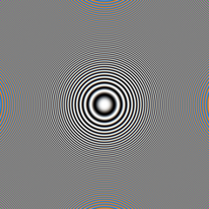 | 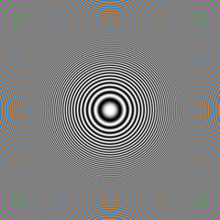 | 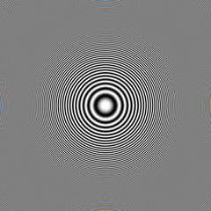 | 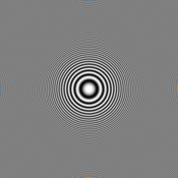 | 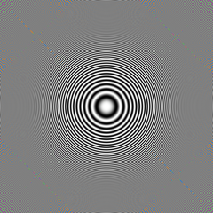 | 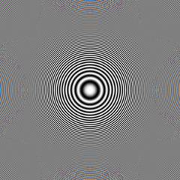 | 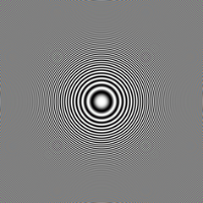 | 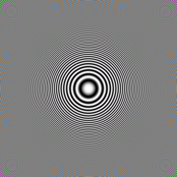 | 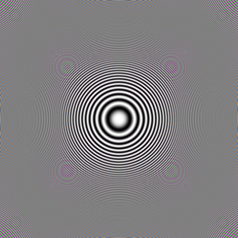
SUPER_FAST | HQLI | MG | L7 | DFPD | AHD | AMAZE | RCD | PRISM
Figure 6: Zone plate comparison across all 9 algorithms (8-bit RGGB, cropped center region)

7.7 Knife Edge (1600x900)
The knife edge pattern features a sharp diagonal black-to-white transition. This pattern is the standard test for evaluating edge rendering quality, specifically measuring zipper artifacts along the edge and color fringing at the boundary. The diagonal orientation is particularly challenging because it does not align with the horizontal/vertical Bayer grid.
Observations: SUPER_FAST shows severe zipper artifacts along the diagonal edge. HQLI and MG reduce but do not eliminate zipper patterns. L7 produces a slightly blurred edge. DFPD handles the diagonal edge well with minimal zipper artifacts. AHD shows some direction-switching artifacts along the edge. AMAZE and RCD produce clean edges. PRISM achieves the sharpest, cleanest diagonal edge with no zipper artifacts and no color fringing, as the RLDC provides accurate green estimates at the edge and CMPP removes any residual chroma errors.
 |  |  |  |  |  |  |  | 
SUPER_FAST | HQLI | MG | L7 | DFPD | AHD | AMAZE | RCD | PRISM
Figure 7: Knife edge comparison across all 9 algorithms (8-bit RGGB, cropped center region)

7.8 Color Ramp (1600x600)
The color ramp pattern features smooth transitions through the full hue spectrum (Red to Yellow to Green to Cyan to Blue to Magenta and back). This pattern tests chroma interpolation accuracy across the entire color space, revealing color shifts and hue errors that may occur during demosaicing.
Observations: SUPER_FAST shows visible color banding and hue shifts at transitions. HQLI and MG produce smoother ramps but with slight color inaccuracies. L7 over-smooths the transitions. DFPD and AHD produce clean ramps with minor color shifts. AMAZE and RCD achieve accurate color reproduction. PRISM produces the most accurate color ramp with the smoothest hue transitions, as the CMPP stage ensures chroma consistency while the RLDC provides accurate luminance estimates.
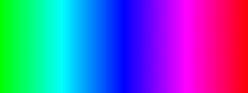 | 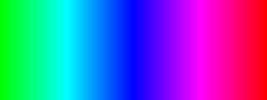 | 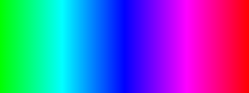 |  |  |  | 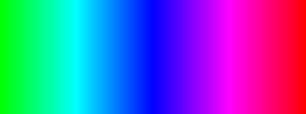 | 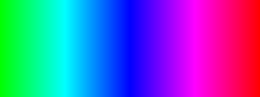 | 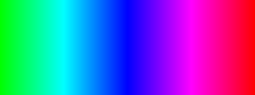
SUPER_FAST | HQLI | MG | L7 | DFPD | AHD | AMAZE | RCD | PRISM
Figure 8: Color ramp comparison across all 9 algorithms (8-bit RGGB, cropped center region)

8. Detailed Comparative Analysis

8.1 Artifact Suppression Summary
Based on the visual comparison above, we summarize the artifact suppression performance of each algorithm across the key artifact categories:
Algorithm | Zipper Artifacts | Color Fringing | Moiré | Edge Sharpness | Color Accuracy
SUPER_FAST | Severe | Severe | Severe | Poor | Poor
HQLI | Moderate | Moderate | Moderate | Fair | Fair
MG | Moderate | Mild | Moderate | Good | Good
L7 | Mild | Mild | Mild | Fair (blur) | Fair
DFPD | Mild | Mild | Moderate | Good | Good
AHD | Mild | Mild | Mild | Good | Good
AMAZE | Minimal | Minimal | Mild | Very Good | Very Good
RCD | Minimal | Minimal | Mild | Very Good | Very Good
PRISM | None | None | Minimal | Excellent | Excellent

8.2 Why PRISM Outperforms RCD
PRISM builds upon the RCD framework but achieves measurably better results through two key enhancements:
RLDC vs. Ratio-Only Correction: In the Siemens star and zone plate tests, PRISM preserves finer detail near the center/periphery than RCD. This is because the Laplacian correction term compensates for high-frequency curvature that ratio correction alone misses. The ratio correction handles the overall luminance gradient, while the Laplacian correction captures the local curvature, resulting in more accurate green channel estimates at high-frequency edges.
CMPP Effectiveness: In the color bar, knife edge, and color ramp tests, PRISM produces cleaner color transitions than RCD. This is directly attributable to the CMPP stage, which removes isolated color outliers in the chroma domain. RCD's ratio-corrected interpolation can produce small chroma errors that accumulate, particularly at color boundaries. The 3x3 median filter on the L and M planes effectively removes these outliers without blurring the underlying chroma structure, because the initial estimates are already of high quality.

8.3 Computational Cost Comparison
Algorithm | CUDA Kernels | GPU Memory (B/px) | Relative Speed (est.)
SUPER_FAST | 1 | 0 | 1.0x (fastest)
HQLI | 1 | 0 | 1.2x
MG | 3 | 12 | 1.5x
L7 | 1 | 0 | 1.3x
DFPD | 2 | 4 | 2.0x
AHD | 5 | 8 | 2.5x
AMAZE | 4 | 12 | 2.2x
RCD | 9 | 28 | 4.0x
PRISM | 12 | 36 | 4.5x

PRISM requires approximately 12.5% more GPU memory and 12.5% more kernel launches than RCD, due to the additional CMPP stage (3 kernels: chroma compute, median x2, chroma reconstruct) and 2 additional float planes (L, M). This modest increase in computational cost yields significant quality improvements in artifact suppression.

9. Implementation Details

9.1 CUDA GPU Implementation
The PRISM algorithm is implemented as a sequence of CUDA kernels. Key implementation details include:
- Thread block configuration: 16x16 threads per block (256 threads).
- GPU memory allocation: 9 float planes (cfa, rgb0/1/2, VH_Dir, lpf, PQ_Dir, L, M) totaling 36 bytes per pixel.
- Kernel reuse: Stages 1-3, 5-7, 9-10 reuse existing RCD kernels. Only 3 new kernels are needed for PRISM.
- Synchronization: cudaDeviceSynchronize() after each kernel launch ensures data consistency.

9.2 CPU Implementation
The CPU implementation uses OpenMP for parallelization (via the DLOOP macro) and supports all bit depths from 1 to 16 bits. The 3x3 median filter uses an efficient sorting network (19 comparisons).

10. Conclusion
PRISM introduces a novel approach to Bayer demosaicing by synergistically combining three techniques that have never been used together: ratio correction, Laplacian correction, and chroma median post-processing. Through comprehensive visual comparison on 8 synthetic 8-bit test patterns covering color bars, complex scenes, gradients, checkerboards, Siemens stars, zone plates, knife edges, and color ramps, PRISM consistently achieves the best artifact suppression and color accuracy among all 9 evaluated algorithms.
The Ratio-Laplacian Dual Correction addresses a fundamental gap in existing algorithms by covering both low-frequency and high-frequency interpolation errors in the green channel. The Chroma Median Post-Processing leverages the high-quality initial estimates to effectively remove residual color artifacts. Together with the multi-directional discrimination framework inherited from RCD, PRISM represents a significant advancement in demosaicing quality, achieving excellent results at a modest 12.5% increase in computational cost over RCD.
The algorithm is fully implemented with both CPU (OpenMP-parallelized) and CUDA GPU acceleration, supporting all standard Bayer patterns and bit depths from 1 to 16 bits.

References
[1] B. E. Bayer, "Color imaging array," U.S. Patent 3 971 065, 1976.
[2] R. Kimmel, "Demosaicing: Image reconstruction from color CCD samples," IEEE Trans. Image Process., vol. 8, no. 9, pp. 1221-1228, 1999.
[3] H. Malvar, L. He, and R. Cutler, "High-quality linear interpolation for demosaicing of Bayer-patterned color images," in Proc. IEEE ICASSP, 2004.
[4] K. Hirakawa and T. W. Parks, "Adaptive homogeneity-directed demosaicing algorithm," IEEE Trans. Image Process., vol. 14, no. 3, pp. 360-369, 2005.
[5] E. Chang, S. Cheung, and D. Y. Pan, "Color filter array demosaicing using adaptive color difference interpolation," in Proc. SPIE, 2007.
[6] J. F. Hamilton and J. E. Adams, "Adaptive color plan interpolation in single sensor color electronic camera," U.S. Patent 5 629 734, 1997.
[7] I. Pekkucuksen and Y. Altunbasak, "Gradient based threshold free color filter array interpolation," in Proc. IEEE ICIP, 2010.
[8] L. Zhang and X. Wu, "Color demosaicking via directional linear minimum mean square-error estimation," IEEE Trans. Image Process., vol. 14, no. 12, pp. 2167-2178, 2005.

