Responsiveness

First, I enter this code within all my html pages, this code allows the page to becoming responsive with I switch up to a mobile view for example.
When creating my photo html page, I had to create an especial CSS class to be within the html so that my pictures will becoming responsive with different devices for example, a mobile phone and any other devices.

Is this picture shows were the class “responsive” where inserted, I also done with will all my picture since very picture needs to be responsive and react within the devices they are being view from. I wll also show you the CSS code bellow.

Other tools that I use for the @media only screen, which allowed me to change the pixel size of my page will their reach a certain pixel size. For example, in the photo CSS I coded this coded so that when the page goes down to 700px the page will reach and stack the photo and top of each other making them reactive and responsive. Meaning that mobile user and small screen devices will be able to see the picture in full affect.

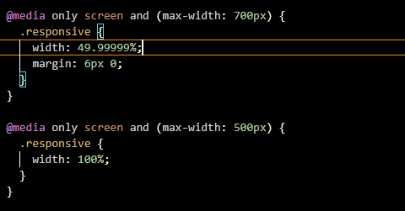

You can see the picture bellow that the page size still hasn’t reach 700px down and the picture are viewable across, but the page will reach 700px down, it will change, and the picture will stack on top of each other

Example for the photo page when is reach 700px.



