carta%20gen

Department of Engineering and Architecture

Master of Science in Communication Engineering

***Advanced Photonics***

*Academic Year 2019-2020*

**Final Assignment Report**

**Student: Sahil Kumar**

**Identification number: 309505**

**Abstract:**

*In this project, I am analyzing the influence of the ring-core profile on the Mode Field Diameter (MFD) of Pure Silica Core Fibers (PSCFs) through numerical simulations based on the Finite Elements Method. I am also comparing the values of ring-core and step-core pure silica core fibers at same value of Effective Area (Aeff) in terms of Mode Field Diameter, by calculating or evaluating the splice loss to Standard Single Mode Fibers. Finally, I show how the effectiveness of the ring-core profile in reducing the MFD mismatch with SSMFs, by comparing the values of splice losses obtained for both simulations.*

1. **Introduction**

In this assignment, it’s important to understand Pure Silica Core Fiber and the terms like Effective Area (Aeff) and Mode Field Diameter (MFD) for Pure Silica Core Fibers as well as their mathematical equations.

**Effective Area** [1] of a Pure Silica Core Fiber is also known as Effective Mode Area, is a quantitative measure of the area which a waveguide or fiber mode effectively covers in the transverse dimensions. Effective Area is measure in meter square. Mathematically it is defined as follows

A*eff = $\frac{(\iint_{s}{ I(x, y)dxdy)^{2}}}{\iint_{s}{{ I}^{2}}(x, y)dxdy}$* ,

here I(x,y) is the intensity distribution and is evaluated from the poynting vector equation [2].

= ℜ $[ \frac{\overline{E } × \overline{H*}}{2} ∙ \hat{z}$],

and its double integral is taken under S which is cross-section area of the fiber.

**Mode Field Diameter** [3] is a measure of the spatial extent of the fundamental mode – is an important parameter for single-mode fibers. MFD plays an important role in estimating the splice losses, source-to-fiber coupling losses, bending and micro bending losses, etc. I am using this formula to calculate the value of MFD in this assignment.

$$κ= \frac{4 × Aeff}{π . {MFD}^{2}}$$

As given in the assignment, I am assuming the value of $κ$ is 1.05 and 1.11 for step-core and ring-core respectively. Also, In Pure Silica Core Fibers with enlarged Effective Area (Aeff) have higher splicing loss to existing Standard Single-Mode Fibers (SSMFs) with Aeff 80 ≃ µm2 and mode field diameter MFD ≃ 10 µm, due to the large MFD mismatch. Then, for analyzing refractive index profiles of ring-core and step-core PSCFs, I am considering only fundamental mode and calculating the following parameters using COMSOL 5.4 Multiphysics

* Effective Area (Aeff ) with respect to wavelength λ
* Mode Field Diameter (MFD) with respect to wavelength λ

Once I have both the values of Effective Area and Mode field Diameter for ring-core and step-core, I am going to use those values to calculate Splice Loss for ring-core as well as step-core using the following mathematical formula

*SL =* 10 $\log_{10}{(\frac{2.{MFD}_{PSCF} . {MFD}_{SSMF}}{{MFD}_{PSCF }^{2}+{ MFD}_{SSMF}^{2}})^{2}}$ dB

1. **Numerical analysis**

I have analyzed refractive index profile of the ring-core and step-core Pure Silica Core Fiber having slightly fluorine doping in the center-core surrounded by a pure silica ring-core. As per the principle of total internal reflection, ring-core should have high refractive index compared to cladding and center-core for keeping the propagation of light inside the ring only. In this design depressed cladding is also fluorine doped. Final design of the fiber has 5(for Ring-core) and 4(for Step-core) geometric regions:

* Center core (Radius denoted by a, Refractive index denoted by η*core*)
* Ring Core (Radius denoted by b, Refractive index denoted by η $ring$)
* Depressed cladding (Radius denoted by c, Refractive index denoted by ηclad)
* Outer cladding (Radius denoted by d and refractive index denoted by ηouterclad)
* Perfectly Matched Layer having width of 5 *µm* as a boundary condition

**Calculation for Obtaining all the required parameters for simulation**

Value of η $ring$ is equal to η $silica$ which is equal to 1.444023622. Value of η $silica$ is obtained from Sellmeier Equation that is given below:

$η_{silica}^{2}$ $-$ 1 = $\sum_{j }{\frac{A_{j {λ }^{2}}}{{λ }^{2}-{λ }_{j}^{2}}}$

Where value of λ is in $μ$*m,* Given table below for different values of $A_{j}$ ${ and λ}_{j}$ for silica.

|  |  |  |
| --- | --- | --- |
| **J** | $$A_{j}$$ | $$λ_{j}$$ |
| 1 | 0.6961663 | 0.0684043 |
| 2 | 0.4079426 | 0.1162414 |
| 3 | 0.8974794 | 9.896161 |

* **Relative Refractive Index differences:**

1. Between ring core and center core is 0.1%

$∆_{1}$ = $\frac{ η{ring}^{2}-η{core}^{2}}{2η{ring}^{2}}$

Using the above formula, we can calculate the value of η*core*

1. Between ring core and depressed cladding is 0.34%

$∆_{2}$ = $\frac{η{ring}^{2}-η{clad}^{2}}{2η{ring}^{2}}$

Using the above formula, we can calculate the value of ηclad

1. Between outer cladding and depressed cladding is 0.1%

$∆_{3}$ = $\frac{η{outerclad}^{2}-η{clad}^{2}}{2η{outerclad}^{2}}$

Using the above formula, we can calculate the value of ηouterclad

**Tables of all the Parameters used in COMSOL simulation are given below:**

**Ring Core**

|  |  |  |
| --- | --- | --- |
| **Name** | **Expression** | **Value** |
| Wavelength | 1550[nm] | 1.55E-6 m |
| b | 6.05[um] | 6.05E-6 m |
| a | b/2.5 | 2.42E-6 m |
| c | 3.5*b | 2.1175E-5 m |
| d | 2.5*c | 5.29375E-5 m |
| Nsilica | (1+(0.6961663*w^2)/(w^2-(0.0684043)^2)+(0.4079426*w^2)/(w^2-(0.1162414)^2)+(0.8974794*w^2)/(w^2-(9.896161) ^2))^0.5 | 1.444023622 |
| W | wavelength*1e6 | 1.55 m |
| Dn1 | 0.001 | 0.001 |
| Ncore | nring*((1-(2*Dn1))^(0.5)) | 1.442578875 |
| Nring | Nsilica | 1.444023622 |
| Dn2 | 0.0034 | 0.0034 |
| Nclad | nring*((1-(2*Dn2))^(0.5)) | 1.439105566 |
| Dn3 | 0.001 | 0.001 |
| Nouterclad | nclad/((1-(2*Dn3))^(0.5)) | 1.440546834 |
| DrPML | 5[um] | 5E-6 m |
| rPML | d+DrPML | 5.79375E-5 m |

**Step Core**

|  |  |  |
| --- | --- | --- |
| **Name** | **Expression** | **Value** |
| Wavelength | 1550[nm] | 1.55E-6 m |
| b | 6.05[um] | 6.05E-6 m |
| a | b/2.5 | 2.42E-6 m |
| c | 3.5*b | 2.1175E-5 m |
| d | 2.5*c | 5.29375E-5 m |
| nsilica | (1+(0.6961663*w^2)/(w^2-(0.0684043)^2)+(0.4079426*w^2)/(w^2-(0.1162414)^2)+(0.8974794*w^2)/(w^2-(9.896161) ^2))^0.5 | 1.444023622 |
| w | wavelength*1e6 | 1.55 m |
| Dn1 | 0 | 0.001 |
| ncore | nring*((1-(2*Dn1))^(0.5)) | 1.442578875 |
| nring | Nsilica | 1.444023622 |
| Dn2 | 0.0034 | 0.0034 |
| nclad | nring*((1-(2*Dn2))^(0.5)) | 1.439105566 |
| Dn3 | 0.001 | 0.001 |
| nouterclad | nclad/((1-(2*Dn3))^(0.5)) | 1.440546834 |
| DrPML | 5[um] | 5E-6 m |
| rPML | d+DrPML | 5.79375E-5 m |

**Physics Controlled Mesh with element size used in this assignment are shown below**

* Ring Core: Element Size – Extra Fine Step Core: Element Size – Extra Fine

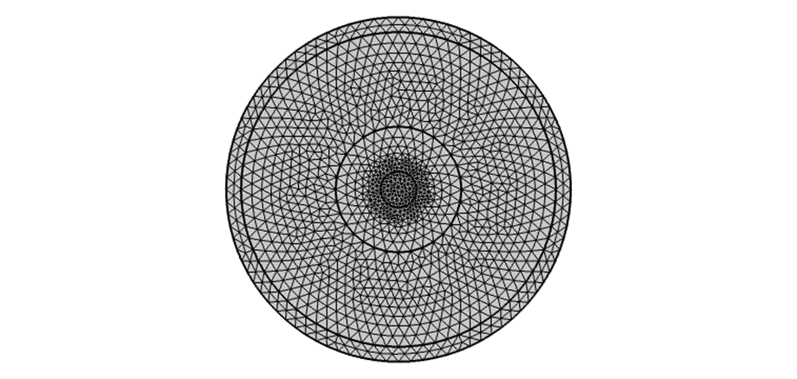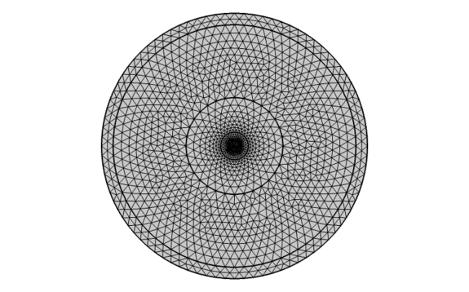

**Figure 1: Mesh Property of Ring Core PSCF Figure 2. Mesh Property of Step Core PSCF**

**Steps to design a model in COMSOL Multiphysics**

1. File $→$ preferences $→$ General $→$ set input and output display precisions to 10. Then, Results $→$ and set display precision to 10
2. Restart and choose the New Model Wizard select model wizard.mph and select 2D then select electromagnetic waves -> frequency domain(emw) in the wave optics module of COMSOL and proceed to Study Mode Analysis.
3. **Parameter**: Declare and Define all the parameters given in the tables of parameter above.
4. **Geometry**: Now go to the geometry, create and build a geometry of PSCF by building all the regions by using circle geometry option. Also define radius as center core(*a)*, ring core(*b)*, cladding(*c)*, Outer cladding(*d)* and rPML
5. **Materials**: Enter refractive index’s values in material section as ncore, nring, nclad, nouterclad and nPML.
6. **Definitions**: Declare and Define the expression for A*eff* and MFD
7. **Mesh**: Select the mesh sequence type as Physics-Controlled and Element Size as Extra fine
8. **Mode analysis:** Search for modes around the core/ring and set desired number of modes to 10 and the Mode analysis frequency to c_const/wavelength, where c is the speed of light.
9. **Parametric Sweep:** Set start frequency at 1500[nm] to end frequency 1600[nm] with a wavelength step of 10[nm] as given, then press compute.
10. **Result**: The Electric field distribution for Fundamental mode (FM) is obtained and plotted on the graphics panel of COMSOL 5.4.
11. **Derived Values**: Effective area as well as MFD, for Effective mode index selection, select Last value and select ‘All’ for parameter selection (wavelength).
12. Previous steps are repeated in both PSCFs, after that in Step-core designing we will try to obtain A*eff* as that of ring core at 1550 [nm] by properly enlarging the ring core diameter b.
13. **Simulation results**

**Results of the Simulation are as follows:**

**Plot of Field Distribution of Ring Core for Fundamental Mode.**

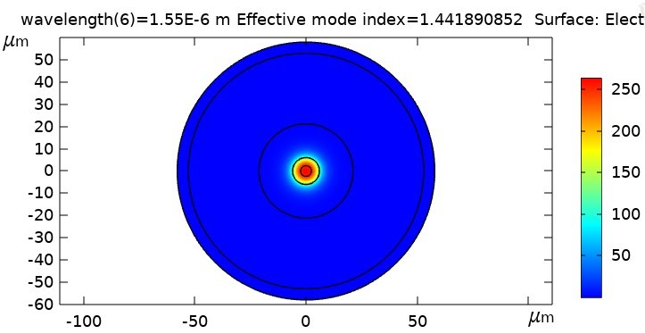

As we can see from the above simulation, propagation is confined in the ring-core for the Fundamental Mode of the PSCF and the intensity is decreasing radially outward from fiber axis and cladding interface. Then, for guided modes, effective refractive index is defined as the following equation.

nclad < neff < ncore

**Plot of Field Distribution of Step Core for Fundamental Mode.**

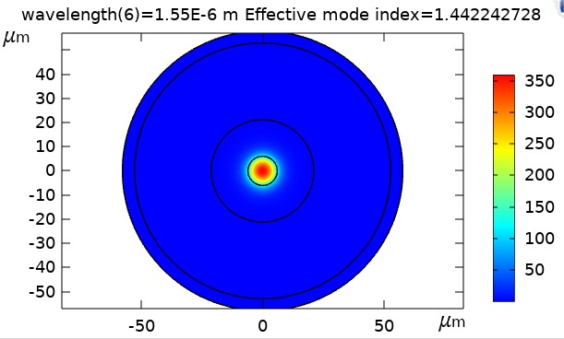

In the above simulation result also the light propagation is totally confined in the core of a step-core PSCF, also intensity of the light is decreasing radially outward from the fiber axis to core and cladding interface.

**Tables obtained from the Simulation of ring-core and step-core PSCFs design.**

|  |  |  |  |  |  |  |  |
| --- | --- | --- | --- | --- | --- | --- | --- |
|  | **Ring Core** |  |  |  |  | **Step-Core** |  |
| **Wavelength** | **Aeff(m2)** | **MFD(m)** |  |  | **Wavelength** | **Aeff(m2)** | **MFD(m)** |
| 1.500000E-06 | 1.255137E-10 | 1.199884E-05 |  |  | 1.500000E-06 | 1.088526E-10 | 1.148894E-05 |
| 1.510000E-06 | 1.260845E-10 | 1.202609E-05 |  |  | 1.510000E-06 | 1.094422E-10 | 1.152002E-05 |
| 1.520000E-06 | 1.266624E-10 | 1.205362E-05 |  |  | 1.520000E-06 | 1.100370E-10 | 1.155128E-05 |
| 1.530000E-06 | 1.272475E-10 | 1.208143E-05 |  |  | 1.530000E-06 | 1.106370E-10 | 1.158273E-05 |
| 1.540000E-06 | 1.278399E-10 | 1.210952E-05 |  |  | 1.540000E-06 | 1.112422E-10 | 1.161436E-05 |
| 1.550000E-06 | **1.284396E-10** | **1.213789E-05** |  |  | 1.550000E-06 | **1.118528E-10** | **1.164619E-05** |
| 1.560000E-06 | 1.290466E-10 | 1.216654E-05 |  |  | 1.560000E-06 | 1.124687E-10 | 1.167821E-05 |
| 1.570000E-06 | 1.296610E-10 | 1.219547E-05 |  |  | 1.570000E-06 | 1.130901E-10 | 1.171043E-05 |
| 1.580000E-06 | 1.302829E-10 | 1.222468E-05 |  |  | 1.580000E-06 | 1.137170E-10 | 1.174284E-05 |
| 1.590000E-06 | 1.309123E-10 | 1.225417E-05 |  |  | 1.590000E-06 | 1.143495E-10 | 1.177545E-05 |
| 1.600000E-06 | 1.315494E-10 | 1.228395E-05 |  |  | 1.600000E-06 | 1.149876E-10 | 1.180827E-05 |

Here we can see that the Aeff values are different for Ring-Core and Step-Core at 1550[nm], to obtain equal value of the Effective area for Step-core PSCF as that of ring-coreat 1550[nm], we can enlarge the ring core diameter b at the same wavelength 1550nm and choosing a right b value which gives the same Effective area as that of Ring-core PSCF.

**Table below showing relation between Effective Area of both ring-core and step-core w.r.t Wavelength.**

|  |  |  |
| --- | --- | --- |
|  | Aeff w.r.t Wavelength | |
| Wavelength | **Aeff(m2) Ring** | **Aeff(m2) Step** |
| 1.500000E-06 | 1.255137E-10 | 1.088526E-10 |
| 1.510000E-06 | 1.260845E-10 | 1.094422E-10 |
| 1.520000E-06 | 1.266624E-10 | 1.100370E-10 |
| 1.530000E-06 | 1.272475E-10 | 1.106370E-10 |
| 1.540000E-06 | 1.278399E-10 | 1.112422E-10 |
| 1.550000E-06 | **1.284396E-10** | **1.118528E-10** |
| 1.560000E-06 | 1.290466E-10 | 1.124687E-10 |
| 1.570000E-06 | 1.296610E-10 | 1.130901E-10 |
| 1.580000E-06 | 1.302829E-10 | 1.137170E-10 |
| 1.590000E-06 | 1.309123E-10 | 1.143495E-10 |
| 1.600000E-06 | 1.315494E-10 | 1.149876E-10 |
|  |  |  |

From a table above effective areas Aeff are varying linearly as wavelength λ increase. At wavelength λ= 1550[nm] effective areas obtained are **1.284396E-10** m2 for ring-core and **1.118528E-10** m2 for step-core. This tell us by increasing the effective area will lead to higher splicing loss to standard single- mode fibers (SSMFs). Here down is the graphical plot of **Aeff** with respect to **Wavelength**, for the table above obtained from the simulations. Whereby the Effective areas seems to be linearly varying w.r.t wavelength.

**Also, we obtain the table as well as the plot of Mode Field Diameter values w.r.t wavelength.**

|  |  |  |
| --- | --- | --- |
| Wavelength | MFD(m) ring | MFD step(m) |
| 1.500000E-06 | 1.199884E-05 | 1.148894E-05 |
| 1.510000E-06 | 1.202609E-05 | 1.152002E-05 |
| 1.520000E-06 | 1.205362E-05 | 1.155128E-05 |
| 1.530000E-06 | 1.208143E-05 | 1.158273E-05 |
| 1.540000E-06 | 1.210952E-05 | 1.161436E-05 |
| 1.550000E-06 | **1.213789E-05** | **1.164619E-05** |
| 1.560000E-06 | 1.216654E-05 | 1.167821E-05 |
| 1.570000E-06 | 1.219547E-05 | 1.171043E-05 |
| 1.580000E-06 | 1.222468E-05 | 1.174284E-05 |
| 1.590000E-06 | 1.225417E-05 | 1.177545E-05 |
| 1.600000E-06 | 1.228395E-05 | 1.180827E-05 |

From the table and a plot above of mode field diameter w.r.t wavelength shows that the MFD is increasing as the values of wavelength increase.

**Table and Plot below obtained after properly enlarging the value of b in step-core.**

|  |  |  |
| --- | --- | --- |
| b values | Aeff(m2) | MFD (m) |
| 6.700000E-06 | 1.266820E-10 | 1.239419E-05 |
| 6.710000E-06 | 1.269234E-10 | 1.240599E-05 |
| 6.720000E-06 | 1.271652E-10 | 1.241780E-05 |
| 6.730000E-06 | 1.274072E-10 | 1.242961E-05 |
| 6.740000E-06 | 1.276497E-10 | 1.244144E-05 |
| 6.750000E-06 | 1.278926E-10 | 1.245327E-05 |
| 6.760000E-06 | 1.281359E-10 | 1.246510E-05 |
| 6.770000E-06 | **1.283795E-10** | **1.247695E-05** |
| 6.780000E-06 | 1.286235E-10 | 1.248880E-05 |
| 6.790000E-06 | 1.288679E-10 | 1.250066E-05 |
| 6.800000E-06 | 1.291128E-10 | 1.251253E-05 |

From a plot above after enlarging ring-core diameter **b** value in order to obtain the same value of A*eff* as that of ring-core PSCF was obtained at **b**= 6.77E-06 m, where the A*eff* is equal to **1.284E-10 $m^{2}.$** The effective area is also varying linearly as **b** value increases.

**Splice Loss Calculations: Obtained as follows,**

**MFD SSMF = 10.3 µm**

**MFD PSCF at ring core = 1.213788886E-5**

**MFD PSCF at step core = 1.247695164E-5**

**From the given formula, Splice Loss is calculated, and losses obtained are as follows**

**SL = -0.116554 dB (for Ring-Core)**

**SL= -0.158695 dB (for Step-Core)**

From splice loss calculations above, it seems that there is lower attenuation loss in ring-core compared to that of step-core after enlarging the b values. Hence, due to lower attenuation loss in ring-core profile it reduces the MFD mismatch with SSMFs compared to Step-core PSCF, this happen because of enlarging the effective area which leads to higher splicing loss to standard single Mode Fibers due to large MFD mismatch.

1. **Conclusions**

Hence, we can reduce the splice loss to Standard single mode fibers by avoiding enlarging of the effective area which cause higher splicing loss, by keeping constant the same effective area as that of ring core at 1550[nm] and design a Step-core by properly enlarging the value of ring core diameter b. This way we can also avoid or reduce large MFD mismatch with SSMFs and improve the effectiveness of the ring core profile propagation of light.

**References**

1. https://www.rp-photonics.com/effective_mode_area.html
2. https://www.sciencedirect.com/topics/engineering/poynting-vector
3. Fundamentals of Fibre Optics in Telecommunication and Sensor Systems by Bishnu P. Pal (Page 282)