**Document Page 1**



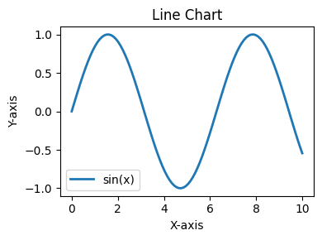

This is a sample report text for page 1 displaying a Line Chart.

|  |  |
| --- | --- |
|  | Page 1 |

**Document Page 2**

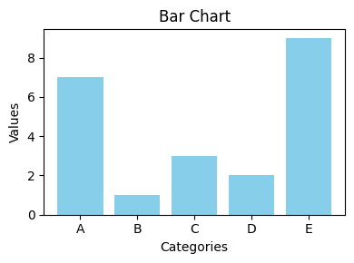

This is a sample report text for page 2 displaying a Bar Chart.

|  |  |
| --- | --- |
|  | Page 2 |

**Document Page 3**

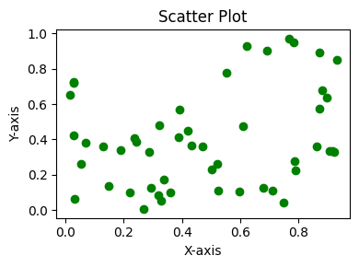

This is a sample report text for page 3 displaying a Scatter Plot.

|  |  |
| --- | --- |
|  | Page 3 |

**Document Page 4**

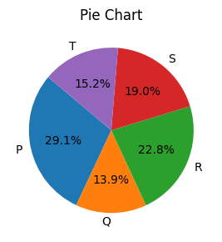

This is a sample report text for page 4 displaying a Pie Chart.

|  |  |
| --- | --- |
|  | Page 4 |

**Document Page 5**



This is a sample report text for page 5 displaying a Line Chart.

|  |  |
| --- | --- |
|  | Page 5 |

**Document Page 6**

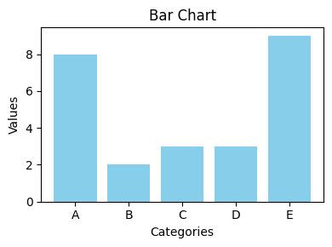

This is a sample report text for page 6 displaying a Bar Chart.

|  |  |
| --- | --- |
|  | Page 6 |

**Document Page 7**

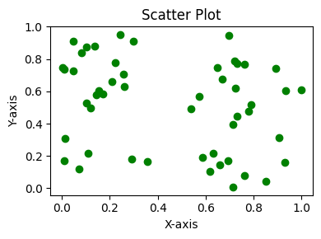

This is a sample report text for page 7 displaying a Scatter Plot.

|  |  |
| --- | --- |
|  | Page 7 |

**Document Page 8**

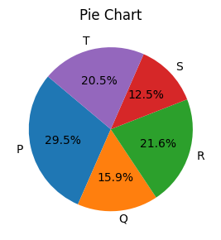

This is a sample report text for page 8 displaying a Pie Chart.

|  |  |
| --- | --- |
|  | Page 8 |

**Document Page 9**



This is a sample report text for page 9 displaying a Line Chart.

|  |  |
| --- | --- |
|  | Page 9 |

**Document Page 10**

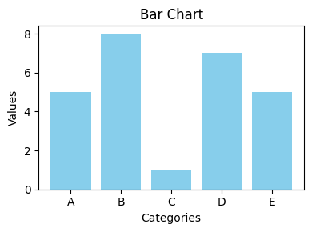

This is a sample report text for page 10 displaying a Bar Chart.

|  |  |
| --- | --- |
|  | Page 10 |

**Document Page 11**

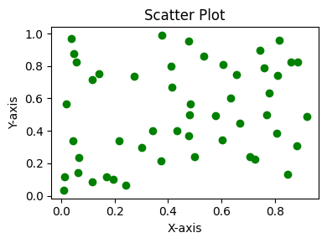

This is a sample report text for page 11 displaying a Scatter Plot.

|  |  |
| --- | --- |
|  | Page 11 |

**Document Page 12**

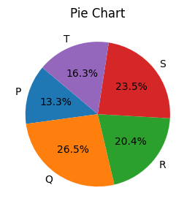

This is a sample report text for page 12 displaying a Pie Chart.

|  |  |
| --- | --- |
|  | Page 12 |

**Document Page 13**



This is a sample report text for page 13 displaying a Line Chart.

|  |  |
| --- | --- |
|  | Page 13 |

**Document Page 14**

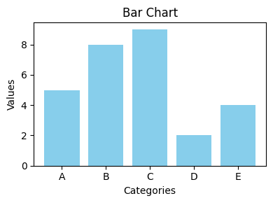

This is a sample report text for page 14 displaying a Bar Chart.

|  |  |
| --- | --- |
|  | Page 14 |

**Document Page 15**

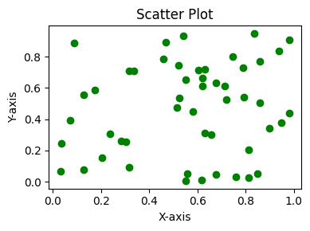

This is a sample report text for page 15 displaying a Scatter Plot.

|  |  |
| --- | --- |
|  | Page 15 |

**Document Page 16**

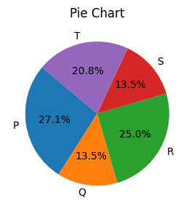

This is a sample report text for page 16 displaying a Pie Chart.

|  |  |
| --- | --- |
|  | Page 16 |

**Document Page 17**



This is a sample report text for page 17 displaying a Line Chart.

|  |  |
| --- | --- |
|  | Page 17 |

**Document Page 18**

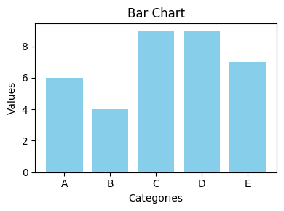

This is a sample report text for page 18 displaying a Bar Chart.

|  |  |
| --- | --- |
|  | Page 18 |

**Document Page 19**

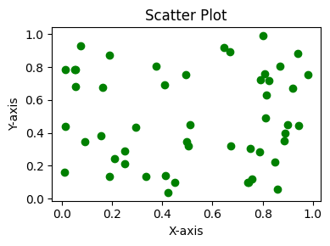

This is a sample report text for page 19 displaying a Scatter Plot.

|  |  |
| --- | --- |
|  | Page 19 |

**Document Page 20**

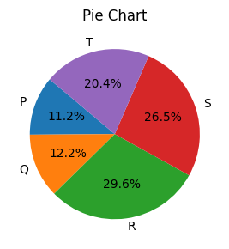

This is a sample report text for page 20 displaying a Pie Chart.

|  |  |
| --- | --- |
|  | Page 20 |

**Document Page 21**



This is a sample report text for page 21 displaying a Line Chart.

|  |  |
| --- | --- |
|  | Page 21 |

**Document Page 22**

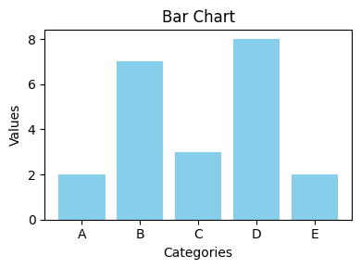

This is a sample report text for page 22 displaying a Bar Chart.

|  |  |
| --- | --- |
|  | Page 22 |

**Document Page 23**

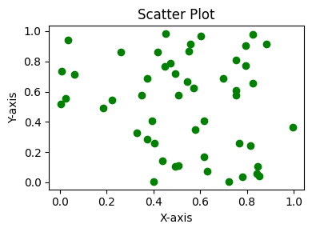

This is a sample report text for page 23 displaying a Scatter Plot.

|  |  |
| --- | --- |
|  | Page 23 |

**Document Page 24**

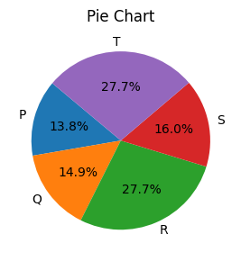

This is a sample report text for page 24 displaying a Pie Chart.

|  |  |
| --- | --- |
|  | Page 24 |

**Document Page 25**



This is a sample report text for page 25 displaying a Line Chart.

|  |  |
| --- | --- |
|  | Page 25 |

**Document Page 26**

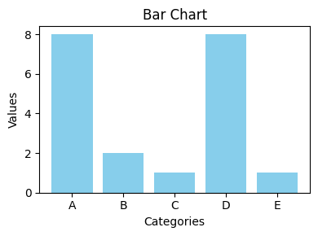

This is a sample report text for page 26 displaying a Bar Chart.

|  |  |
| --- | --- |
|  | Page 26 |

**Document Page 27**

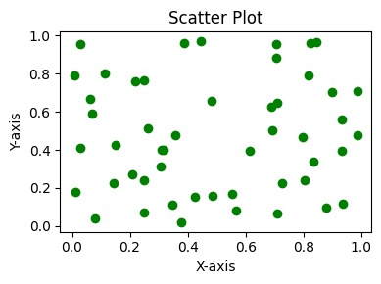

This is a sample report text for page 27 displaying a Scatter Plot.

|  |  |
| --- | --- |
|  | Page 27 |

**Document Page 28**

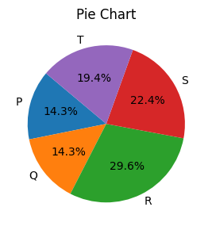

This is a sample report text for page 28 displaying a Pie Chart.

|  |  |
| --- | --- |
|  | Page 28 |

**Document Page 29**



This is a sample report text for page 29 displaying a Line Chart.

|  |  |
| --- | --- |
|  | Page 29 |

**Document Page 30**

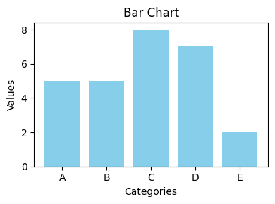

This is a sample report text for page 30 displaying a Bar Chart.

|  |  |
| --- | --- |
|  | Page 30 |

**Document Page 31**

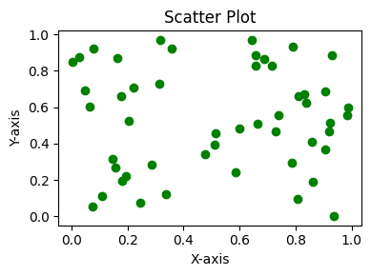

This is a sample report text for page 31 displaying a Scatter Plot.

|  |  |
| --- | --- |
|  | Page 31 |

**Document Page 32**

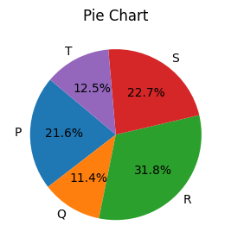

This is a sample report text for page 32 displaying a Pie Chart.

|  |  |
| --- | --- |
|  | Page 32 |

**Document Page 33**



This is a sample report text for page 33 displaying a Line Chart.

|  |  |
| --- | --- |
|  | Page 33 |

**Document Page 34**

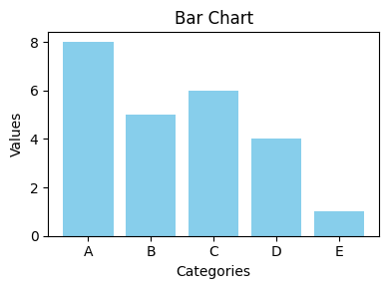

This is a sample report text for page 34 displaying a Bar Chart.

|  |  |
| --- | --- |
|  | Page 34 |

**Document Page 35**

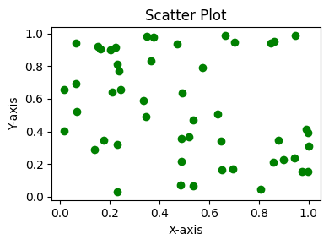

This is a sample report text for page 35 displaying a Scatter Plot.

|  |  |
| --- | --- |
|  | Page 35 |

**Document Page 36**

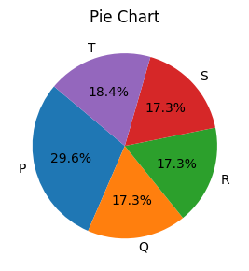

This is a sample report text for page 36 displaying a Pie Chart.

|  |  |
| --- | --- |
|  | Page 36 |

**Document Page 37**



This is a sample report text for page 37 displaying a Line Chart.

|  |  |
| --- | --- |
|  | Page 37 |

**Document Page 38**

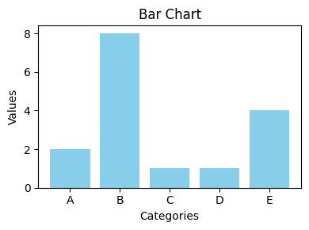

This is a sample report text for page 38 displaying a Bar Chart.

|  |  |
| --- | --- |
|  | Page 38 |

**Document Page 39**

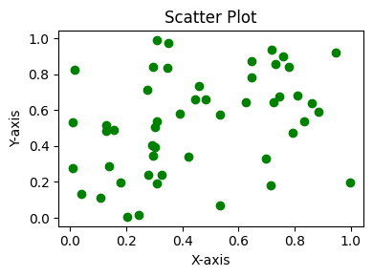

This is a sample report text for page 39 displaying a Scatter Plot.

|  |  |
| --- | --- |
|  | Page 39 |

**Document Page 40**

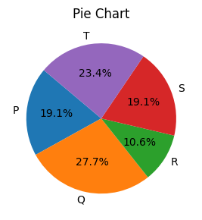

This is a sample report text for page 40 displaying a Pie Chart.

|  |  |
| --- | --- |
|  | Page 40 |

**Document Page 41**



This is a sample report text for page 41 displaying a Line Chart.

|  |  |
| --- | --- |
|  | Page 41 |

**Document Page 42**

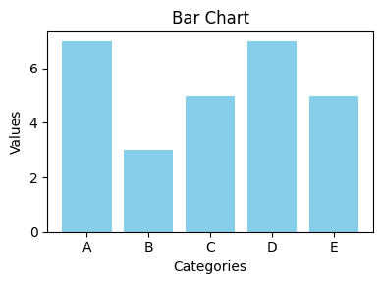

This is a sample report text for page 42 displaying a Bar Chart.

|  |  |
| --- | --- |
|  | Page 42 |

**Document Page 43**

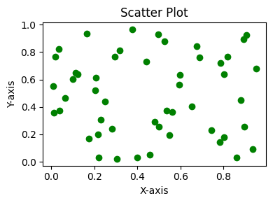

This is a sample report text for page 43 displaying a Scatter Plot.

|  |  |
| --- | --- |
|  | Page 43 |

**Document Page 44**

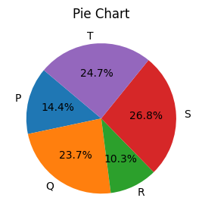

This is a sample report text for page 44 displaying a Pie Chart.

|  |  |
| --- | --- |
|  | Page 44 |

**Document Page 45**



This is a sample report text for page 45 displaying a Line Chart.

|  |  |
| --- | --- |
|  | Page 45 |

**Document Page 46**

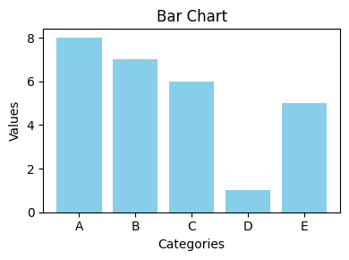

This is a sample report text for page 46 displaying a Bar Chart.

|  |  |
| --- | --- |
|  | Page 46 |

**Document Page 47**

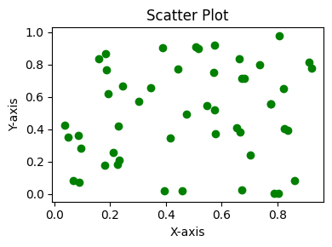

This is a sample report text for page 47 displaying a Scatter Plot.

|  |  |
| --- | --- |
|  | Page 47 |

**Document Page 48**

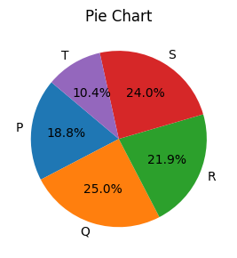

This is a sample report text for page 48 displaying a Pie Chart.

|  |  |
| --- | --- |
|  | Page 48 |

**Document Page 49**



This is a sample report text for page 49 displaying a Line Chart.

|  |  |
| --- | --- |
|  | Page 49 |

**Document Page 50**

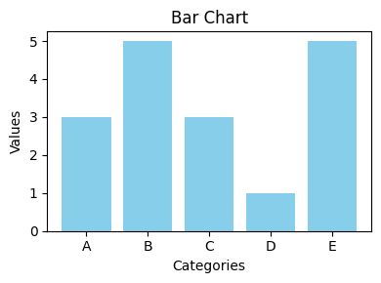

This is a sample report text for page 50 displaying a Bar Chart.

|  |  |
| --- | --- |
|  | Page 50 |