***COER CAR***

* ***Anmol Ratan Tiwari***

**Description : In this project , I created a website to buy or sell a Car completely free to all the users without any extra hidden charge. The website provides all the details of the car .**

**Tech Used :**

**Frontend : HTML , CSS , JavaScript**

**Database : MongoDB**

**Backend : NodeJS Python ( Backend )**

**Github URL :**

**Webpages : Index.html , login.html , contact us.html , about us**

**Steps to run the project :**

**Step 1 : Clone the project from Github to your system.**

### Step 2 : Download Node.js Installer and install NPM through command prompt

### Step 3 : Double click on index.html and it will take you to the Homepage of Website.

### 

### Homepage of Website :

### 

**Contact Us Page :**

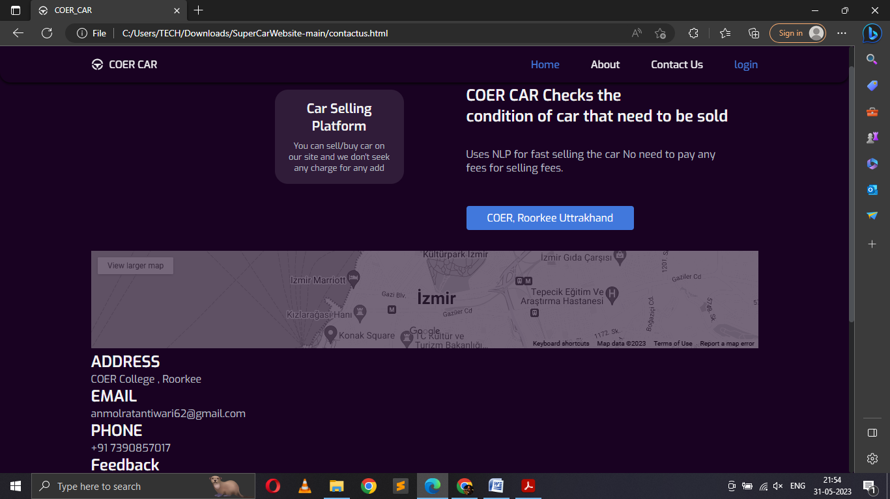

**Login Page :**

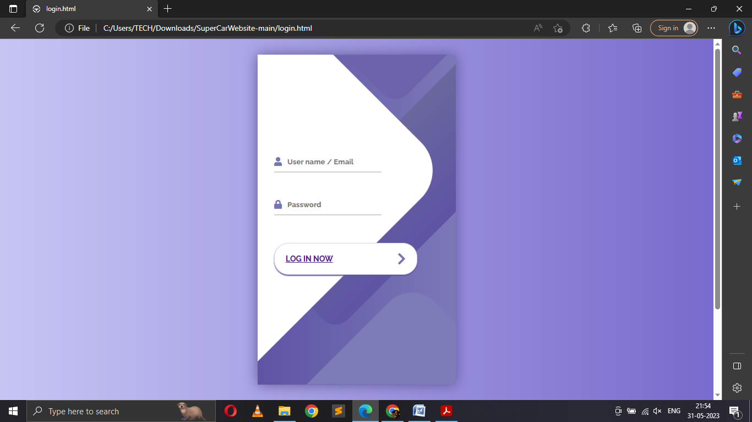

**About Us :**

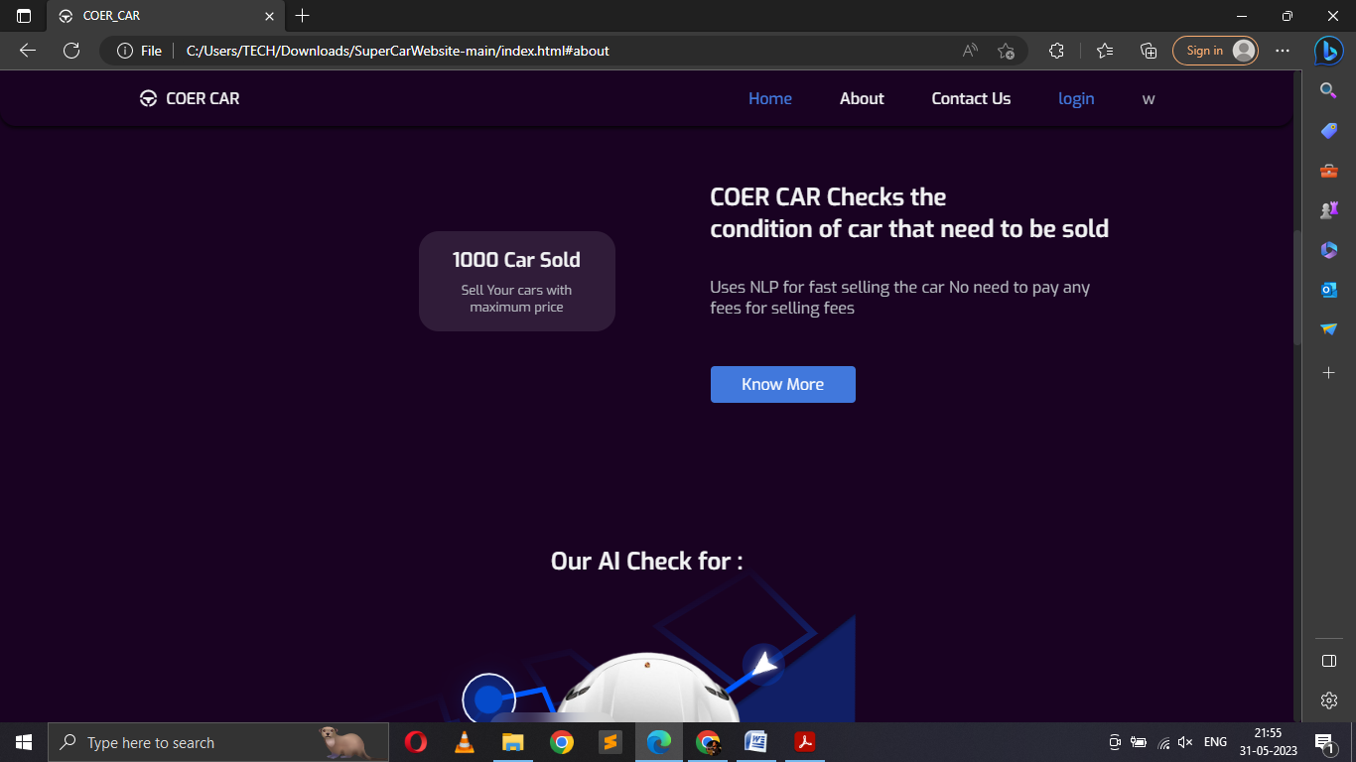

**Cars Buy Section :**

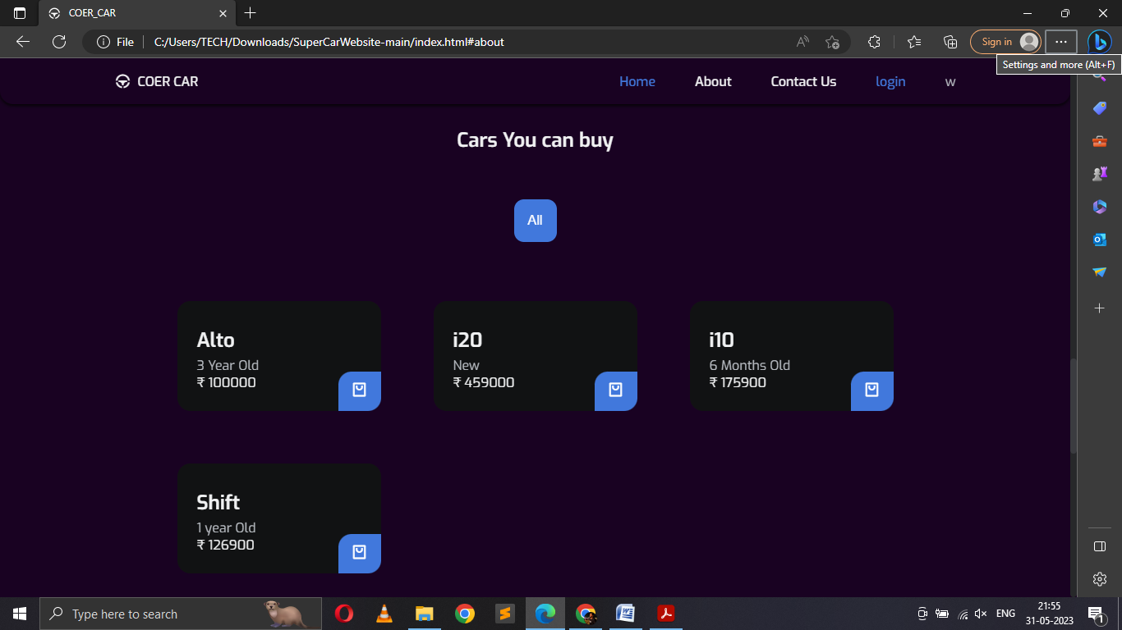

**MongoDB Database :**

