OBJECT ORIENTED PROGRAMMING USING JAVA Ex. No. 4 Implementation of Arrays in Java

Question 1:

Construct a Java program to perform the following task using an array.

i. Read marks of one course for all students in a class.

ii. To find the number of students passed in the course

iii. To find the number of students failed in the course

iv. To count the number of students secured O, A, B, C, D and E grade in a class

Program:

import java.io.\*;

import java.util.\*;

class Main

{

public static void main(String args[])

{

Scanner obj = new Scanner(System.in);

int n,i,pass=0, fail=0 , o=0, a=0, b=0, c=0, d=0, e=0;

System.out.println("Enter the number of students: ");

n=obj.nextInt();

int arr[] = new int[n];

System.out.println("Enter the marks: ");

for(i=0; i<n; i++)

arr[i]=obj.nextInt();

for(i=0; i<n; i++)

{

if(arr[i]>=90)

{

o++;

pass++;

}

else if (arr[i]>=80)

{

a++;

pass++;

}

else if (arr[i]>=70)

{

b++;

pass++;

}

else if (arr[i]>=60)

{

c++;

pass++;

}

else if(arr[i]>=50)

{

d++;

pass++;

}

else

{

e++;

fail++;

}

}

System.out.println("Number of students who passed: " +pass);

System.out.println("Number of students who failed: " +fail);

System.out.println("O grade: "+o+" student(s).");

System.out.println("A grade: "+a+" student(s).");

System.out.println("B grade: "+b+" student(s).");

System.out.println("C grade: "+c+" student(s).");

System.out.println("D grade: "+d+" student(s).");

System.out.println("E grade: "+e+" student(s).");

}

}

Output:

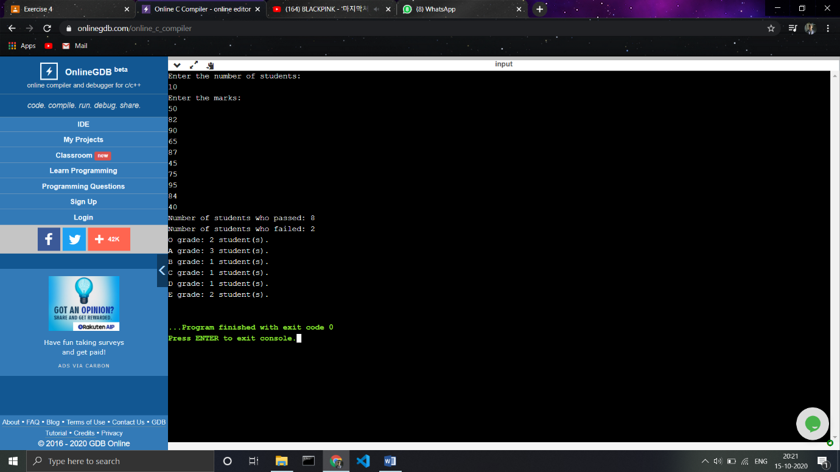

Question 2:

Write a Java program to find all pairs of elements in an array whose sum is equal to a specified number.

Program:

import java.io.\*;

import java.util.\*;

class Main

{

public static void main(String args[])

{

Scanner obj = new Scanner(System.in);

int n,i,j,x;

System.out.println("Enter the length of the array: ");

n=obj.nextInt();

System.out.println("Enter the elements: ");

int arr[] = new int[n];

for(i=0; i<n; i++)

arr[i] = obj.nextInt();

System.out.println("Enter the check value(sum value): ");

x=obj.nextInt();

System.out.println("The pairs are: ");

for(i=0; i<n; i++)

{

for(j=i; j<n; j++)

{

if(arr[i]+arr[j]==x && arr[i]!=arr[j])

System.out.println(arr[i]+ " and " + arr[j]+'.');

}

}

}

}

Output:

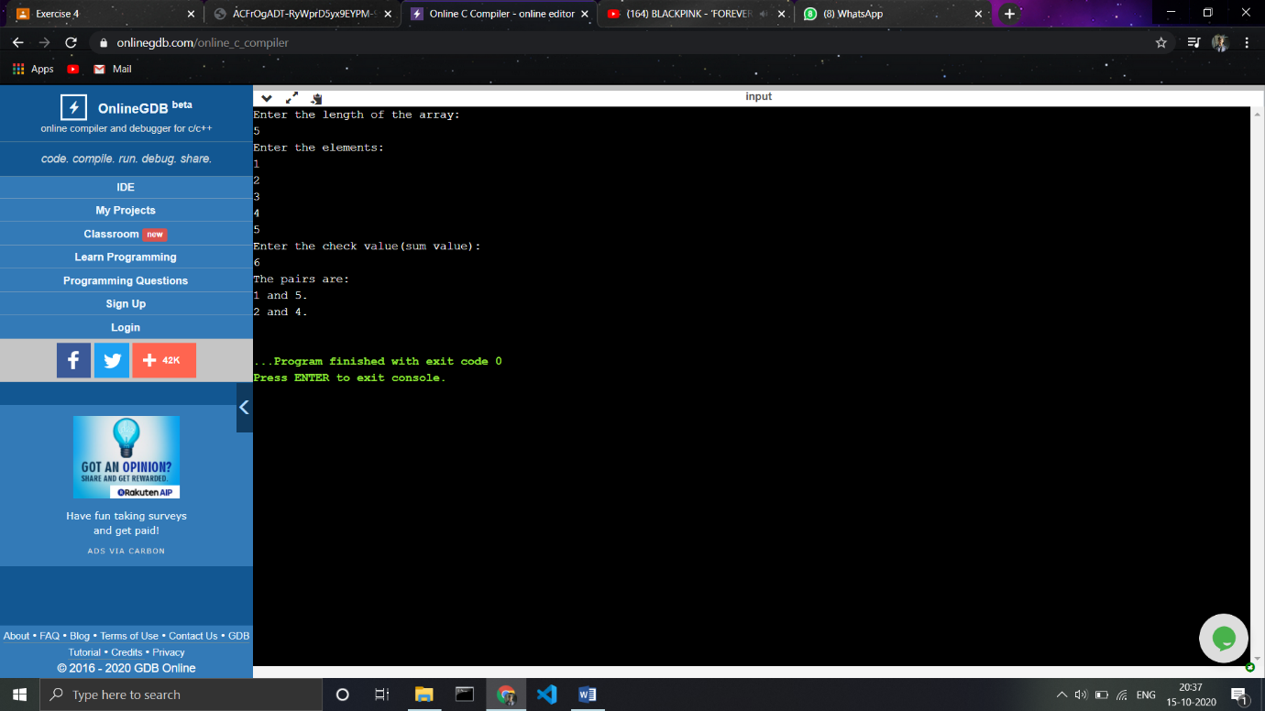

Question 3:

Write a Java program to find the common elements between two arrays of integers.

Program:

import java.io.\*;

import java.util.\*;

class Main

{

public static void main(String args[])

{

Scanner obj = new Scanner(System.in);

int n,i,j,m;

System.out.println("Enter the length of the first array: ");

m=obj.nextInt();

System.out.println("Enter the elementsof the first array: ");

int arr1[] = new int[m];

for(i=0; i<m; i++)

arr1[i] = obj.nextInt();

System.out.println("Enter the length of the second array: ");

n=obj.nextInt();

System.out.println("Enter the elementsof the second array: ");

int arr2[] = new int[n];

for(i=0; i<n; i++)

arr2[i] = obj.nextInt();

System.out.println("The common numbers are: ");

for(i=0; i<m; i++)

{

for(j=0; j<n; j++)

{

if(arr1[i]==arr2[j])

System.out.println(arr2[j]);

}

}

}

}

Output:

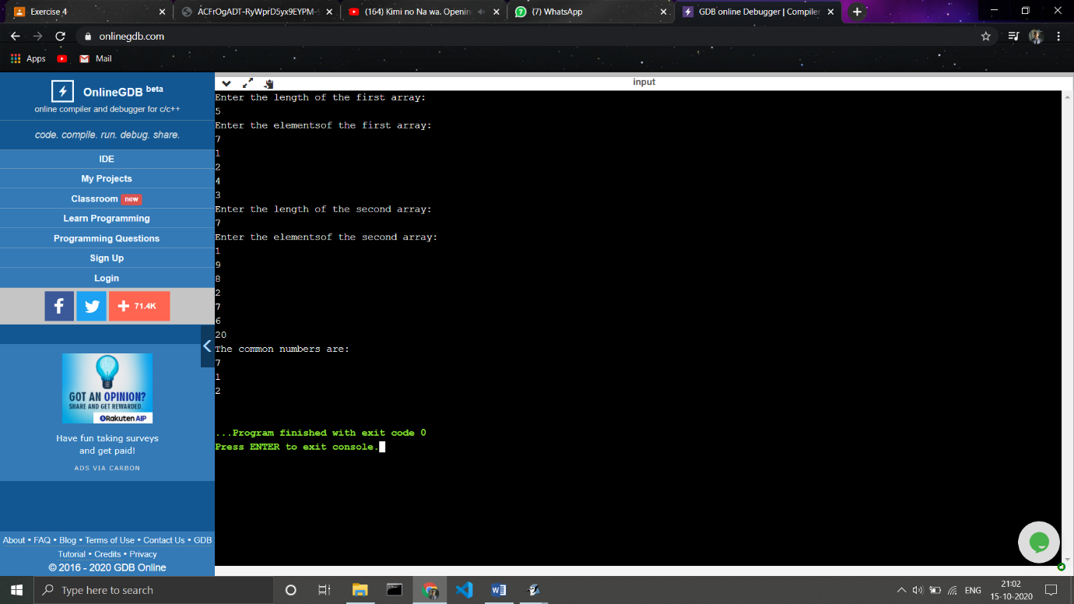

Question 4:

Write a Java program to remove duplicate elements from an array.

Program:

import java.io.\*;

import java.util.\*;

class Main

{

public static void main(String args[])

{

Scanner obj = new Scanner(System.in);

int n,i,j,m,k;

System.out.println("Enter the length array: ");

n=obj.nextInt();

System.out.println("Enter the elements of the array: ");

int arr[] = new int[n];

for(i=0; i<n; i++)

arr[i] = obj.nextInt();

System.out.println("After removing duplicates if any : ");

for(i=0; i<n; i++)

{

for(j=i; j<n; j++)

{

if(arr[i]==arr[j] && i!=j)

{

for(k=j; k<n-1; k++)

{

arr[k]=arr[k+1];

}

n-=1;

}

}

}

for(i=0; i<n; i++)

System.out.println(arr[i]);

}

}

Output:

