A scanned card with personal data follows.
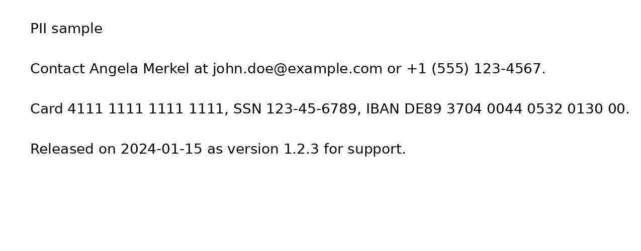
End.

