The screenshot below carries text the OCR can read.
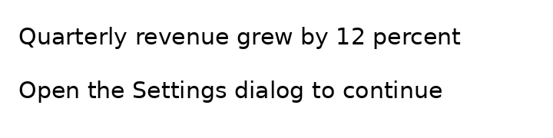
A tiny icon follows; it is too small to read.
The end.

