

A Project report

On

**Orphanage Management**

By

Arti Zoad

Batch:-2020-4965

Center:- Pune Chinchwad

Under The Guidance of,

Jayanth V.

Technical Trainer

**Edubridge**

**School Of Coding**

**Introduction:**

This project shows the different Orphanages, from where we can adopt child. This project gives details of orphanages available. So that the child who don’t have parent gets someone who can take care of them and also the people who don’t have their own child can get child from the orphanage and live their life happily.

This project is developed in Java,Jsp,Html ,Css and MySql.

**Software Requirements:**

Front End: Java/J2EE Technologies(Jsp),HTML,CSS,JDBC.

Back end: MySql.

Middleware/Server: Apache Tomcat v7.0.

IDE: Eclipse IDE for Java EE Developers

Browser: Best result on Google Chrome.

**Data Dictionary:**

Table Name: OrphanageListf121

create table OrphanageListf121

(name varchar(50),child varchar(20),

Address varchar(50),

ContactNo int(60),

Email_id varchar(50));

Table Name: SaveAdoptionRequest1

create table SaveAdoptionRequest1

(orphanage varchar(40),

first_name varchar(20),

last_name varchar(20),

cno varchar(30),

email_id varchar(20));

Table Name: users

create table users(userid varchar(20)

,password varchar(20),

fname varchar(20),

lname varchar(20),

email varchar(20));

**Screenshots:**

Home Page:-

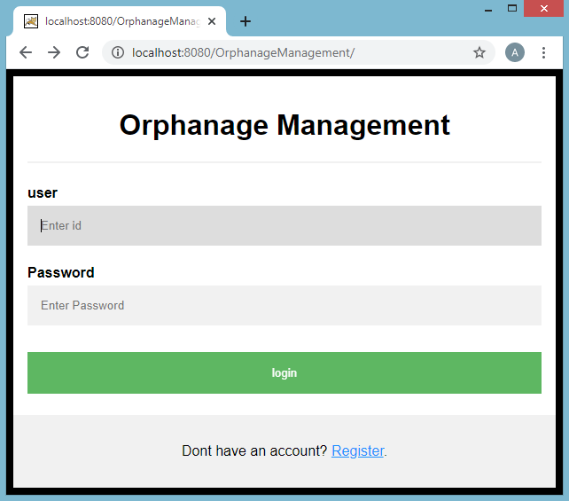

After Login:

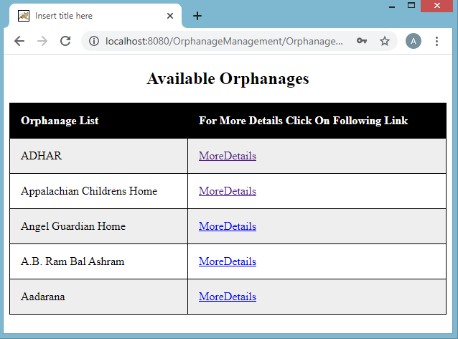

After Clicking on Particular Orphanage :

