

# Interview Homework Project (iOS)

## Overview

Below you will find a simple set of requirements to construct a basic iOS app that consumes a JSON feed from Amazon S3. The JSON file is a list of bar venues used by our NFL12 application.

We have also provided some sketch wireframes to guide you in the design of this application.

We want you to write an iOS app that displays this data to the user on both iPhone and iPad layout.

**Source Code Repository**

Please upload your code to GitHub, and share that repository link with us.

### 3rd Party Libraries

You can use whatever code or 3rd party libraries that you desire.

### Evaluation

We will be evaluating your app against a few criteria:

* Organization
* iOS/Objective-C fundamentals
* iOS design

We suggest that you start a new project in Xcode for this exercise. Once you have completed the exercise to the best of your ability please ZIP up your project to email to us.

Don’t be afraid if you get stuck on a particular area, or think that it will take you too long to complete. When you have something you are comfortable with send it along! Just let us know which parts of the assignment have been omitted - you will not be evaluated on features that are left out in this manner.

### Helpful Reading

* Model-View-Controller design: <http://developer.apple.com/library/ios/documentation/general/conceptual/devpedia-cocoacore/MVC.html>
* UIViewController layout <http://developer.apple.com/library/ios/featuredarticles/ViewControllerPGforiPhoneOS/AboutViewControllers/AboutViewControllers.html#//apple_ref/doc/uid/TP40007457-CH112-SW17>

### Style Guidelines

Please try to adhere to Apple’s style guidelines: http://developer.apple.com/library/mac/documentation/Cocoa/Conceptual/CodingGuidelines/CodingGuidelines.html

In addition, please try to follow to a few style guidelines that we use at Phunware. This will help us better evaluate your code by not getting hung up on code-style.

#### Write Short Methods

To the extent that it is feasible, methods should be kept small and focused. It is, however, recognized that long methods are sometimes appropriate, so no hard limit is placed on method length. If a method exceeds 40 lines or so, think about whether it can be broken up without harming the structure of the program.

#### Follow MVC App Architecture

In addition to short methods, your classes should be kept concise as well. For example, don’t try to write the entire app in one ViewController. Consider breaking your class up into individual classes based on their function.

## 

## 

## Requirements

* Consume the following JSON feed: <https://s3.amazonaws.com/jon-hancock-phunware/nflapi-static.json>
  + You should do this by performing any necessary network calls in the app. Do not store this file locally in the app.
* Display the feed in a master/detail type app
  + Scrollable view that shows all the venues, and then show the details of a venue when tapped.
  + Design and layout are up to you, as long as it follows Apple’s standard UI guidelines and best practices.
* Should run on both iPhone and iPad
  + Portrait only on iPhone, portrait and landscape on iPad.
  + For help with implementing the iPad layouts, see the link above about View Controller layout (the section titled About Split View Controllers).
* You may use Storyboards, Interface Builder, or write your layouts programmatically.
  + With whatever route you choose, you should try to avoid hard-coding view sizes and positions where possible. Of course, some views will require some specific layouts, but try to keep things spaced relatively.
* You may use ARC or Manual Retain-Release.
* Can use whatever 3rd party libraries you want.
* Should work on iOS 8.0 and above only. Design with iOS 8 in mind
* Each Venue may or may not have an image associated with it.
  + For the ones that do, you should load the image appropriately and display it to the user according to the wireframes. (These images are available online with full links in the JSON feed.)
* Each Venue may or may not have schedule information associated with it.
* All schedule times are in GMT, and should be represented in the user’s timezone.

{

"zip": "70130",

"phone": "(504) 582-3000",

"ticket_link": "http://www.nfl.com/superbowl/47/events/nfl-experience",

"state": "LA ",

"pcode": 10,

"city": "New Orleans",

"id": 16150,

"tollfreephone": "(555) 555-5555",

"schedule": [

{

"end_date": "2013-01-30 20:00:00 -0800",

"start_date": "2013-01-30 13:00:00 -0800"

},

{

"end_date": "2013-01-31 20:00:00 -0800",

"start_date": "2013-01-31 08:00:00 -0800"

}

],

"address": "900 Convention Center Blvd",

"image_url": "http://lorempixel.com/900/500/city/",

"description": "",

"name": "Verizon Training Ground @ NFL Experience",

"longitude": -90.064287,

"latitude": 29.941511

}

## 

## 

## Wireframes

iPhone Home Screen

## 

iPhone Detail Screen

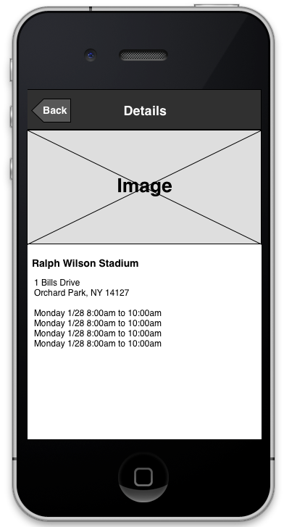

iPad Landscape Screen

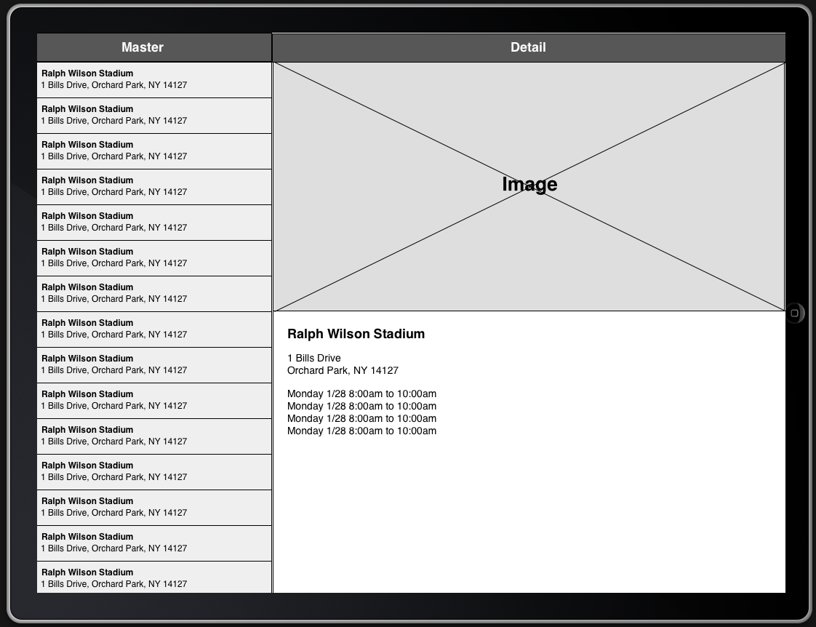

iPad Portrait Screen

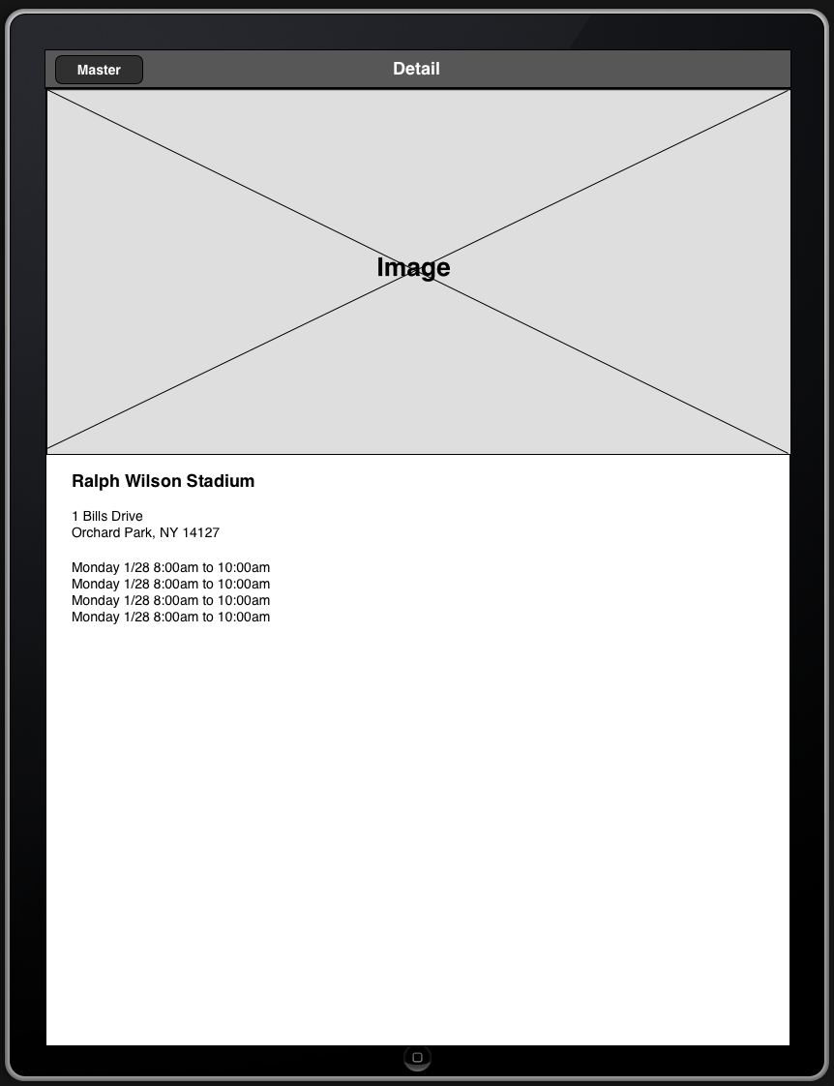

Note - Either of the following options are fine (or other similar layouts):

