Convolutional neural networks (CNN)
Lessons from neuroscience → start by extracting low-level features of the image, gradually build up spatial invariance (find pattern anywhere), multiple level of processing to link features and relationship.
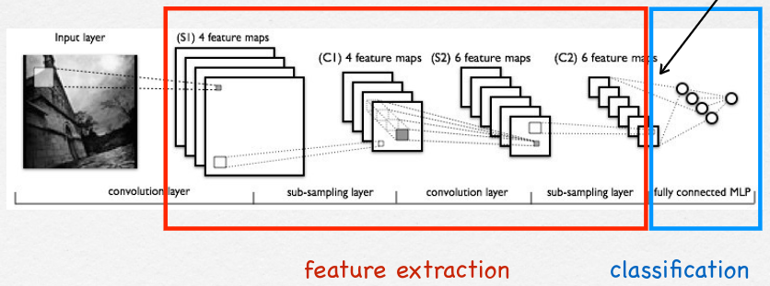
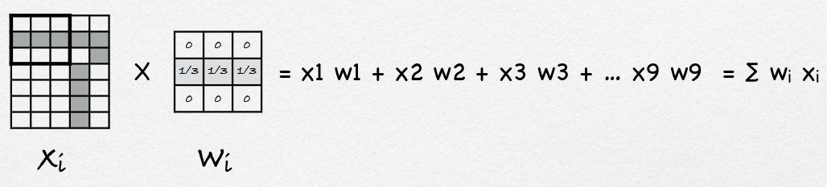
Sub-sampling layes → Maxpool after a convolutional layer eliminate all non max values to provide a sort of summary to upper layers of statistics of features in lower layers (it is a form of non linear down sampling, average pooling is also doable).
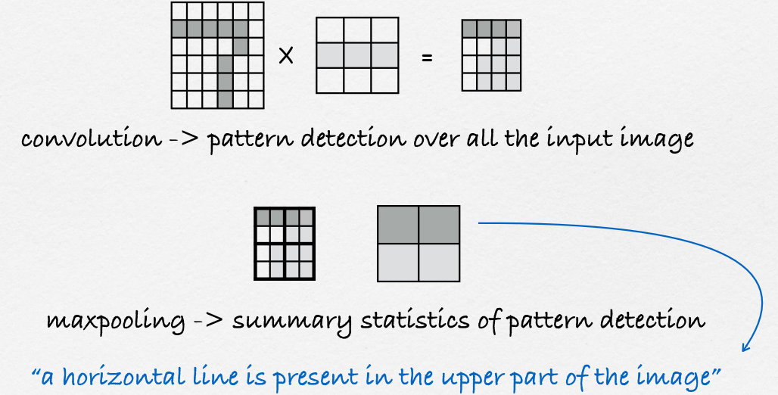
Fully-connected layers → is a multi-layer perceptron or ANN or shallow networks.
Flatenning → after convolution and pooling we flatten the images into a vector to use it as input in ANN.
We can use the gradient descent trick in CNN.
With keras:

Padding = dépendant du filtre (3x3 = 1, ...)
Stride = déplacement du filtre dans l’image input
Filtre doit passer sur toute l’image
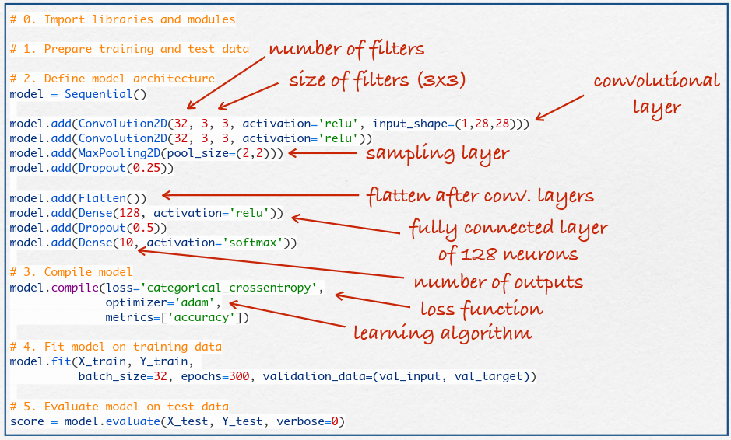
From shallow to deep NN
ensemble models → models composed of multiple neural network (multiple instance of same model trained the same, multiple instance of same model trained differently, multiple variation of shallow models) → ensemble averaging, we can take the mean of most frequent output of the ensemble model to create desired final output (frequently performs better because errors average out).
Vanishing gradient problem → phenomenon that occurs during the training of deep NN, where the gradients that are used to update the network become extremely small or vanish as they are backpropagated. Thus, gradient does not provide adequate info about how to adapt weights in the 1st layers. ReLU avoids the saturation issues of fcts like sigmoid or tanh, that can cause the gradients to vanish. (ReLU, leaky ReLU).
Deep networks → Deep belief network (Not good, consist on multiple layers of stochastic neural networks called Restricted Boltzmann Machines (RBM), bidirectional and symmetric), CNN.
Trick to train deep NN → train weights between 2 first layers using so-called auto-encoder architecture in attempt to reproduce inputs and outputs, fix those weights and repeat same process on other weights, finalize by backpropagation step.
Spatial processing and weight sharing → Each hidden neuron sequentially processes small regions of the input image until processing the complete input image using the same weights, without padding we reduce size of image.
Multiple convolutions with different kernels to detect multiple features → Each “neuron” applies a particular
filter or kernel to the complete input
image to detect a given feature. The outputs of each neuron is a new image, when processing multidimensional images (e.g., RGB or hyperspectral), each neuron adds up the outputs of the filters applied on each channel.
Hierarchical feature detection → the first layer detects low-level features; the following detects combinations of low-level features, and so on.
New activation functions → ReLU and softmax for output.
Dropout to avoid overfitting → When a neuron is dropped out, the other neurons have to learn more stuff in order to compensate the missing neuron.
Avoiding overfitting → more data, data augmentation (rotation, crop/zoom, translation, color pertubation, flip), architectures that generalize well, regularization, batch regu, reduce architecture complexity.
CNN architecture
LeNet-5 → Large networks trained by Backpropagation can be applied to real image-recognition problems without complex pre-processing requiring detailed engineering.
ImageNet → Large visual database designed for use in visual object recognition software research, data human labelled.
AlexNet → Used ReLus (instead of tanh), data augmentation and dropout, won 2012 ImageNet challenge.
ZF Net → Used smaller kernel sizes (7x7) and increasing number of filters, won 2013 ILSVRC.
VGG Net → strictly used 3x3 filters with stride and pad of 1, along with 2x2 maxpooling layers with stride 2 (Number of kernels: 64, 128, 256, 512, 512), The Alexnet convolutional kernels of sizes 11x11, 5x5, and 3x3 can be replicated by making use of multiple 3x3 kernels as building blocks.
GoogLeNet → A new architecture with more than 100 layers in total, but not necessarily stacked up sequentially and without fully-connected layers. It uses 12x less weights than AlexNet, concat multiple sizes kernels.
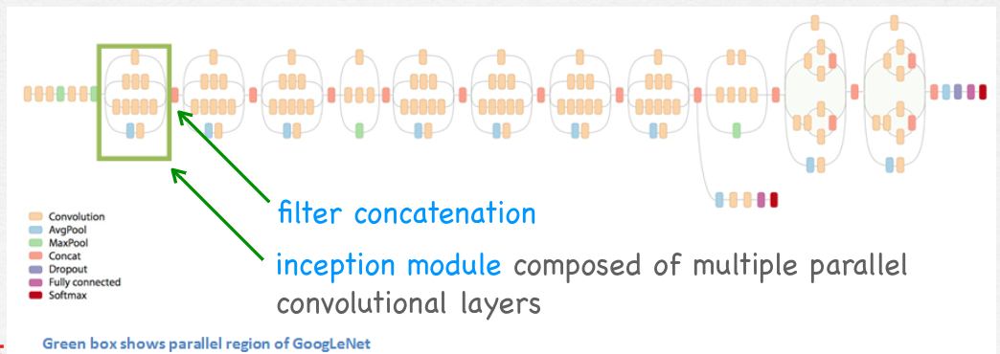
Ideas behind Inception Networks → instead of choosing a single kernel size concatenate outputs of different size to be able to detect features at different scales (use 1x1 before 5x5 or 3x3 convolutions to perform feature pooling or dimensionality reduction and reduce number of operations.
Batch-normalization → start by normalizing the inputs (per dimension) per batch (i.e., by setting the mean to zero and the standard deviation to 1), but then use the learnable parameters 𝛾 and 𝛽 to scale and shift the input data. 𝛾 and 𝛽 are learned over all the database and serve to restore the expressiveness of the network (after ex. ReLU).
ResNet → use a 152 layers CNN with shortcut connections because they noticed a degradation in perf by going deeper on ImageNet benchmark (vanishing gradient problem), Residual block →
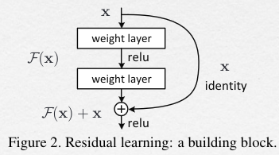
Transfer learning
Use the first layers of a CNN that was previously trained (i.e., with lots of data) and expect to be able to fine-tune only the subsequent ones in order to use it for a new task.
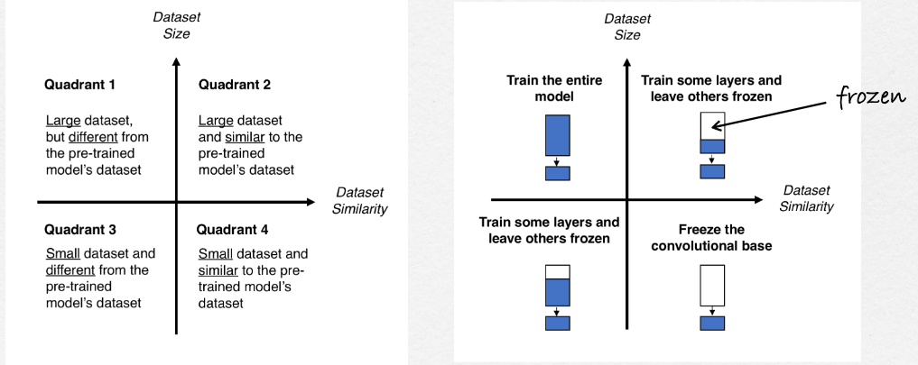
MobileNet → reach comparable performances to larger architectures but using fewer parameters, use depth-wise separable convolutions to build light weight deep neural networks (In depth-wise convolutions the channels
are first kept separate and a 1x1 layer of convolutions is finally used to combine the multiple channel).
Vector embedings → any object can be reduced to a vector of numerical values, which we can consider to be features of those objects, such a representation makes it possible to translate semantic similarity as perceived by humans to proximity in a vector space.
An alternative way of performing transfer learning
consists on using a pre-trained model to compute vector
embeddings from the input data and using those vectors
as inputs to a new model that is trained using the new data.
Few-shot learning → when our training set contains few exemples, use meta-learning to solve.
Meta learning → The idea is to train a model for a certain number of epochs on a variety of learning tasks (𝜏1, 𝜏2,…), such that at the end, it can solve a new learning task using only a small number of training samples.
Deep troubles
CNN just compute features from input data and find correlations between input patterns to the computed features and classes, but we cannot predict CNN behavior, possible biases in the training dataset.
CNN doesn’t understand the data it’s processing, faces with more eyes or mouth outside face will still be classified as face.
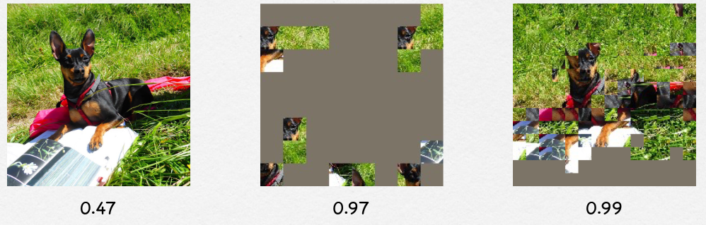
Adversarial attacks → CNN easily fooled (Add a single pixel, add specific noise, …)
Visualization tools →
Feature map visualization →
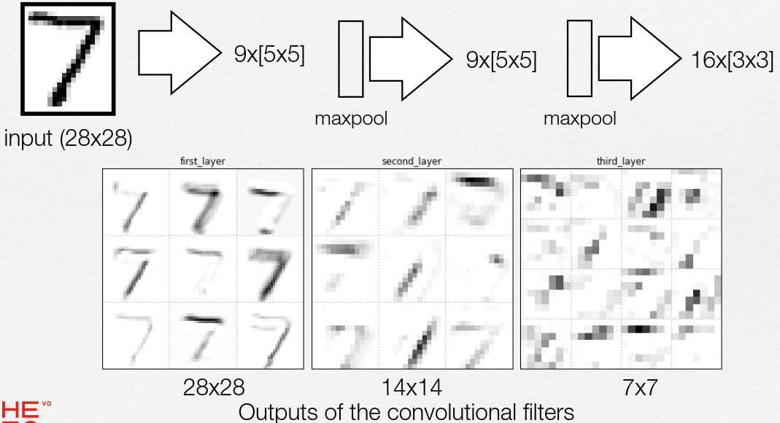Activation maximization → what sort of input pattern maximizes the activation of a particular filter,
Filters activation statistics →
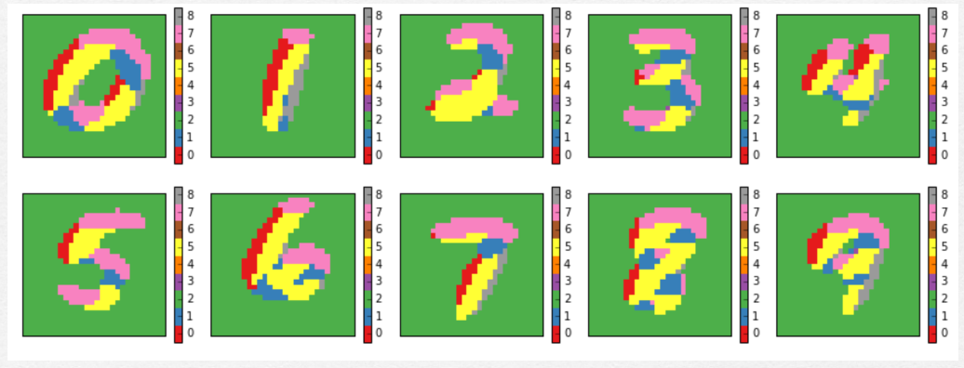
Occlusion analysis → fin what is the most discriminative object or part of the image for the CNN by hiding always the same part of the image for different classes.
Class activation class → replace the fully-connected part by a GAP layer followed by a dense linear layer using a softmax output. We train this network and obtain weights w1 to wn, the CAM for a given image is the weighted sum of the last-
layer’s filter activations. It is finally upsampled to match the
input image size, result in a heat-map.
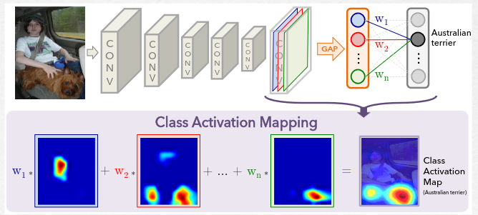
Current CNN biased towards texture-based features (not shape), Geographical bias of ImageNet (few Africa or Asia).
Plus
Pour convolutional layers dans Kera → calcul params (taille image ( largeur * hauteur) * nbr images en sorties * nbr images en entrée + nbr biais ( = nbr images en sorties))
Pour Dense layers → nbr entrées * nbr sorties + biais (=nbr sorties)
Kernel calcul: ImageIn * filter … + biais → f(x) = output image

