Interactive programming
ATTENTION une fois en IO() plus de retour
-- >> va ingnorer dans tous les cas la valeur a tandis que >>= attend qu'on la traite (avec éventuellement un callback vide si on veut l'ignorer)
echo' :: IO ()
echo' = putStrLn "Give me a value" >>= \_ -> getLine
>>= \str -> putStrLn ("You gave me: " ++ str)
Monads and more
Functor
fmap Permet de mapper sur un Contexte :
e2 :: Maybe Integer
e2 = fmap (+1) (Just 1)
-- => Just 2
On garde le contexte de Maybe Integer et on applique la fonction (+1).
<$ remplace la valeur en gardant le contexte :
e6 :: [Integer]
e6 = 1 <$ [1, 2, 3]
-- => [1, 1, 1]
Un functor a ces 2 méthodes :
class Functor f where
fmap :: (a -> b) -> f a -> f b
(<$) :: a -> f b -> f a
fmap doit suivre ces règles :
fmap id x == id x
fmap f (fmap g x) == fmap (f . g) x
Ex implémentation Functor (définir fmap) :
data Option a = Some a | None
instance Functor Option where
fmap f None = None
fmap f (Some a) = Some (f a)

Applicatives
Généralisation des functors, les functors qui supportent pure et <*> sont des applicative functors :
class Functor f => Applicative f where
pure :: a -> f a
(<*>) :: f (a -> b) -> f a -> f b
<*> associe à gauche, généralise l’application d’une fonction ou on encapsule les arguments et le résultat dans des structures f.
pure convertit une valeur de type a dans une structure de type f a.
ex :
instance Applicative Maybe where
pure :: a -> Maybe a
pure = Just
(<*>) :: Maybe (a -> b) -> Maybe a -> Maybe b
Nothing <*> _ = Nothing
(Just g) <*> mx = fmap g mx
e8 :: Maybe Integer
e8 = pure (+1) <*> Just 1
-- => Just 2
e9 :: Maybe Integer
e9 = pure (+) <*> Just 1 <*> Just 2
-- > Just 3
Règles pour Applicative :
pure id <*> x = x
pure (g x) = pure g <*> pure x
x <*> pure y = pure (\g -> g y) <*> xor
x <*> (y <*> z) = (pure (.)) <*> x <*> y <*> z
Monads
type applicative m qui supporte return et >>=
class Applicative m => Monad m where
return :: a -> m a
(>>=) :: m a -> (a -> m b) -> m b
>>= bind le résultat du premier argument au deuxième.
return = pure.
Ex :
Transforme les listes en type monadique :
instance Monad [] where
(>>=) :: [a] -> (a -> [b]) -> [b]
xs >>= f = [y | x <- xs, y <- f x]
pairs :: [a] -> [b] -> [(a, b)]
pairs xs ys = do x <- xs
y <- ys
return (x, y)
pairs [1, 2] [3, 4]
-- => [(1, 3), (1, 4), (2, 3), (2, 4)]
Un avantage de l’abstraction le concepts des Monads est la capacité de définir des fonctions générique qui peuvent être utilisées avec tous Monads :
version Monad de map :
mapM :: Monad m => (a -> m b) -> [a] -> m [b]
mapM f [] = return []
mapM f (x:xs) = do y <- f x
ys <- mapM f xs
return (y:ys)
convert :: Char -> Maybe Int
mapM convert "1234"
-- => Just [1, 2, 3, 4]
mapM convert "123a"
-- => Nothing
Règle pour Monad:
return x >>= f = f x
mx >>= return = mx
(mx >>= f) >>= g = mx >>= (\x -> (f x >>= g))
Evaluation
Innermost
square (3 + 4)
= square 7
= 7 * 7
= 49
Outermost
square (3 + 4)
= (3 + 4) * (3 + 4)
= 7 * (3 + 4)
= 7 * 7
= 49
Lazy = que ce qu’on a besoin sur le moment
Lambda calculus
Original Expression :
((λxyz.xyz)(λx.xx)(λx.x))x
Step 1 : Beta Reduction
(λxyz.xyz)(λx.xx) ⇒ λyz.(λx.xx)yz
Step 2 : Substitute (λx.xx) for x :
λyz.(λx.xx)yz ⇒ λyz.((λx.xx)y)z
Step 3 : Further Reduce :
(λx.xx)y ⇒ yy
donc λyz.(yy)z
Step 4 : Substitute (λx.x) for y :
(λyz.(yy)z)(λx.x) ⇒ λz.((λx.x)(λx.x))z
Step 5 : Reduce (λx.x)(λx.x) :
(λx.x)(λx.x) ⇒ λx.x
Step 6 : Final Substitution :
λz.(λx.x)z ⇒ λz.z
Step 7 : Apply to x :
(λz.z)x ⇒ x
Design of programming language
Typing rules
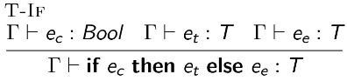
Tokens
Identifiers → names chosen by programmer (x, foo…)
Keywords → names already in language (if, while, return…)
Separators → punctuation or paired delimiters (}, ;…)
Operators → (+, <, =…)
Literals → (true, 3.13, “hello”…)
Comments → line, block (//, /* */)
Regex
abc → the set of strings with the single member {abc}.
a|b|c → the set of independent characters {a, b, c}.
a∗ → the infinite set {ϵ, a, aa, aaa}.
ab∗ → the infinite set {a, ab, abb}.
a(bc|d)∗e → the set of strings including {ae, abce, abcde, ade, …}.
----------------------------------------
. → Any character except newline
[abc] → Any of a, b, or c
[a-z] → Character between a and z
^abc → Matches start of a string
abc$ → Matches end of a string
\d → Digit (0-9)
\D → Not a digit
\s → Whitespace
\S → Not a whitespace
\w → Word character (alphanumeric or _)
\W → Not a word character
a* → Zero or more of a
a+ → One or more of a
a? → Zero or one of a
an → Exactly n of a
an, → n or more of a
an,m → Between n and m of a
\ → Escape special character
| → Alternation (OR)
(abc) → Grouping
\1 → Backreference to group 1
Finite automata
2 types
Non -deterministe FA (NFA) et Deterministe FA (DFA)
DFA → 1 transition par input et pas de ε-transition
NFA → 1 ou plus transition par input et ε-transition possible
ε-transition → transition sans input (automate dans plusieurs états en mm temps)
convertir NFA en DFA
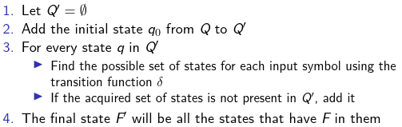
NFA
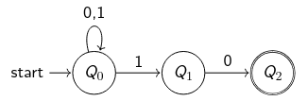
DFA
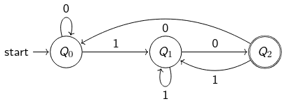
Syntax analysis
Context free grammar (CFG )
Ressemble à BNF avec S, A, X... à la place des expression… (BNF est une version formattée de CFG)
Backus-Naur form (BNF)
ex :
⟨stmts⟩ ::= ⟨stmt⟩ ‘;’
| ⟨stmt⟩ ‘;’ ⟨stmts⟩
Desugaring
f x y = x * y
f = \x y -> x * y
f = \x -> \y -> x * y
Abstract tree
représentation en arbre de la structure abstraite syntaxique du code source
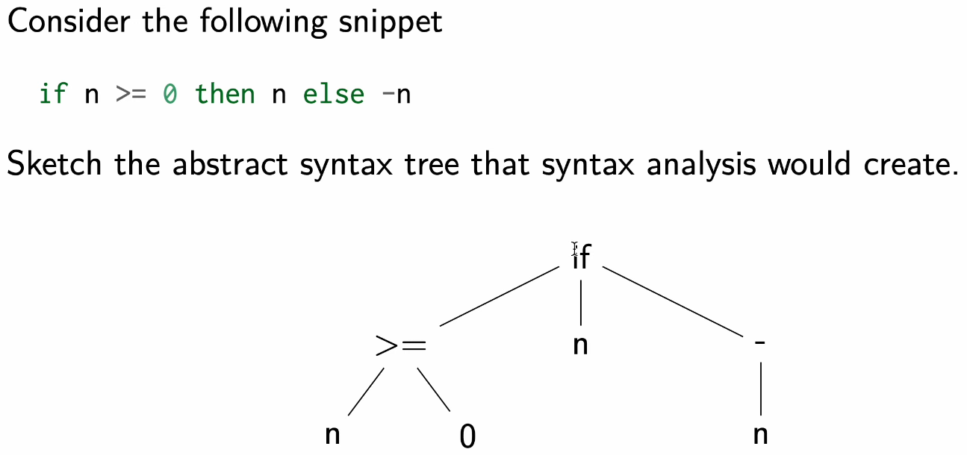
Parse tree
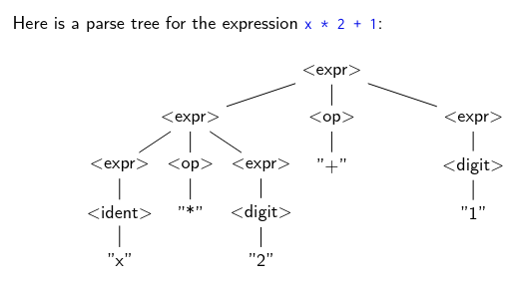
Extended BNF
Ajoute des expressions optionnelles ([expr ]), repetitions 0 ou plus ({ expr }), grouping (( expr )).
Derivation
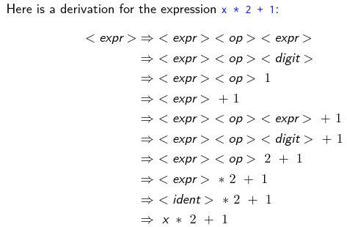
Ambiguity
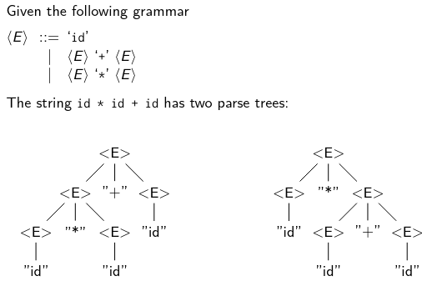
Example reading file
import System.Environment ( getArgs, getProgName )
import Control.Monad ( unless, forM_ )
data Option = Bytes Int | Count Int
deriving Show
parseArgs :: [String] -> (Option, [String])
parseArgs args = case args of
("-c":n:rest) -> (Bytes $ read n, rest)
("-n":n:rest) -> (Count $ read n, rest)
_ -> (Count 10, args)
bytes :: Int -> String -> String
bytes n str
| n <= 0 = error ("head: illegal byte count -- " ++ show n)
| otherwise = take n str
count :: Int -> String -> String
count n str
| n <= 0 = error ("head: illegal line count -- " ++ show n)
| otherwise = unlines $ take n $ lines str
usage :: IO ()
usage = do
progName <- getProgName
putStrLn (progName ++ "[-n count | -c bytes] [files...]")
putStrLn " -c bytes - Print bytes of each of the specified files."
putStrLn " -n count - Print count lines of each of the specified files."
main :: IO ()
main = do
args <- getArgs
if null args then usage
else do
let (option, files) = parseArgs args
let action = case option of
Count n -> count n
Bytes n -> bytes n
unless (null files) $ do
if length files == 1 then
processFile action (head files)
else
forM_ files $ \file -> do
putStrLn ("==> " ++ file ++ " <==")
processFile action file
where
processFile action file = do
contents <- readFile file
putStrLn $ action contents

