HTML
Only describes content of page no prog language.
META TAGS: describe content of page.
To please SEO use the right tags, provide metadata, good structure.
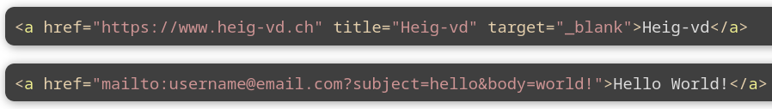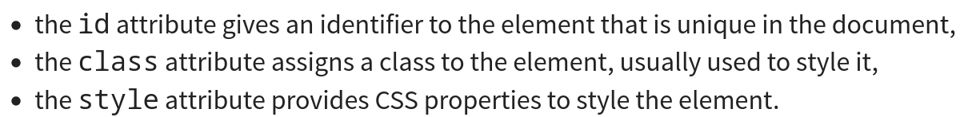
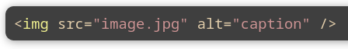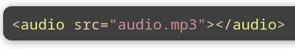
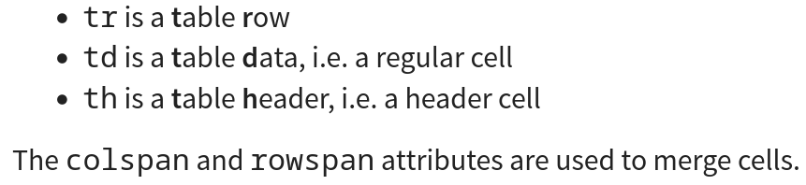
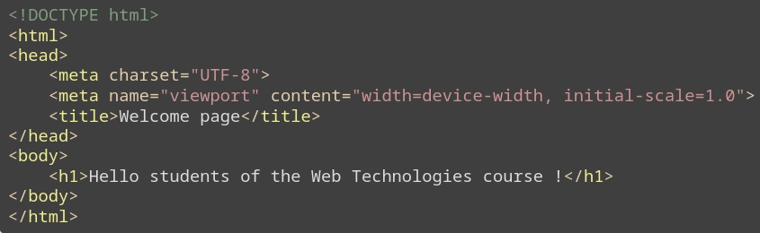CSS
Read top to bottom once, describe rendering of elements.
Selectors:
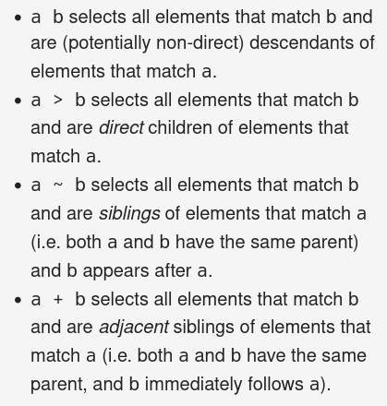
Priority:
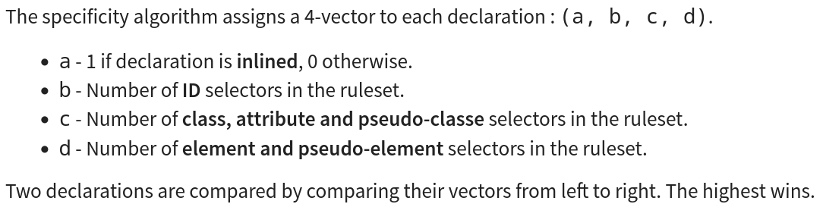
Inheritance of properties:
You can use the inherit keyword to force inheritance.
Box:
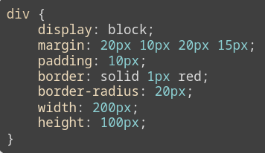
DOM
Object oriented representation of structure of a doc, programming interface for HTML and XML to let programs manipulate docs.
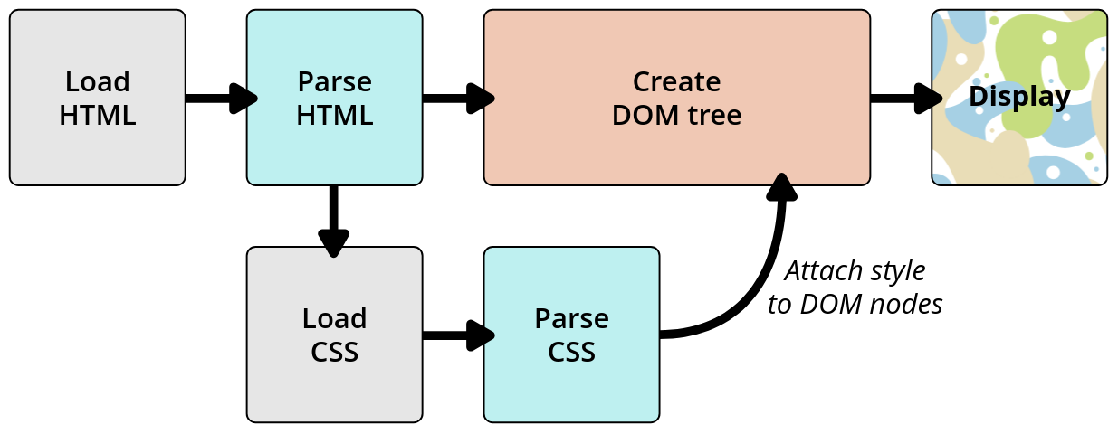
Javascript
Interpreted or Just-int-time (hot parts of code compiled → rest interpreted), function considered as variables.
Dynamic (performs at runtime), OOP and prototype-based, Imperative, Declarative. (template → `PI = ${Math.PI}`)
Types:
7 primitives (Undefined, Number, Boolean, String, BigInt, Symbol, Null) (console.log(undefined var) → ERROR)
Variables:
let = block-scoped (cannot be re-declared), var = global or func (can be overriden), const = blocscope, nothing = global
For loop:
for...in is for object (iterate “name” properties of object)
for...of is for array (if use for...in → indexes)
Func:
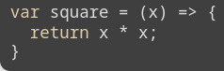
REGEX:
Declared: var re = /<regex>/
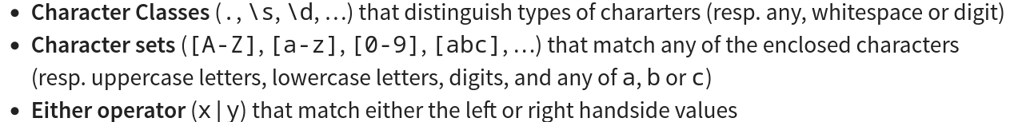
Quantifiers: ‘*’ 0 or many (b*),’+’ 1 or many, ‘?’ 0 or 1, ‘{n}’ n times, ‘{n, m}’ at least n and at max m.
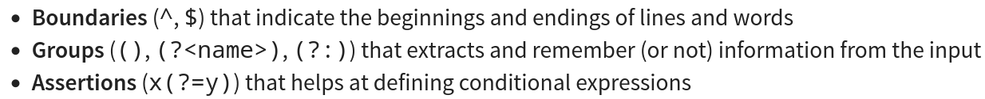
OOP
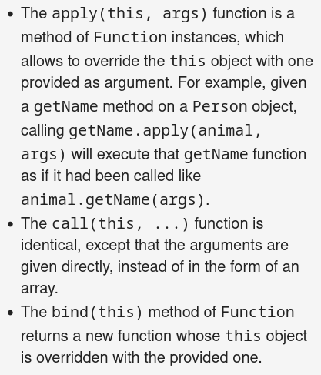
Private properties → # before (#color → access in object this.#color). Super() exist to call constructor or functions. The constructor is declared like this → constructor(args){}

Dom manipulation
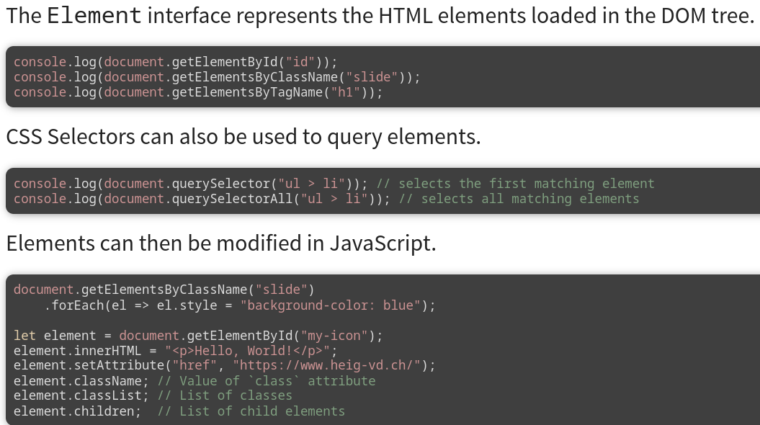
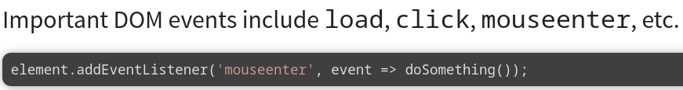
Or ‘keydown’
Ex
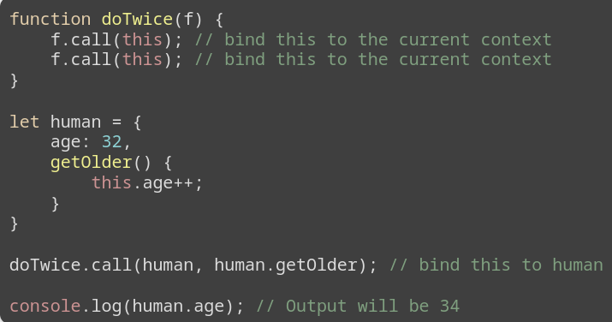
Testing
Unit test
Test separable unit of software, employed at low-level to ensure function or module performs as intended, fast to implement and execute.
Integration test
Individuals units of software that pass unit test are assembled together into components → integration test assure that components made of different parts work together as intended, sometimes slow to implement and execute.
System test
All components that pass integration test are put together into the system → system test verify end to end functionality of the system, Usually hard to automate and very expensive to implement and execute.
IF NOT TESTED ASSUME BROKEN
Decomposition is the best friend of testable code
Write lots of unit tests, some integration test and a few system test.
Array
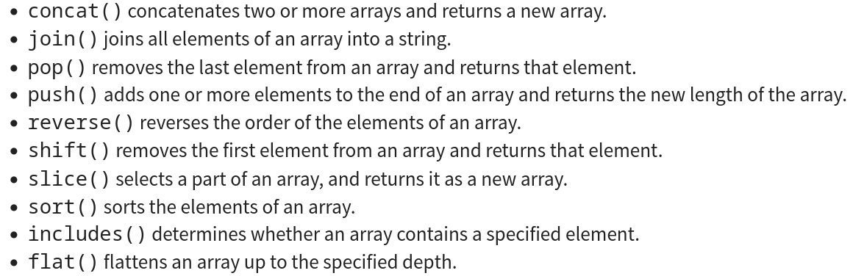
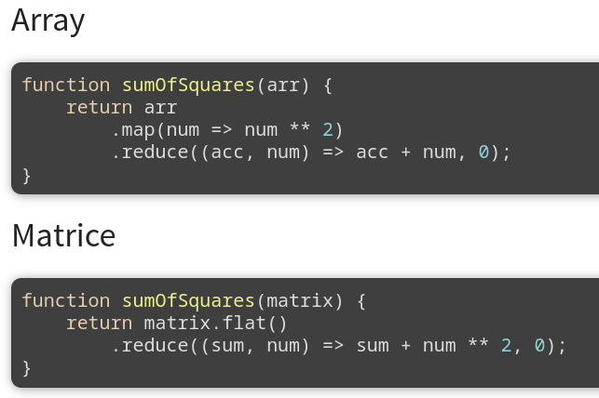
Web framework
Express, Koa, Fastify, NestJS
MPA
Multi-pages, for each request → new page
+
Easy to maintain, develop, scale, test, secure, reference, deploy and debug
-
Now very responsive, user-friendly and interactive
MVC
Model → data, View → displaying, Controller → handling user actions and updating.
Used with MPA.

