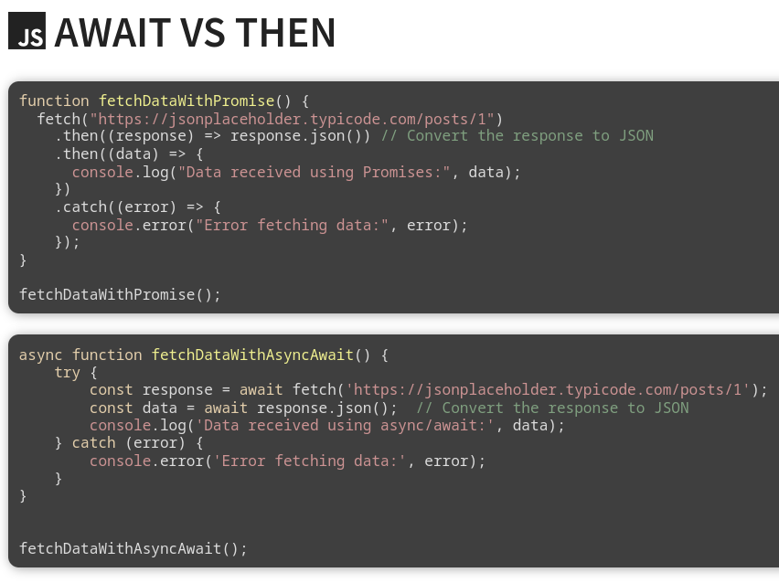
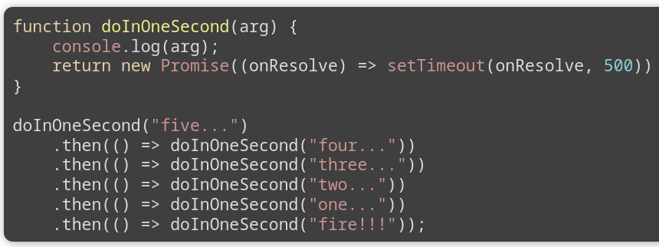
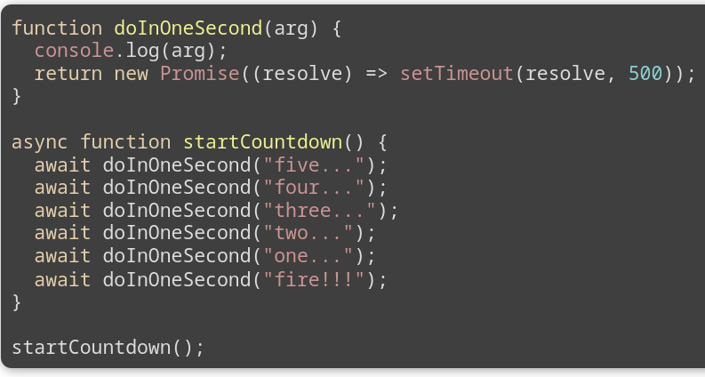
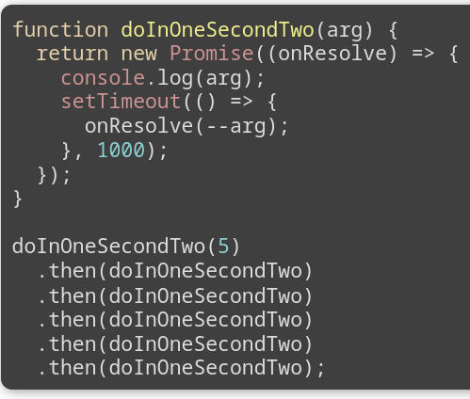
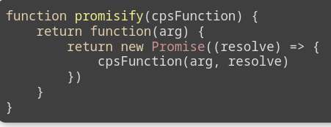
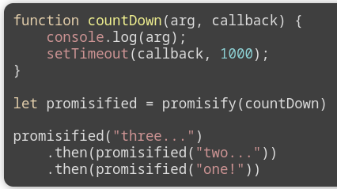
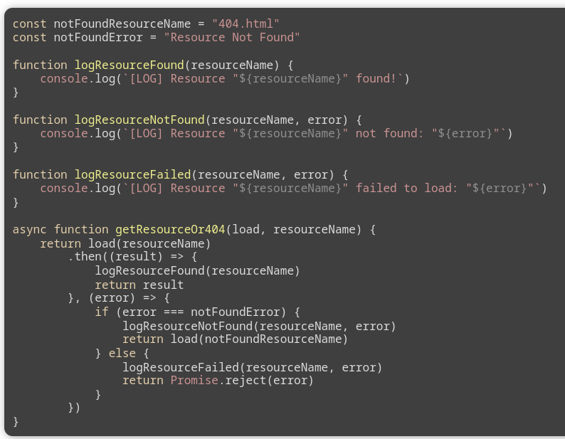
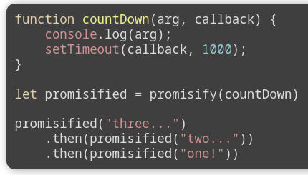
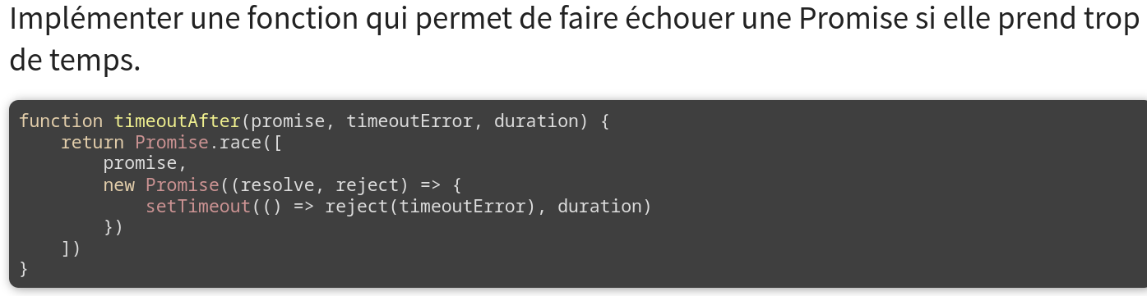
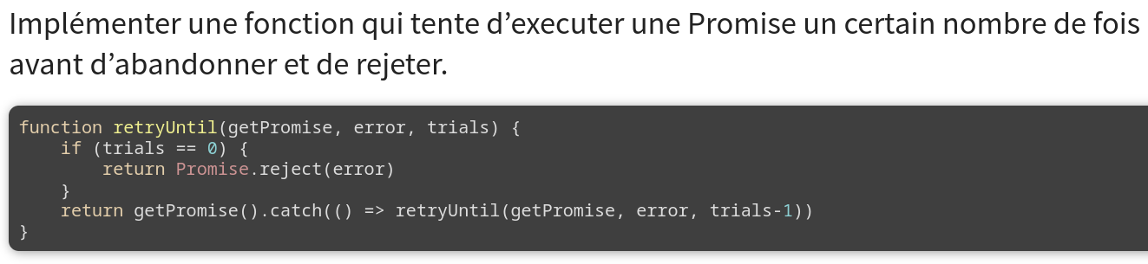
JSON
no functions, dates or undefined.
JSON.stringify converts JavaScript Object into JSON String (no func or prototype or private).
JSON.parse converts JSON Strng into JavaScript Object
JSON requires double quote around property and string
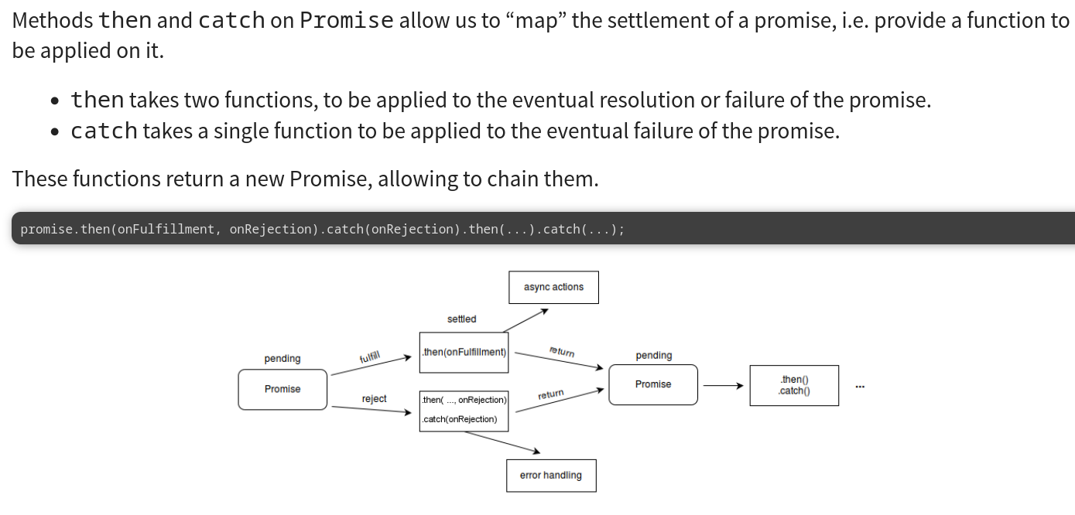
Iterable = [promise1, promise2, promise3, …]
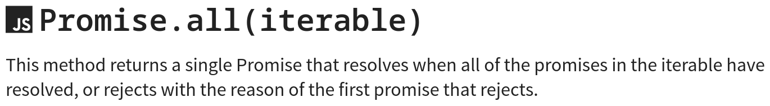
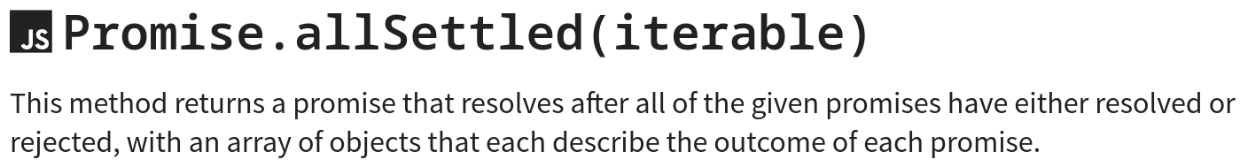
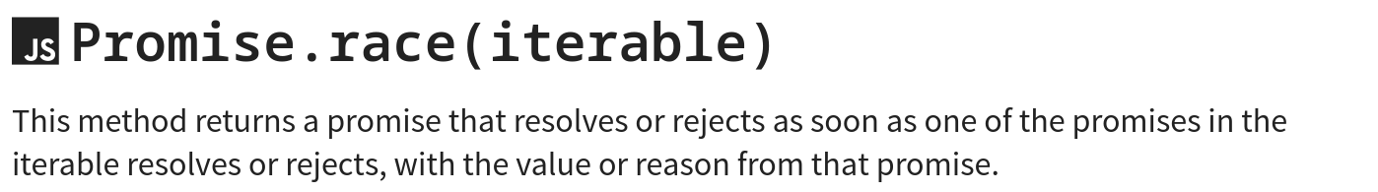
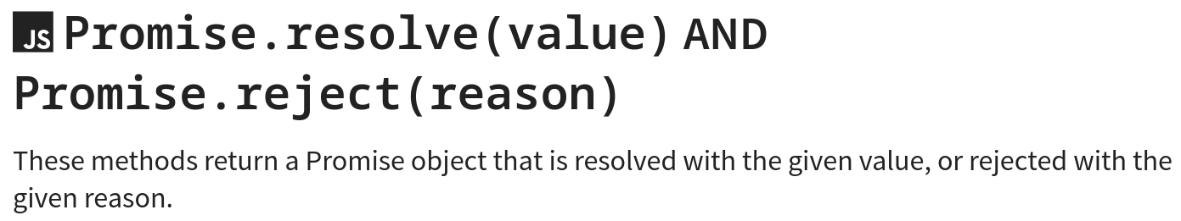
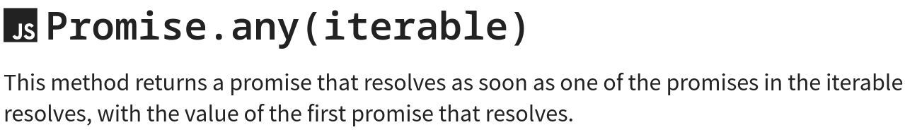
Ex output: [{status: “rejected”, reason: “…”}, {status: “fulfilled”, value: “…”}]
Exs:
Fetch API
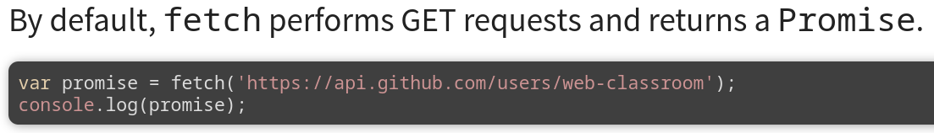
REST
stands for REpresentational State Transfer.
Client-server, Uniform interface, Stateless, Cache, Layered System, Code-on-demand(optional).
Uniform interface → for HTTP {identification of resources (e.g. URI), Manipulation or ressources (e.g. GET, POST, …), Self-descriptive messages (e.g. Content-type: application/json), Hypermedia as the engine application state (HATEOAS)}.
Async function
await keyword in it, implicitly returns a promise if not explicit in body.
Await → launch an error if promise rejected, evaluated at the completion of promise, make the function wait till promise settled.
ATTENTION Crypter n’existe pas.
Décrypter comme déchiffrer mais sans clé.
Same origin policy
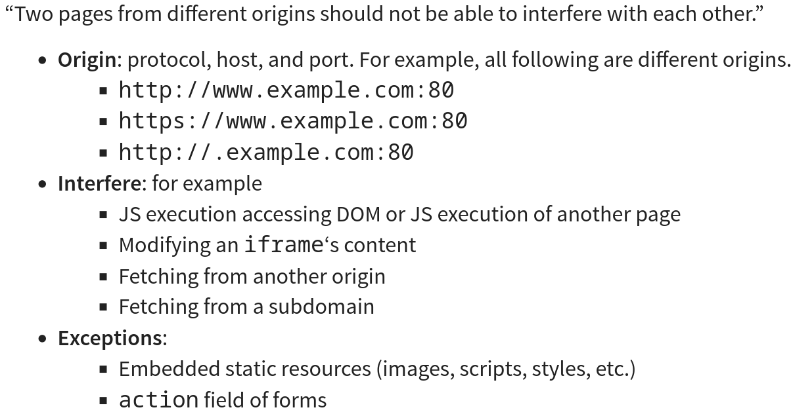
Cross-origin resource sharing (CORS)
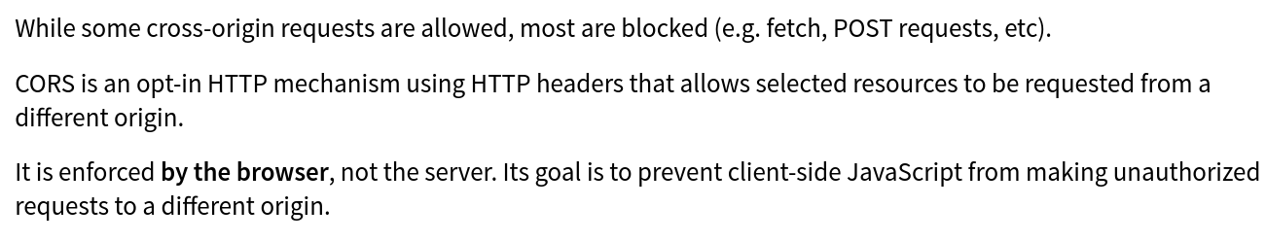
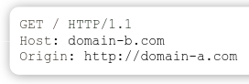
Here Origin in header tell where it’s from.

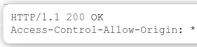
Response from domain-b.com tell if allowed under Access-control… (* = all)
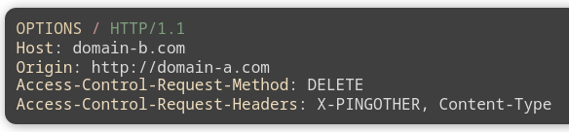Ask if DELETE is ok on domain-b.com and headers used
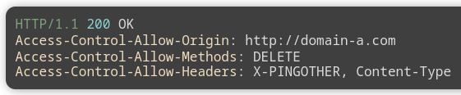
Response if allowed
Cookies
each request browser send all cookies associated with server
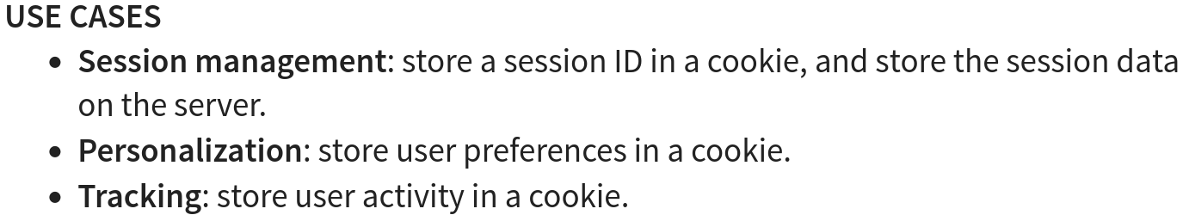
cookie = name + value (+ expiration date + …)
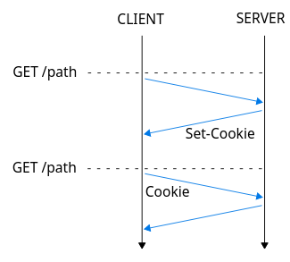

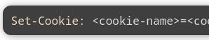
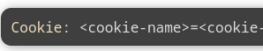

Session cookie with expires or max age
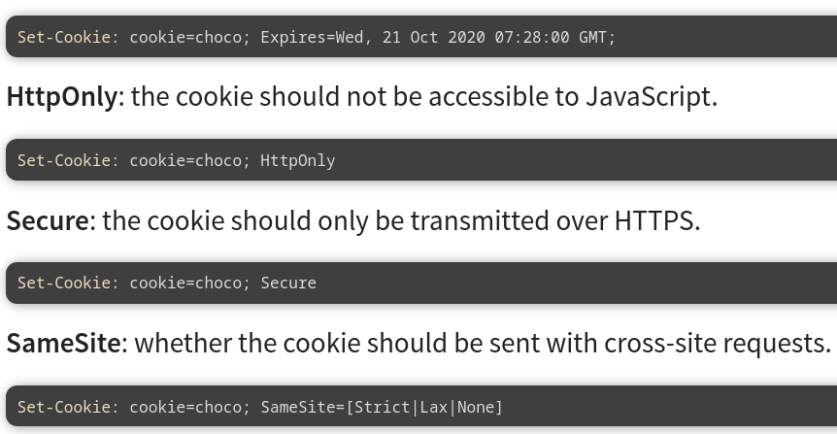
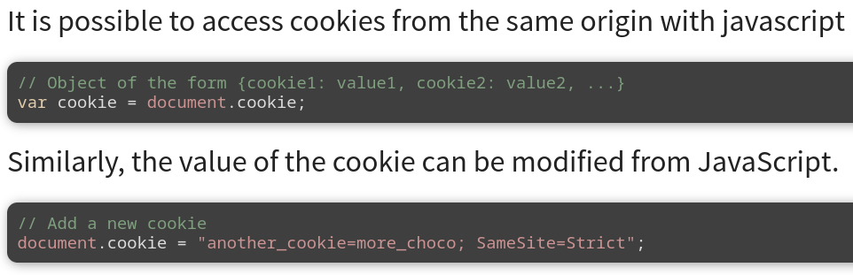
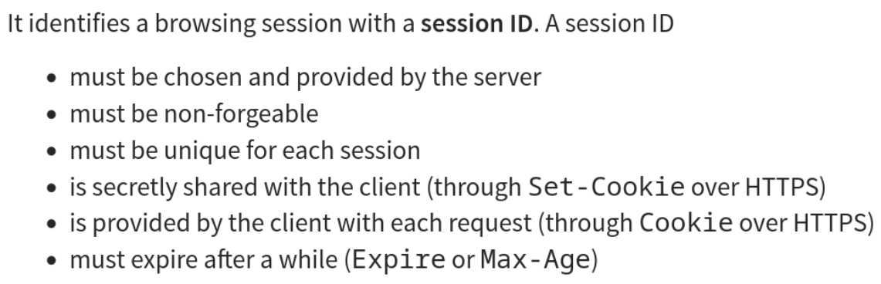
CSRF Tokens
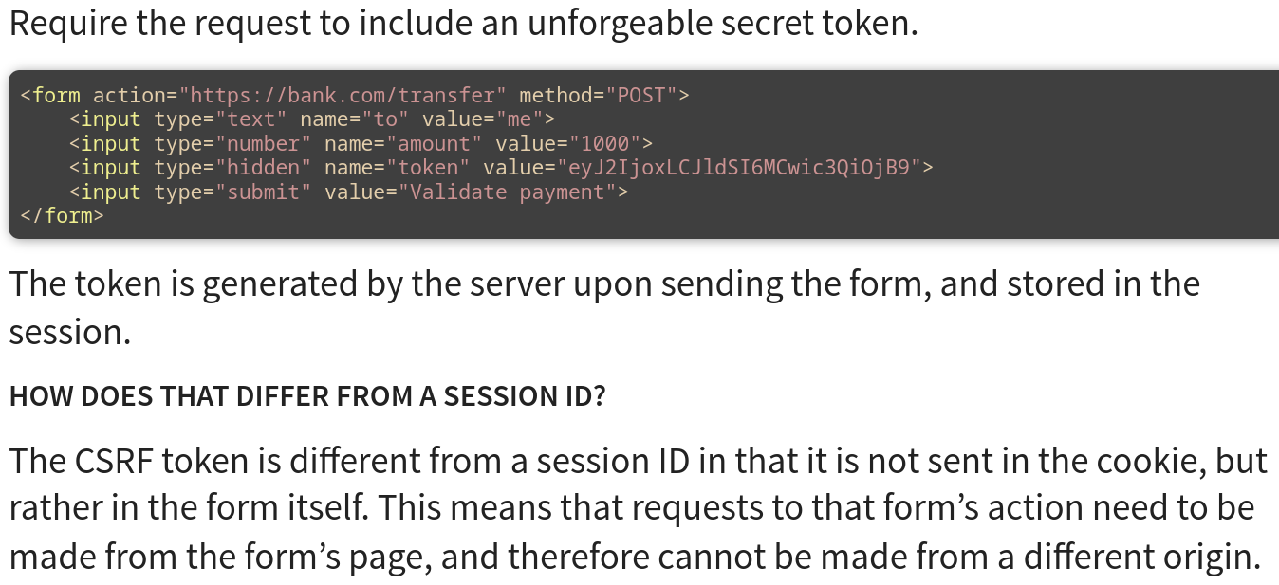
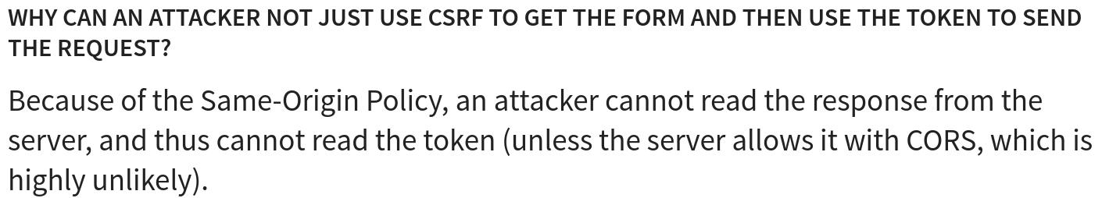
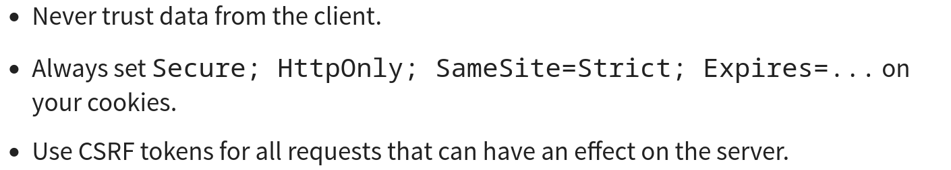
XSS (Cross-site scripting)
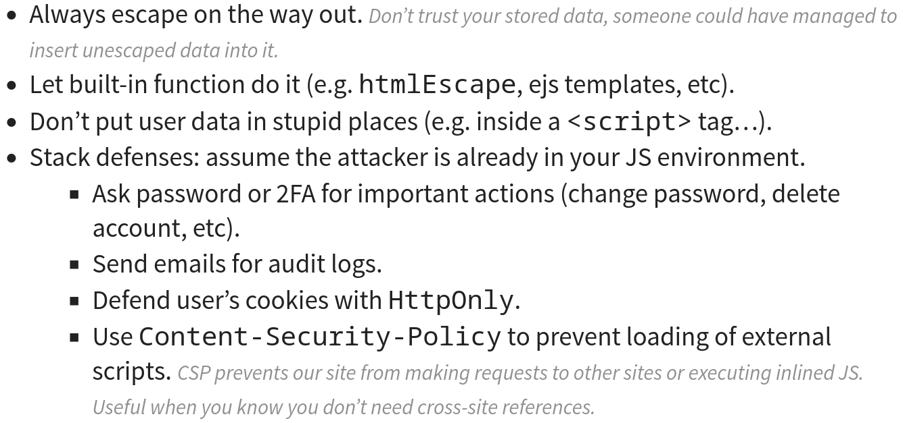
CSRF Tokens and XSS not related (CSRF cross-site request)

