Министерство науки и высшего образования Российской Федерации

Пензенский государственный университет

Кафедра «Вычислительная техника»

**ОТЧЕТ**

по лабораторной работе №3

по дисциплине: «Разработка КП приложений»

на тему «Обработка исключительных ситуаций»

Выполнили:

студенты группы 19ВВ1

Артемов К.А.

Григорьева Д.Д.

Мереняшева Е.А.

Приняли:

Юрова О.В.

Карамышева Н.С.

Пенза 2022

**Цель работы:** изучить механизм обработки исключительных ситуаций.

**Лабораторное задание**

Модифицировать приложение из предыдущей лабораторной работы, реализовав проверку вводимых данных с использованием механизма исключений. Необходимо создать свой класс, унаследованный от класса Exception, и генерировать исключение, если возникает попытка создать экземпляр класса RecIntegral со значениями, не являющимися числами в диапазоне от 0,000001 до 1000000. В качестве обработки исключения необходимо выводить диалог, содержащий предупреждение о некорректности введенных данных. Оформление лабораторной работы должно быть выполнено в соответствии с требованиями, приведенными в Приложении 2.

# Вариант 4



LinkedList

**Ход выполнения работы:**

Алгоритм работы программы.

Создан новый класс MyException, унаследованный от Exception, также пронаследованны все конструкторы.

В класс RecIntegral все свойства стали private. Были добавлены сеторы и геторы. В сеторах были созданы проверки из который бросались исключения.

В конструкторах для проверки исключений код был заключен в конструкцию try… catch

**Листинг:**

**Класс RecIntegral**

/*

* Click nbfs://nbhost/SystemFileSystem/Templates/Licenses/license-default.txt to change this license

* Click nbfs://nbhost/SystemFileSystem/Templates/Classes/Class.java to edit this template

*/

package my.numberaddition;

import javax.swing.JOptionPane;

/**

*

* @author ArtK0

*/

public class RecIntegral {

private double down;

private double up;

private double step;

private double res;

public double getDown() {

return down;

}

public void setDown(double down) throws MyException {

if(!prov(down)){

throw new MyException("Нижняя граница выходит из диапазона");

}

this.down = down;

}

public double getUp() {

return up;

}

public void setUp(double up) throws MyException {

if(!prov(up)){

throw new MyException("Верхняя граница выходит из диапазона");

}

if(this.getDown()>=up){

throw new MyException("верхняя граница меньше чем нижняя");

}

this.up = up;

}

public double getStep() {

return step;

}

public void setStep(double step) throws MyException {

if(!prov(step)){

throw new MyException("Шаг выходит из диапазона");

}

if(step>(this.getUp()-this.getDown())){

throw new MyException("Шаг перевашает");

}

this.step = step;

}

public double getRes() {

return res;

}

public void setRes(double res) throws MyException {

if(!prov(res)){

throw new MyException("Res is incorrect");

}

this.res = res;

}

public boolean prov(double a){

return a>0.000001 && a<1000000;

}

public RecIntegral(Object down,Object up,Object step,Object res) throws MyException{

try {

this.setDown(Double.parseDouble(down.toString()));

this.setUp(Double.parseDouble(up.toString()));

this.setStep(Double.parseDouble(step.toString()));

this.setRes(Double.parseDouble(res.toString()));

} catch (NumberFormatException e) {

throw new MyException("ошибка встречен символ или ,", e);

}catch (MyException ex) {

JOptionPane.showMessageDialog(null, ex.getMessage(),"err",JOptionPane.ERROR_MESSAGE);

}

}

public RecIntegral(Object down,Object up,Object step) throws MyException{

try {

this.setDown(Double.parseDouble(down.toString()));

this.setUp(Double.parseDouble(up.toString()));

this.setStep(Double.parseDouble(step.toString()));

} catch (NumberFormatException e) {

throw new MyException("ошибка встречен символ или ,", e);

}catch (MyException ex) {

JOptionPane.showMessageDialog(null, ex.getMessage(),"err",JOptionPane.ERROR_MESSAGE);

}

}

}

**Класс MyException**

/*

* Click nbfs://nbhost/SystemFileSystem/Templates/Licenses/license-default.txt to change this license

* Click nbfs://nbhost/SystemFileSystem/Templates/Classes/Class.java to edit this template

*/

package my.numberaddition;

/**

*

* @author ArtK0

*/

public class MyException extends Exception{

public MyException() {

}

public MyException(String message) {

super(message);

}

public MyException(String message, Throwable cause) {

super(message, cause);

}

public MyException(Throwable cause) {

super(cause);

}

public MyException(String message, Throwable cause, boolean enableSuppression, boolean writableStackTrace) {

super(message, cause, enableSuppression, writableStackTrace);

}

}

**ContactEditorUI**

/*

* Click nbfs://nbhost/SystemFileSystem/Templates/Licenses/license-default.txt to change this license

* Click nbfs://nbhost/SystemFileSystem/Templates/GUIForms/JFrame.java to edit this template

*/

package my.numberaddition;

import java.util.Iterator;

import java.util.LinkedList;

import java.util.List;

import javax.swing.JOptionPane;

import javax.swing.table.DefaultTableModel;

/**

*

* @author ArtK0

*/

public class ContactEditorUI extends javax.swing.JFrame {

List<RecIntegral> list = new LinkedList<>();

/**

* Creates new form ContactEditorUI

*/

public ContactEditorUI() {

initComponents();

}

/**

* This method is called from within the constructor to initialize the form.

* WARNING: Do NOT modify this code. The content of this method is always

* regenerated by the Form Editor.

*/

@SuppressWarnings("unchecked")

// <editor-fold defaultstate="collapsed" desc="Generated Code">

private void initComponents() {

jButton1 = new javax.swing.JButton();

jtf_down = new javax.swing.JTextField();

jtf_up = new javax.swing.JTextField();

jtf_step = new javax.swing.JTextField();

jScrollPane1 = new javax.swing.JScrollPane();

table_integral = new javax.swing.JTable();

btn_add = new javax.swing.JButton();

btn_remove = new javax.swing.JButton();

btn_calc = new javax.swing.JButton();

jLabel1 = new javax.swing.JLabel();

jLabel2 = new javax.swing.JLabel();

jLabel3 = new javax.swing.JLabel();

jLabel4 = new javax.swing.JLabel();

btn_add_table = new javax.swing.JButton();

btn_clear = new javax.swing.JButton();

btn_save = new javax.swing.JButton();

jButton1.setText("jButton1");

setDefaultCloseOperation(javax.swing.WindowConstants.EXIT_ON_CLOSE);

setTitle("1");

jtf_down.setToolTipText("");

jtf_down.setMinimumSize(new java.awt.Dimension(60, 20));

jtf_down.addActionListener(new java.awt.event.ActionListener() {

public void actionPerformed(java.awt.event.ActionEvent evt) {

jtf_downActionPerformed(evt);

}

});

jtf_up.setMinimumSize(new java.awt.Dimension(60, 20));

jtf_up.setName(""); // NOI18N

jtf_up.addActionListener(new java.awt.event.ActionListener() {

public void actionPerformed(java.awt.event.ActionEvent evt) {

jtf_upActionPerformed(evt);

}

});

jtf_step.setToolTipText("");

jtf_step.setMinimumSize(new java.awt.Dimension(60, 20));

table_integral.setModel(new javax.swing.table.DefaultTableModel(

new Object [][] {

},

new String [] {

"Нижняя граница", "верхняя граница", "шаг", "результат"

}

) {

boolean[] canEdit = new boolean [] {

true, true, true, false

};

public boolean isCellEditable(int rowIndex, int columnIndex) {

return canEdit [columnIndex];

}

});

jScrollPane1.setViewportView(table_integral);

btn_add.setText("Добавить");

btn_add.setMaximumSize(new java.awt.Dimension(90, 23));

btn_add.setMinimumSize(new java.awt.Dimension(90, 23));

btn_add.setPreferredSize(new java.awt.Dimension(90, 23));

btn_add.addActionListener(new java.awt.event.ActionListener() {

public void actionPerformed(java.awt.event.ActionEvent evt) {

btn_addActionPerformed(evt);

}

});

btn_remove.setText("удалить");

btn_remove.setMinimumSize(new java.awt.Dimension(90, 23));

btn_remove.setPreferredSize(new java.awt.Dimension(90, 23));

btn_remove.addActionListener(new java.awt.event.ActionListener() {

public void actionPerformed(java.awt.event.ActionEvent evt) {

btn_removeActionPerformed(evt);

}

});

btn_calc.setText("Выполнить");

btn_calc.setToolTipText("");

btn_calc.setMinimumSize(new java.awt.Dimension(90, 23));

btn_calc.setPreferredSize(new java.awt.Dimension(90, 23));

btn_calc.addActionListener(new java.awt.event.ActionListener() {

public void actionPerformed(java.awt.event.ActionEvent evt) {

btn_calcActionPerformed(evt);

}

});

jLabel1.setFont(new java.awt.Font("Tahoma", 2, 12)); // NOI18N

jLabel1.setText("Шаг");

jLabel2.setFont(new java.awt.Font("Tahoma", 2, 12)); // NOI18N

jLabel2.setText("Верхняя граница");

jLabel3.setFont(new java.awt.Font("Tahoma", 2, 12)); // NOI18N

jLabel3.setText("Нижняя граница");

jLabel4.setFont(new java.awt.Font("Tahoma", 1, 24)); // NOI18N

jLabel4.setHorizontalAlignment(javax.swing.SwingConstants.LEFT);

jLabel4.setText("Свойства интегрирования");

btn_add_table.setText("Заполнить");

btn_add_table.addActionListener(new java.awt.event.ActionListener() {

public void actionPerformed(java.awt.event.ActionEvent evt) {

btn_add_tableActionPerformed(evt);

}

});

btn_clear.setText("Очистить");

btn_clear.addActionListener(new java.awt.event.ActionListener() {

public void actionPerformed(java.awt.event.ActionEvent evt) {

btn_clearActionPerformed(evt);

}

});

btn_save.setText("Сохранить");

btn_save.addActionListener(new java.awt.event.ActionListener() {

public void actionPerformed(java.awt.event.ActionEvent evt) {

btn_saveActionPerformed(evt);

}

});

javax.swing.GroupLayout layout = new javax.swing.GroupLayout(getContentPane());

getContentPane().setLayout(layout);

layout.setHorizontalGroup(

layout.createParallelGroup(javax.swing.GroupLayout.Alignment.LEADING)

.addGroup(javax.swing.GroupLayout.Alignment.TRAILING, layout.createSequentialGroup()

.addGroup(layout.createParallelGroup(javax.swing.GroupLayout.Alignment.LEADING)

.addGroup(layout.createSequentialGroup()

.addGap(43, 43, 43)

.addGroup(layout.createParallelGroup(javax.swing.GroupLayout.Alignment.LEADING, false)

.addComponent(jLabel2, javax.swing.GroupLayout.DEFAULT_SIZE, 105, Short.MAX_VALUE)

.addComponent(jLabel3, javax.swing.GroupLayout.DEFAULT_SIZE, javax.swing.GroupLayout.DEFAULT_SIZE, Short.MAX_VALUE)

.addComponent(jLabel1, javax.swing.GroupLayout.DEFAULT_SIZE, javax.swing.GroupLayout.DEFAULT_SIZE, Short.MAX_VALUE))

.addGap(55, 55, 55)

.addGroup(layout.createParallelGroup(javax.swing.GroupLayout.Alignment.LEADING)

.addComponent(jtf_down, javax.swing.GroupLayout.PREFERRED_SIZE, 150, javax.swing.GroupLayout.PREFERRED_SIZE)

.addComponent(jtf_up, javax.swing.GroupLayout.PREFERRED_SIZE, 150, javax.swing.GroupLayout.PREFERRED_SIZE)

.addComponent(jtf_step, javax.swing.GroupLayout.PREFERRED_SIZE, 150, javax.swing.GroupLayout.PREFERRED_SIZE)))

.addGroup(layout.createSequentialGroup()

.addGap(21, 21, 21)

.addGroup(layout.createParallelGroup(javax.swing.GroupLayout.Alignment.LEADING)

.addGroup(layout.createSequentialGroup()

.addComponent(jScrollPane1, javax.swing.GroupLayout.PREFERRED_SIZE, 500, javax.swing.GroupLayout.PREFERRED_SIZE)

.addGap(18, 18, 18)

.addGroup(layout.createParallelGroup(javax.swing.GroupLayout.Alignment.LEADING)

.addComponent(btn_add, javax.swing.GroupLayout.PREFERRED_SIZE, 105, javax.swing.GroupLayout.PREFERRED_SIZE)

.addComponent(btn_remove, javax.swing.GroupLayout.PREFERRED_SIZE, 105, javax.swing.GroupLayout.PREFERRED_SIZE)

.addComponent(btn_calc, javax.swing.GroupLayout.PREFERRED_SIZE, 105, javax.swing.GroupLayout.PREFERRED_SIZE)))

.addComponent(jLabel4)

.addGroup(layout.createSequentialGroup()

.addGap(10, 10, 10)

.addComponent(btn_save, javax.swing.GroupLayout.PREFERRED_SIZE, 105, javax.swing.GroupLayout.PREFERRED_SIZE)

.addGap(18, 18, 18)

.addComponent(btn_clear, javax.swing.GroupLayout.PREFERRED_SIZE, 105, javax.swing.GroupLayout.PREFERRED_SIZE)

.addGap(18, 18, 18)

.addComponent(btn_add_table, javax.swing.GroupLayout.PREFERRED_SIZE, 105, javax.swing.GroupLayout.PREFERRED_SIZE)))))

.addContainerGap(javax.swing.GroupLayout.DEFAULT_SIZE, Short.MAX_VALUE))

);

layout.setVerticalGroup(

layout.createParallelGroup(javax.swing.GroupLayout.Alignment.LEADING)

.addGroup(layout.createSequentialGroup()

.addContainerGap()

.addComponent(jLabel4)

.addGap(14, 14, 14)

.addGroup(layout.createParallelGroup(javax.swing.GroupLayout.Alignment.BASELINE)

.addComponent(jLabel3)

.addComponent(jtf_down, javax.swing.GroupLayout.DEFAULT_SIZE, javax.swing.GroupLayout.DEFAULT_SIZE, javax.swing.GroupLayout.PREFERRED_SIZE))

.addPreferredGap(javax.swing.LayoutStyle.ComponentPlacement.UNRELATED)

.addGroup(layout.createParallelGroup(javax.swing.GroupLayout.Alignment.BASELINE)

.addComponent(jLabel2)

.addComponent(jtf_up, javax.swing.GroupLayout.PREFERRED_SIZE, javax.swing.GroupLayout.DEFAULT_SIZE, javax.swing.GroupLayout.PREFERRED_SIZE))

.addPreferredGap(javax.swing.LayoutStyle.ComponentPlacement.UNRELATED)

.addGroup(layout.createParallelGroup(javax.swing.GroupLayout.Alignment.BASELINE)

.addComponent(jLabel1)

.addComponent(jtf_step, javax.swing.GroupLayout.PREFERRED_SIZE, javax.swing.GroupLayout.DEFAULT_SIZE, javax.swing.GroupLayout.PREFERRED_SIZE))

.addGap(18, 18, 18)

.addGroup(layout.createParallelGroup(javax.swing.GroupLayout.Alignment.LEADING)

.addGroup(layout.createSequentialGroup()

.addComponent(btn_add, javax.swing.GroupLayout.PREFERRED_SIZE, javax.swing.GroupLayout.DEFAULT_SIZE, javax.swing.GroupLayout.PREFERRED_SIZE)

.addGap(18, 18, 18)

.addComponent(btn_remove, javax.swing.GroupLayout.PREFERRED_SIZE, javax.swing.GroupLayout.DEFAULT_SIZE, javax.swing.GroupLayout.PREFERRED_SIZE)

.addGap(18, 18, 18)

.addComponent(btn_calc, javax.swing.GroupLayout.PREFERRED_SIZE, javax.swing.GroupLayout.DEFAULT_SIZE, javax.swing.GroupLayout.PREFERRED_SIZE))

.addComponent(jScrollPane1, javax.swing.GroupLayout.PREFERRED_SIZE, 125, javax.swing.GroupLayout.PREFERRED_SIZE))

.addPreferredGap(javax.swing.LayoutStyle.ComponentPlacement.UNRELATED)

.addGroup(layout.createParallelGroup(javax.swing.GroupLayout.Alignment.BASELINE)

.addComponent(btn_save)

.addComponent(btn_clear)

.addComponent(btn_add_table))

.addContainerGap(13, Short.MAX_VALUE))

);

pack();

}// </editor-fold>

private void jtf_upActionPerformed(java.awt.event.ActionEvent evt) {

// TODO add your handling code here:

}

private void jtf_downActionPerformed(java.awt.event.ActionEvent evt) {

// TODO add your handling code here:

}

private void btn_addActionPerformed(java.awt.event.ActionEvent evt) {

DefaultTableModel model = (DefaultTableModel)table_integral.getModel();

model.addRow(new Object[]{jtf_down.getText(),jtf_up.getText(), jtf_step.getText()});

}

private void btn_removeActionPerformed(java.awt.event.ActionEvent evt) {

DefaultTableModel model = (DefaultTableModel)table_integral.getModel();

model.removeRow(table_integral.getSelectedRow());

}

private void btn_calcActionPerformed(java.awt.event.ActionEvent evt) {

DefaultTableModel model = (DefaultTableModel)table_integral.getModel();

int row = table_integral.getSelectedRow();

try {

model.setValueAt(

integral(

(model.getValueAt(row, 0)),

(model.getValueAt(row, 1)),

(model.getValueAt(row, 2))

),

table_integral.getSelectedRow(),

3);

} catch (MyException e) {

if(e.getCause()!= null){

JOptionPane.showMessageDialog(null, e.getMessage()+" ("+e.getCause()+")","err",JOptionPane.ERROR_MESSAGE );

}else{

JOptionPane.showMessageDialog(null, e.getMessage(),"err",JOptionPane.ERROR_MESSAGE );

}

}

}

private void btn_add_tableActionPerformed(java.awt.event.ActionEvent evt) {

DefaultTableModel model = (DefaultTableModel)table_integral.getModel();

Iterator<RecIntegral> iterator = list.iterator();

while(iterator.hasNext()){

RecIntegral rec = iterator.next();

model.addRow(new Object[]{rec.getDown(),rec.getUp(),rec.getStep(),rec.getRes()});

iterator.remove();

}

}

private void btn_clearActionPerformed(java.awt.event.ActionEvent evt) {

DefaultTableModel model = (DefaultTableModel)table_integral.getModel();

model.setRowCount(0);

}

private void btn_saveActionPerformed(java.awt.event.ActionEvent evt) {

DefaultTableModel model = (DefaultTableModel)table_integral.getModel();

for (int i=0;i<model.getRowCount();i++){

if(model.getValueAt(i, 3)== null){

try {

list.add(new RecIntegral(model.getValueAt(i, 0),model.getValueAt(i, 1),model.getValueAt(i, 2)));

} catch (MyException e) {

JOptionPane.showMessageDialog(null, e.getMessage()+" ("+e.getCause()+")","err",JOptionPane.ERROR_MESSAGE);

}

//list.add(new RecIntegral(Double.parseDouble((model.getValueAt(i, 0)).toString()),Double.parseDouble((model.getValueAt(i, 1)).toString()),Double.parseDouble((model.getValueAt(i, 2)).toString())));

}

else{

try {

list.add(new RecIntegral(model.getValueAt(i, 0),model.getValueAt(i, 1),model.getValueAt(i, 2),model.getValueAt(i, 3)));

} catch (MyException e) {

JOptionPane.showMessageDialog(null, e.getMessage()+" ("+e.getCause()+")","err",JOptionPane.ERROR_MESSAGE);

}

// list.add(new RecIntegral(Double.parseDouble((model.getValueAt(i, 0)).toString()),Double.parseDouble((model.getValueAt(i, 1)).toString()),Double.parseDouble((model.getValueAt(i, 2)).toString()),Double.parseDouble((model.getValueAt(i, 3)).toString())));

}

}

}

public double f(double x) {

double F=Math.tan(x);

return F;

}

public double integral(Object a1, Object b1, Object h1) throws MyException{

try{

double a =Double.parseDouble(a1.toString());

double b =Double.parseDouble(b1.toString());

double h = Double.parseDouble(h1.toString());

if(b<a){

throw new MyException("верхняя граница меньше чем нижняя");

}

if(h>(b-a)){

throw new MyException("Шаг перевашает");

}

double res=0;

int n = (int)((b-a)/h);

res += f(a)+f(b);

for(int i = 1; i < n; i++){

res += 2*f(a + h*i );

}

return h*res/2;

}catch(NumberFormatException e){

throw new MyException("ошибка встречен символ или ,", e);

}

}

/**

* @param args the command line arguments

*/

public static void main(String args[]) {

/* Set the Nimbus look and feel */

//<editor-fold defaultstate="collapsed" desc=" Look and feel setting code (optional) ">

/* If Nimbus (introduced in Java SE 6) is not available, stay with the default look and feel.

* For details see http://download.oracle.com/javase/tutorial/uiswing/lookandfeel/plaf.html

*/

try {

for (javax.swing.UIManager.LookAndFeelInfo info : javax.swing.UIManager.getInstalledLookAndFeels()) {

if ("Nimbus".equals(info.getName())) {

javax.swing.UIManager.setLookAndFeel(info.getClassName());

break;

}

}

} catch (ClassNotFoundException ex) {

java.util.logging.Logger.getLogger(ContactEditorUI.class.getName()).log(java.util.logging.Level.SEVERE, null, ex);

} catch (InstantiationException ex) {

java.util.logging.Logger.getLogger(ContactEditorUI.class.getName()).log(java.util.logging.Level.SEVERE, null, ex);

} catch (IllegalAccessException ex) {

java.util.logging.Logger.getLogger(ContactEditorUI.class.getName()).log(java.util.logging.Level.SEVERE, null, ex);

} catch (javax.swing.UnsupportedLookAndFeelException ex) {

java.util.logging.Logger.getLogger(ContactEditorUI.class.getName()).log(java.util.logging.Level.SEVERE, null, ex);

}

//</editor-fold>

/* Create and display the form */

java.awt.EventQueue.invokeLater(new Runnable() {

public void run() {

new ContactEditorUI().setVisible(true);

}

});

}

// Variables declaration - do not modify

private javax.swing.JButton btn_add;

private javax.swing.JButton btn_add_table;

private javax.swing.JButton btn_calc;

private javax.swing.JButton btn_clear;

private javax.swing.JButton btn_remove;

private javax.swing.JButton btn_save;

private javax.swing.JButton jButton1;

private javax.swing.JLabel jLabel1;

private javax.swing.JLabel jLabel2;

private javax.swing.JLabel jLabel3;

private javax.swing.JLabel jLabel4;

private javax.swing.JScrollPane jScrollPane1;

private javax.swing.JTextField jtf_down;

private javax.swing.JTextField jtf_step;

private javax.swing.JTextField jtf_up;

private javax.swing.JTable table_integral;

// End of variables declaration

}

**Результаты выполнения программы**

Если шаг превышает

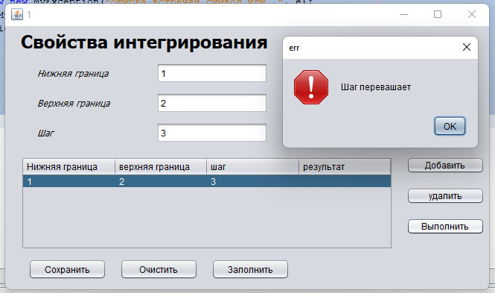

Параметры выходят за пределы от 0,0000001 и 1000000

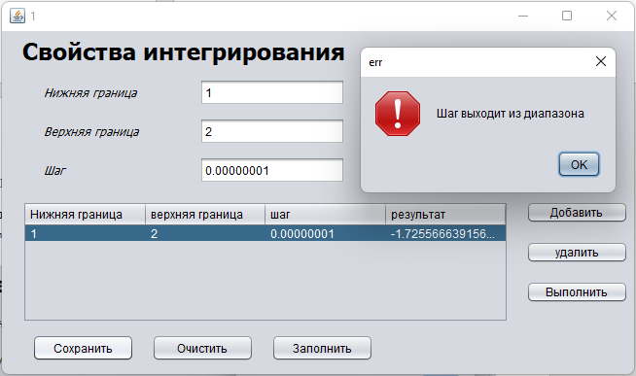

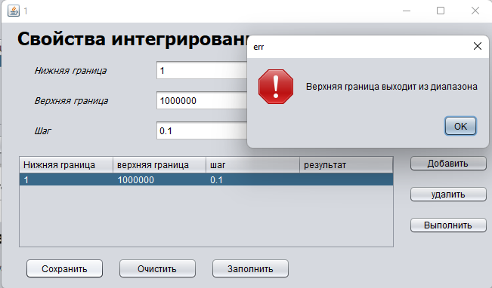

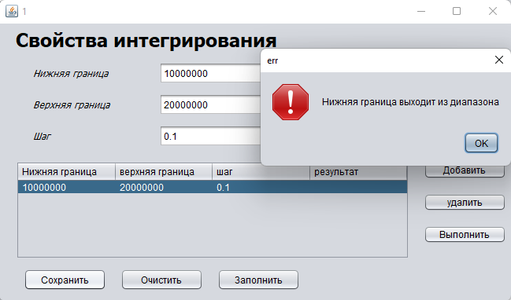

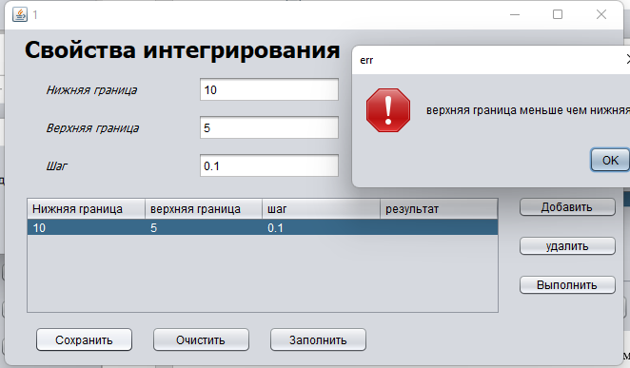

**Вывод:** выполняя лабораторное задание, изучили механизм обработки исключительных ситуаций.