1. Students: Kentbayev Arthur

Smirnov Dmitry

1. Project topic: Delivery Management System(Such as Yandex or Glovo)
2. Basic functionalities: In the application, anyone can register and order any product, or food from their favorite restaurant in a few clicks.
3. Microservices:

1.  Customers

2. Couriers

3. Orders

4. Payment

5. Product

6. Feedback

5. Description of ours microservices:

Customers microservices - This microservice is responsible for our customers, and their actions, and also manages their balance.

Couriers - Responsible for all actions with couriers, couriers accept orders, shows a list of all available couriers.

Orders - order creation, order cancellation, order tracking and history of your orders.

Payment - payment for orders, verification of payment.

Products - This microservice is responsible for the list of goods and products that a client can order, it stores all information about available products.

Feedback - This microservice is responsible for feedback, after the order, the client can write a feedback, rate the order and the courier.

6. Our Diagram

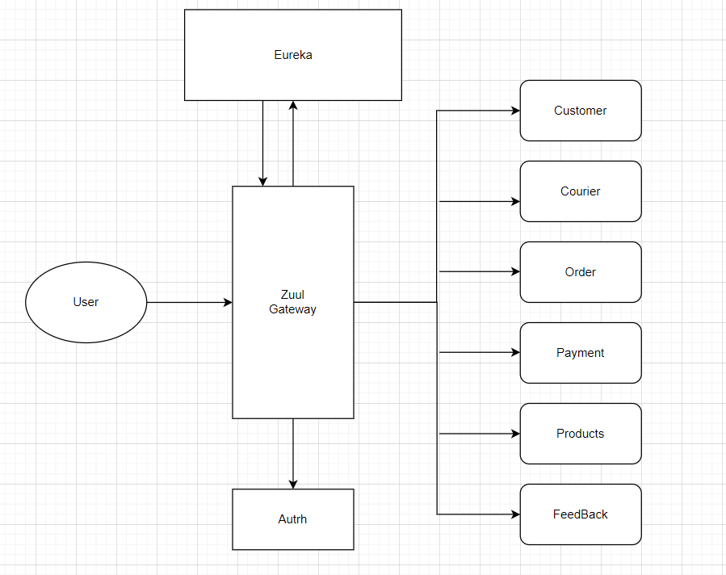

**Logics**

**Home page**

The user sees a list of all restaurants, can go to any one and select a product, when choosing a product, and make a order.

**Customer**

Selects a product from the list of available ones and places an order. Then the client sees the status of the order.

After delivery of the order, the client can leave a report.

It all depends on the status, you can always know the status of the current order.

**Courier**

Sees a list of available orders, and can accept one, after accepting an order, the order disappears from the list of available

The courier can change the order status.