Orbiter Universal Autopilots (UAP) 0.3.0
Autopilots framework for Orbiter space flight simulator.
( ORBITER is written and maintained by Martin Schweiger http://www.orbitersim.com )

Contents

Description and basics.......................................................................................................1
Using UAP MFD.................................................................................................................2
Scenario files.......................................................................................................................5
Autopilot descriptions........................................................................................................6

Description and basics

Orbiter Universal Autopilots is a framework for writing and running universal and sequence-able autopilots in Orbiter. If you heard about Redshift by Bernd R. Fix., UAP is something similar, but much better.

What can it be used for?
From the player point of view, it's an MFD that one can use to define a series of actions to be performed on the current vessel, like lift off, climb to orbit, wait for apoapsis, circularize.
- The sequence of autopilots run fully automatic, starting next one as the previous completes.
- It is designed to be saved to scenario at any point, and be resumed correctly on reload.
- The framework allows autopilots to be orientation – independent, thus, ascent autopilot can be run with any engine, for example.

From a developer point of view, it could have been a nice framework for writing autopilots, but unless there is a noticeable interest in it, no SDK release is planned.

How to use it?
Simple. Enable uap module in the launchpad, use the UAP MFD.

Using UAP MFD

UAP MFD is opened by Shift+B.
- It shows the status of the UAP system for current vessel.
- The system is MFD-independent, the autopilots will run regardless of which MFD's are open and on which vessels.

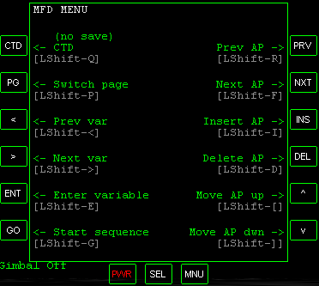
Keys:
The key scheme resembles TransX – there are steps in a sequence, and there are variables for each step.
- STP , S - Terminate current sequence
- PG , P - Switch page. Each page have separate functions on it.
- < , < - Previous variable, previous AP in insert list
- > , > - Next variable, next AP in insert list
- ENT, E - Enter new value for current variable, select highlighted action
- GO , G - Start the sequence
- PRV, R - Previous step in the sequence
- NXT, F - Next step in the sequence
- INS , I - Insert step into sequence
- DEL , D - Remove step from sequence
- ^ , [ - Move selected step up
- v , ] - Move selected step down
- , A - Toggle between auto time accel, disable time accel limits, and limit time accel
- , T - Up time accel if limited, in auto time accel mode

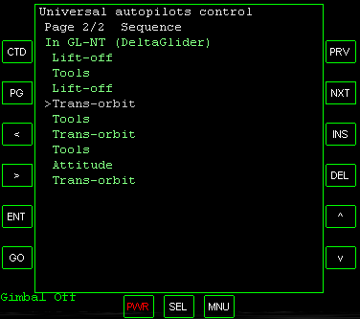
Sequence page
On this page you can edit or define the sequence of autopilots for current vessel.
Keys used: INS, DEL, ^, v, PRV, NXT.
INS adds new step after selected, or creates the sequence if none are defined.

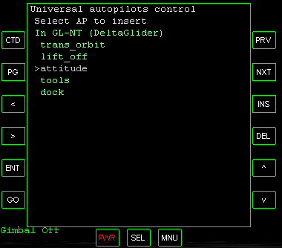
After pressing INS the AP selection menu will open.
Select with < and >, end confirm with ENT.

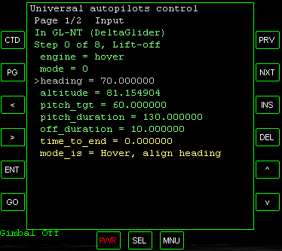
Input variables page
Here one can change or view the variables of the current AP in the sequence.
- The APs are cycled by PRV and NXT, variables are selected by < and >.
- Pressing ENT will open the input prompt for the highlighted variable.
- Changing input variables is not possible for completed or running APs
- Yellow variables are info variables, that shows information about the things current AP is doing. These cannot be edited.

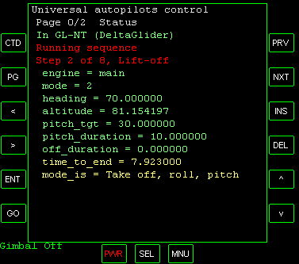
Status page
Status page shows the state of the current sequence and the variables of the step being executed.
As in input page, green are user inputted variables and yellow are info variables.

Scenario files

The sequences are stored in the scenario files in uap section in strings like one below:
>GL-NT:lift_off(mode=0,engine=hover,heading=70),tools(type=0,key=g).
The format is simple:
- First symbol defines if the sequence is running (>) or not ($).
- The vessel name, followed by :
- A list of autopilots with variables in (), separated by comas.
- A . at the end.
- Variables are name=value string, separated by comas
- Lines can be broken at any point to enhance readability
- Lines should not exceed 250 symbols

Autopilot descriptions

Lift-off autopilot
Gets the vessel off the pad, either in vertical climb or in hover to altitude.
Can perform roll and pitch open-loop guidance
- engine specifies the engine to use
- target specifies the target vessel to align into a plane of
- mode defines what to do:
  - 0 is hover to altitude and turn to heading
  - 1 is boost at full and turn to heading
  - 2 is boost, turn to heading and pitch down/up
  - 3 is hover on main and hover engines, pitching up
- heading is desired launch heading
- altitude is desired altitude for modes 0 and 3
- pitch_tgt is final pitch for mode 2
- pitch_duration is the time to perform pitch maneuver for
- off_duration is the time between lift-off and start of roll
- mode_is deciphers the mode variable

Get on pad autopilot
Lands a vessel at a given location on an airless world. Could do it from orbit, but takes manual timing.
- engine specifies the engine to use
- tgt_lat is the latitude
- tgt_lon is the longitude

Runway take-off autopilot
Gets the vessel off the runway, and turns to desired heading
- engine specifies the engine to use
- thrust specifies thrust level to use, fuel saving
- altitude defines the altitude to stop above
- v1 defines take-off speed
- heading is desired launch heading
- gear_key is the key to close landing gears with

Aerial state hold autopilot
Keeps the vessel in the atmosphere at given altitude, speed and heading, with given rates of them.
- engine specifies the engine to use
- altitude defines the altitude to hold
- velocity defines speed to hold
- heading is heading to hold
- alt_rate defines the altitude change rate
- vel_rate defines speed change rate
- hdg_rate is heading change rate
- onoff defines what to hold - 1 is altitude, 2 is heading, 4 is speed (bit field, 1+2=3 - hold heading and altitude, for example)

Trans-orbit autopilot
Gets you from one orbit to another with the same plane, or from suborbital trajectory to orbit with a given plane.
- engine specifies the engine to use (main, hover, retro, maininv)
- target specifies the target vessel to align into a plane of
- heading is desired launch heading if no target is set, or -1 if doesn't matter
- apoapsis defines apoapsis altitude
- periapsis defines periapsis altitude
- kind defines what kind of guidance is expected - 0 means apoapsis and periapsis are defined, 1 means only apoapsis is defined
- ta defines true anomaly (angle from periapsis) to put the vessel at

Hohmann autopilot
Gets you from an orbit of a planet to an orbit of its moon
- engine specifies the engine to use
- target specifies the target moon/planet to go to
- tgt_orbit_alt defines the altitude of the orbit around destination

Align planes autopilot
Aligns vessel orbital plane with the target.
- engine specifies the engine to use
- target specifies the target vessel to align into a plane of
- rinc_delta is the inclination difference to stop at

Sync orbits autopilot
Performs orbit phasing to put you and your target at the same point in space-time.
Only works if your orbit is below the target orbit
- engine specifies the engine to use
- target specifies the target object to align into a plane of
- max_dv_to_use is the maximum delta-v to use in planning the maneuver
- tgt_distance is the distance to target that is considered as success
- minimize specifies what should be the main parameter:
  - 0 is use minimum Delta-V
  - 1 is go for minimum time to sync
  - 2 is try for maximum precision

Approach autopilot
Moves your vessel withing a given distance from the target
- engine specifies the engine to use
- target specifies the target vessel to align into a plane of
- max_velocity is the maximum velocity in approach
- tgt_distance is the distance to target that is considered as success

Docking autopilot
Docks the vessel to the target near-by
- target specifies what to dock with
- port is the port to dock to
- with_port is the port on our vessel to use

Tools "autopilot"
Performs various functions, like key presses or waiting.
It does only ONE thing, not a mix of them - i.e. no wait and key press, either wait or press key.
- mode defines what to do
- param is the sound to make
- target specifies the target vessel for triggering
  - 0 is key press on target (or you if blank)
  - 1 is wait for time dt
  - 2 is wait till at apoapsis
  - 3 is wait til periapsis
  - 4 is start target sequence
  - 5 is wait for target vessel's sequence to complete
  - 6 is undock
  - 7 is make noise
- key is the key to be pressed
- dt is time to wait

Attitude autopilots
Performs attitude maneuvers. So far can only point prograde or retrograde, or do killrot.

