Arthur Liou

CS352

Project Proposal

**Topic Name**: Club Website and Guestlist - Usability Project

**Project Idea Description**: Taking a page out of the professor’s ideas, “The UI for an event registration system for your club. “, this project proposal is to create (or redesign) a club’s website.

For the purposes of this description, I will be using the Temple SF website. Temple SF is a popular nightclub in San Francisco. However, the website, while fulfilling a lot of fundamental requirements and use cases that a club would want in a website, is hampered by a “simple” design that hampers usability and having users. Not to mention, the ticket checkout, reservation, and guest list signups are all not very UX friendly and does not fit in with the overall vibe / design of the website.

**Why this idea is interesting**: This project would have a lot of the background / fundamentals all set up. In terms of features and functionality a user may want from a club’s website, Temple SF’s website has a lot of features and information tabs already set up. But the problem is that the website isn’t very well put together from a usability perspective. Depending on a designer’s idea of an ideal project to redesign, this would be one of those, where many of the ideas and features are already there and (from a software perspective) already built out, and is now a matter to finding out which ones to focus on, leading us to focus on user research and interaction to figure out what matters most to the website’s viewers

In addition, it’s not limited to just this particular club’s website. If the project team so desired, this scenario can be applied to various clubs, music festival concerts (Coachella, EDC) website’s, which typically while having great fundamental functionality does not have great design.

**Pictures**:

Top of the Page

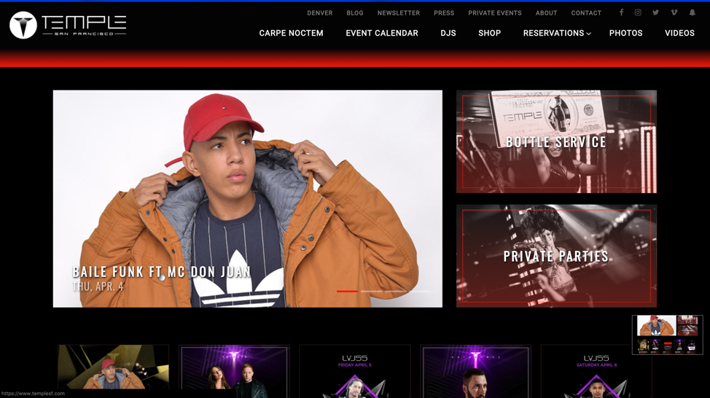

Middle of the Page

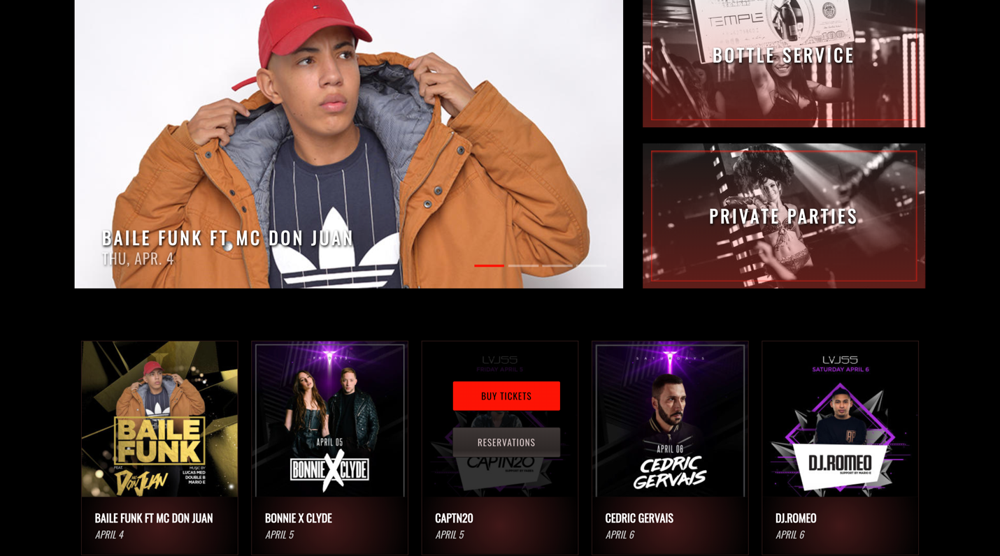  
Bottom of the Page (I’ve boxed in red areas which are excessive, redundant, etc).

