Arthur Liou

CS 352

Activity #2: Analysis of An Application Using the Design Principals

**Prompt**

Your goal is to apply the design principles of visibility, feedback, constraints, consistency, affordance (we covered them in Module 1)

• Select any software that already existed. It could be something you have helped to write (e.g., for a class or work), but any other commercial or open source software is ok too. It can have a very simple or very complex user interface. Include one or more screenshots of the user interface.

• For each design principle provide a concrete example of how the software's UI **supports** that principle. Be sure to justify why you are saying that the example supports that principle (3-5 sentences per principle). You can also include screenshot of the UI that shows how it supports the principal. If nothing about your UI at all supports a design principle, you can say so, but you must write a justification for that as well.

• For each design principle, provide a concrete example of how the software violates that principle (with justifications: 3-5 sentences per principle). You can also include screenshot of the UI that shows how it violates the principal. If nothing about your UI at all violates a design principle, you can say so, but you must write a justification for that as well. Any suggestion for improvement?

You should be able to come up with at least 2 pages, feel free to include images if you wish. Please submit a .pdf file to Canvas for Activity 2.

**Response**

Software Selected: Greenhouse Software. <https://www.greenhouse.io/>.

Summary: Greenhouse is a Recruiting Software & Applicant Tracking System SaaS product. The following screenshots I’m using are from what I see at work as my company uses Greenhouse as our ATS. I’ll include one screenshot from the employee / ATS side and one from the non-company / applicant side.

Dashboard Screenshot

Application Screenshot / Workflow: <https://boards.greenhouse.io/c3iot/jobs/4056606002>

5 Screenshots over the next 2-3 pages.

Image 1 - Job Posting Page P1

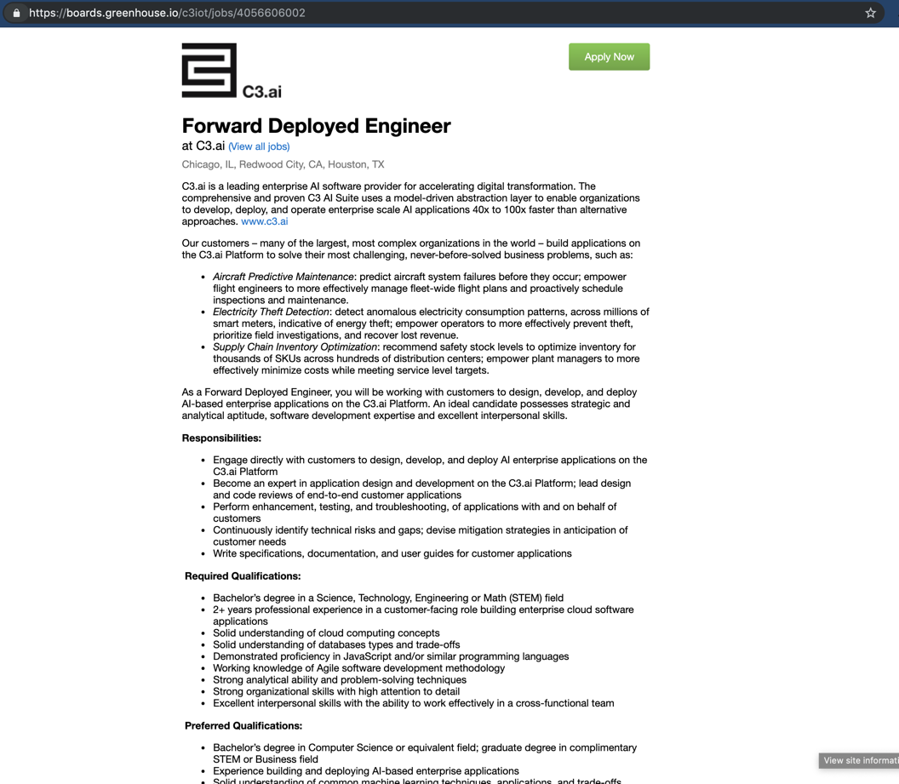

Image 2 - Job Posting Page P2

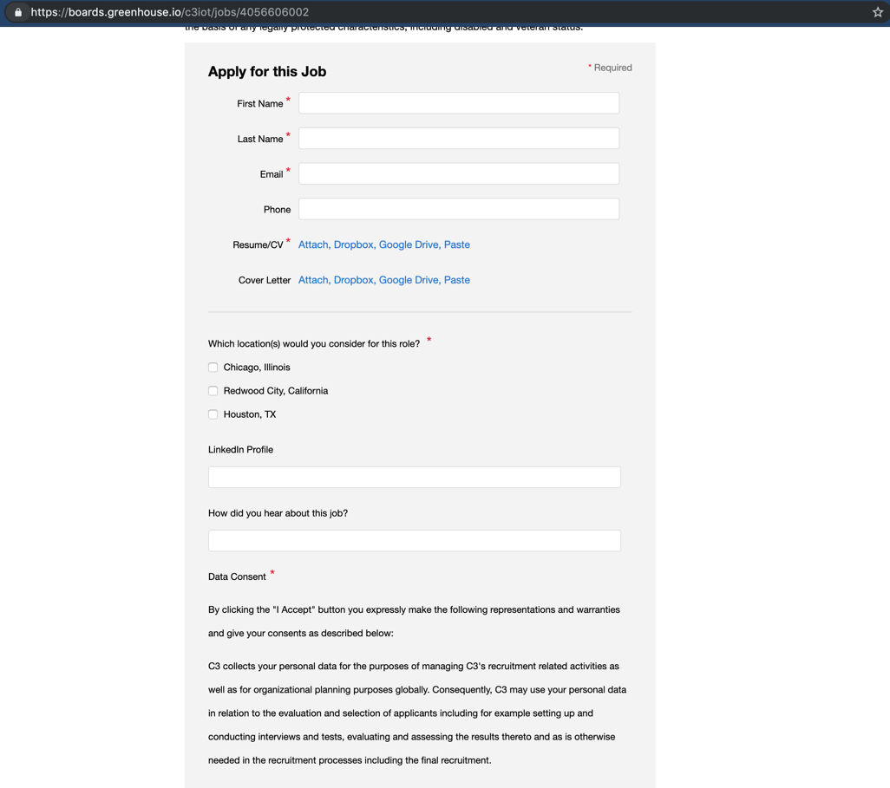

Image 3 - Job Posting Page P3. Since it is clear the following two images are back to back, consider the pair as image 3.

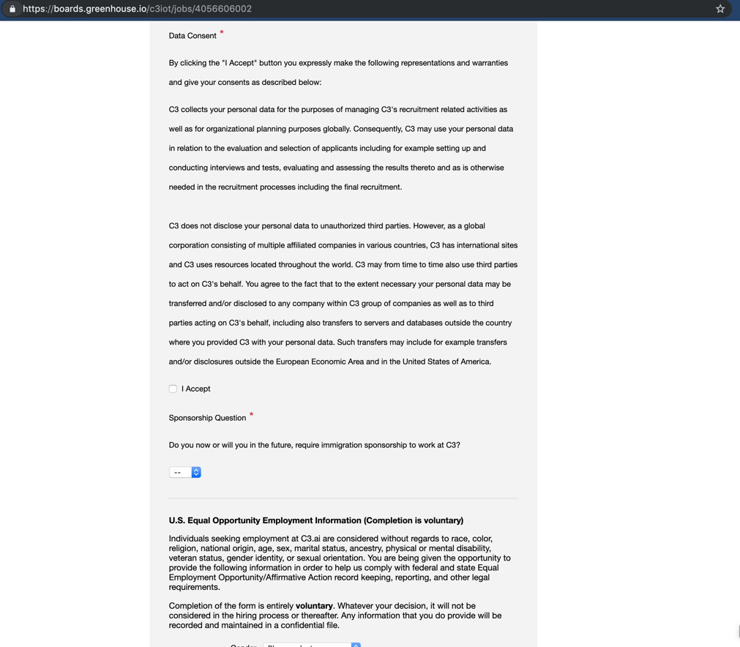

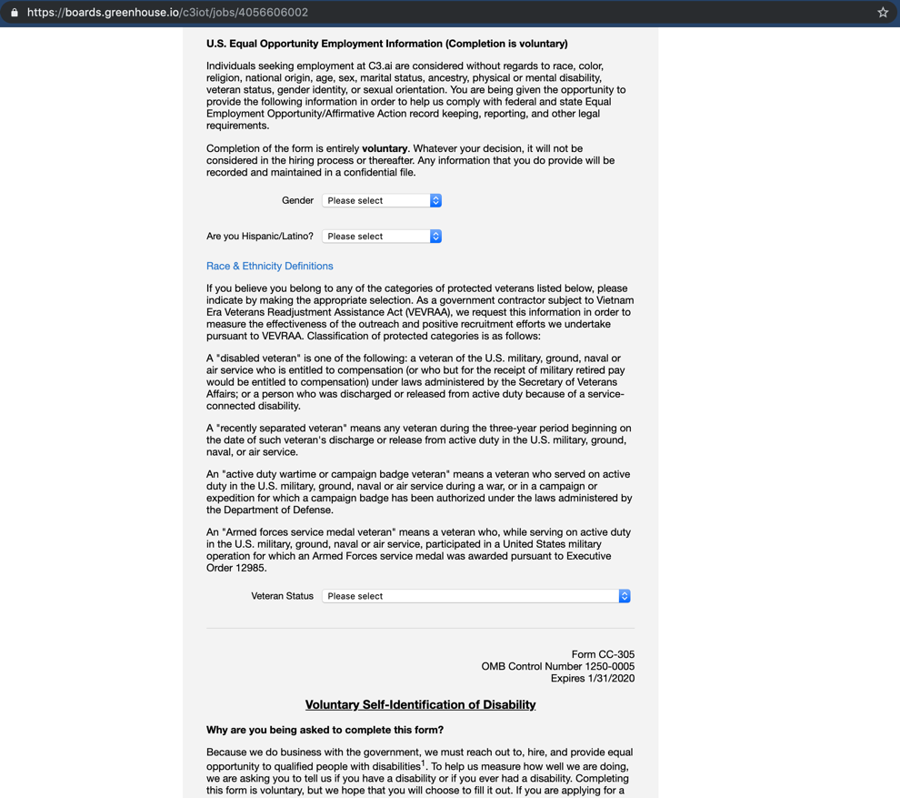

Image 4 - Job Posting Page P4 + Submission Butto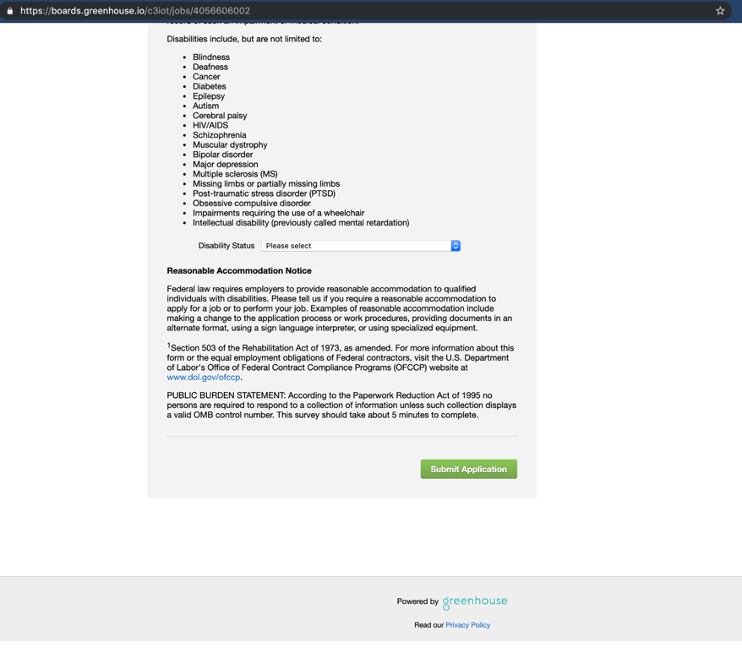

Image 5 – Employer Facing Dashboard / ATS

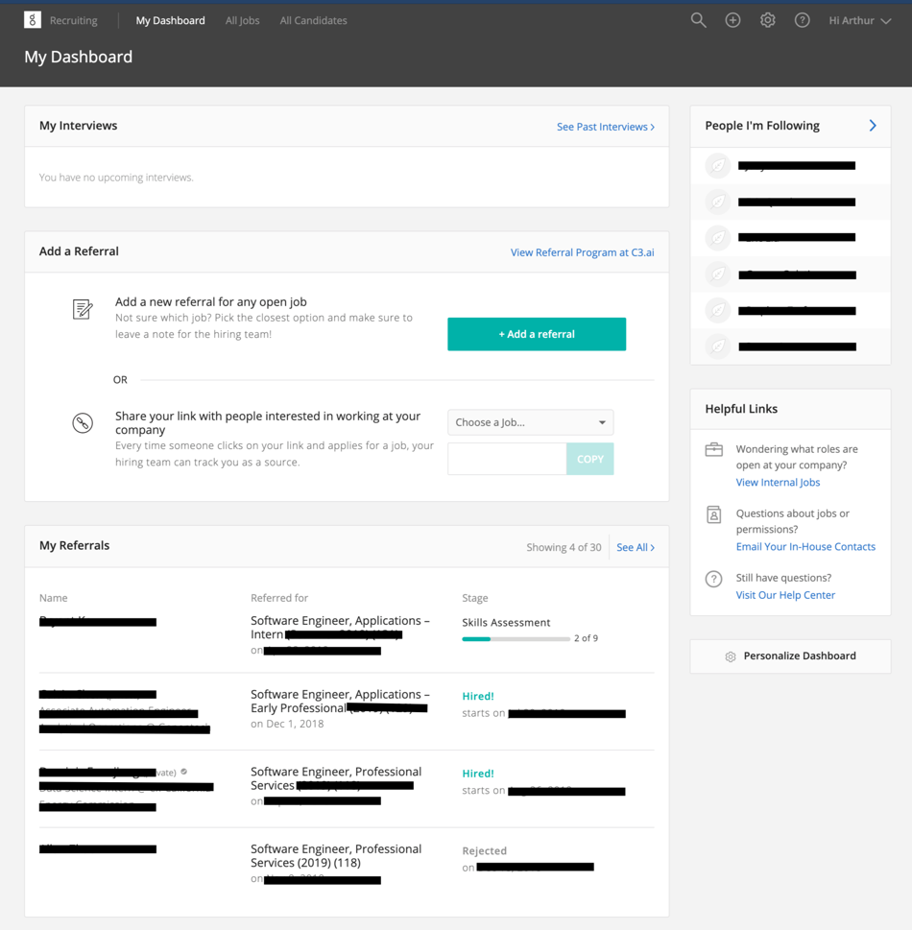

**Design Principals**

1. Visibility – Can I see the functions and interactions?
   1. Screenshot – See Image 5 Above
   2. Example
      1. Dashboard
   3. Justification
      1. This is a good example of visibility because at each point in the dashboard, “My Dashboard, All Jobs, My Candidates”, Add a Referral, My Referrals, My Interviews” is very clear about the possible functions and interaction, it is clear what the function of this application consists of and what interactions a user may have in each section. For example, across the header / top, there are a few links for the main functions / interactions I would want as an employer user. In the center, I have two primary sections that I would want as an employee: my upcoming interviews, and section to add referrals. Most of the links on the page are light blue or green (Greenhouse’s color) so it is visible for a user like myself to tell apart links.
   4. Violation Example
      1. “My Referrals” Names
   5. Violation Justification Example
      1. This is a good violation example of visibility because as I have blacked out the names under “My Referrals”, you will not be able to see this interaction, but the names listed there are not linked. Conversely in the “People I’m Following” section in the top right, the names are linked to the candidate profile. This violates the Visibility example because most users would expect that a name. While it is in line with the non light blue or green I mentioned in the previous section, why are some other links, such the links in the header not also similarly colored? It could be because they are obvious links, but in in the body / section it is not as apparent.
2. Feedback – What’s the object or device doing right now?
   1. Screenshot – See Image 5 Above
   2. Example
      1. On the employee’s dashboard, the software (object/device) displays the quick view / summary of the important information and links to what a user might want to do.
   3. Justification
      1. This is a good example of feedback because the application shows you the high level information from all different parts of the application – referrals / adding referrals, jobs, candidates, candidates I follow, my interviews, and helpful links, along with a section that allows the user to personalize the dashboard.
   4. Violation Example
      1. I am unable to find a violation of this design principle.
   5. Violation Justification Example
      1. This is difficult to determine a violation because this is like proving a negative or try to prove something doesn’t exist when there is no evidence to support that because it doesn’t exist, so there is nothing to justify the violation of the constrains design principle. A violation here would be to find an object/device that does not work as intended (ie a bug). That is something that has not happened with Greenhouse; I’ve used their software for far too many years and have not encountered a Production bug on their application yet.
3. Constraints – What can’t I do that
   1. Screenshot
      1. 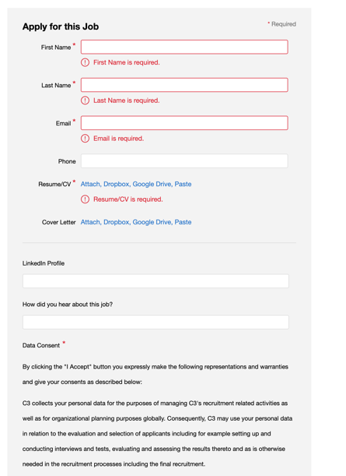
   2. Example
      1. If I try to submit an application without filling out one of the input boxes that are marked with a red asterisk, then the application fails to go through.
   3. Justification
      1. This is a good example of constraints because it shows that I, as the user, cannot do on the application / software. The application distinctly tells me that XYZ section is required or a box must be checked.
   4. Violation Example
      1. I am unable to find a violation of this design principle.
   5. Violation Justification Example
      1. This is difficult to determine a violation because this is like proving a negative or try to prove something doesn’t exist when there is no evidence to support that because it doesn’t exist, so there is nothing to justify the violation of the constrains design principle. Trying to find a violation example of “What I can’t do that”. That is something that has not happened with Greenhouse; I’ve used their software for far too many years and have not encountered a Production bug on their application yet.
4. Consistency – Is this familiar?
   1. Screenshot – Images 1-4 – Job Post Page
   2. Example
      1. The job post page is very familiar and consistent for most customers / companies that use Greenhouse.
   3. Justification
      1. This is a good example of consistency because the job post page is very familiar and consistent for most customers / companies that use Greenhouse. Most of these job applications are in a consistent format, having name, email, phone number, resume, optional cover letter, work authorization, optional candidate info, “why this job”, or some kind of the combination of (or in addition to) the above.
      2. Examples: <https://boards.greenhouse.io/venmo/jobs/1663433?gh_jid=1663433>
      3. <https://www.hubspot.com/jobs/apply?gh_jid=86940> (Doesn’t explicitly say Hubspot uses Greenhouse, but they are a Greenhouse customer).
   4. Violation Example
      1. Not each company that uses Greenhouse has the same type of application.
   5. Violation Justification Example
      1. This is a good violation example of consistency because the Hubspot and Venmo application forms in the link above are way shorter than the C3.ai job posted in the screenshots above. Since each application has a different set of questions (but based on the items I mentioned in the Justification section above), as an applicant, it’s a mild annoyance as I won’t get a consistent user experience across different companies. For example, sometimes the application form is short and sweet but other times it is very long.
5. Affordance – How do I use it?
   1. Screenshot – Images 1-4 – Job Post Page
   2. Example
      1. As an applicant, I know how to use the application form and can easily fill it out and submit.
   3. Justification
      1. This is a good example of affordance because I essentially fill out the all the areas on the form, especially the ones with the red asterisk, until I get to the end and hit the submit form. It is easy to fill out since it’s a “start at the top, end at the bottom” type of form with a nice green “Submit Application” button at the end.
   4. Violation Example
      1. It isn’t clear where to submit the application until you get to the bottom of the page.
   5. Violation Justification Example
      1. This is a good violation example of affordance because when one first navigates to the page / arrives at the application, a user unfamiliar with Greenhouse or modern job applications might not figure out where to submit the application, the most important part of the application from the applicant’s perspective. Especially since this particular application is very lengthy top-down, the affordance isn’t great as the user will have to scroll all the way down before figuring out that the “Submit Application” button is at the very bottom.