Arthur Liou

CS373

**Week 9-10 Writeup**

Prompt: Submitting a write-up of your thoughts, impressions, and any conclusions based on the material from the week. Each week will have its own assignment in the grades page.

For the first part of this week’s writeup, I’m reflecting on the topic – Mobile Security. I originally thought this week would be very engaging material, similar to how I found the material last week. Unfortunately, I found this week’s material (concepts and labs) rather dull, disengaging, and an incredible letdown to end the course, having not yet taken the final.

For a brief summary of what we covered and learned, see my lecture notes below.

**Lecture Notes**

Lesson 1 – Mobile Security

* History of Mobile Devices, Mobile OS History.
* World-wide Smartphone Sales. Android takes way off.
* Apple iOS Slide, Microsoft Windows Phone, Google Android, also other mobile OS
* Mobile OS Executable environments, security features
* Running Apps in the Same Process vs. Android Sandboxing

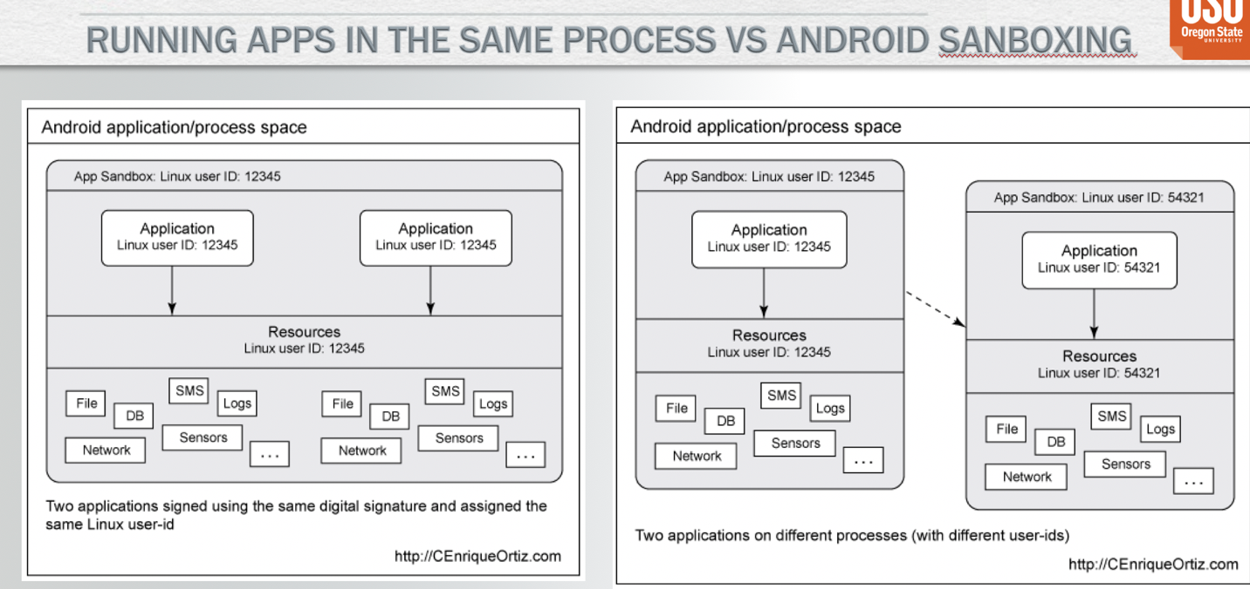

* System Security Bypasses – Jailbreaking, Rooting in Android, Security Enhancements
* Mobile Malware Genesis, started in 2000-2004
* Middle Ages – 2005-2006, 2006-2008
* Calm Before the Storm – 2008-2010, New Platforms with Smartphone revolution, market share changed, new capabilities
* Symbian Worm YXES: First Mobile Botnet
* Ikee – first Ios malware. Jailbroken phones (2009)
* First Android Malware in the wild. Fakeplayer, Tapsnake
* Andrew Malware Revolution – exponential increase
* Geimini – first android botnet – 2010, China, Leaks sensitive info to a remote server
* PJApps – Interception of SMS messages, Found 2011 targeting Chinese users
* Droiddream – android market nightmare, 2011, many apps, XOR obfuscation (embeded key), attempts to root device using two public exploits
* Google Action – Remote Kill Switch
* Android Fundamentals

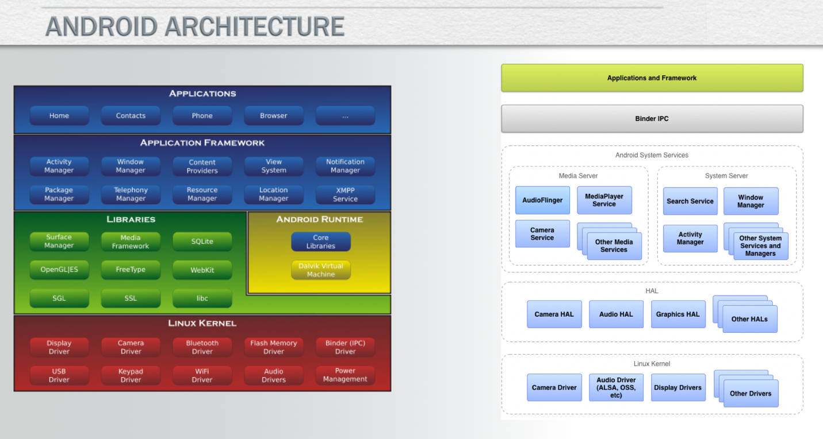

* Android Runtimes, Dalvik architectures
* Application sandboxing in android vs linux
* Android application components: Activities, Services, Broadcast Receivers, Content Providers
* Android interprocess communication: official and nonofficial
* Intents – messages between components
* Sticky Broadcasts
* Android application permissions
* Android Manifest.xml encoded inside the APK file.
* Labs and Slides related to the labs, tools
* Appendix Slides
* Analog Systems (1G), Digital Cellular Networks (2G), Mobile Broadband Data (2.5G-3G), IP Networks (3.5G & 4G)