MNA Monitor Report
Name: __________________________________ Email: __________________________________

Address: ________________________________ Phone: _________________________________

________________________________________ Date: __________________________________

General Information
Property Name |  |  | Property Number
Acreage |  |  | Classification
Describe Property's Use (high traffic, few apparent visits etc.)
Access: (directions from nearest road, 4-wheel drive requirements, easement trail, etc.) |  | Parking: (Is there a parking lot? How many cars? If not, where do visitors park?)

Report Based On Observation of:
Entire Boundary |  | Entire Property |  | Portion of Property

Boundary Signs
Not present |  | Posted on Some Boundaries |  | Posted on All Boundaries
Please Indicate On Dashed Line Which Type of Boundary Signs this Sanctuary Has
A, B, & C Refer to the Sanctuary’s Class
A/B Toll-free #  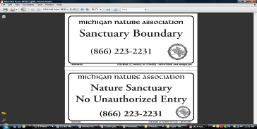  -------------------  C Toll-free #  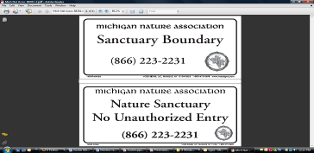  ------------------- | A/B Website  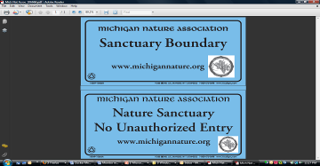  -------------------  C Website  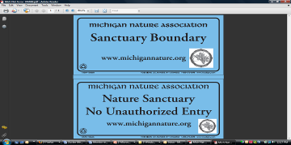  ------------------ | Old & Outdated  Usually white with black letters Phone number is from Avoca, Yale Mt. Clemons or Fruitport  -------------------  No Boundary Signs  ------------------
Trails How many trails? ________
Do You Need Additional Signs Mailed to You?
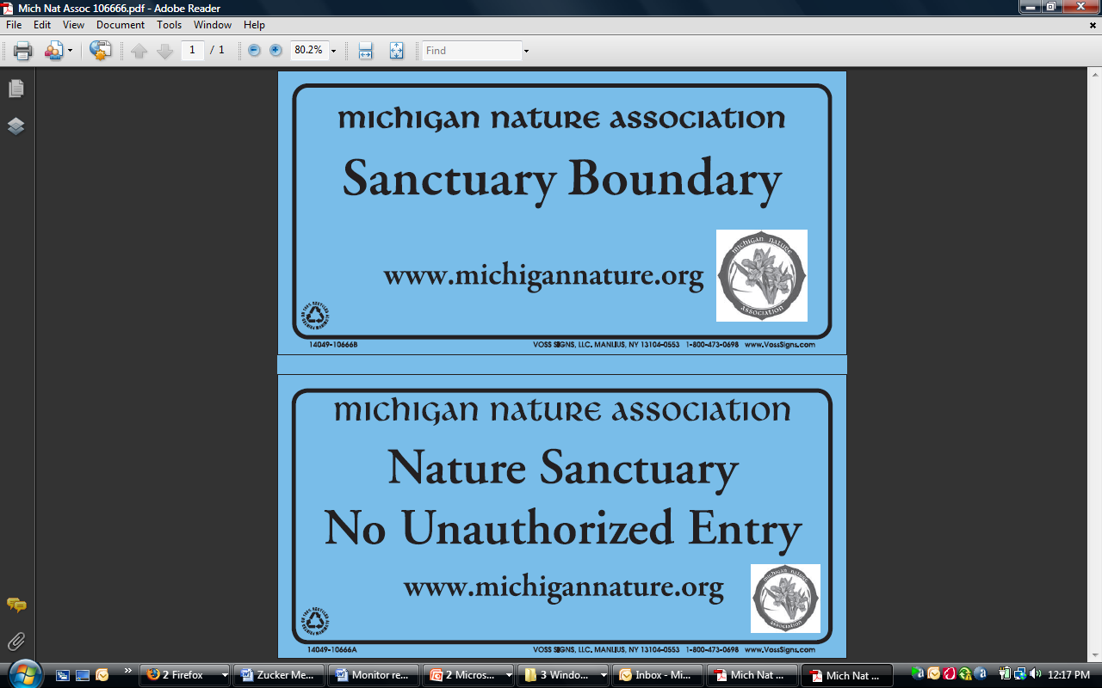 | 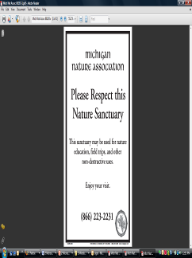 | 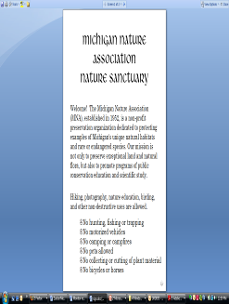
 |  | 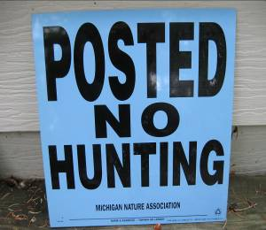
A/B Sanctuary Boundary
How many ______?
A/B Please Respect
How many ______?
A/B Sanctuary Rules
How many ______?
How many ______?
C Sanctuary Boundary
All Classes
How many ______?
All Classes
How many ______?
Conditions: | Markings:  What color? How are they marked? | Needs:
♦- blue for primary trail
♦- yellow for secondary trail
♦- lavender for tertiary trail
♦- green for quaternary trail
♦- white for easement trail

What do you need? _______

How many? ___________

Structures
Please Describe: | Needs:

Violations
Vandalism |  | Dumping |  | Plant Removal
Hunting/Poaching |  | ORV |  | Other
Explain Circumstances:
Birds
Scientific Name | Common Name | Nesting? | Habitat

Plants - Native
Scientific Name | Common Name | In Flower? | Habitat
Plants - Invasive/Non-Native
Scientific Name | Common Name | How many? | Near quality habitat?

Insects, Mammals, Herps, Fish, Snails, Mussels, Etc.
Scientific Name | Common Name | How many? | Habitat

Rare Species
Please Describe Current Distribution and Condition:
Suggestions/Comments

Steward Name (Printed) ______________________________________

Steward Signature ___________________________________________

Please Attach Photos From Your Visit If Possible

