# Hardware & Transmission Booklet

|  |  |  |  |
| --- | --- | --- | --- |
|  | Grade D/E outcomes | Grade C outcomes | Grade B/A outcomes |
| **3.1.1.1** | To draw out the basic operations of a Computer | To label and explain major parts of a computer system | To describe the communication between different devices and justify the need for each aspect |
| **3.1.1.2** |
| **3.1.4.2** | To state the major components of the control unit | To describe how these components interact connect | To summarise the individual aspects of the control unit and explain the processes involved |
| **3.1.4.2** | To state the components use when registering/carrying out instructions | To explain how these components interact when registering/carrying out instructions | To summarise the individual registers and explain the processes involved |
| **3.1.4.3** | To state what buses are when conveying information | To explain how these buses are different | To showcase how the information is sent around the PC describe the use of each component |
| **3.1.4.4** | To state different methods of connecting devices | To explore the strengths and weaknesses of each | To justify the use of connections for different tasks |
| **3.1.4.5** | To state the difference between ROM and RAM | To explain how ROM and RAM exist within a computer system |  |
| **3.1.4.6** | To state how primary and secondary storage differ | To explain methods of secondary storage | To summarise the uses and characteristics of a range of storage media |
| **3.1.4.7** | To verify what buffers and interrupts are | to explain the need for buffers and interrupts | To summarise the uses and characteristics of a range of components within a system |
| **3.1.4.8** | To state a variety of hardware used in computer systems | To explain the purpose of a variety of pieces of hardware | To evaluate the best hardware for scenarios and systems by discounting others |
| **3.1.4.9** |

|  |  |  |  |
| --- | --- | --- | --- |
|  | Grade D/E outcomes | Grade C outcomes | Grade B/A outcomes |
| **3.1.5.1** | Pupils can state the difference between types of network | key characteristics are described for both LAN and WAN | Explanation of networks use technical terminology to describe the flow of communications |
| **3.1.5.2** | State the hardware/software required for a network | Explain how the hardware handles data |  |
| **3.1.5.3** | State the different transmission types | Explain the differences between the models | Express in terms of speed and security the effectiveness of the data transmission types |
| **3.1.5.4** | To state what bit rate is | To explain how bit rates are measured | To evaluate the importance of timing for data/instructions to be sent |
| **3.1.5.5** | To state methods of error checking | To explain with accuracy the difference between the methods |  |
| **3.1.5.6** | To state the two types of switching | To explain them in terms of efficiency and security | To explain how packets allow the communication of data within a network |
| **3.1.5.7** |
| **3.1.5.8** | To state what protocols are and name different protocols that need to occur | To explain different types of protocols and give accurate description of both physical and logical protocols | To justify the need to layering, handshakes and protocols in the transmission of data |
| **3.1.5.9** |
| **3.1.5.10** |

## 3.1.4a basics of a system

What are the key components of a PC?

CPU, PSU, GPU, RAM, HDD

What are the key components of a system?

INPUT CPU MEMORY OUTPUT

Create a visual representation of a system that is clearly labelled (input, output, storage, process).

Explain how information flows through the system and what type of processes occur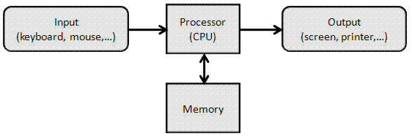

Instructions are passed through the control unit and are allocated areas within memory and are interpreted into accessible functions in the PC by the processor.

This task requires an individual element, a group element and a second individual element

1. On your own have a go at drawing out what happens to within a computer system.
2. Go round the room and add to your visualisation by asking others what they know
3. Using the text books available and other resources complete your initial notes on how a computer system works

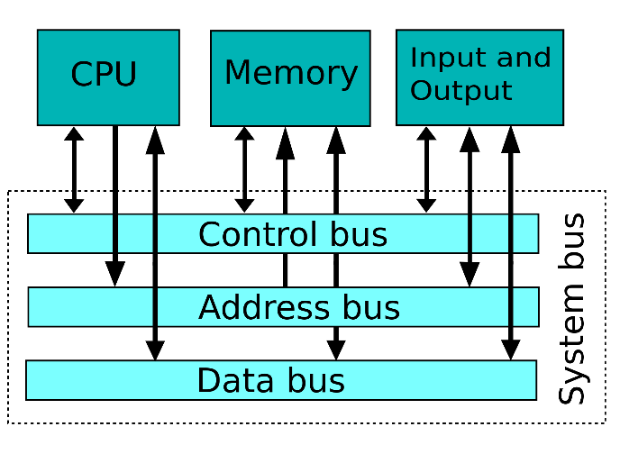

## 3.1.4h & i

Data input device: a device that can be used to insert data into a computer or other computational device

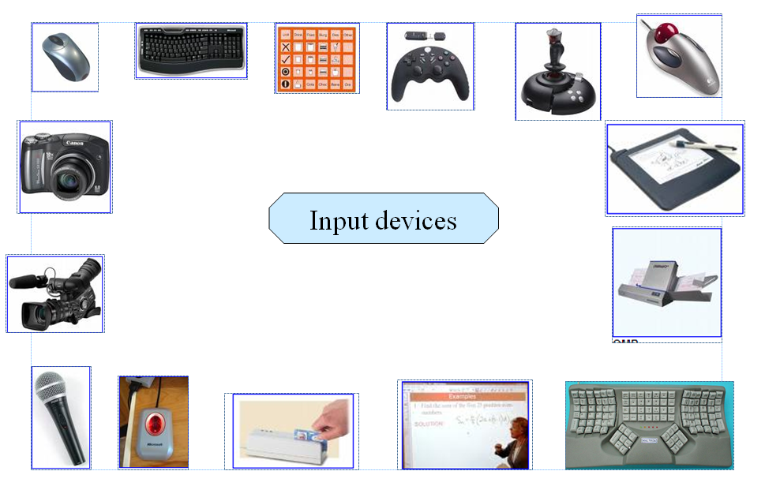

Task1 Can you name all 15 input devices above?

|  |  |  |  |  |
| --- | --- | --- | --- | --- |
| Mouse | Keyboard | Camera | Camcorder | Microphone |
| Fingerprint scanner | Card reader | Tablet | Joystick | Gamepad |
| Projector | printer |  |  |  |

Task 2 – using the devices above and more that you know off/find create a continuum of most to least common devices you may utilise.

A copy of the PPT to download is on the google drive

## Assessment report

Choose a scenario below and complete the questions below

* Scenario 1- Factory manufacturing cars
* Scenario 2 – Bank
* Scenario 3 – Football stadium

What devices would be used in this scenario?

* A computer system containing programs used to 3d model cars and a program to test how the physics would theoretically work with the car, allowing the factory to see whether new car designs would work. They would also contain programs allowing them to view the current progress of the machinery and allowing htem to see if any problems have occurred during the automation.
* Explain how these peripherals would be used within the scenario (discounting the use of possible alternatives)
* A mouse would be used as input, the projector as a display to show the current status of the factory machinery to view whether it’s working. The Camcorder could be used to have a real-time view of the machinery and the keyboard could be used to input text into the machine. The Card reader and fingerprint reader could be used to see if people have the required access to get to places within the area.

|  |  |  |  |
| --- | --- | --- | --- |
|  | Grade D/E outcomes | Grade C outcomes | Grade B/A outcomes |
| **3.1.4.h & i** | To state a variety of hardware used in computer systems | To explain the purpose of a variety of pieces of hardware | To evaluate the best hardware for scenarios and systems by discounting others |

## 3.1.4a How CPU works

Watch this

<http://www.youtube.com/watch?v=cNN_tTXABUA&feature=kp>

Read this

<http://homepage.cs.uri.edu/faculty/wolfe/book/Readings/Reading04.htm>

Describe the function of each of the following/feedback to the class what each item does

|  |  |
| --- | --- |
| **Component** | **What does it do?** |
| **CU** | Computes all the instructions |
| **ALU** | Performs the arithmetic calculations |
| **North Bridge** | Handles the communication between the RAM & GPU |
| **Control bus** | Receives the instructions |
| **Memory Unit** | Stores the data |

## Progress checker

|  |  |  |  |
| --- | --- | --- | --- |
|  | Grade D/E outcomes | Grade C outcomes | Grade B/A outcomes |
| **3.1.1.1** | To draw out the basic operations of a Computer | To label and explain major parts of a computer system | To describe the communication between different devices and justify the need for each aspect |
| **3.1.1.2** |
| **3.1.4.2** | To state the major components of the control unit | To describe how these components interact connect | To summarise the individual aspects of the control unit and explain the processes involved |

## 3.1.4b Registers

<http://www.teach-ict.com/as_as_computing/ocr/H447/F453/3_3_3/vonn_neuman/miniweb/pg4.htm>

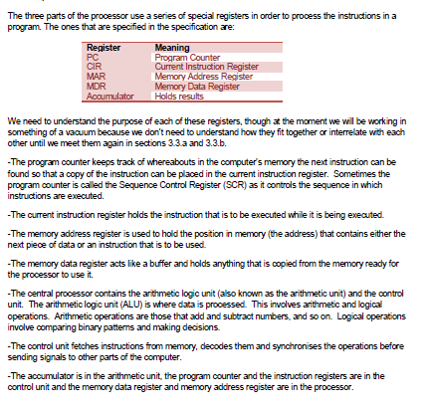

Task - Create a visual that represents what happens to instructions as they are compiled and executed the components above

## Progress checker

|  |  |  |  |
| --- | --- | --- | --- |
|  | Grade D/E outcomes | Grade C outcomes | Grade B/A outcomes |
| **3.1.4.2** | To state the components use when registering/carrying out instructions | To explain how these components interact when registering/carrying out instructions | To summarise the individual registers and explain the processes involved |

## 3.1.4c buses

Buses carry people, what do computer buses do?

Carry data

Find out and add to your drawing what the following buses do

* Control Bus
* Address Bus
* Data Bus

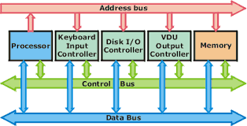

## Progress checker

|  |  |  |  |
| --- | --- | --- | --- |
|  | Grade D/E outcomes | Grade C outcomes | Grade B/A outcomes |
| **3.1.4.3** | To state what buses are when conveying information | To explain how these buses are different | To showcase how the information is sent around the PC describe the use of each component |

## 3.1.5e ROM & RAM

**Task 1**

Why do computers need a mixture of ROM and RAM?

* RAM can be written to by any program whereas ROM cannot, but ROM is needed to hold the BIOS which boots up the computer

Why would it be a mistake to have the operating system only on the ROM?

* The computer would then be cleared from the memory upon power loss.

**Task 2**

What do the following mean?

PROM - **Programmable read-only memory**

EPROM - Erasable programmable read-only memory

EAROM - electrically alterable read-only memory

SRAM - **static RAM**

 Random Access Memory that retains data bits in its memory as long as power is being supplied

DRAM - **Dynamic random access memory**

memory that is typically used for data or program code that a **computer** processor needs to function

How are they different?

Rom is used to store the BIOS whereas the RAM is used to store random data to be used by the programs and the os such as variables and running programs.

## Progress checker

|  |  |  |  |
| --- | --- | --- | --- |
|  | Grade D/E outcomes | Grade C outcomes | Grade B/A outcomes |
| **3.1.4.5** | To state the difference between ROM and RAM | To explain how ROM and RAM exist within a computer system |  |

## 3.1.4f Storage

Task 1

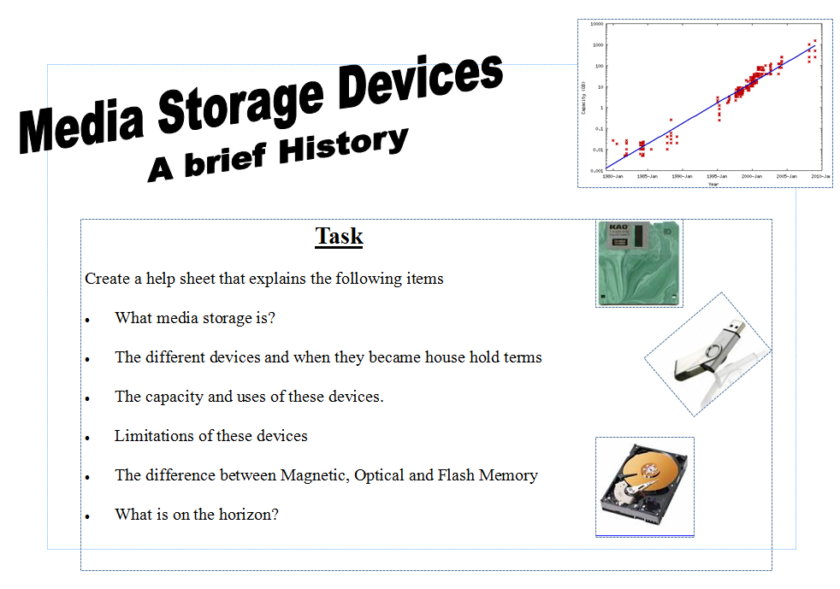

The table below may help you collect your research

|  |  |  |  |  |
| --- | --- | --- | --- | --- |
| ***Storage Device*** | ***Relative cost*** | ***Storage capacity*** | ***Speed (slow, moderate or fast)*** | ***Description*** |
| Optical drive- CD | £2 | 256mb | Fast | Can easily hold an album of music and allow for listening in moderately high quality. |
| Optical drive- DVD | £4 | 2gb | fast | Can easily hold a video and maintain a high enough speed to watch without any cutting. |
| External hard drive | £60 | 1tb | moderate | Can store a moderate amount of data and is persistant with a decent amount of read/write cycles. |
| Magnetic tape drive | - | 190tb | fast | Allows for large storage of data per Sq In. However, unsupported by most computer systems. |
| ZIP-drive | £5 | 1gb | moderate | Can quickly and easily store data and be transferred to another system. |
| Solid State Drive | £250 | 1tb | fast | Can quickly store and retrieve data but has a low amount of read/write operations |

Reseach how a HDD works – add this to your movie

## Extension –

Either

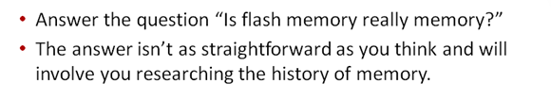

Or

Sequential or direct access – what do they mean and how do they work?

## Progress checker

|  |  |  |  |
| --- | --- | --- | --- |
|  | Grade D/E outcomes | Grade C outcomes | Grade B/A outcomes |
| **3.1.4.6** | To state how primary and secondary storage differ | To explain methods of secondary storage | To summarise the uses and characteristics of a range of storage media |

## 3.1.7g Buffers and Interupts

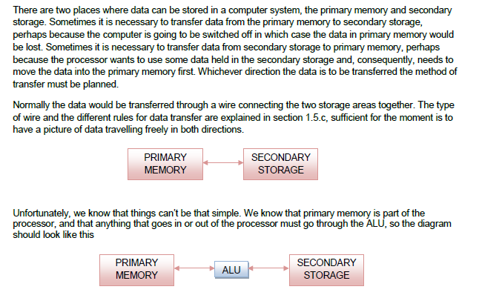

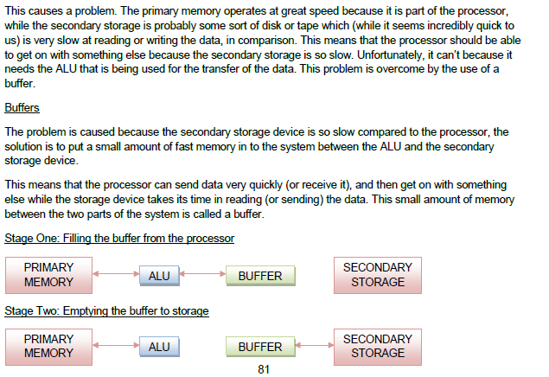

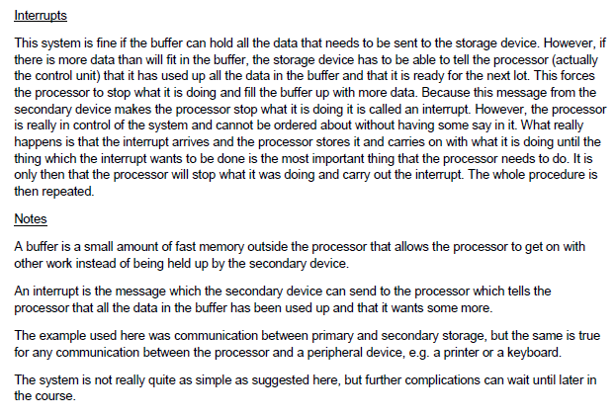

Task – Add to your visual representation the use of buffers and interrupts (we started this in 3.1.4b

## Progress checker

|  |  |  |  |
| --- | --- | --- | --- |
|  | Grade D/E outcomes | Grade C outcomes | Grade B/A outcomes |
| **3.1.4.7** | To verify what buffers and interrupts are | to explain the need for buffers and interrupts | To summarise the uses and characteristics of a range of components within a system |

## 3.1.4h & i

Computer outputs are around us everyday, many of them we do not necessarily see. Complete the PPT on the google drive (download it first) and try to add some weird, wacky and wonderful output devices to the work.

|  |  |  |  |
| --- | --- | --- | --- |
|  | Grade D/E outcomes | Grade C outcomes | Grade B/A outcomes |
| **3.1.4.h & i** | To state a variety of hardware used in computer systems | To explain the purpose of a variety of pieces of hardware | To evaluate the best hardware for scenarios and systems by discounting others |

Your Movie should now contain

|  |  |  |
| --- | --- | --- |
| Section | Information | Key terms |
| Input devices | How instructions are added into a computer system  What connections exist on the standard PC | OCR, OMR, MICR, RFID, Chip and Pin |
| CPU | What the CPU does?  The different components of the CPU  How the different pieces of Hardware interconnect | Program Counter  Memory Address register  Memory data register  Current instruction register  Data Bus  Control bus  Address bus |
| Storage | RAM & ROM  What are they? Why are both required?  What secondary storage devices are available ?  What are the major differences between them?  How a HDD works  Are archiving and back ups the same thing? | ROM  RAM  Secondary  Primary  Volatile  Read/write head  Archive  Back up |
| Buffers/interrupts | Why are they needed?  How do they fit into the computer system? | Buffer  Interrupt |
| Output | The different devices that are connected to computer systems and what they do | Actuator  Specialist devices |
| Optional extras | North bridge  South bridge  Graphics card  How flash memory works |  |