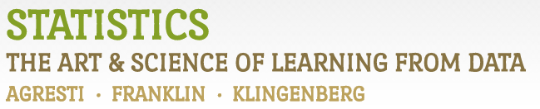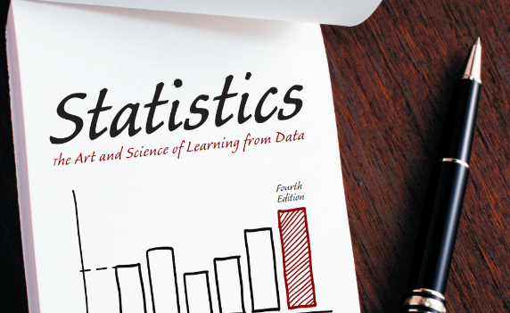

Chapter 1

# Example 5: Google Analytics – Creating a Data File

Create the data file as shown in Example 5 in Excel and save it as a .csv file. Here, I have given it the name “GoogleAnalyticsExample5.csv”.

> # Create the data file as shown in Example 5 with Excel

> # Save the file as a .csv file and name it "DataExercise5.csv"

>

> # Now, select this .csv file from your hard drive:

> mypath <- file.choose()

> # Now R knows the location of your file:

> mypath

[1] "C:\\ASS\\Git\\data\\Chapter1\\GoogleAnalyticsExample5.csv"

> # The read.csv command reads in .csv files:

> dataEx5 <- read.csv(mypath)

> # We can now view the file:

> dataEx5

Visitor Country Browser Device Minutes Age Gender

1 1 US Safari mobile 6 28 female

2 2 Brazil Chrome desktop 2 38 female

3 3 US Chrome mobile 8 16 non-binary