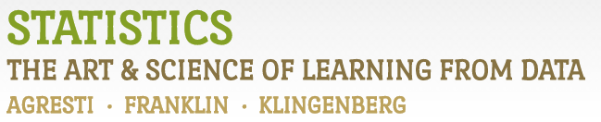

Chapter 2

# Example 10: Center of the Cereal Sodium Data – Mean & Median

> # Read in Sodium values:

> Sodium <- c(0, 340, 70, 140, 200, 180, 210, 150, 100, 130, 140, 180, 190, 160,290, 50, 220, 180, 200, 210)

> # To find the Mean:

> mean(Sodium)

[1] 167

> # To find the Median:

> median(Sodium)

[1] 180