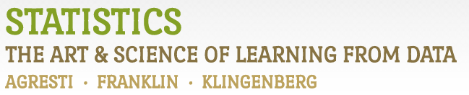

Chapter 2

# Example 3: US Shark Attacks – Pie and Bar Charts

> # Create dataset. I’m including `\n` here for line breaks.

> State <- c('Florida', 'Hawaii', 'South \n Carolina', 'California', 'North \n Carolina', 'Texas', 'Other')

> Frequency <- c(203, 51, 34, 33, 23, 16, 27)

>

> # Create basic pie chart:

> pie(Frequency, labels=State, col=rainbow(7), main='Pie Chart of Shark Attacks')

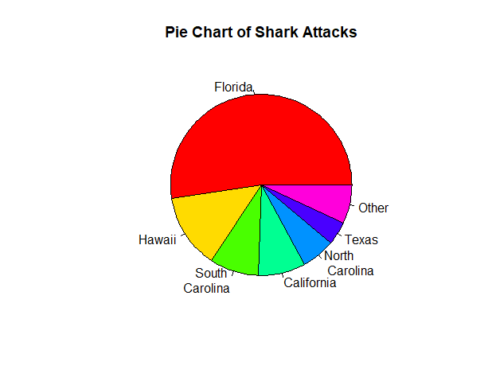

> # Create basic bar graph showing counts:

> barplot(Frequency, names.arg=State, cex.names=0.8, col=rainbow(7), xlab='State', ylab='Frequency', main='Bar Chart of Shark Attacks')

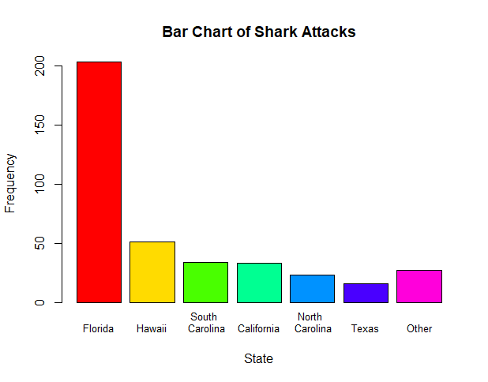

> # Create basic bar graph showing percentages:

> Percent <- 100*(Frequency/sum(Frequency))

> barplot(Percent, names.arg=State, cex.names=0.8, col=rainbow(7), xlab='State', ylab='Percent (%)', main='Bar Chart of Shark Attacks')

