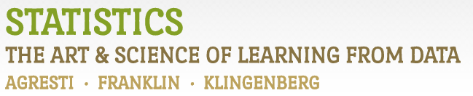

Chapter 2

# Example 4: Health Values of Cereals – Dotplots

> # Read in Sodium values:

> Sodium <- c(0, 340, 70, 140, 200, 180, 210, 150, 100, 130, 140, 180, 190, 160,290, 50, 220, 180, 200, 210)

>

> # Create Dotplot:

> stripchart(Sodium, method="stack", pch=19, ylim=c(0,3), frame.plot=FALSE, xlab="Sodium Content (mg)", main="Dotplot")

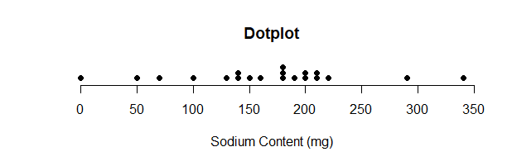

> # You may have to resize the plotting window and then execute the command again for this plot to look nice.

> # You may also have to try different values for ylim

> # A dotplot can be obtained with the ggplot2 library.

> # To install it, type install.packages(ggplot2)

> library(ggplot2)

> ggplot(data.frame(Sodium), aes(x=Sodium)) +

+ geom_dotplot() +

+ labs(x="Sodium Content (mg)", title="Dotplot", subtitle="Sodium Content of 20 Breakfast Cereals") +

+ theme_classic() +

+ theme(axis.line.y=element_blank(),

+ axis.text.y=element_blank(),

+ axis.ticks.y=element_blank(),

+ axis.title.y=element_blank()

+ )

`stat_bindot()` using `bins = 30`. Pick better value with `binwidth`.

