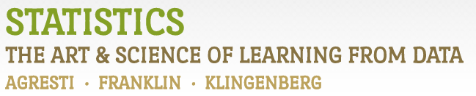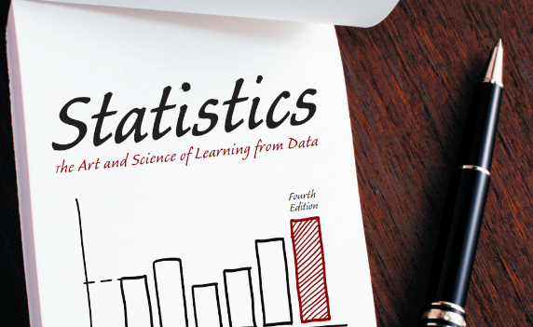

Chapter 2

# Example 6: TV Watching – Histograms

> # Read in data from file:

> GSS <- read.csv(file='https://raw.githubusercontent.com/artofstat/data/master/Chapter2/TVhours.csv')

>

> # Create Histogram:

> hist(GSS$tvhours, xlab="Hours of Watching TV", main="Histogram of the Numbers of Hours Watching TV per Day")



> # For more fine tuning, it is better to use the ggplot2 library.

> # If you haven't installed it already, first type: install.packages(ggplot2)

>

> library(ggplot2)

> # Basic plot:

> ggplot(GSS, aes(x=tvhours)) +

+ geom_histogram(binwidth=1, color="black", fill="orchid") +

+ labs(x="Hours of Watching TV", y="Frequency",

+ title="Histogram of the Numbers of Hours Watching TV per Day",

+ subtitle="Source: General Social Survey 2012") +

+ theme_bw()



> # Plotting percentages rather than counts on the y-axis:

> ggplot(GSS, aes(x=tvhours, y=100*(..count../sum(..count..)))) +

+ geom_histogram(binwidth=1, color="black", fill="orchid") +

+ labs(x="Hours of Watching TV", y="Percent (%)",

+ title="Histogram of the Numbers of Hours Watching TV per Day",

+ subtitle="Source: General Social Survey 2012") +

+ theme_bw()



> # More fine-tuning such as labels on x-axis:

> ggplot(GSS, aes(x=tvhours)) +

+ geom_histogram(center=0, binwidth=1, color="black", fill="orchid") +

+ labs(x="Hours of Watching TV", y="Frequency",

+ title="Histogram of the Numbers of Hours Watching TV per Day",

+ subtitle="Source: General Social Survey 2012") +

+ theme_bw() +

+ scale_y_continuous(limits=c(0,350), breaks=seq(0,350,50), expand=c(0,0)) +

+ scale_x_continuous(breaks=seq(0,25,1)) +

+ theme(panel.grid.major.x=element_blank(), panel.grid.minor.x=element_blank())



|  |
| --- |
| > # with percentages rather than counts:  > ggplot(GSS, aes(x=tvhours, y=100*(..count../sum(..count..)))) +  + geom_histogram(center=0, binwidth=1, color="black", fill="orchid") +  + labs(x="Hours of Watching TV", y="Percent (%)",  + title="Histogram of the Numbers of Hours Watching TV per Day",  + subtitle="Source: General Social Survey 2012") +  + theme_bw() +  + scale_y_continuous(limits=c(0,26), breaks=seq(0,25,5), expand=c(0,0)) +  + scale_x_continuous(breaks=seq(0,25,1)) +  + theme(panel.grid.major.x=element_blank(), panel.grid.minor.x=element_blank()) |
|  |
| |  | | --- | |  | |

