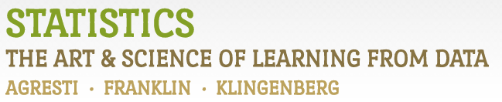

Chapter 2

# Example 7: Health Value of Cereals – Histograms

> # Read in Sodium values:

> Sodium <- c(0, 340, 70, 140, 200, 180, 210, 150, 100, 130, 140, 180, 190, 160,290, 50, 220, 180, 200, 210)

> # Create Basic Histogram:

> hist(Sodium, xlab="Sodium (mg)", ylab="Frequency", main="Distribution of Sodium Values in Cereals", col="tan")

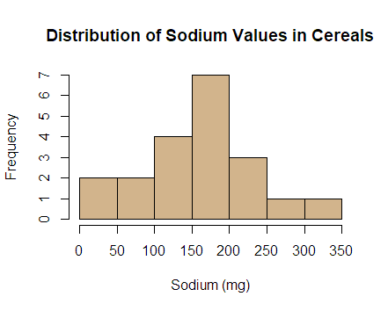

> # Changing the bins by providing the boundaries.

> # (Note: right=FALSE puts an observation such as 120 in the interval from 120-160 and not 80-120)

> hist(Sodium, breaks=seq(0,360,40), right=FALSE, xlab="Sodium (mg)", ylab="Frequency", main="Distribution of Sodium Values in Cereals", col="tan")

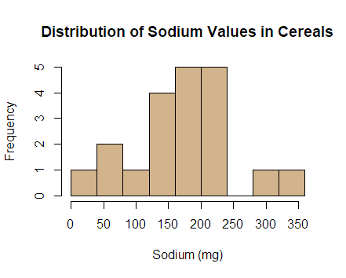

> # Another way to request a certain number of bins:

> hist(Sodium, breaks=10, xlab="Sodium (mg)", ylab="Frequency", main="Distribution of Sodium Values in Cereals", col="tan")



> # Too few breaks:

> hist(Sodium, breaks=2, xlab="Sodium (mg)", ylab="Frequency", main="Distribution of Sodium Values in Cereals", col="tan")

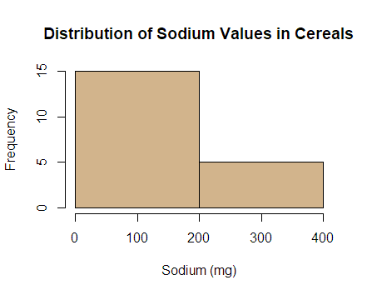

> # Too many breaks:

> hist(Sodium, breaks=30, xlab="Sodium (mg)", ylab="Frequency", main="Distribution of Sodium Values in Cereals", col="tan")

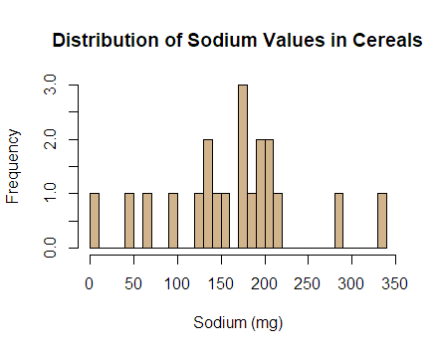

> # For more fine tuning, it is better to use the ggplot2 library.

> # If you haven't installed it already, first type: install.packages(ggplot2)

> library(ggplot2)

> # Adjusting x-axis labels:

> ggplot(data.frame(Sodium), aes(x=Sodium)) +

+ geom_histogram(breaks=seq(0,360,40), color="black", fill="tan") +

+ labs(x="Sodium (mg)", y="Frequency",

+ title="Distribution of Sodium Values in Cereals") +

+ scale_x_continuous(breaks=seq(0,360,40)) +

+ scale_y_continuous(limit=c(0,7), breaks=1:7, expand=c(0,0)) +

+ theme_bw() +

+ theme(panel.grid.minor=element_blank())

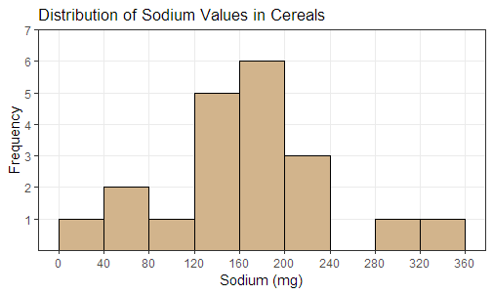

> # Plotting percentages rather than counts on the y-axis:

> ggplot(data.frame(Sodium), aes(x=Sodium, y=100*(..count../sum(..count..)))) +

+ geom_histogram(breaks=seq(0,360,40), color="black", fill="tan") +

+ labs(x="Sodium (mg)", y="Percent (%)",

+ title="Distribution of Sodium Values in Cereals") +

+ scale_x_continuous(breaks=seq(0,360,40)) +

+ scale_y_continuous(limit=c(0,32), breaks=seq(0,30,5), expand=c(0,0)) +

+ theme_classic() +

+ theme(panel.grid.minor=element_blank())

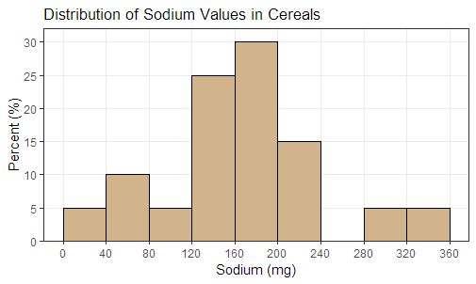

> # R actually defines intervals open to the left and closed to the right

> # To get the histograms perfectly match the ones in the textbook, use closed="left":

> ggplot(data.frame(Sodium), aes(x=Sodium, y=100*(..count../sum(..count..)))) +

+ geom_histogram(breaks=seq(0,360,40), closed="left", color="black", fill="tan") +

+ labs(x="Sodium (mg)", y="Percent (%)",

+ title="Distribution of Sodium Values in Cereals") +

+ scale_x_continuous(breaks=seq(0,360,40)) +

+ scale_y_continuous(limit=c(0,27), breaks=seq(0,25,5), expand=c(0,0)) +

+ theme_classic() +

+ theme(panel.grid.minor=element_blank())

