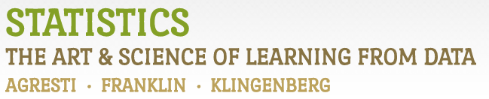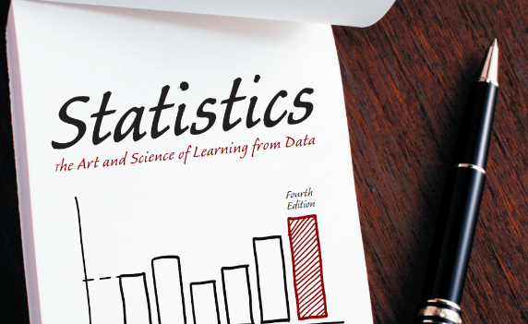

Chapter 2

# Example 9: Warming Trends in NYC – Time Trends

> # Read in dataset (using updated version):

> temps <- read.csv('http://www.artofstats.com/data/chapter2/central_park_yearly_temps_upto2017.csv')

> attach(temps) # so we can refer to variable names

> # Basic Time Plot:

> plot(x=YEAR, y=ANNUAL, type='l', ylab='Average Temperature', main='Annual Average Temperature in Central Park (1869-2017)')

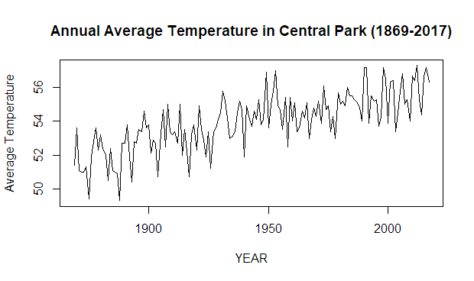

> # Include Points:

> plot(x=YEAR, y=ANNUAL, type='o', pch=19, ylab='Average Temperature', main='Annual Average Temperature in Central Park (1869-2017)')

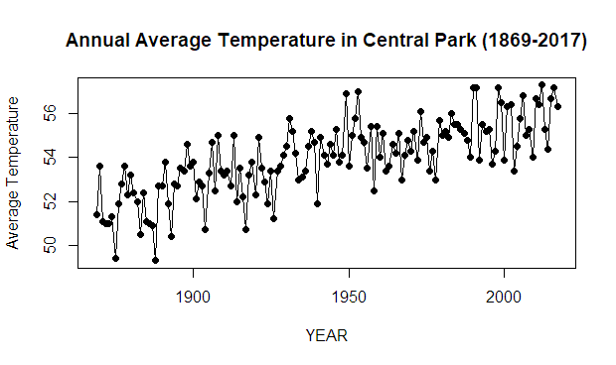

> # Include Smooth Trend Line:

> scatter.smooth(x=YEAR, y=ANNUAL, type='o', pch=19, lpars=list(col='red', lwd=2), ylab='Average Temperature', main='Annual Average Temperature in Central Park (1869-2017)')

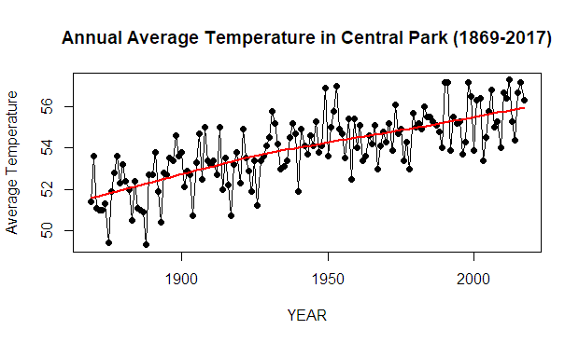

> # For more fine tuning, it is better to use the ggplot2 library.

> # If you haven't installed it already, first type: install.packages(ggplot2)

> library(ggplot2)

> ggplot(data=temps, aes(x=YEAR, y=ANNUAL)) +

+ geom_point(color='blue') +

+ geom_line() +

+ geom_smooth(col='red', fill='orange') +

+ labs(y='Average Temperature', title='Annual Average Temperature in Central Park (1869-2017)') +

+ scale_x_continuous(breaks=seq(min(YEAR),max(YEAR),10)) +

+ theme_bw() +

+ theme(panel.grid.minor.x=element_blank())

`geom_smooth()` using method = 'loess' and formula 'y ~ x'

