ABB_Analog_block
Request

Version 0.1
2016-12-15

Revision History

Date | Version | Author | Comments
2016/12/15 | 0.1 | Song Pan | Initial Version

Content

1 Request 4
2 Block Diagram 5
3 APB interface waveform 5
4 Register mapping 6
5 IO pins list 6

Request
For Sirius project, we need develop one block to control ABB analog block, which is working at 20Mhz with APB interface.
This IP need provide APB master interface to connect NOC system, which is 32bit address space and 32bit data width with little endian.
This IP only have one clock.
This IP only have one asynchronous resetn from PIN_POR_RSTN.

SAR-ADC has 16 channel analog inputs, then mux out only one channel and deal with it. Because the SAR-ADC sample clock frequency is only 9.09Mhz, output data updated rate is very low for CPU access.
It need support 2 work modes. One is SW mode, the other is HW scan mode.
In SW mode, it just reads one data SAR10_DOUT_3[9:0] from register once by the edge of SRA10_DOUT_SYNC_3.
In HW scan mode it stores the data into FIFO(10bit data width) per channel. B14[3:0] register is REG_SAR10_VIN_SEL[3:0] , which is used to select the related sample channel.
When data is ready (ready threshold can be programmed), it generates interrupt for CPU to access. Every channel has separated ready flag or valid data count.
When HW mode is working, SW mode can’t work at all. Default is SW mode.
The max support channel number is 16. The min and default is only 1 channel. It can support select or enable programmed channel number. Based on it, HW scan mode logic will only check the enable channel data and store.
Total data stored FIFO can be shared by 16 channels. When 16 channels is enable, only 8 fifo data per channel. FIFO depth is 16x8.
It needs support 1/2 and 1/4 down sample rates to store the data. It can save longer time data.
Interrupt register definition should include interrupt status register (RO), interrupt mask register(RW), interrupt clear register(RW).

For Temp sensor, just only support SW mode, latch data TS_DOUT into read only register by TS_DATA_VALID(pulse width is 28.16us) as 1.
For PVT sensor, just store PVT_OUT into read only register directly.
All output marked as RO in sirius_inout sheet, connect it to TOP module and latch the value into RO register at the same time.
All Bxx in Sirius_reg sheet, allocate ABB_CORE_REG page register to control. Don’t change the byte offset. Take care the marked RW for read and write both, RO for read only.
All register access is 32 bits align. Don’t support 16bit/8bit access mode.

Block Diagram
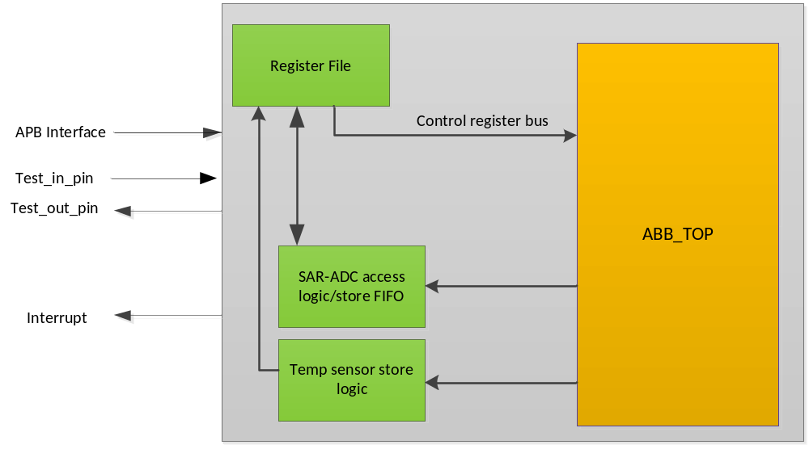

Figure 1 Top connection diagram

APB interface waveform
APB read data waveform with Little endian
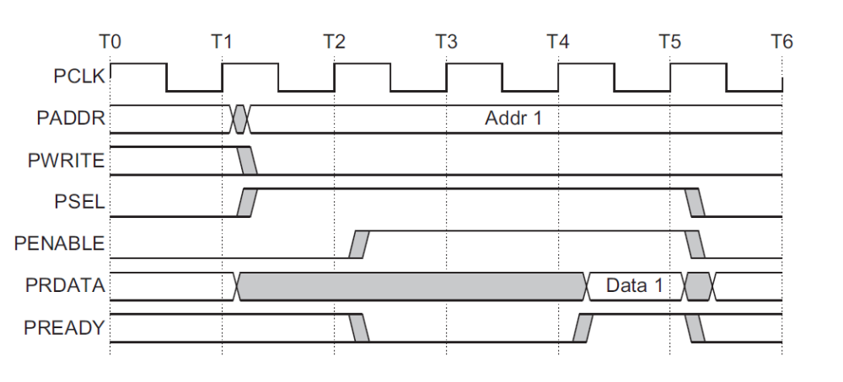

APB write data waveform with Little endian.

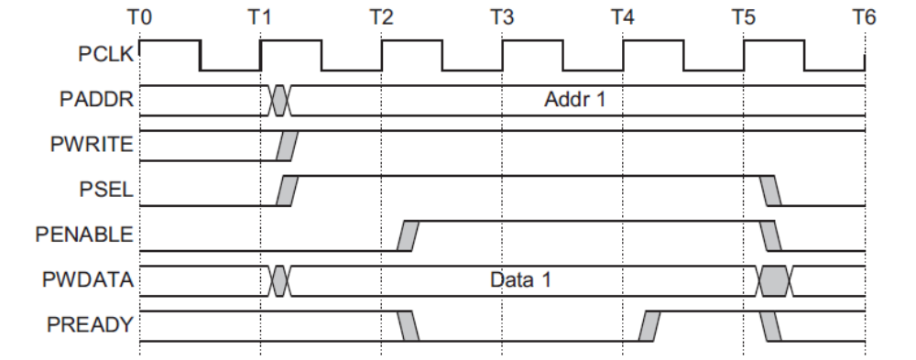

Register mapping
Register mapping includes the below function
Generic name | Description | Space range | Note
ABB_CORE_REG | Control and status register | 0x00 to 0x80
ABB_WRAP_REG | Control and status register | 0x80 to 0xF0 | Include interrupt control/ ADC HW scan mode control

IO pins list
There 16bit test_in from PAD,and 16bit test_out to PAD for ADC / DAC / PLL_CLOCK output ATE test. Other analog module ATE test only goes through register access. Need confirm register access by SPI debugger interface.

