SPI2APB Debug Port
Request

Version 0.2
2016-10-20

Revision History

Date | Version | Author | Comments
2016/10/20 | 0.1 | Song Pan | Initial Version
2016/10/21 | 0.2 | Song Pan | Update SPI with Big endian transaction format

Content

1 Request 4
2 Block Diagram 4
3 SPI Command Format 4
4 APB interface waveform 5

Request
For Sirius project, we need develop one SPI2APB debug port to access whole system register from PC side when CPU/DSP is not ready. It will be easily and simply used to tune DDR/PLL setting bypassing CPU/DSP.
This IP will have one external SPI interface with BIG endian format and clock speed is no more special requirement. Just keep the current 8020 project 10Mhz access speed.
This IP need provide APB master interface to connect NOC system, which is 32bit address space and 32bit data width with little endian.
This IP only have one clock and asynchronous CDC logic is processed by NOC.
This IP only have one asynchronous resetn.

Block Diagram
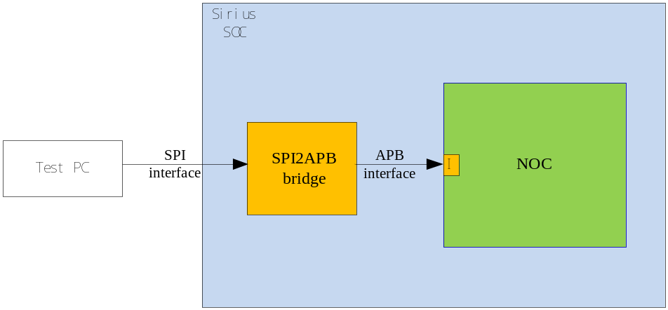

Figure 1 Top connection diagram

Note: different color means different clock domain. NOC will process asynchronous CDC logic.

SPI Command Format
SPI write command format with BIG endian:
8bit command + 32bit write address+ 32bit write data

SPI read command format with BIG endian:
8bit command+32bit read address+ N cycle turnaround time + 32bit read back data
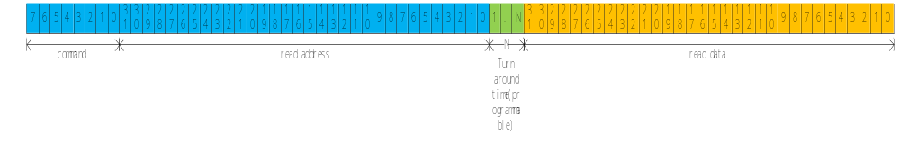

APB interface waveform
APB read data waveform with Little endian
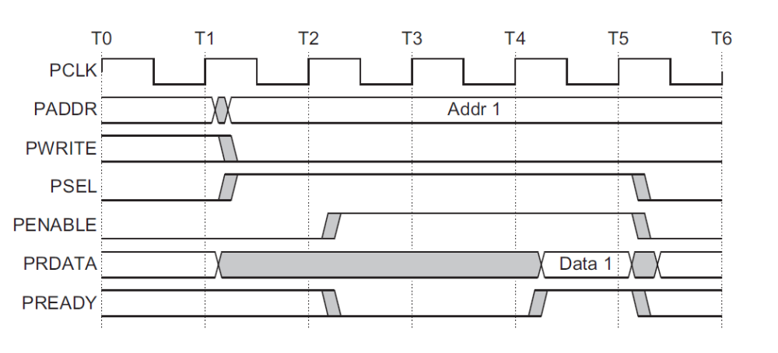

APB write data waveform with Little endian.

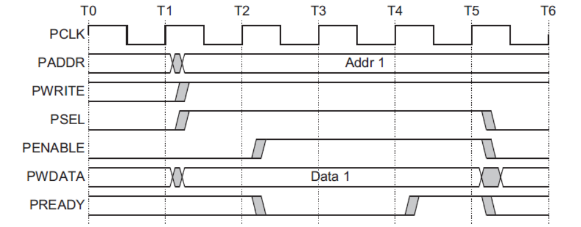

RTL Design
PAD definition:
SPI_MS3_CS0N_PAD – csn
SPI_MS3_SCLK_PAD – sclk
SPI_MS3_DI_PAD – mosi
SPI_MS3_DO_PAD – miso

sclk can be up to 25MHz in simulation.

Write command: 0x1e
Example waveform: write address 0x301c0000, data 0x23323323
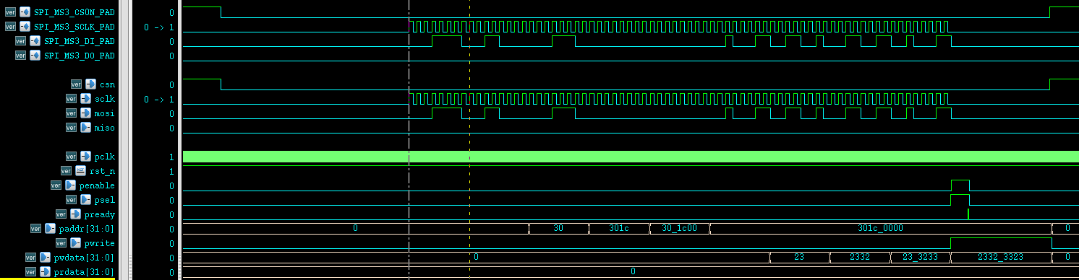

Read command: 0x1f
Turnaround time need to be larger than 700ns and should not generate sclk during turnaround time.
Example waveform: read address 0x301c0000
