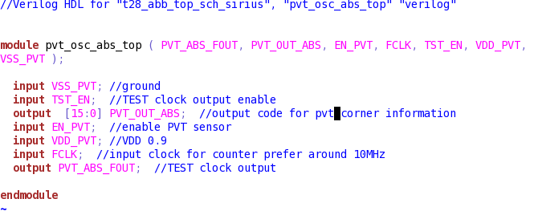

|  |  |  |  |
| --- | --- | --- | --- |
| corner | TT_30_0.9V | SS_-40_0.81V(slowest) | FF_-40_0.99V(fastest) |
| PVT_OUT_ABS(DEC) | 89 | 213 | 60 |

|  |  |  |  |  |  |
| --- | --- | --- | --- | --- | --- |
| In/out | Pin name | Effective bits | Description | Default value | WR/RO |
| Input | VSS_PVT |  |  |  |  |
| input | TST_EN |  |  | 1’b0 | WR |
| Output | PVT_OUT_ABS | [15:0] |  |  | RO |
| Input | EN_PVT |  |  | 1’b0 | WR |
| Input | VDD_PVT |  |  |  |  |
| input | FCLK |  |  |  |  |
| output | PVT_ABS_FOUT |  |  |  |  |