# HEVC Codec Input/Output Pixel Format

## 1 Source_Frame Input Video Format

### 1.1 Source Frame Format

Hevc encoder frame format is configured by CMD_ENC_SRC_FORMAT[2:0](0x00000184).

#### Planar

4:2:2 planar , Y/U/V(3-plane)分开存放，每两个水平Y采样点，有一个Cb和一个Cr采样点

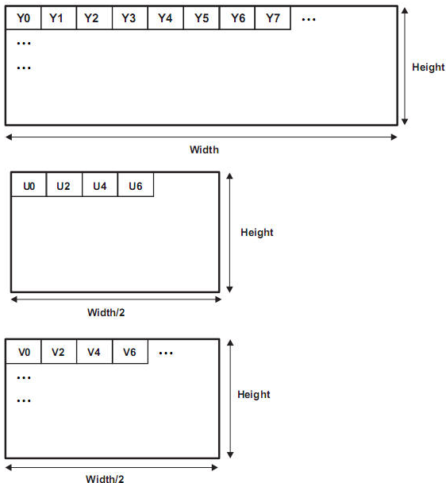

4:2:0 planar 跟YUV422 Planar 类似，但对于Cb和Cr的采样在水平和垂直方向都减少为2:1

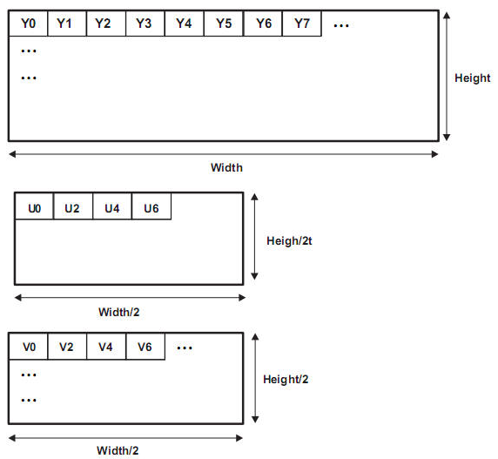

#### Tiled Sub-CTU frame map

Within a sub-CTU(32x32), the first row of 16x32 is read in vertical direction and then the second row of 16x32 is read .

#### 1.1.2 CbCr interleaved (NV12/ semi-planar) (NV21 belong to YUV420 ???)

4:2:2 semi-planar,跟YUV422 Planar的一样，但是U、V是交叉存放的(NV12,2-plane)

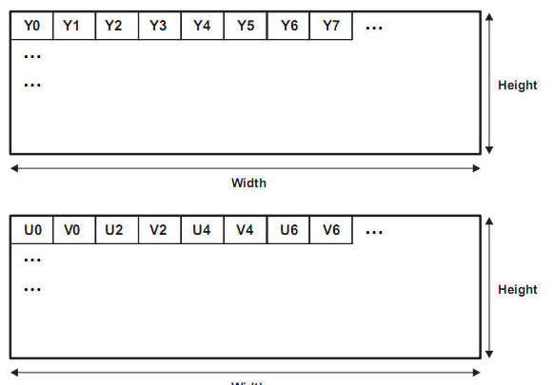

4:2:0 semi-planar, 跟YUV420 Planar的一样，但是U、V是交叉存放的(NV12,2-plane)

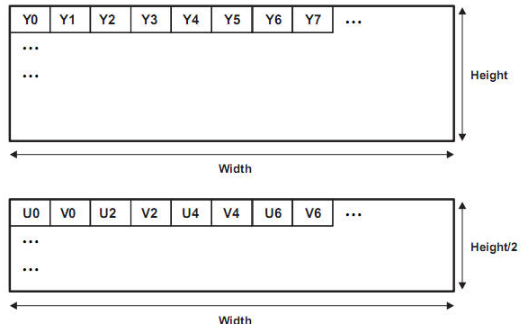

#### 1.1.3 CrCb interleaved (NV21/ semi-planar)

与1.1.2 CbCr interleaved 类似，只是交叉存放时是以CrCb方式存放(NV21, 2-plane)

#### 1.1.4 Packed mode (YUYV)

与1.1.6 UYVY packed 模式类似, 1-plane

#### 1.1.5 Packed mode (YVYU)

与1.1.6 UYVY packed 模式类似, 1-plane

#### 1.1.6 Packed mode (UYVY)

这个格式的数据量跟YUV422 Planar的一样，但是Y、U、V是交叉打包存放的, 1-plane

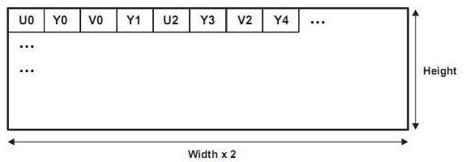

#### 1.1.7 Packed mode (VYUY)

与1.1.6 UYVY packed 模式类似, , 1-plane

### 1.2 Source Pixel Format

Src Pixel Format is configured by CMD_ENC_SRC_FORMAT[5:3](0x00000184).

#### 1.2.1 Register Setting

[4:3]

0: 8bits

1: 16bits(1pix/2byte)

2: 32bits(3pix/4byte)

[5]

Left justified

#### 1.2.2 pixel packing format

0: 8bit mode

1: 16bit mode – LSB padding

2: 16bit mode – MSB padding

3: 32bit mode – LSB padding

4: 32bit mode – MSB padding

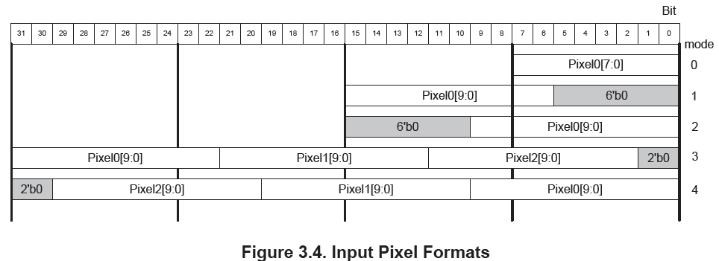

### 1.3 Source Endian

HEVC uses only 16-byte aligned access through the AXI bus interface and support 16 endian mode when transferring data through the interface.

#### 1.3.1 Read and Write operation with Endian mode

Eg: Mem[ADDR] = 0xFFEEDDCCBBAA99887766554433221100, ADDR[3:0] is always 4’d0;

The data ordering in Data[127:0] are as followings with 16 endian mode .

#### 1.3.1.0 Little Endian

Endian_Mode = 4’b0000 (128bit Little Endian)

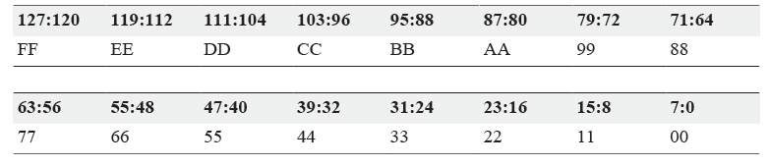

#### 1.3.1.1 Bit Endian

Endian_Mode = 4’b1111 (128bit Big Endian)

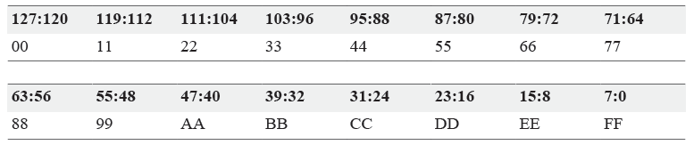

#### 1.3.1.2 Others Endian mode

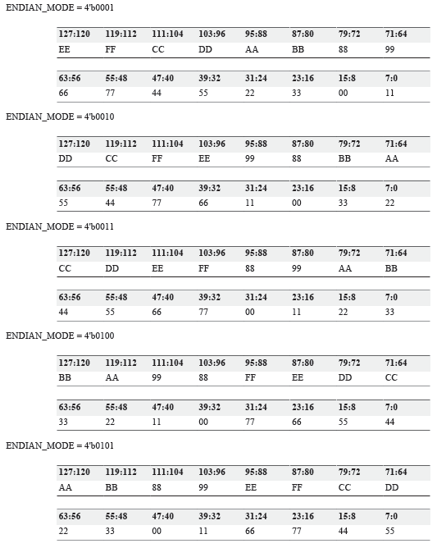

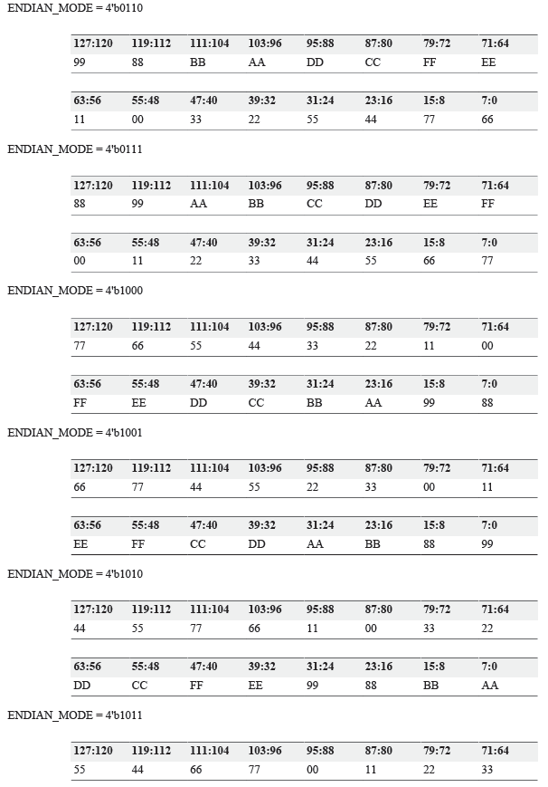

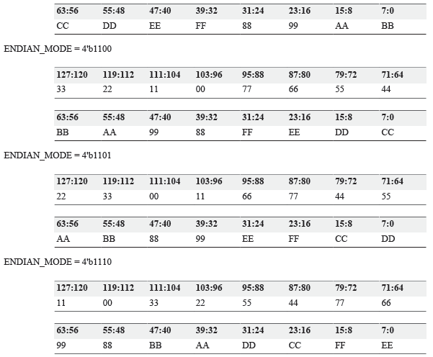

### 1.4 Map type

Linear map

### 1.5 Sampling Format

4:2:2 / 4:2:0

### 1.6 Alignment/Stride

#### 1.6.1 Alignment

亮度Luma Frame buffer基地址以16byte 对齐

色度 Cb frame buffer 基地址以16byte 对齐

色度 CR frame buffer 基地址以16byte 对齐

Note:



#### 1.6.2 Stride

Luma/Chroma Stride 必须是16的倍数

#### 1.6.2.1 Luma stride calculate

|  |  |  |  |  |
| --- | --- | --- | --- | --- |
| Pix_format  sample | 8bit | 10bit  (1pix/2Byte) | 10bit  (3pix/4Byte) | Packed  (4:2:2) |
| 4:2:0 | Align32(Width) | Align32(Width)*2 | Max(Lumastride,  ChromaStride)  *(Refer: Note 3) |  |
| 4:2:2 | Align32(Width) | Align32(Width)*2 | *(Refer: Note 4) |

Note: 1> Linear_Frame_Map

2> Width = (SrcFrameWidth + 7) & ~7 ;

Height = (SrcFrameHeight + 7) & ~7;

3> In case 420_p10_32bit or 422_p10_32bit

Width_tmp = Align32(Width);

lumaStride = ((Align16(Width_tmp)+11)/12)*16 ;

chromaStride = ((Align16(Width_tmp /2)+11)*(cbcr_interleave ? 2 : 1)/12)*16 ;

lumaStride = cbcr_interleave ? MAX(luamStride,chromaStride) : lumaStride ;

4> In Packed case

|  |  |  |  |
| --- | --- | --- | --- |
| packed  Pix_format | YUYV/YVYU  UYVY/VYUY | YUYV_16bit/YVYU_16bit  UYVY_16bit/VYUY_16bit | YUYV_32bit/YVYU_32bit  UYVY_32bit/VYUY_32bit |
| 8bit | Align32(Width)*2 | ----- | ----- |
| 10bit | ----- | Align32(Width)*4 | Align32(Width*2)*2 |

#### 1.6.2.2 Chroma stride calculate

## 2 Codec IP Source Frame Requirement in Sirius

### 2.0 Codec IPS

Codec IPs includes H264/HEVC/JPEG Codec and Display .

### 2.1 Endian Mode

Little Endian Mode

Eg: 128bit Little Endian

Mem[ADDR] = 0xFFEEDDCCBBAA99887766554433221100



### 2.2 Pixel Format

8bit mode : 1pixel/per byte

10bit mode: 1pixel/2 bytes (LSB/MSB 待定)

3pixel/4 bytes (LSB/MSB 待定)

12bit mode: 1pixel/2 bytes (JPEG待定)

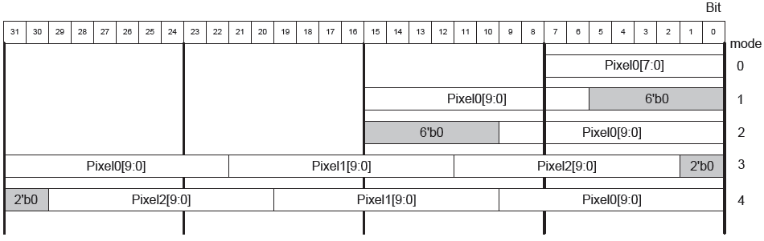

### 2.2 YUV Frame Format

Planar Mode

Cb/Cr Interleave mode

### 2.3 YUV Down sampling(4:4:4 -> 4:2:2 -> 4:2:0)

#### 2.3.1 YUV4:4:4

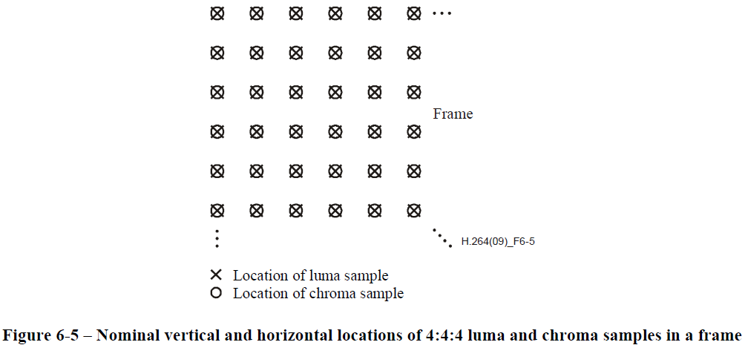

#### 2.3.2 YUV4:2:2

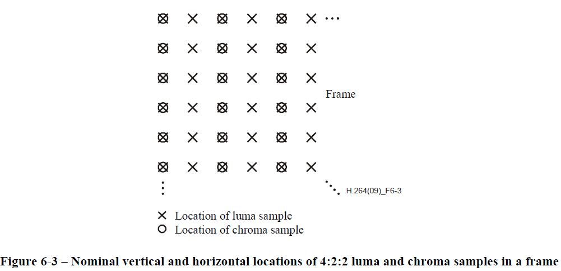

#### 2.3.3 YUV4:2:0

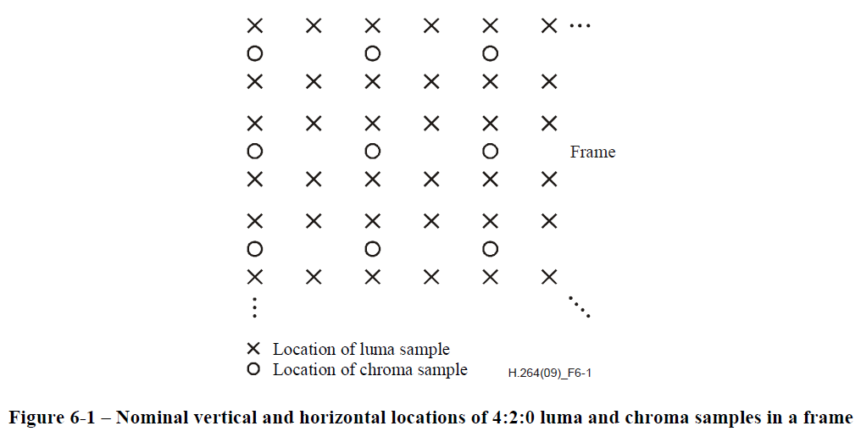

### 2.4 HEVC YUV Data Format in DDR

#### 2.4.1 Planar Mode Mapping



Note:

1> Y/Cb/Cr Base Addr is configurable by register

2> Luma/Chroma Stride is configurable by register

3> Cb_Height = (Sampling mode == 4:2:2 ? Height : Height/2 ); //Cr_Height = Cb_Height

#### 2.4.2 Cb/Cr Interleave Mode Mapping



Note:

1> Y/Cb/Cr Base Addr is configurable by register

2> Luma/Chroma Stride is configurable by register

3> Cb_Height = (Sampling mode == 4:2:2 ? Height : Height/2 ); //Cr_Height = Cb_Height

### 2.6 RGB2YUV

### 2.5 Optional Feature

⑴ Sampling mode 4:0:0

⑵ Big Endian mode

⑶ 4:2:2 Packed Frame format

⑷ Sampling mode 4:4:0 (jpeg)

⑸

⑹ sampling in Top and Bottom Fields

4:2:0 Top and Bottom Fields sampling

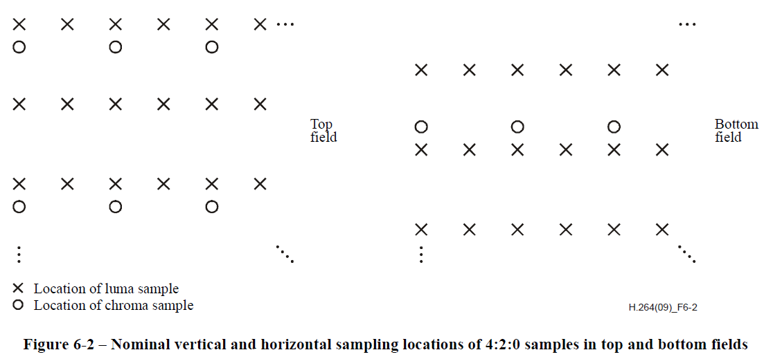

4:2:2 Top and Bottom Fields sampling

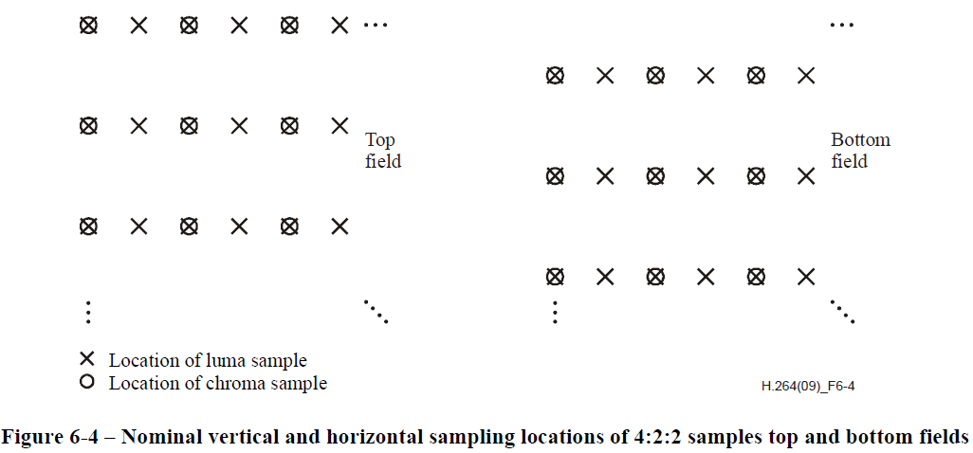

4:4:4 Top and Bottom Fields sampling

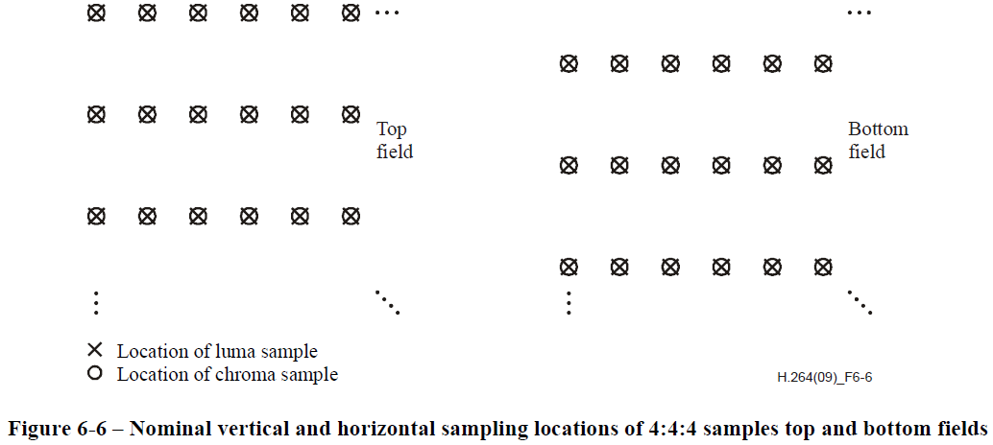

## 3 HEVC Codec Input/Output Pixel Format

### 3.1 HEVC Encoder Source Input Format

3.1.1 Pixel packing format

--0: 8bit pixel mode

--1: 10bit-pixel in 2bytes(1P2B)- right aligned

--5: 10bit-pixel in 2bytes(1P2B) - left aligned

--2: Three 10bit-pixels in 4bytes(3P4B) - right aligned

--6: Three 10bit-pixels in 4bytes(3P4B) - left aligned

Note: Configurable with one of 16 endianness modes





### 3.2 HEVC Decoder Output Pixel Format

