1. PLL_CFG

Example:

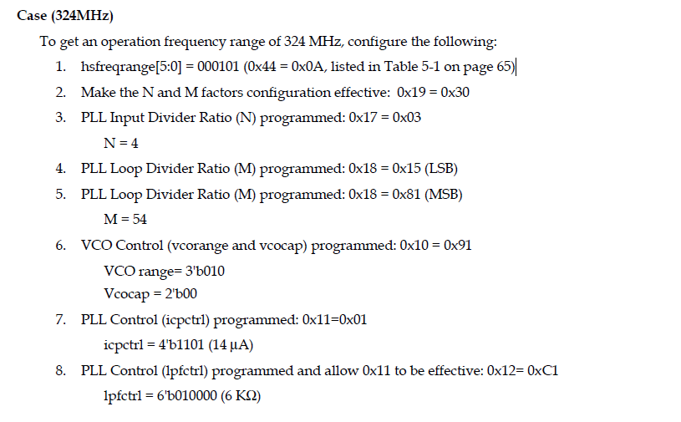

Note: <phy_reset=0&&phy_shutdown=0>, testclr< high pluse>

1,hsfreqrange;

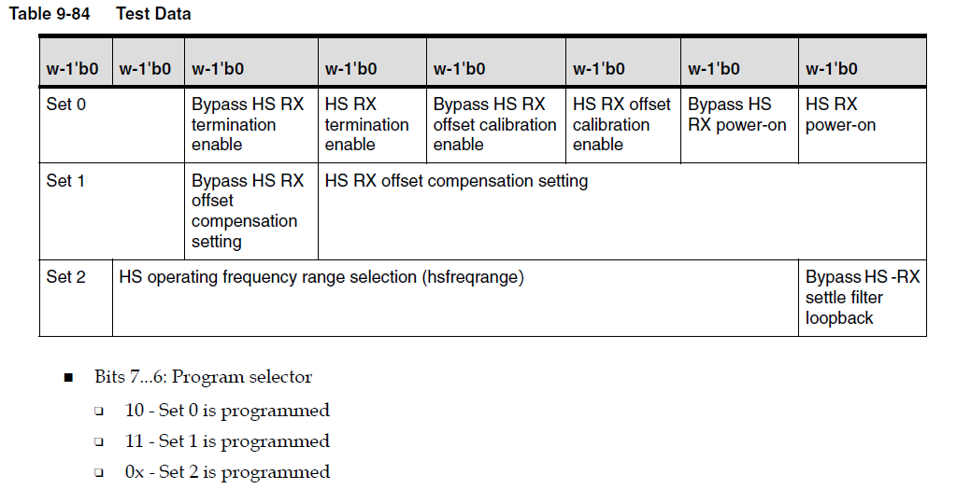

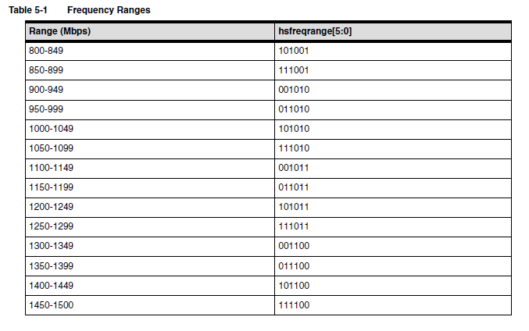

2,N/M;

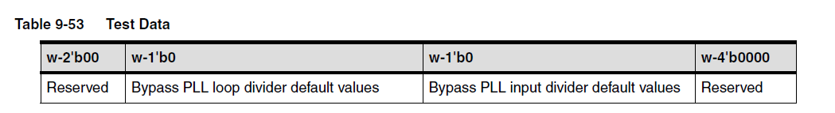

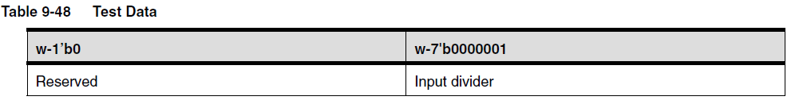

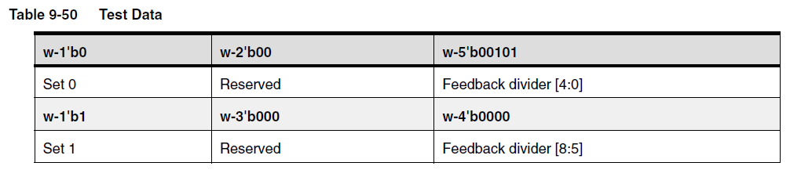

3. vcorange/vcocap/icpctrl/lpfctrl

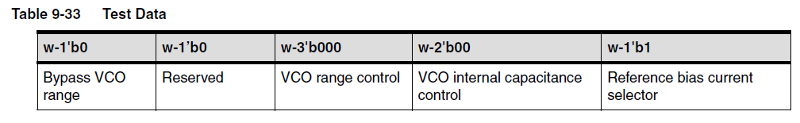

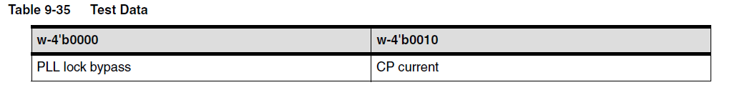

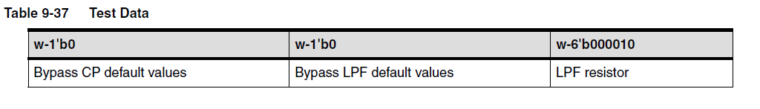

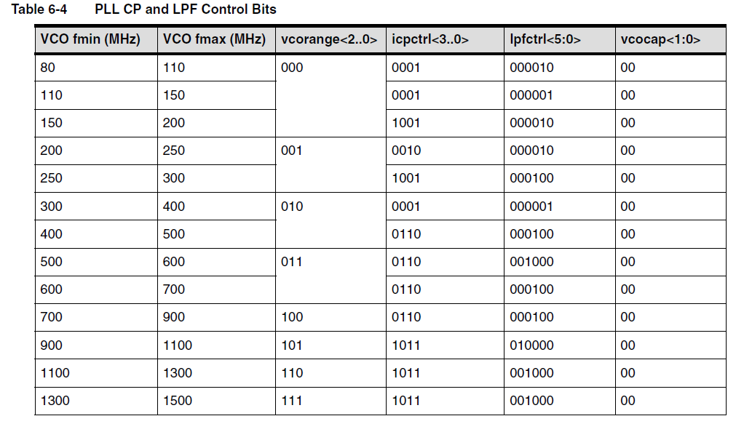

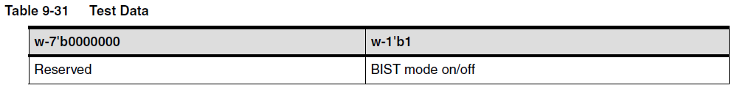

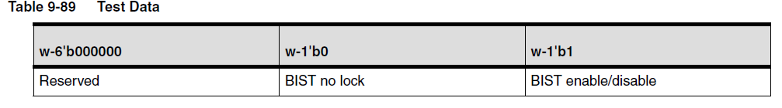

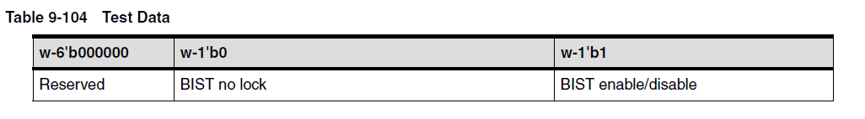

**HOST_CFG/**

**Number of lanes/interrupt/data_type/sync_feathers/timing_mode/has/hbp/hfp/**