DAM MONITORING SYSTEM

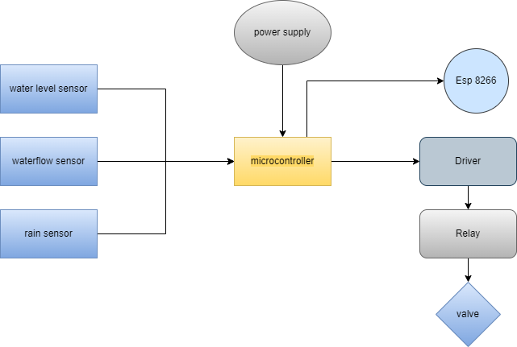

Block Diagram

Water Level sensor:

* By controlling resistance, a potentiometer can determine how much current flows through a circuit

Water Flow Sensor:

* water flows through the rotor and rotor rolls.
* speed changes with different rate of flow.
* The hall-effect sensor outputs the corresponding pulse signal.

Rain Sensor:

* This sensor is a resistive dipole.
* Based on the moisture it shows the resistance.
* It shows more resistance when it is dry and shows less resistance when it is wet

Microcontroller:

* PIC microcontroller
* High performace RISC cpu.
* Very Fast.
* Power consumption less.
* Easy programming.

Esp 8266:

* Low cost micro wifi chip.
* RISC processor.

Driver:

* Used to control another circuit or component.

Relay:

* Electrically operated Switch.
* Controlls valve.