Artsiom Losich, 454

A&P, Lab. 3A

Task 1

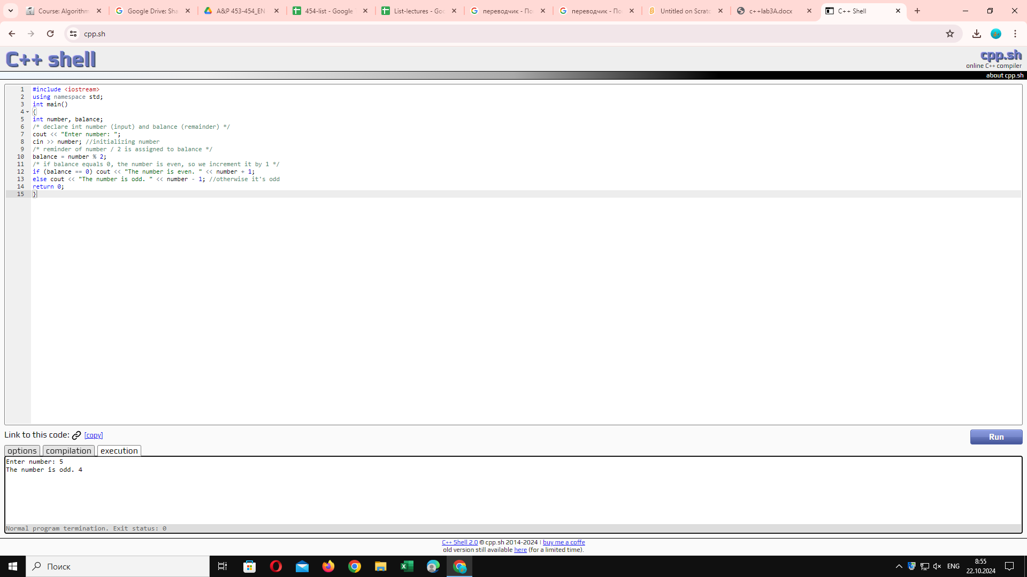

Task 2

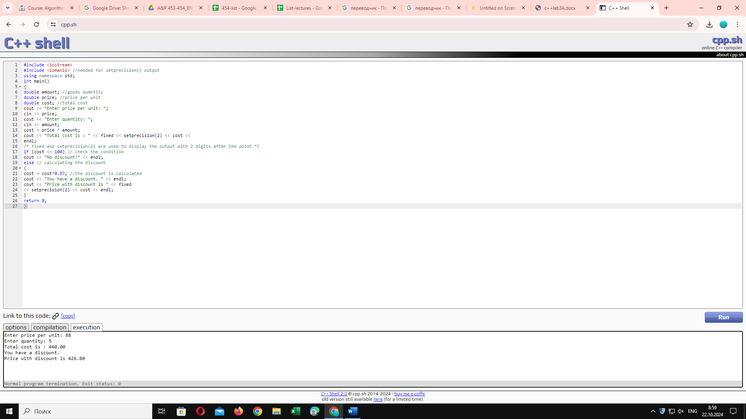

Task 3

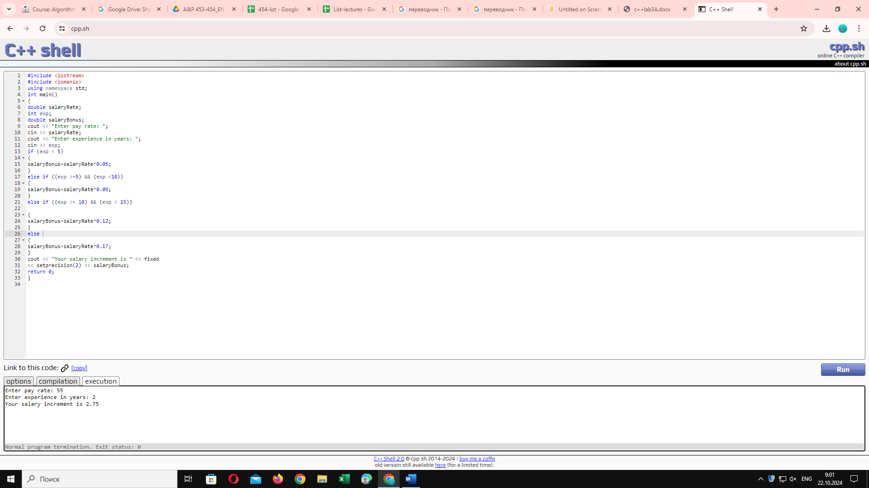

Task 4

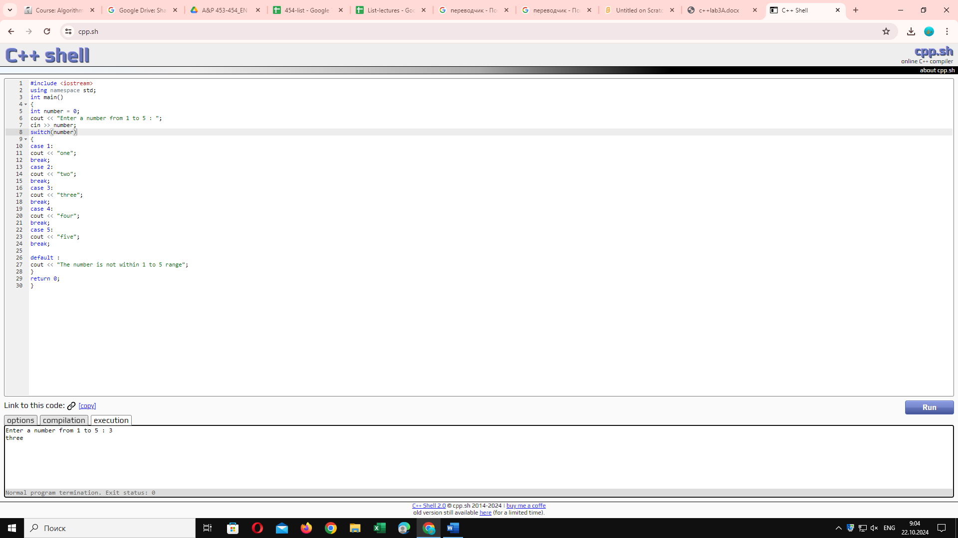

Task 5.1

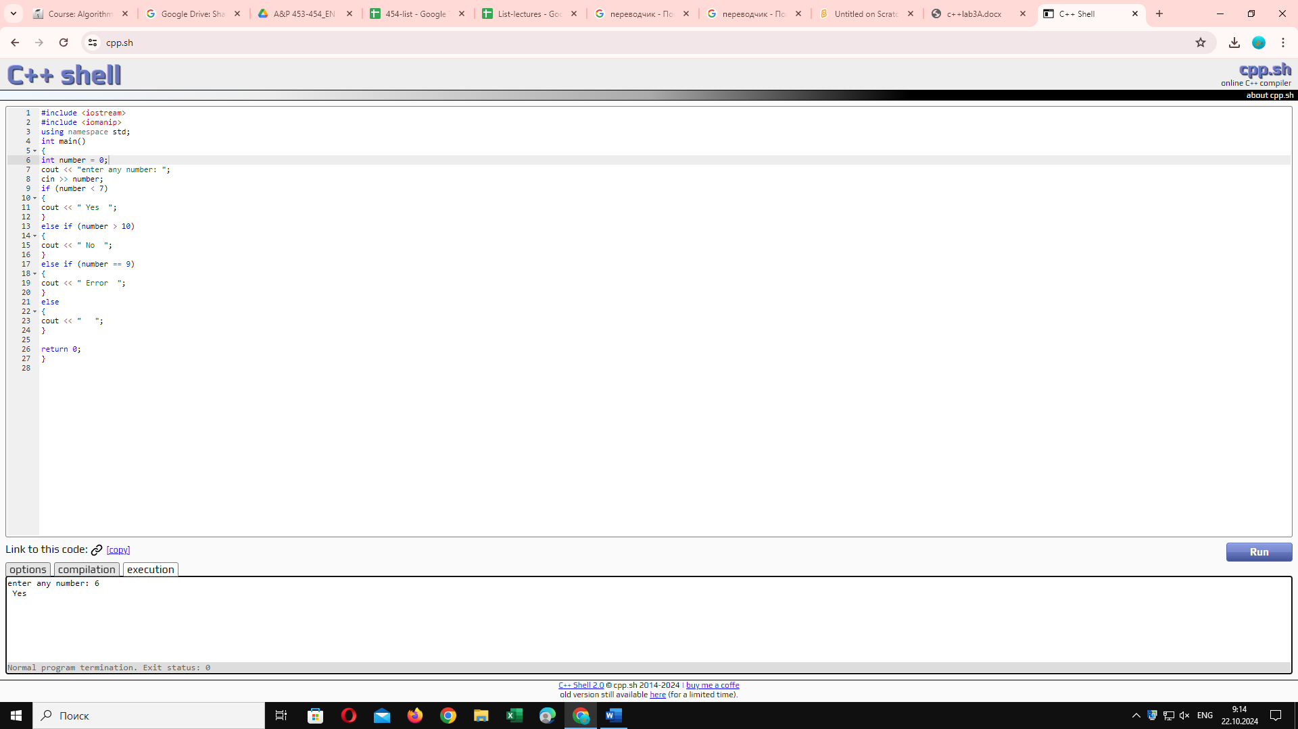

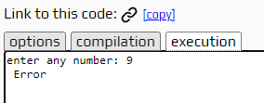

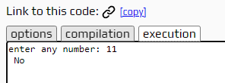

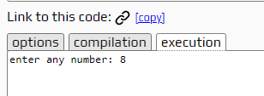

Task 5.2

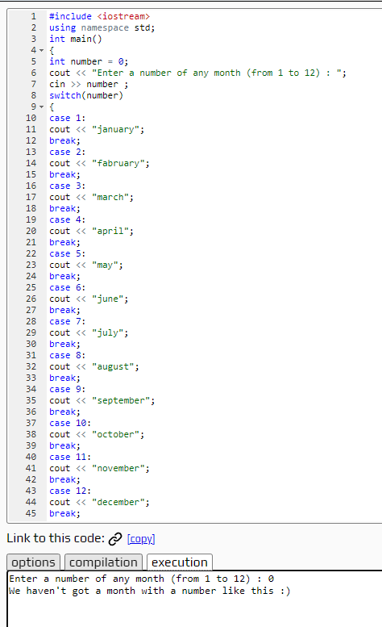

#include <iostream>

using namespace std;

int main()

{

int number = 0;

cout << "Enter a number of any month (from 1 to 12) : ";

cin >> number ;

switch(number)

{

case 1:

cout << "january";

break;

case 2:

cout << "fabruary";

break;

case 3:

cout << "march";

break;

case 4:

cout << "april";

break;

case 5:

cout << "may";

break;

case 6:

cout << "june";

break;

case 7:

cout << "july";

break;

case 8:

cout << "august";

break;

case 9:

cout << "september";

break;

case 10:

cout << "october";

break;

case 11:

cout << "november";

break;

case 12:

cout << "december";

break;

default :

cout << "We haven't got a month with a number like this :)";

}

return 0;

}

Task 5.3

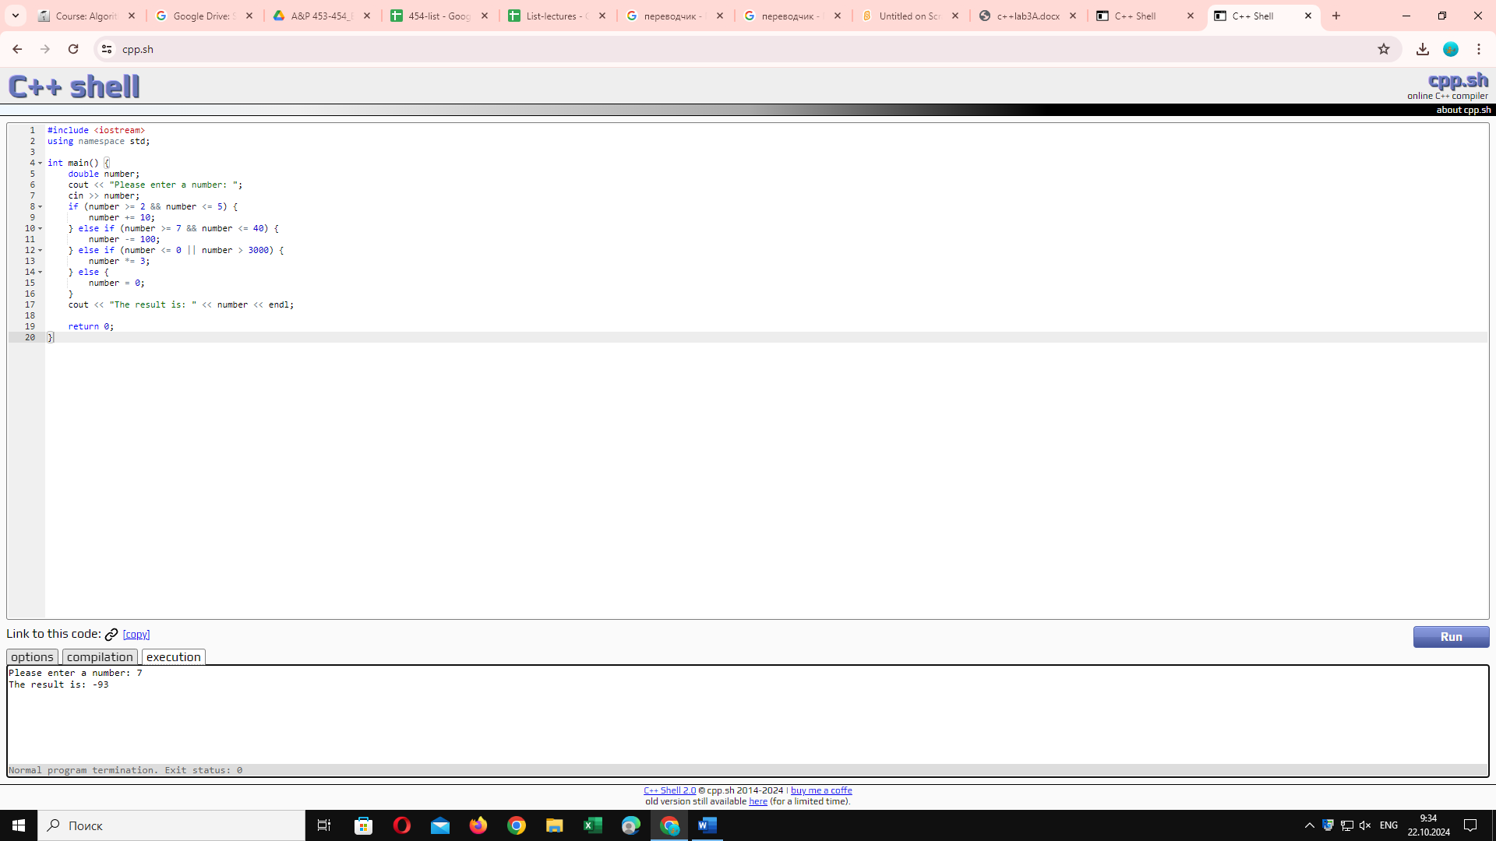

#include <iostream>

#include <iomanip>

using namespace std;

int main() {

double number;

cout << "Please enter a number: ";

cin >> number;

if (number >= 2 && number <= 5) {

number += 10;

} else if (number >= 7 && number <= 40) {

number -= 100;

} else if (number <= 0 || number > 3000) {

number \*= 3;

} else {

number = 0;

}

cout << "The result is: " << number << endl;

return 0;

}

Task 6

Everything was clear. The problems in task 5 were exciting.

BONUS TASK

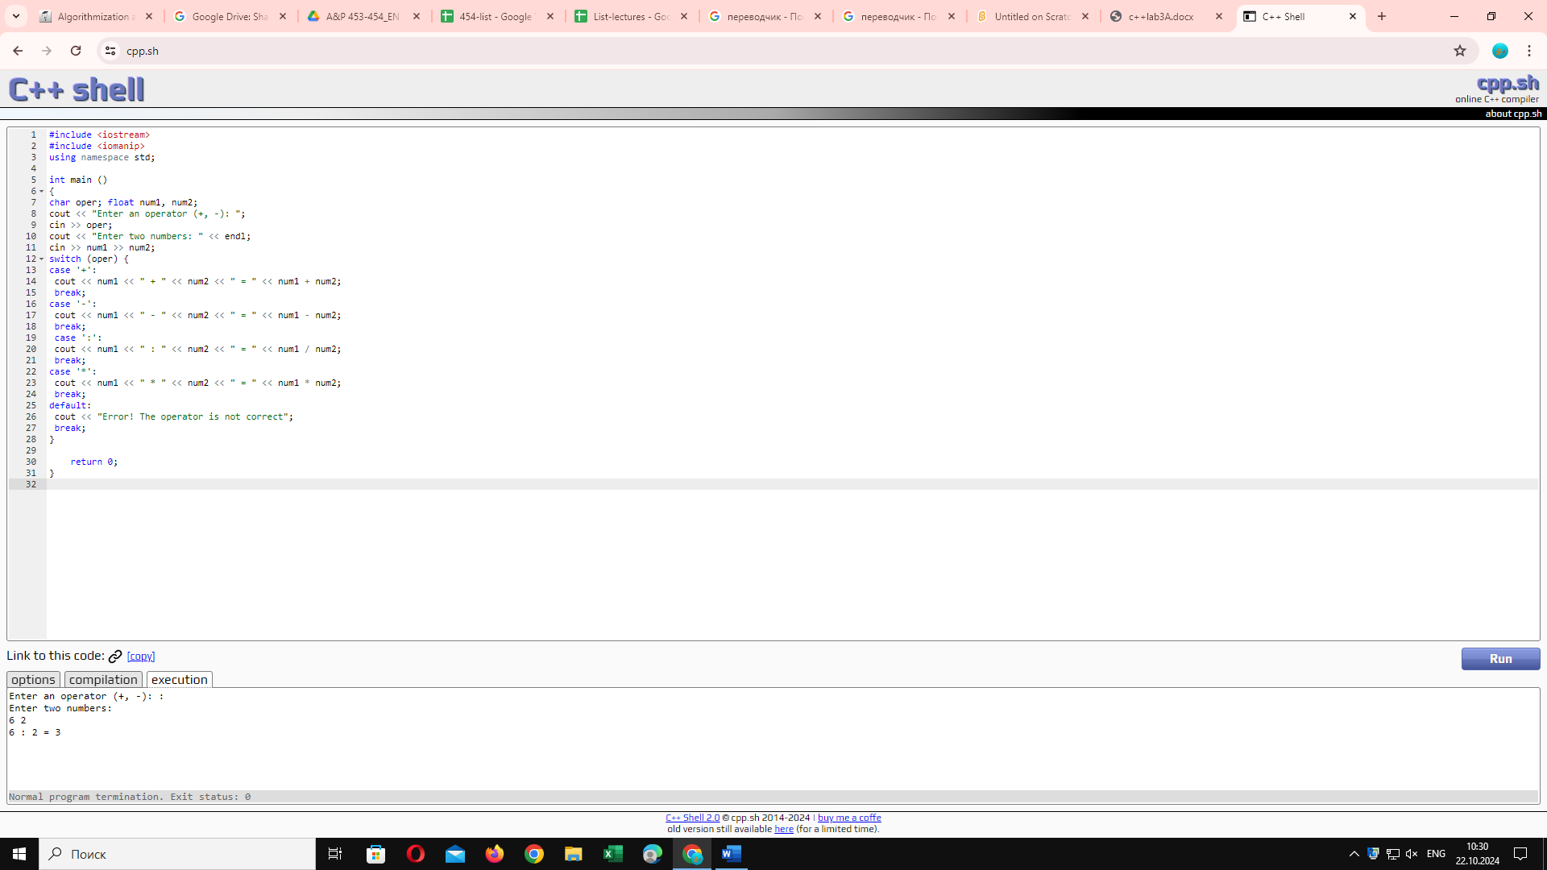

#include <iostream>

#include <iomanip>

using namespace std;

int main ()

{

char oper; float num1, num2;

cout << "Enter an operator (+, -, \*, :): ";

cin >> oper;

cout << "Enter two numbers: " << endl;

cin >> num1 >> num2;

switch (oper) {

case '+':

cout << num1 << " + " << num2 << " = " << num1 + num2;

break;

case '-':

cout << num1 << " - " << num2 << " = " << num1 - num2;

break;

case ':':

cout << num1 << " : " << num2 << " = " << num1 / num2;

break;

case '\*':

cout << num1 << " \* " << num2 << " = " << num1 \* num2;

break;

default:

cout << "Error! The operator is not correct";

break;

}

return 0;

}