Artsiom Losich, 454

Lab 3B, A&P

Task 1

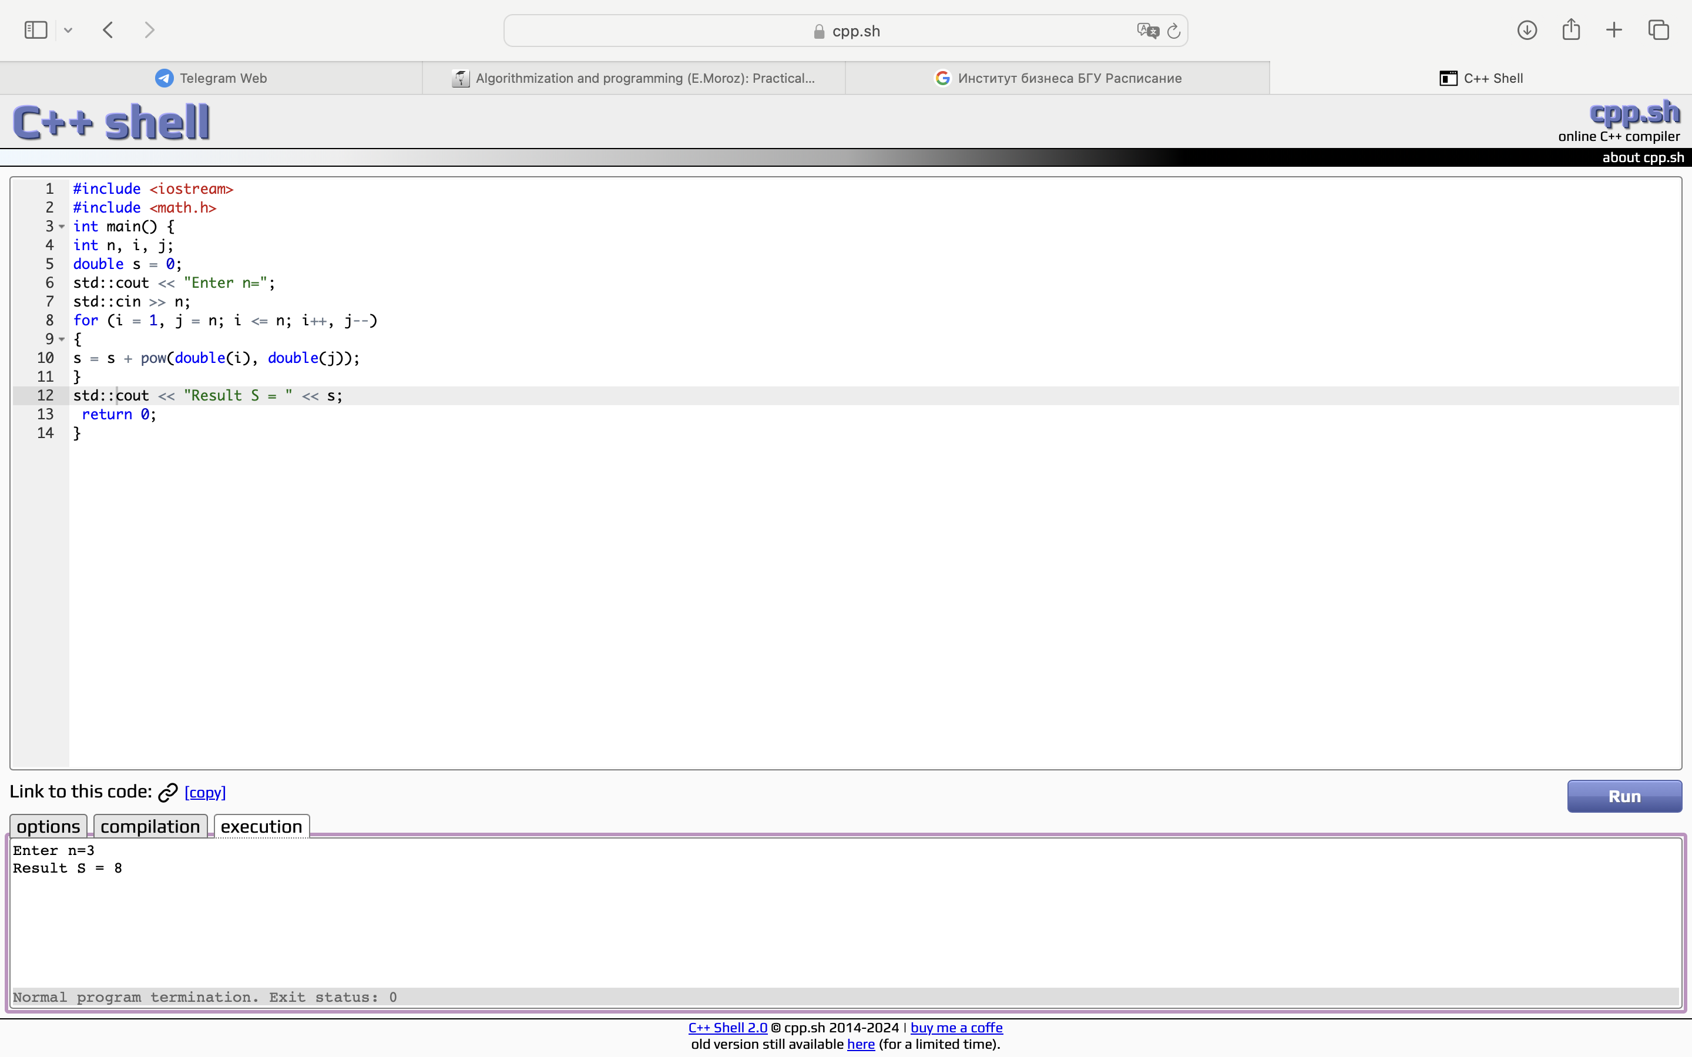

Task 2

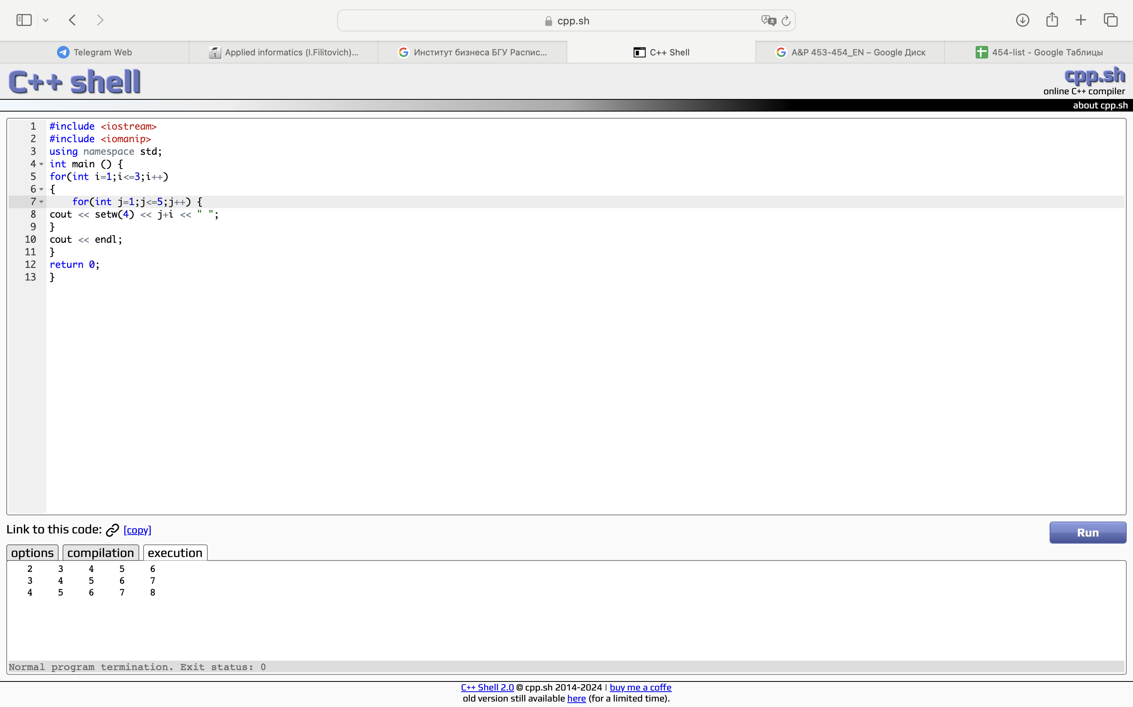

Task 3

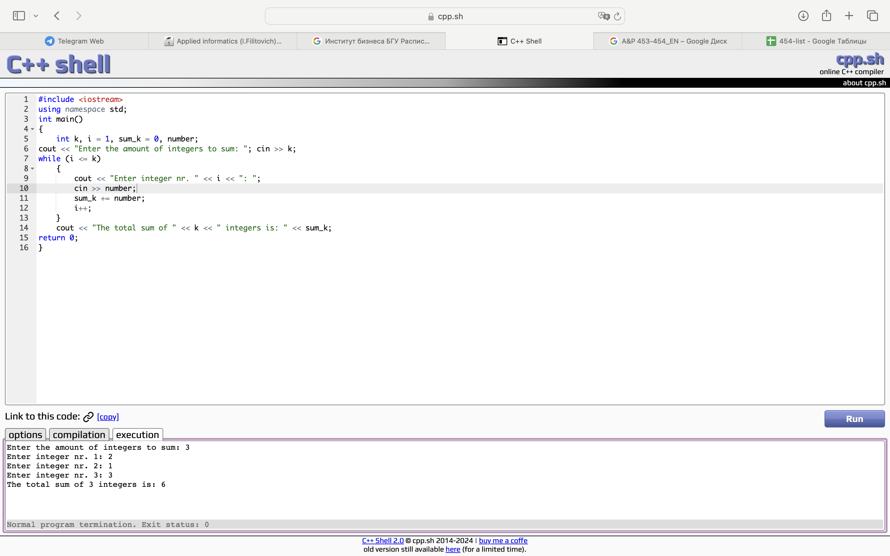

Task 4.1

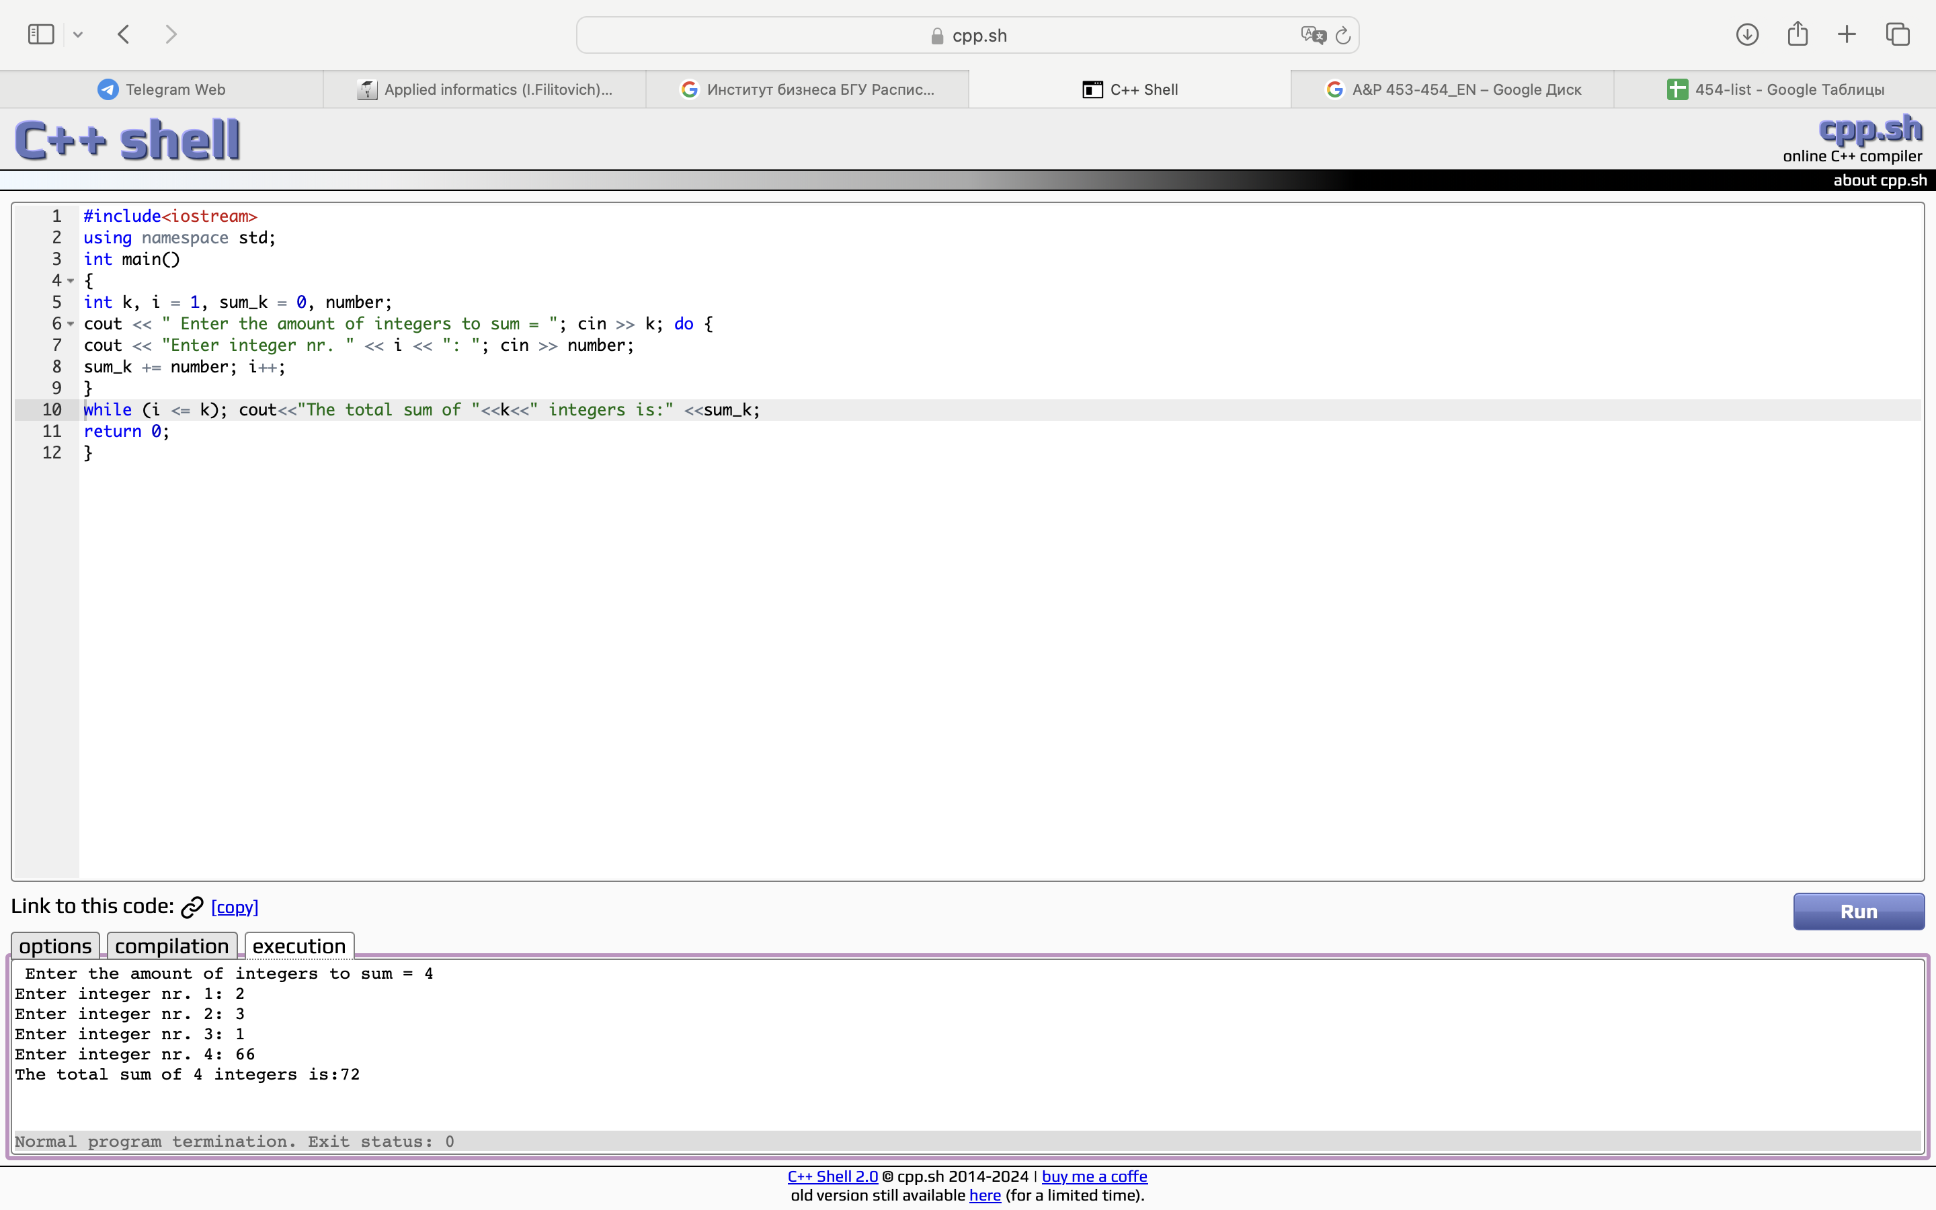

Task 4.2

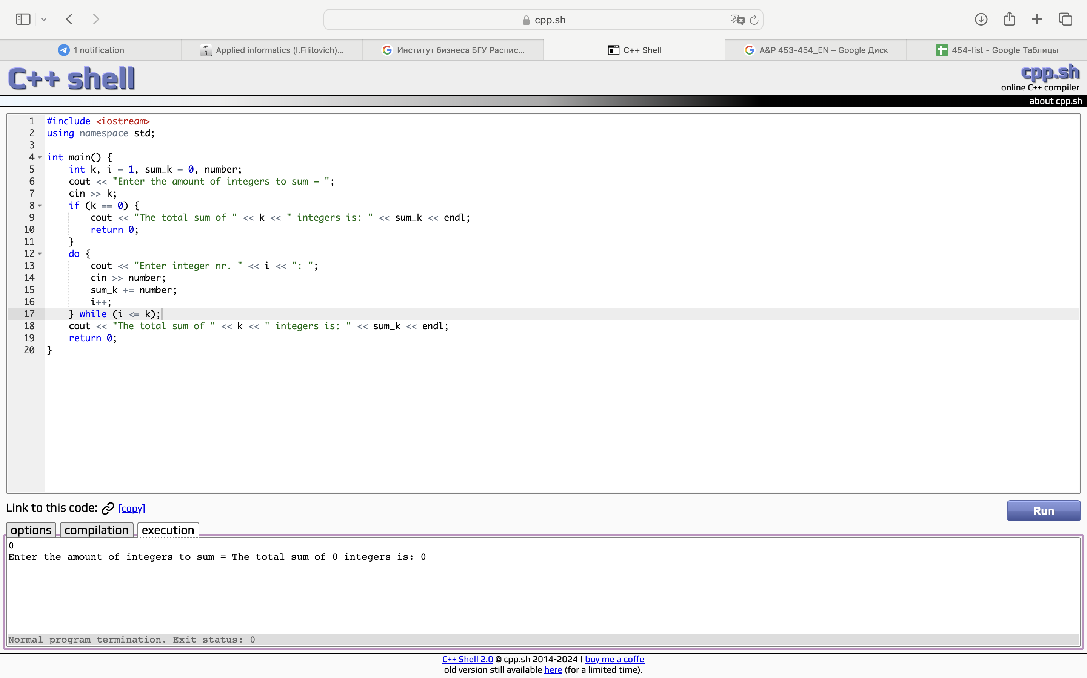

#include <iostream>

using namespace std;

int main() {

int k, i = 1, sum_k = 0, number;

cout << "Enter the amount of integers to sum = ";

cin >> k;

if (k == 0) {

cout << "The total sum of " << k << " integers is: " << sum_k << endl;

return 0;

}

do {

cout << "Enter integer nr. " << i << ": ";

cin >> number;

sum_k += number;

i++;

} while (i <= k);

cout << "The total sum of " << k << " integers is: " << sum_k << endl;

return 0;

}

Task 4.3

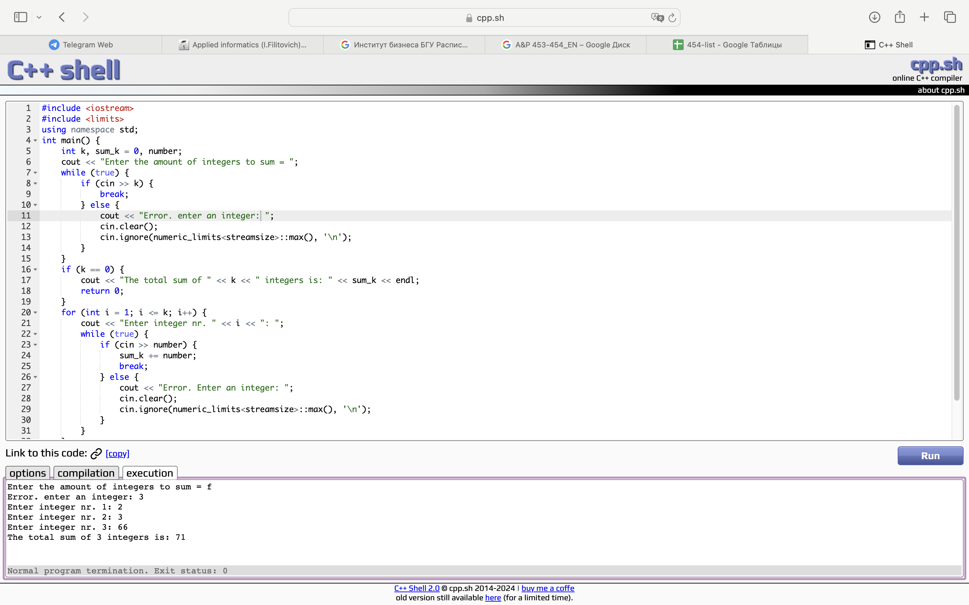#include <iostream>

#include <limits>

using namespace std;

int main() {

int k, sum_k = 0, number;

cout << "Enter the amount of integers to sum = ";

while (true) {

if (cin >> k) {

break;

} else {

cout << "Error. enter an integer: ";

cin.clear();

cin.ignore(numeric_limits<streamsize>::max(), '\n');

}

}

if (k == 0) {

cout << "The total sum of " << k << " integers is: " << sum_k << endl;

return 0;

}

for (int i = 1; i <= k; i++) {

cout << "Enter integer nr. " << i << ": ";

while (true) {

if (cin >> number) {

sum_k += number;

break;

} else {

cout << "Error. Enter an integer: ";

cin.clear();

cin.ignore(numeric_limits<streamsize>::max(), '\n');

}

}

}

cout << "The total sum of " << k << " integers is: " << sum_k << endl;

return 0;

}

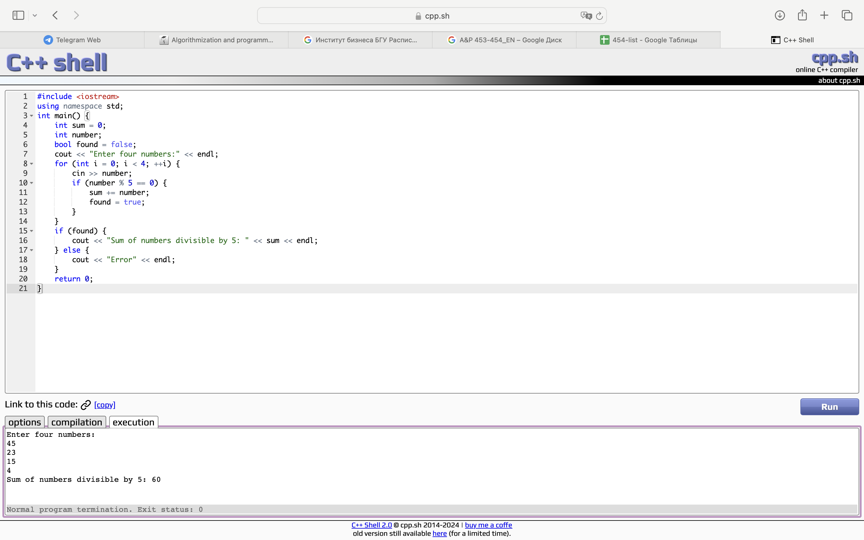Task 5.1

#include <iostream>

using namespace std;

int main() {

int sum = 0;

int number;

bool found = false;

cout << "Enter four numbers:" << endl;

for (int i = 0; i < 4; ++i) {

cin >> number;

if (number % 5 == 0) {

sum += number;

found = true;

}

}

if (found) {

cout << "Sum of numbers divisible by 5: " << sum << endl;

} else {

cout << "Error" << endl;

}

return 0;

}

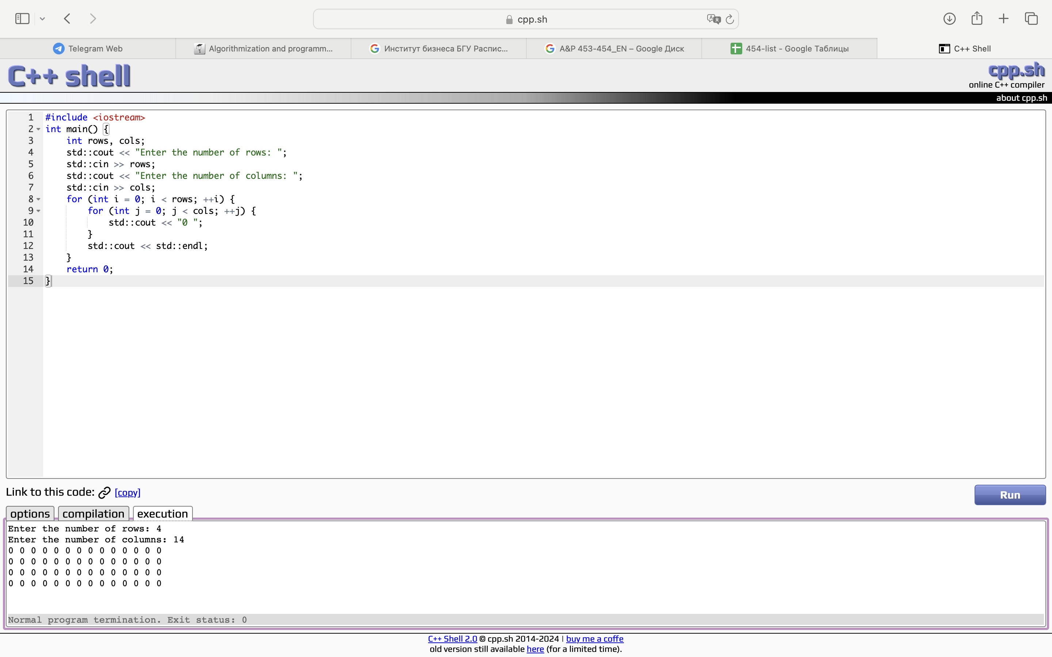

Task 5.2

#include <iostream>

int main() {

int rows, cols;

std::cout << "Enter the number of rows: ";

std::cin >> rows;

std::cout << "Enter the number of columns: ";

std::cin >> cols;

for (int i = 0; i < rows; ++i) {

for (int j = 0; j < cols; ++j) {

std::cout << "0 ";

}

std::cout << std::endl;

}

return 0;

}

Task 5.3

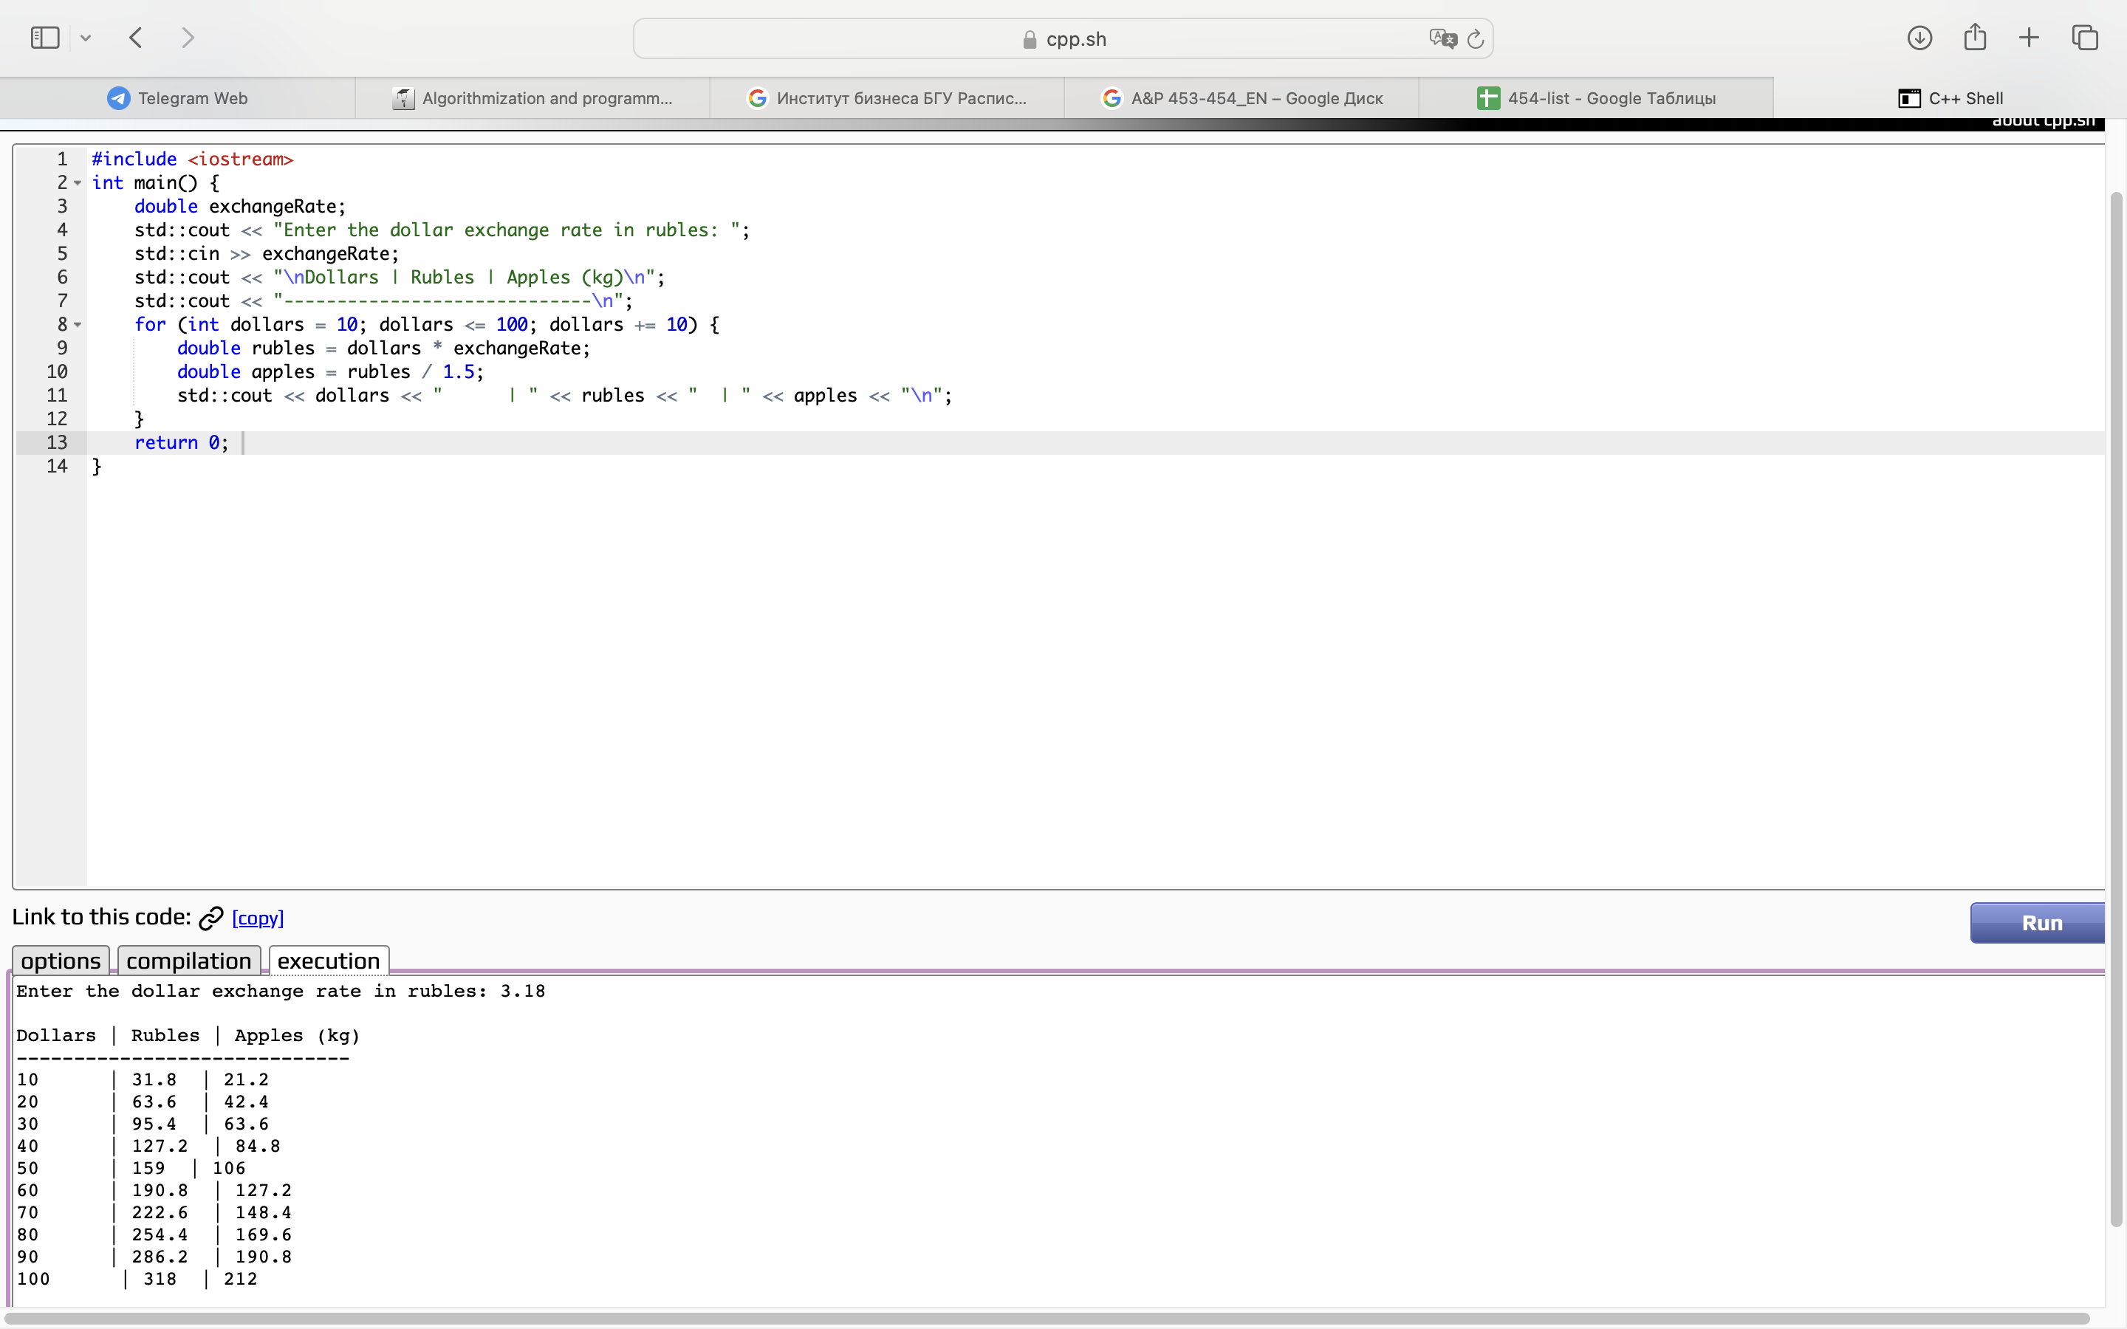

#include <iostream>

int main() {

double exchangeRate;

std::cout << "Enter the dollar exchange rate in rubles: ";

std::cin >> exchangeRate;

std::cout << "\nDollars | Rubles | Apples (kg)\n";

std::cout << "-----------------------------\n";

for (int dollars = 10; dollars <= 100; dollars += 10) {

double rubles = dollars * exchangeRate;

double apples = rubles / 1.5;

std::cout << dollars << " | " << rubles << " | " << apples << "\n";

}

return 0;

}

Task BONUS

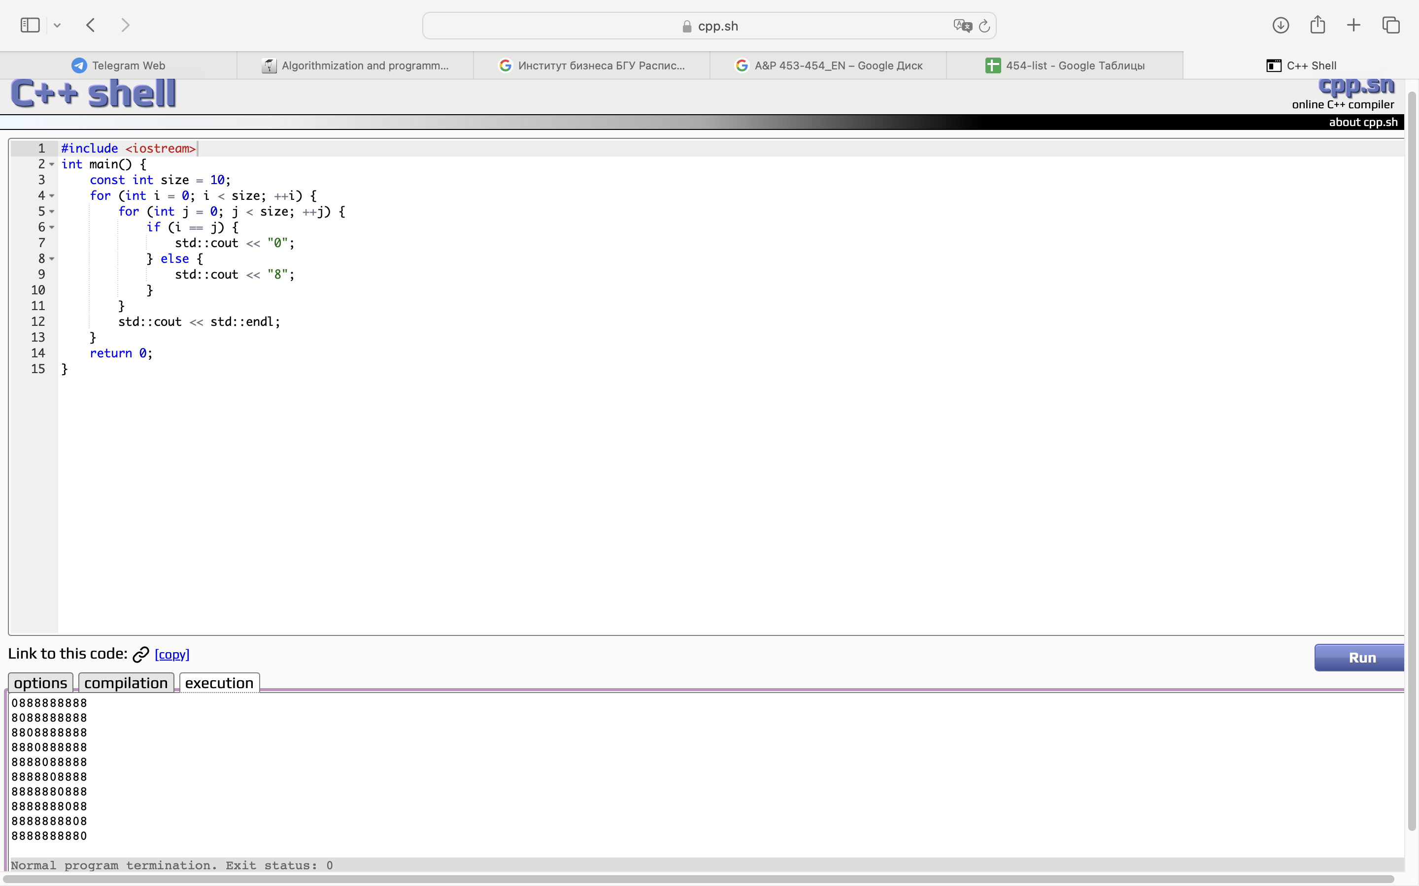

#include <iostream>

int main() {

const int size = 10;

for (int i = 0; i < size; ++i) {

for (int j = 0; j < size; ++j) {

if (i == j) {

std::cout << "0";

} else {

std::cout << "8";

}

}

std::cout << std::endl;

}

return 0;

}