In order to connect to the Raspberry Pi 3 b+ trough Ethernet, follow next steps:

- Execute ethernet-connection.sh script. Next screen will appears.
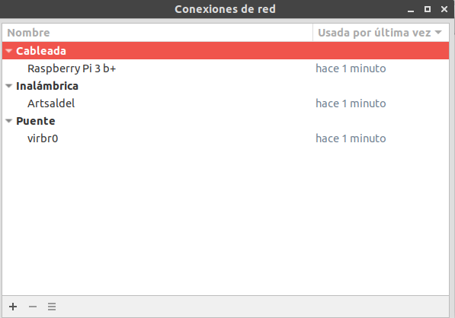

- Select “Ethernet” (or “Cableada” in spanish) and add (+ button) a new configuration. Next screen will appears.

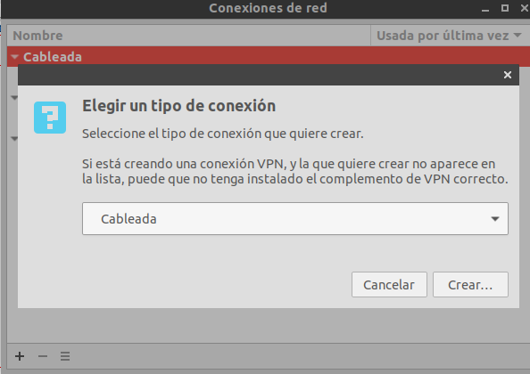

- Select “Ethernet” (or “Cableada” in spanish) and push “Create” button (or “Crear” in spanish). Next screen will appears.

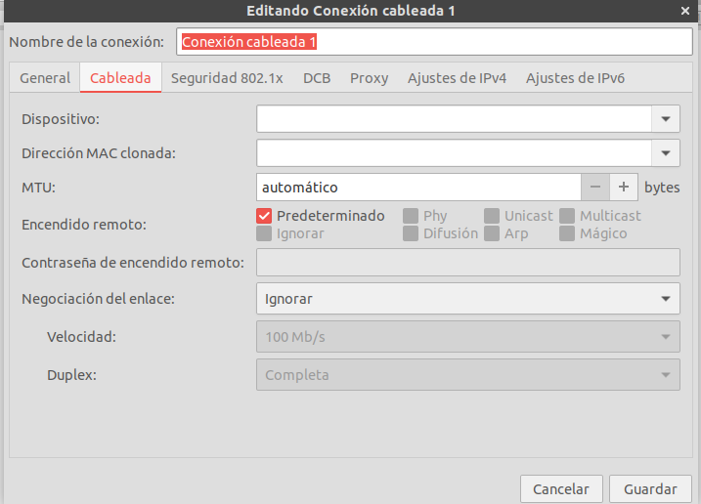

- Go to “IPv4 settings” (or “Ajustes de IPv4” in spanish). On “Method” combobox (or “Método” in spanish) select “Shared to other computers” (or “Compartida con otros equipos” in spanish) and set a name for the “Connection Name” (or “Nombre de la conexión” in spanish) as next screen. Save the connection and wire your PC and Raspberry Pi 3 b+ trough an ethernet cable.

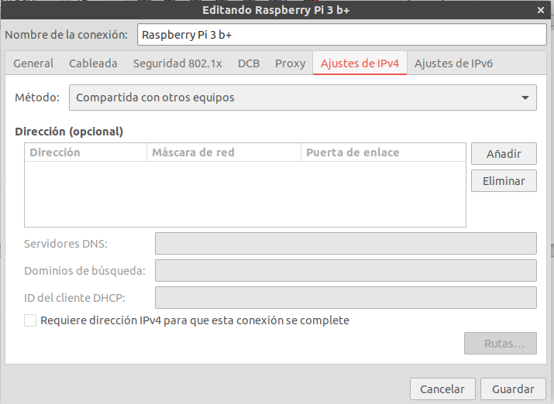

- Now go to Ubuntu Settings and select the Raspberry Pi 3 b+ ethernet connection. Then connect trough ssh executing below command in the terminal.

$ ssh root@10.42.0.92

- If the connection doesn’t allow ssh or the connection is refused, connect the Raspberry Pi 3 b+ to a hdmi screen and execute below command in terminal, then search for the correct ip.

$ ifconfig

