The gui history of the all branches

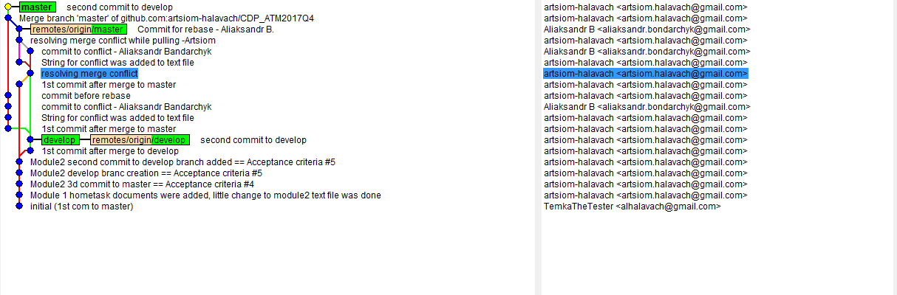

Log of the rebasing and Cherry pick

Artsiom_Halavach1@EPBYMINW1873 MINGW64 /d/CDP/GIT/CDP_ATM2017Q4 (master|MERGING)

$ git pull origin master

error: You have not concluded your merge (MERGE_HEAD exists).

hint: Please, commit your changes before merging.

fatal: Exiting because of unfinished merge.

Artsiom_Halavach1@EPBYMINW1873 MINGW64 /d/CDP/GIT/CDP_ATM2017Q4 (master|MERGING)

$ git pull --continue

error: unknown option `continue'

usage: git pull [<options>] [<repository> [<refspec>...]]

-v, --verbose be more verbose

-q, --quiet be more quiet

--progress force progress reporting

--recurse-submodules[=<on-demand>]

control for recursive fetching of submodules

Options related to merging

-r, --rebase[=<false|true|preserve|interactive>]

incorporate changes by rebasing rather than merging

-n do not show a diffstat at the end of the merge

--stat show a diffstat at the end of the merge

--log[=<n>] add (at most <n>) entries from shortlog to merge commi t message

--squash create a single commit instead of doing a merge

--commit perform a commit if the merge succeeds (default)

--edit edit message before committing

--ff allow fast-forward

--ff-only abort if fast-forward is not possible

--verify-signatures verify that the named commit has a valid GPG signature

--autostash automatically stash/stash pop before and after rebase

-s, --strategy <strategy>

merge strategy to use

-X, --strategy-option <option=value>

option for selected merge strategy

-S, --gpg-sign[=<key-id>]

GPG sign commit

--allow-unrelated-histories

allow merging unrelated histories

Options related to fetching

--all fetch from all remotes

-a, --append append to .git/FETCH_HEAD instead of overwriting

--upload-pack <path> path to upload pack on remote end

-f, --force force overwrite of local branch

-t, --tags fetch all tags and associated objects

-p, --prune prune remote-tracking branches no longer on remote

-j, --jobs[=<n>] number of submodules pulled in parallel

--dry-run dry run

-k, --keep keep downloaded pack

--depth <depth> deepen history of shallow clone

--unshallow convert to a complete repository

--update-shallow accept refs that update .git/shallow

--refmap <refmap> specify fetch refmap

Artsiom_Halavach1@EPBYMINW1873 MINGW64 /d/CDP/GIT/CDP_ATM2017Q4 (master|MERGING)

$ git merge --continue

[master 92064b4] Merge branch 'master' of github.com:artsiom-halavach/CDP_ATM201 7Q4

Artsiom_Halavach1@EPBYMINW1873 MINGW64 /d/CDP/GIT/CDP_ATM2017Q4 (master)

$ git che

checkout cherry cherry-pick

Artsiom_Halavach1@EPBYMINW1873 MINGW64 /d/CDP/GIT/CDP_ATM2017Q4 (master)

$ git cherry-pick pull origin master

fatal: bad revision 'pull'

Artsiom_Halavach1@EPBYMINW1873 MINGW64 /d/CDP/GIT/CDP_ATM2017Q4 (master)

$ git cherry-pick 8b3b809

error: could not apply 8b3b809... Module2 second commit to develop branch added == Acceptance criteria #5

hint: after resolving the conflicts, mark the corrected paths

hint: with 'git add <paths>' or 'git rm <paths>'

hint: and commit the result with 'git commit'

Artsiom_Halavach1@EPBYMINW1873 MINGW64 /d/CDP/GIT/CDP_ATM2017Q4 (master|CHERRY-P ICKING)

$ git cherry-pick --abort

Artsiom_Halavach1@EPBYMINW1873 MINGW64 /d/CDP/GIT/CDP_ATM2017Q4 (master)

$ git cherry-pick 9d997ce

error: could not apply 9d997ce... second commit to develop

hint: after resolving the conflicts, mark the corrected paths

hint: with 'git add <paths>' or 'git rm <paths>'

hint: and commit the result with 'git commit'

Artsiom_Halavach1@EPBYMINW1873 MINGW64 /d/CDP/GIT/CDP_ATM2017Q4 (master|CHERRY-P ICKING)

$ ^C

Artsiom_Halavach1@EPBYMINW1873 MINGW64 /d/CDP/GIT/CDP_ATM2017Q4 (master|CHERRY-P ICKING)

$ git status

On branch master

Your branch is ahead of 'origin/master' by 5 commits.

(use "git push" to publish your local commits)

You are currently cherry-picking commit 9d997ce.

(fix conflicts and run "git cherry-pick --continue")

(use "git cherry-pick --abort" to cancel the cherry-pick operation)

Unmerged paths:

(use "git add <file>..." to mark resolution)

both modified: Module2/GitTest.txt

Untracked files:

(use "git add <file>..." to include in what will be committed)

.gitignore

Module2/GitTest.txt.orig

ReadMe.txt

no changes added to commit (use "git add" and/or "git commit -a")

Artsiom_Halavach1@EPBYMINW1873 MINGW64 /d/CDP/GIT/CDP_ATM2017Q4 (master|CHERRY-P ICKING)

$ git add Module2/GitTest.txt

Artsiom_Halavach1@EPBYMINW1873 MINGW64 /d/CDP/GIT/CDP_ATM2017Q4 (master|CHERRY-P ICKING)

$ git cherry-pick --continue

[master 45a3e36] second commit to develop

Date: Tue Nov 28 17:35:18 2017 +0300

1 file changed, 6 insertions(+), 1 deletion(-)

Artsiom_Halavach1@EPBYMINW1873 MINGW64 /d/CDP/GIT/CDP_ATM2017Q4 (master)

$ git cherry

+ 8fcd8776c2b03a147610fa8867c719eb49b2c26a

+ e8dfcea861789e6fb3ea2b8a9acc0bb3d7376c74

+ 4350244cc659a523f8e30487117242cf09eb25c2

+ 0d711d06850e9e847d8f587f4878db460306ee08

+ 45a3e362286f1305e63b68727868bfa8284bda6a