How to check task implementation:
- Install java7+, git 2.7+, gradle 3+, tomcat7+
- Download/clone this repository
- Change tomcat location in build.gradle according your local installation
- Open command line in project root folder
- Run “gradle buildAndStartWebapp” command
- Follow next link on your browser: localhost:{tomcat HTTP port}/todo and see that web application successfully started

Following tasks will be performed before the application deployment:
  - Compile code.
  - Build code.
  - Run unit tests.
  - Create html tests results report.
  - PMD
  - Create war file
You can find html file with Junit test report here: {project root folder}/build/reports/tests/test/index.html
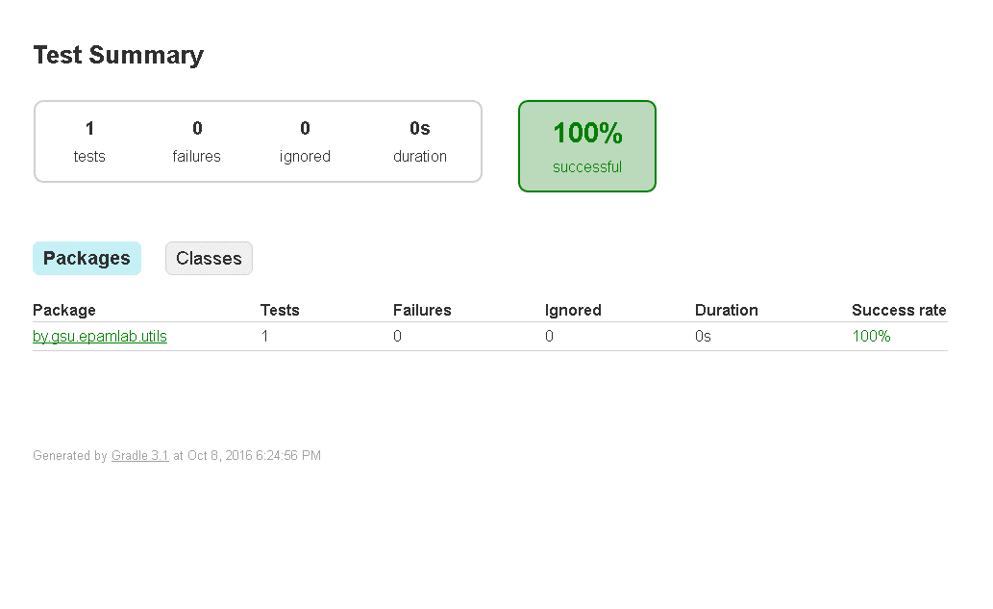

Next custom tasks will be started immediately after:
- Copy war file into {tomcat}/webapps/ folder
- Start local tomcat

