

From Data to Dollars

A comprehensive analysis of airbnb pricing strategies

Cheromaine Smith | Christine Kwan | Yesul Song | IST 652: Scripting for Data Analysis | June 9, 2024

# Introduction

In recent years the tourism industry has become one of the biggest drivers of economic development in the world. With an estimated value of $1.9 trillion for just the United States alone ( S.R.D., 2024), this industry has supported 9.5 million American jobs and accounted for 2.9% of the U.S. GDP (BEHSUDI , 2020). Over the last few years, the economic impact of tourism has only increased, with the average cost of a vacation in 2024 costing $1,986/week, while a family of four comes in at a whopping $7,936 (GOGO Charters, 2024). These rising costs have led to people working overtime to find ways to reduce cost.

Introducing Airbnb, in 2007 two hosts welcomed three guests to their San Francisco home (AirBnb, 2024). With business conferences becoming more popular, the prices increasing and availability of hotel rooms decreasing they saw an opportunity to rent out the air mattress in their living room to conference attendees. They went on to create a website named “Airbed and Breakfast’” or as we now know it Airbnb. Turning this seed from an idea to a 93-billion-dollar company with hosts and locations all over the world (The Nasdaq Stock Market, 2024).

In the world of data science, being an innovator in the marketing industry is a highly coveted role. The aim of this report is to answer the question, “Can we use Airbnb historical data to build a tool that will assist not only host but discover their perfect rental. From the host side, these individuals would be able to use this tool to figure out pricing of their stays, features that place them in a different price point and which neighborhoods they should be listing in. On the guest side, they are able to interact with a multitude of hosts, have access to the prices by neighborhood and be able to search by keyword for rentals. Through data exploration and use of linear regression analysis, correlation matrices, decision trees and random forest, we hope to discover trends that will provide owners and guests with the knowledge to make informed travel arrangements.

# Data Overview

## about the data

This dataset provides a highly detailed view of homestay listings within Seattle. To provide further insight, this file consisted of three (3) different datasets: calendar, listings, and reviews. These datasets provide a wide overview of the Airbnb business from listing ids and rental descriptions to numbers of bedrooms and bathrooms, with a bit of owner review ratings mixed in. This compilation of historical data allows for in-depth analysis of owner ratings, rental features, and the possible impact of various factors on the tourism industry.

As discussed above the dataset lives in three separate CSV files that were downloaded from Kaggle.com. The datasets are as follows:

*Figure 1: The three datasets used for the Airbnb analysis.*

*Workbook 1: calendar.csv*

This spreadsheet captures listing IDs with their price and availability for that day. Each row corresponds to a specific listing.

* listing id: The unique identifier ID for the listing.
* date: The date the information of the listing was tracked.
* available: Whether or not the listing was available.
* price: The price of the listing on the day this data was recorded.

*Workbook 2: listings.csv*

This spreadsheet captures full descriptions, location, price, and features for listings with the average review scores provided by guest who have stayed in the rental. Each row corresponds to a specific listing.

* id: A unique identifier for each listing
* listing url: The website link for the listing.
* scrape id: The id for the data collection was collected.
* last scraped: The date this data was collected.
* name: The listing name on the Airbnb Website
* summary: The written description summary of the listing.
* space: A description of the listing with information about booking.
* description: This description matches the description given in the space variable.
* experiences offered: Any special experience like festivals or rides.
* neighborhood overview: A description of the neighborhood.
* notes: Comments about amenities or events happening at the listing during the guest stay.
* transit: A description of the proximity to transportation.
* thumbnail url: The website link for the pictures
* medium url: Additional pictures of the listing.
* picture url: A link to all listing photos.
* xl picture url: Pictures opened in full screen instead of partial screen.
* host id: A host unique identifier.
* host url: The link to the host profile.
* host name: The host’s name as shown on their profile.
* host since: Date when the individual became a host.
* host location: The location of the host.
* host about: The about section of a host profile.
* host response time: This is how long it takes a host on average to respond to inquiries.
* host response rate: This shows a percentage of messages the host has responded to.
* host acceptance rate: A percentage of bookings the host has accepted.
* host is superhost: A binary option of whether or not the host is a superhost.
* host thumbnail url: The link for the host thumbnail photo.
* host picture url: The host main profile picture link.
* host neighborhood: The neighborhood the host is located in.
* host listings count: How many properties the host has listed on Airbnb.
* host total listings count: Total count of listings the host has.
* host verifications: The variety of ways a host has been verified.
* host has profile pic: A binary option of whether or not a host has a profile pic.
* host identity verified: A binary option of whether or not a host identity was verified.
* street: The street address of the listing.
* neighborhood: The neighborhood the listing is located in.
* neighborhood cleansed: A refined version of the neighborhood listing.
* neighborhood group cleansed: The refined list has been narrowed down further.
* city: The city the listing is located in.
* state: The state the listing is located in.
* zip code: The zip code the listing is located in.
* market: The city the listing is located in.
* smart location: City and state combination for listing location
* country code: The country abbreviation for the listing location.
* country: The country the listing is located in.
* latitude: Part of the exact coordinates of the listing.
* longitude: Part of the exact coordinates of the listing.
* is location exact: Binary option for whether or not a location is exact.
* property type: Type of listing whether a house, apartment, cabin, camper etc.
* room type: Description of the type of listing whether an entire home, private room etc.
* accommodates: Numeric descriptor of how many guests can occupy the listing.
* bathrooms: Number of bathrooms in the listing.
* bedrooms: Number of bedrooms in the listing.
* beds: Number of actual beds on the property as you can have 5 bedrooms but 7 beds.
* bed type: Types of bed whether it is a real bed, futon, or an air mattress.
* amenities: Items for the guest pleasure when staying like tv, fireplaces, washer, dryers etc.
* square feet: How large the listing is overall.
* price: This is the price per night for staying at the listing.
* weekly price: The weekly price for booking the listing.
* monthly price: The monthly price for booking the listing.
* security deposit: The amount you may pay on the listing to reserve your date.
* cleaning fee: The amount a host charges for cleaning within the reservation price.
* guests included: The amount of extra guest that may be staying at a listing.
* extra people: The charge per additional guest staying at the location.
* minimum nights: The minimum number of nights a guest is able to reserve the listing for.
* maximum nights: The maximum number of nights a guest is able to reserve the listing for.
* calendar updated: The last time the host availability calendar was updated.
* has availability: Binary true/false choice for whether or not a listing has any availability.
* availability 30: The amount of availability within the next 30 days.
* availability 60: The amount of availability within the next 60 days.
* availability 90: The amount of availability within the next 90 days.
* availability 365: The amount of availability within the next 365 days.
* calendar last scraped: The last time the availability calendar information was retrieved.
* number of reviews: The number of reviews for a listing.
* first review: The date of the first review.
* last review: The date of the last review.
* review scores rating: Overall review score rating based on the other categories.
* review scores accuracy: A rating between 1 and 10 about accuracy of listing description.
* review scores cleanliness: A rating between 1 and 10 about cleanliness within the listing.
* review scores check-in: A rating between 1 and 10 about the ease of checking-in.
* review scores communication: A rating between 1 and 10 about host communication.
* review scores location: A rating between 1 and 10 about accuracy of listing location.
* review scores value: A rating between 1 and 10 about listing value in regard to price.
* requires license: Binary true/false about whether or not a license is required.
* license: Binary yes or no of whether or not someone has a license.
* jurisdiction names: The state the listing is located in.
* instant bookable: Binary true/false on whether you can reserve the listing right away.
* cancellation policy: The seriousness of a host cancellation policy whether flexible, moderate, or strict.
* require guest profile picture: Binary true/false on whether guest or required to upload a photo.
* require guest phone verification: Binary true/false on whether guest or required to verify phone number.
* calculated host listings count: Calculated field on the total amount of listings owned by the host.
* reviews per month: Calculation of the average reviews per month, which serves as a double check on if there are missing data.

*Workbook 3: reviews.csv*

This spreadsheet captures unique IDs for each reviewer and the detailed reviews they left on these Seattle rentals. Each row corresponds to a specific reviewer.

* listing id: The unique identifier ID for the listing.
* id: This is the unique id for the review comment itself.
* date: The date a listing was reviewed.
* reviewer id: The unique identifier ID for the reviewer/guest.
* reviewer name: This is the person that left the review name.
* comments: These are the comments left by that specific reviewer.

*Figure 2: Description of the variables we focused on during this analysis.*

## data preparation/cleaning

In data science one of the first things you are taught is, “Garbage in, Garbage out”, meaning if you complete an analysis using dirty data all your subsequent results will be inaccurate. Therefore, the most essential step of any analysis is the initial preprocessing cleaning and preparation of the datasets. This cleaning step consist of removing any noise, formatting variables into integers, strings and floats and most importantly deciding how to handle null values within your dataset. These cleaning steps not only set yourself up for success but breaks your data into a format that can be easily fed to machine learning models. While the reviews and calendar spreadsheets were relatively clean, the listings spreadsheet required more manipulation.

*Figure 3: Breakdown of methods used to clean the data.*

The initial listings dataset had a comprehensive record of listings in the Seattle area, detailing aspects such as bedrooms, bathrooms, review ratings, host ratings, description, features, amenities and even transit. Once the libraries were imported and the datasets were loaded, much of the introductionary analysis involved identifying the noise, and checking each variable for completeness and accuracy. Some records listed null values(i.e. host response rate), possibly indicating newer hosts while others were missing information entirely. After the initial review, we began to clean each spreadsheet separately, below are the steps that were taken:

### Calendar Cleaning

Within the calendar dataset, we found that there were missing values and formatting issues regarding dates and money. First, we removed the dollar sign symbol from the price variable so that it could be formatted numeric. The date variable was formatted to the standard datetime assignment. Next, the availability was converted to Boolean form of T for True and F for False. Finally, all rows that had missing or null values were dropped from the dataset, reducing the overall population.

### Listing Cleaning

With the listings dataset being the largest one, we focused on narrowing down what was needed and identifying any issues with the variables we wanted to analyze. Certain variables that listed host URL and listing URL, for example, provided no value when it came to our analysis, so we removed them from contention. As previously done within the calendar dataset, once the irrelevant variables were removed the focus became formatting all price related columns, zip codes, bedrooms, and bathrooms to numeric. Any missing values that were in specific text columns were filled in with empty strings, as we deemed an empty string would always be better than leaving them as NaN. Finally, two new variables were created in price per bedroom and price per guest, to be used in prediction analysis.

### Review Cleaning

The final dataset that was cleaned was the reviews dataset. Like the previous dataset, this spreadsheet also had formatting issues and missing information. All dates on this spreadsheet were formatted from date to datetime format. Next, we filled in all missing values in the comments section with empty strings to ensure consistency and prevent any issues that may emerge during text analysis.

Once all spreadsheets were cleaned individually, one final check for missing values were ran and the cleaned datasets were saved.

## exploratory data analysis

The Exploratory Data Analysis or EDA for short is when an open exploration of the data is completed to get a “feel” for the data. The EDA not only helps data scientist see a preview of the data they are preparing to analyze, but it also helps in identifying problems within the data, highlighting interesting relationships between variables, and showcasing patterns within the data. When the EDA is done correctly, it can help data scientists confirm that they are asking the right questions about the data which can be answered practically.

Throughout the cleaning portion, we made a concerted effort to continue to find ways to review our data. The Seattle datasets had a wide array of data types – including geographical data, text data, and time series data to name a few. This variety has allowed us to create several visualizations, including bar plots, correlation matrix and decision trees. Within the EDA, we set out to answer the questions:

* What is the most common price ranged for Airbnb listings in Seattle? How can hosts price their properties competitively within these ranges?

As prices are the biggest determining factor for most consumers, we believed it would be useful to view the price distribution. As shown in the chart below, the price distribution was right-skewed or positively skewed. A positively skewed distribution means that the average price will be greater than median price. Using this chart, we hoped to be able to identify the most common price range and provide actionable pricing strategies for hosts. The bar plot showed us that the optimal pricing range was between $100 and $150, followed by $50 to $100. Offering this information in our tool, would allow host to stay competitive and offer higher price ranges for competitive amenities. However, this was just a general review of the data, in order to help hosts position their listings competitively in the market and increase their booking rates this approach would need further improvement.

*Figure 4: This chart shows a graph of listing prices for all listings located in Seattle.*

# Methods of Analysis/Business Questions

## What ARE the average listing prices by neighborhood?

As we determined during the EDA, we wanted to see if we could narrow down the price bands further. To conduct this analysis, we calculated the average price and grouped them by neighborhood. Through this analysis, we found that the Delridge neighborhood was the cheapest at $83, while the Magnolia neighborhood was most expensive at $177. To provide even more detailed information, we could narrow it down to price bands based on required features and amenities. Over the years we have seen companies like Ticketmaster execute this well by keeping their consumer based well informed.

*Figure 5: Table of neighborhoods in Seattle and their average listing prices*

A graph of prices by Seattle neighborhoods.


*Figure 6: A graph of listing price within different Seattle neighborhoods.*

## Write a program to predict what a host listing price should be in different neighborhoods within seattle?

As a new business owner, figuring out pricing can be very stressful. How do new host know what their listing prices should be? Do they need to factor cleaning into the listing prices? How do they competitively market their listing regardless of what neighborhood it is in. Introducing our pricing program, this program collects from the hosts standard information such as bedrooms, bathrooms and zip code then advises on a suggested price point for their listings. The below figures show 3 different examples of this program in action. Future updates to this program, will use more information like amenities, proximity to transportation/metro areas and guest count to suggest prices of listings.

*Figure 7: Three examples of how this pricing simulator tool will work for hosts.*

1. Using a function, perform a keyword search on amenities within a listing and return the core features of that listing.

The tool useability to host and guest alike was a essential part in the project. The current Airbnb system is very standard in that it asks surface level questions. These questions are location, amount of guest, bedroom, and bathroom. This is very reminiscent to the AOL days where people would ask others Age/ Gender/ Location. However, the truth of the matter is that there is a lot more than the standard that goes into choosing a vacation location. When planning for a family it gets more difficult as whether or not the location is kid friendly or has distraction amenities is key

We recognized that this is a feature the Airbnb application is sorely lacking. Yes, all this information is listed once you click into a listing. However, in the current times who has the time to click on each listing to see if it has the amenities you need. We realized this was where we can step in. Using our keyword finder tool, guest will be able to search by keywords such as TV or Kid Friendly. This will direct them to an output of about 50 listings, with not only the listing ID but general information like bedroom, bathroom, price, and the link to the listing. Below is a sample of how the keyword finder tool works.

*Figure 8: This shows how the keyword finder functions works to locate listings for guests.*

1. is there a correlation between host response rate and the multitude of review type categories?

Reviews and host response rate seems to be a few variables that tend to get forgotten in the grand scheme of things. We wanted to know if it was possible to influence a host response time. While it was not surprising that there aren’t any truly strong correlations, the correlation between reviews per month and a host total listing were surprising. The expectation was that more reviews meant more money coming in which could be used to buy other listings.

However, the correlation matrix showed us that this was not the true as these two variables actually had a relatively strong negative relationship. This means that as the reviews per months decreased a host would have more listings, or vice versa. It also occurred to us that maybe this correlation meant that host of more expensive listings had more locations because they could afford to. Which in turn leads to less reviews because not everyone can afford these listings. It would be interesting in a future update to study what the population size of host with multiple locations are versus the host with few.

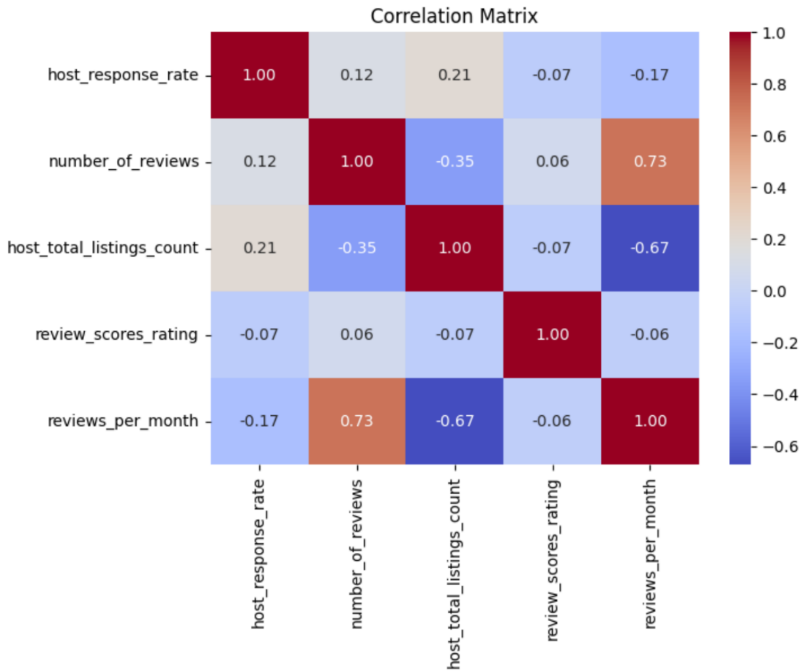

*Figure 9: A correlation matrix showing the relationship between a host response rate and several different review categories.*

## WHat is the top 10 AIRBNB LISTING IN THE SEATTLE AREA?

To conduct this analysis, we sorted the review scores rating variable from highest to lowest, with two listings at the top with a rating of 100% and the lowest rating of the 10 at 93%. To make it easier to view, we only included the necessary parameters like ‘id’, ‘name’, ‘summary’, ‘neighborhood cleansed’, ‘room type’ to name a few. The results showed that most of the top 10 listings were located in the Alki and North Admiral neighborhoods. Just reviewing the map, both of these locations are close to the waterfront and very close to downtown Seattle which seemed to have played a role in the positive ratings.

*Figure 10: View of the top 10 Airbnb listings in Seattle by review rating.*

## How do the number of reviews and review scores impact the price of a listing?

To conduct this analysis, first we extracted all the parameters that we believed could plan an impact on the price of a listing. This opened the door to variables like beds, bedrooms, room type, accommodates, and property type to name a few. This dataset was then saved as its own spreadsheet to be used for machine learning models. Starting the machine learning process, we split the dataset into a 70% training and 30% test dataset. The decision was made to use a supervised learning model, as we were wanted a model that would be easy to use/interpret and great at estimating missing data we chose a random forest model.

A random forest model uses three important variables to measure impact MSE, RMSE and R2. However, what does all this mean? MSE stands for Mean Squared Error which is used to evaluate the performance of a regression model. RMSE on the other hand is short for the Root Mean Square Error which is used to evaluate the accuracy of a predictive model. R2/R-Squared represents the proportion of variance in the dependent variable that is predictable from the independent variables in a regression model.

The random forest model found an MSE of 8369.73 , RMSE of 91.48 and R2 of -0.38%. Even though the R-Squared is low, it does not necessarily mean our model is bad, just as a high R-Squared doesn’t necessarily mean good. We need to consider the picture as a whole. In this scenario, our results show that while the model’s fit is poor as indicated by the negative R-Squared value, suggesting that it is performing worse than a simple mean prediction, the RMSE and MSE provide us with concrete measures of prediction error. This suggests that the model is not capturing the underlying pattern in the data effectively. Therefore, it is crucial to revisit feature selection, model parameters, and perhaps consider more data preprocessing or exploring alternative modeling techniques to improve performance.

*Figure 11: Results of the first random forest model to be compared with the decision tree.*

1. Predict the future prices of listings based on historical data and identified trends?

The last model conducted focused on the accuracy of using historical information from the zip code, accommodates, bathrooms, bedrooms, and beds columns to predict price. To start, the dataset was split into two by features and the target variable. This dataset was then split into 70% training and 30% test. Once that was complete it was time to create and train the model. This model provided an MSE of 4312.98, RMSE of 65.67 and a R-Squared of 0.4827.

Figure 12: Results of the second random forest model

# Conclusion

The findings within this project exposes a promising yet challenging landscape for predictive modeling in the marketing industries. While the models provided unique insights and demonstrated a variety of ways to not only measure success but succeed. It has become apparent that the task of forecasting listing prices requires more information. Throughout this report, one important aspect that was not considered was the economy. We are in an economic climate where price continues to rise, and competitive marketing is removing the general public from the consumer lists. The unpredictability of the economy, influenced by factors like big corporations and influential individual’s interests pose a significant challenge to predictive accuracy. Unless we are able to find a way to take these factors into account, we will never be innovators in the market.

While there were parts of the research that highlighted the value of regression models as a mean to offer strategic insights into the tourism industry, it is important to take the nuances into consideration. These models showcase not only the current capabilities of predictive analytics, but also stresses the importance of model refinement. Through every business question, we have discussed ways in which these models can be improved to provide a better-quality product to our customers. As more information becomes available the need for data driven decision making by leveraging machine learning techniques and historical data should increase. As a society, we need to continue to hold each other accountable, so that a lower income family of 4 will be able to afford a vacation for less than $7,936/week.

# Team Log

Everyone had equal participation in this project and each task was assigned accordingly after every team meeting. The team worked in sprints to plan and finish tasks consistently. While each person was assigned a specific task, there was constant communication via team’s chat, and everyone had equal responsibility to approve any changes. These tasks and timelines were logged using a platform called Trello. The below screenshots show a breakdown of the tasks below:

*Figure 13: Screenshot of the team’s task breakdown*

# References

AirBnB. (2024, June 6). *About Us*. Airbnb Newsroom. https://news.airbnb.com/en-in/about-us/

BEHSUDI , A. (2020, December 1). *Impact of the pandemic on tourism – IMF F&D*. IMF. https://www.imf.org/en/Publications/fandd/issues/2020/12/impact-of-the-pandemic-on-tourism-behsudi#:~:text=Before%20COVID%2D19%2C%20travel%20and,million%20people%20took%20foreign%20trips.

GOGO Charters. (2024, May 15). *Average vacation costs in 2024*. GOGO Charters. https://gogocharters.com/blog/average-vacation-cost/

The Nasdaq Stock Market. (2024, June 13). *Airbnb Inc (ABNB) stock price & news*. Google Finance. https://www.google.com/finance/quote/ABNB:NASDAQ?sa=X&ved=2ahUKEwjV_Zn87dmGAxVCkIkEHdCuCW0Q3ecFegQIOhAi

S. R. D. (2024, April 2). *Global Tourism Sector Market Size 2023*. Statista. https://www.statista.com/statistics/1220218/tourism-industry-market-size-global/#:~:text=The%20market%20size%20of%20the,(COVID%2D19)%20pandemic.