Product Design
Team | Team Number: 48
Members | Shaleen Garg  Shreyash Shriyam  Ashutosh Ranjan

Design Model

Chat Room | Class state  - Room No.  - User Name: The user chatting in this room.  - Chat content : Chat messages between the bot and the user.  Class behavior(methods)  - displayScreen(): Displays the chat to the user.
User | Class state  - User name: The user has got a name.  - User Room no.: The user has been alloted a specific room to chat to the bot.  Class behavior(methods)  - placeRequests(): Places requests via chat.  - pays() :Pays after request has been successfully fulfilled.  - MakeChoice() :Chooses what he/she wants
Bot | Class state  - Room no.: The room in which it is chatting.  Class behavior(methods)  - Replies() : Replies to queries from the user.  - ChecksDatabase(): Checks database to incorporate the requests made by the user.  - ConfirmsOrder(): Confirms the order.
Database | Class state  - Keeps all the details of all the flights available.  Class behavior(methods)  - ProvidesDetails(): Provides details about the requests made by the bot.
Payment Service | Class state  - Keeps all the forms to be flled to be able to pay.  Class behavior(methods)  - ConfirmsPayment(): Confirms the payment once the transaction is successful.
.

Class Diagram
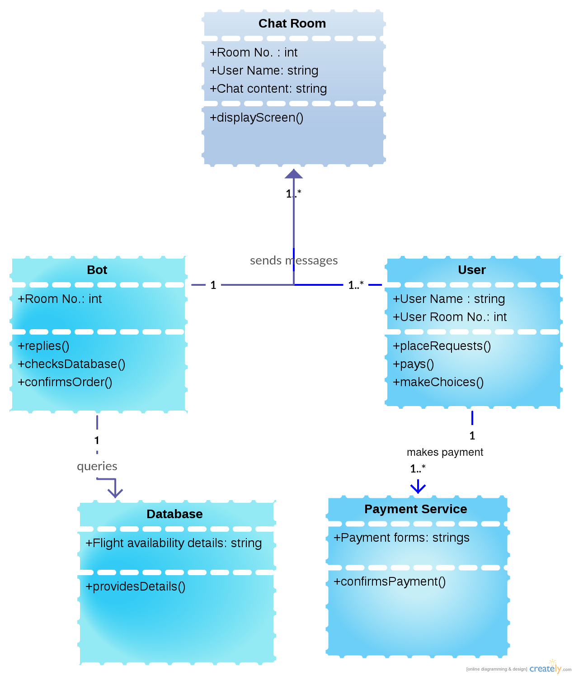

Sequence Diagram(s)

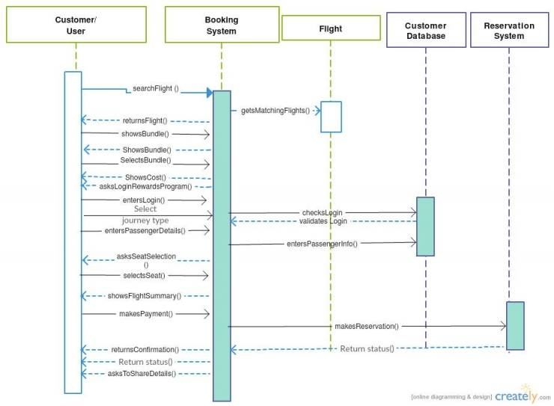

Design Rationale
1. We started to build an IOS app using swift language but found it expensive and time consuming as it needed an account supported financially, so we shifted to ionic framework.
2. Ionic imposed similar problems, debugging was harder and was difficult to support multiple platforms using single codebase so shifted to cordova framework.
3. Primary usage was of HTML/CSS and AngularJs as it was fast and easy to implement with less learning curve.
4. Since it was difficult to work on native platform with high learning curve we used cordova, it was easy to work on for hybrid applications.Plus there was scope for code reuse.
5. Finally we decided to make the app for android store because it was free and ios store required an account and financial support which was a problem at that time.

