**ICS261: SSAD & Project**

|  |  |
| --- | --- |
| Team number | ***48*** |
| Project Title | ***iOS App development of SuperGenie. The app will allow users to place orders for anything via Chat.*** |
| Document | SSAD Project Concept Document |
| Creation date | ***24th day of August, 2015*** |
| Created By | ***Shaleen Garg, Ashutosh Ranjan, Shreyash Shriyam*** |
| Client | ***Mr Prabhjot Singh , SuperGenie*** |

**Description**

This project requires us to develop a hybrid mobile application for iphone smartphone.This applications enables the user to order things like food, groceries, book travel tickets, hotels, movie tickets and also make bill payments all under one roof.

*Technology used : Javascript, Angular Js, Ionic Framework*

**Profile of Users**

This project has a wide range of end-users. The only prerequisites for a user to use this application is to be able to launch the application and type text message to the client. It is useful for the men and women who are busy at work.It is helpful for children who don't have time to physically go to different shops to buy some things. The interface design is so simple that anyone from a teen-ager to an old man can use it. Also the payment modes are very reliable and can be used with ease.It is also open to the market of restaurants, grocery stores, online booking sites and online payment sites who want to take full advantage of this growing online world.

**Usage Model and Diagrams (if any)**

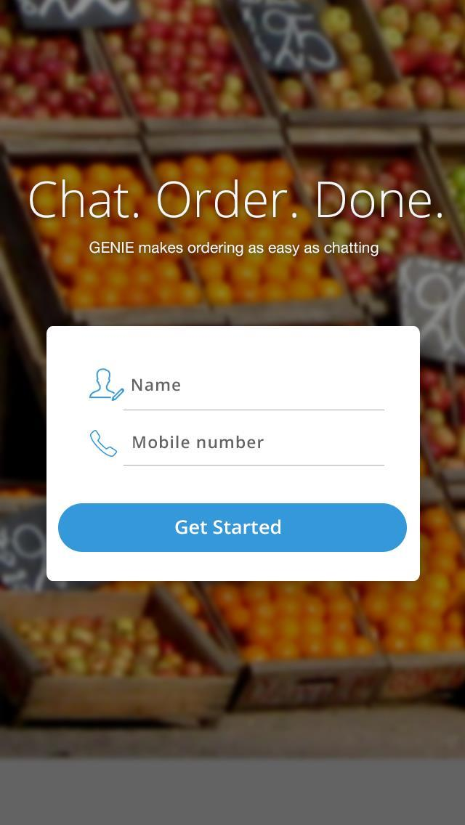

The end user can just install the application from the ios app store in his/her iphone. No hassle of tedious logins, the login can be simply done by typing the name and the phone number.

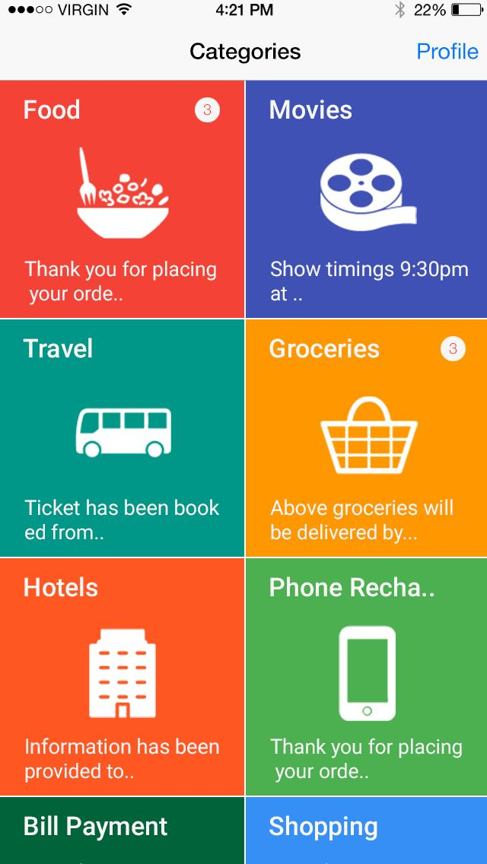This is the main page of the application where the end-user chooses which item he wants to use.

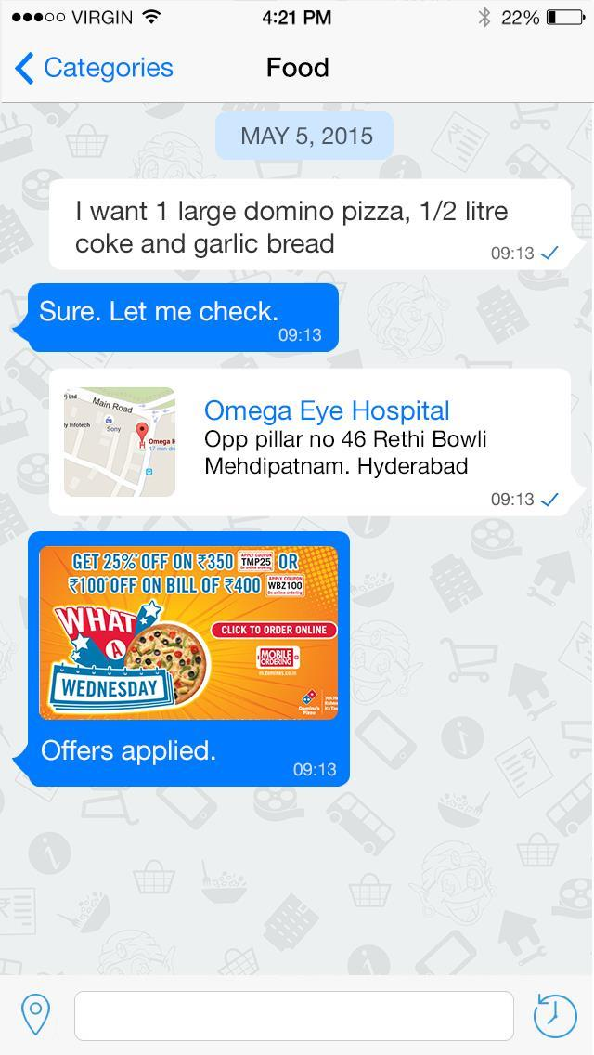If the user chooses the food section , he can order any food item as easilty as chatting . Same goes for every other item in the application.

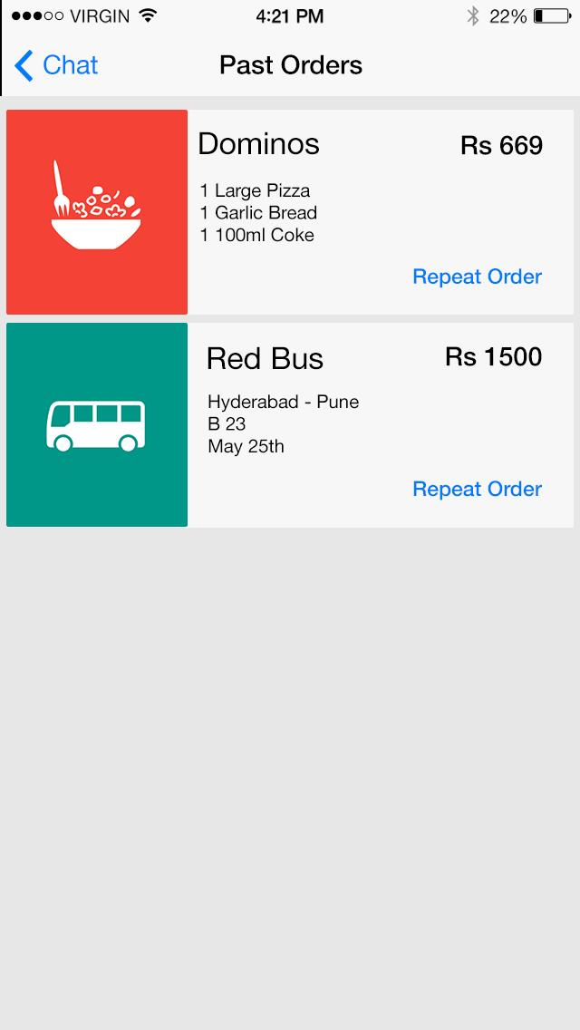

The user can also lookup his past orders.