**ITCS443 Parallel and Distributed System**

**Lab6: Introduction to CUDA**

1. vecInc.cu
   * Source code

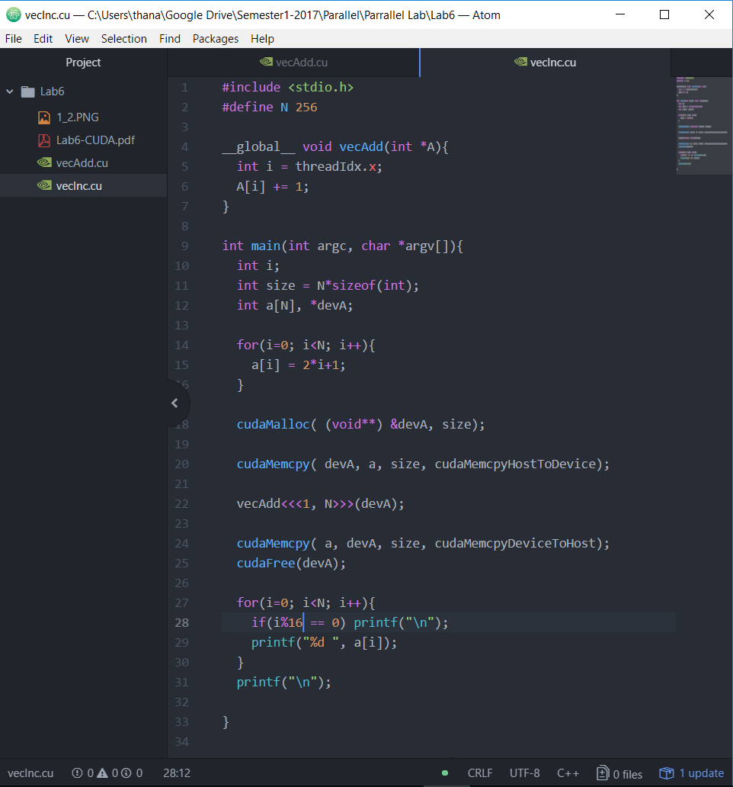

* Output

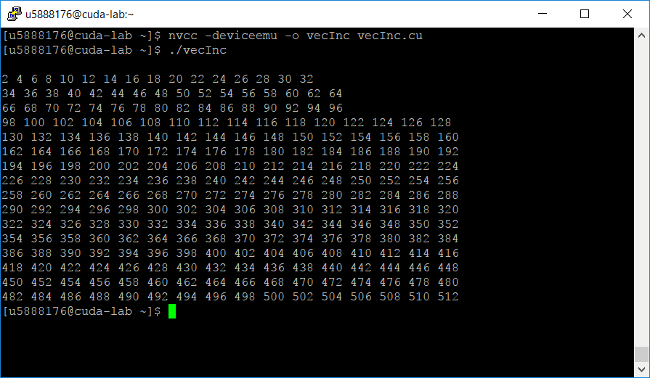

1. vecInc2.cu
   * Source code

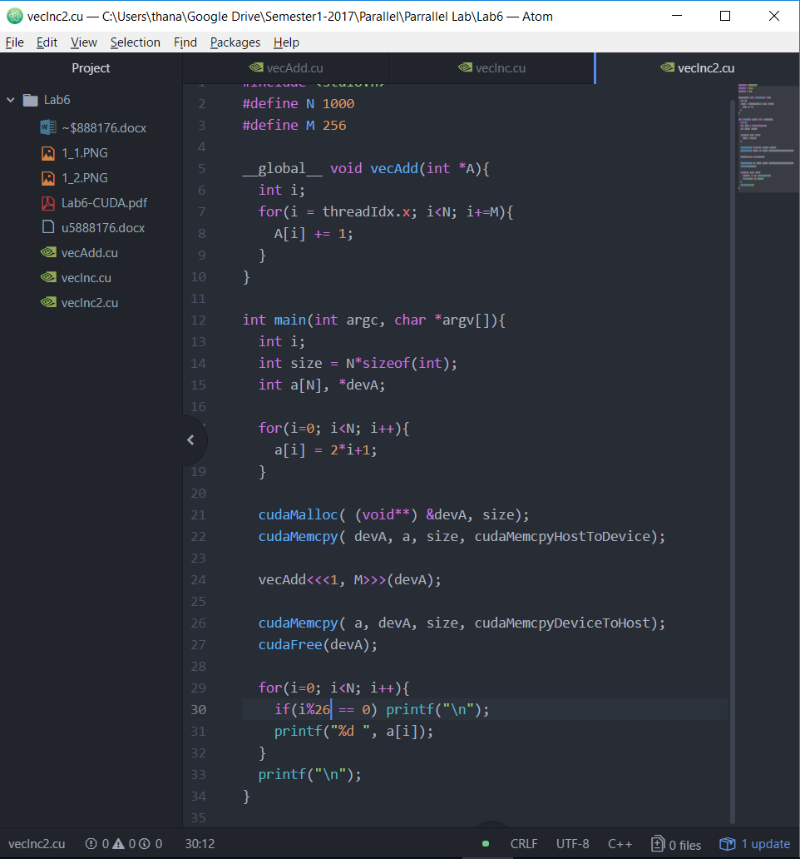

* + Output

