KAUNO TECHNOLOGIJOS UNIVERSITETAS
INFORMATIKOS FAKULTETAS

Algoritmų sudarymas ir analizė
3 laboratorinis darbas (19 variantas)

Atliko: IFF-6 gr. studentas
Artūras Šlajus
Data: 2009-05-11
Dėstytojas: Valdas Astrovas

Kaunas, 2009

Turinys
Turinys 2
Užduotys 3
Fordo-Fulkerseno algoritmas 3
Algoritmas 3
Veikimo laikai 4
Artikuliacijos taškų suradimas grafe naudojant DFS 5
Algoritmas 5
Veikimo laikai 8
Išvados 9

Užduotys

Fordo-Fulkerseno algoritmas
Rasti maksimalų tekmės iš vienos grafo viršūnės į kitą srautą nekryptiniame grafe.

Algoritmas
Algoritmas parašytas Ruby kalboje. Jo sudėtingumas O(E |f*|), kur E yra grafo briaunų skaičius, o |f*| yra optimali tekėjimo srovė.
class FlowNetwork
def initialize
@adjency = {}
@flow = {}
end

def add_vertex(vertex)
@adjency[vertex] = []
end

def get_edges(vertex)
@adjency[vertex]
end

def add_edge(source_vertex, vertex, capacity=0)
@adjency[source_vertex].push([vertex, capacity])
@adjency[vertex].push([source_vertex, 0])
@flow[ [source_vertex, vertex] ] = 0
@flow[ [vertex, source_vertex] ] = 0
end

def find_path(source, sink, path=[])
$operations += 1
return path if source == sink

$operations += 1
get_edges(source).each do |vertex, capacity|
$operations += 3
residual = capacity - @flow[ [source, vertex] ]
edge = [source, vertex, residual]
if residual > 0 and not path.include?(edge)
$operations += 2
result = find_path(vertex, sink, path + [edge])
return result unless result.nil?
end
end

nil
end

def max_flow(source, sink)
$operations += 1
path = find_path(source, sink)
until path.nil?
$operations += 2
flow = path.map { |source_vertex, vertex, residual| residual }.min
path.each do |source_vertex, vertex, residual|
$operations += 2
@flow[ [source_vertex, vertex] ] += flow
@flow[ [vertex, source_vertex] ] -= flow
end
$operations += 1
path = find_path(source, sink)
end

# Return sum of flow
$operations += 1
get_edges(source).inject(0) do |sum, data|
sum + @flow[ [source, data[0]] ]
end
end
end

if __FILE__ == $0
require 'benchmark'
srand(300)

100.step(3000, 300) do |vertexes|
edges = 0

g = FlowNetwork.new
g.add_vertex :source
g.add_vertex :target

last_vertex = nil
vertexes.times do |i|
name = :"vertex#{i}"
g.add_vertex name

edges += 2
g.add_edge(:source, name, 20 + i % 10) # From source to this
g.add_edge(name, :target, 20 + i % 10) # From this to target
# From last vertex to this
unless last_vertex.nil?
edges += 1
g.add_edge(last_vertex, name, 20 + i % 10)
end

last_vertex = name
end

$operations = 0
time = Benchmark.realtime { g.max_flow(:source, :target) }
puts "%10d %10d %10d %8.3f" % [vertexes, edges, $operations, time]
$stdout.flush
end
end

Veikimo laikai
Viršūnių sk. | Briaunų sk. | Operacijų sk. | Laikas s.
100 | 299 | 17654 | 0.015
400 | 1199 | 250604 | 0.422
700 | 2099 | 753554 | 1.344
1000 | 2999 | 1526504 | 2.547
1300 | 3899 | 2569454 | 4.359
1600 | 4799 | 3882404 | 7.204
1900 | 5699 | 5465354 | 10.656
2200 | 6599 | 7318304 | 12.813
2500 | 7499 | 9441254 | 15.782
2800 | 8399 | 11834204 | 22.813

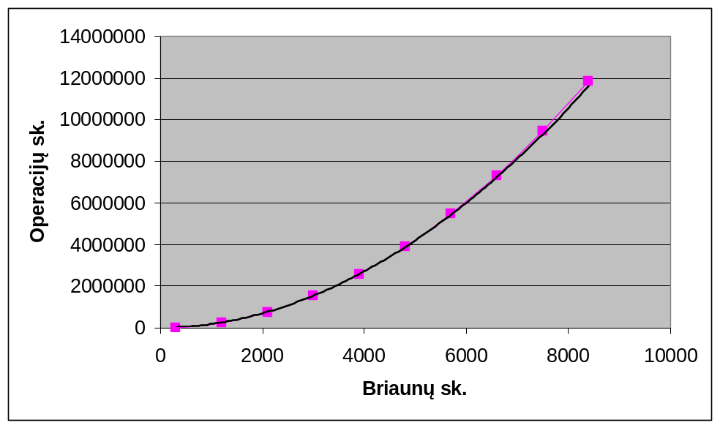
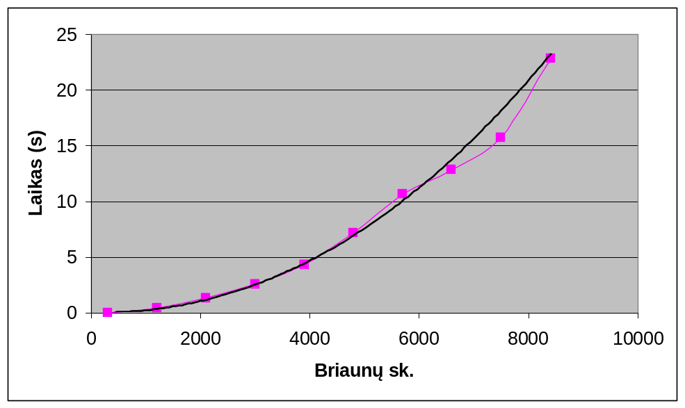

Artikuliacijos taškų suradimas grafe naudojant DFS
Jungiajame grafe surasti viršūnes, kurias pašalinus grafas tampa nebejungusis. Paieška daroma su DFS (Depth first search).

Algoritmas
Algoritmas parašytas Java kalboje. Jo sudėtingumas O(|E|). Taip yra, nes algoritmas turi pereiti per visas briaunas. Kitos operacijos galima sakyti priklauso O(1) ir algoritmo sudėtingumui įtakos nedaro.

Vertex.java

package articulationpointsjava;

import java.util.ArrayList;

public class Vertex {
public int number = 0;
public ArrayList<Vertex> neighbors = new ArrayList<Vertex>();
public boolean visited = false;
public int num = -1;
public int low = -1;
public Vertex parent = null;

public Vertex(int number) {
this.number = number;
}

public void connect(Vertex vertex) {
this.connect(vertex, true);
}

public void connect(Vertex vertex, boolean bidirectional) {
if (! neighbors.contains(vertex)) {
neighbors.add(vertex);
if (bidirectional)
vertex.connect(this, false);
}
}

@Override
public String toString() {
String s = String.format(" %-4d: ", this.number);
for (Vertex v: neighbors) {
s += (new Integer(v.number)).toString() + ", ";
}
s += String.format("(visited: %s, num: %d, low: %d)",
this.visited, this.num, this.low);
return s;
}
}

Graph.java
package articulationpointsjava;

import java.util.ArrayList;
import java.util.HashMap;

public class Graph {
HashMap<Integer,Vertex> vertexes = new HashMap<Integer,Vertex>();

void initVertex(int number) {
if (! vertexes.containsKey(number))
vertexes.put(number, new Vertex(number));
}

void connect(int source, int target) {
this.connect(source, target, true);
}

void connect(int source, int target, boolean bidirectional) {
vertexes.get(source).connect(vertexes.get(target), bidirectional);
}

void reset() {
for (Vertex v: vertexes.values()) {
v.visited = false;
v.num = -1;
v.low = -1;
}
}

private int counter;
private ArrayList<Vertex> apoints;
private Vertex root;
private ArrayList<Vertex> root_children;

ArrayList<Vertex> findArt(int number) {
Vertex vertex = vertexes.get(number);

counter = 0;
apoints = new ArrayList<Vertex>();
root = vertex;
root_children = new ArrayList<Vertex>();
findArtRecursive(vertex);
if (root_children.size() >= 2)
apoints.add(root);
return apoints;
}

void findArtRecursive(Vertex vertex) {
Main.operations += 3;
vertex.visited = true;
counter += 1;
vertex.low = vertex.num = counter;

// O(n)
for (Vertex neighbor: vertex.neighbors) {
if (! neighbor.visited) { // Forward edge
Main.operations += 4;
neighbor.parent = vertex;
if (vertex == root) {
Main.operations += 1;
root_children.add(neighbor);
}

findArtRecursive(neighbor);

Main.operations += 2;
if (vertex != root && neighbor.low >= vertex.num)
apoints.add(vertex);
vertex.low = Math.min(vertex.low, neighbor.low); // Rule 3
}
else if (vertex.parent != neighbor) { // Back edge
Main.operations += 2;
vertex.low = Math.min(vertex.low, neighbor.num); // Rule 2
}
}
}

@Override
public String toString() {
String s = String.format("Graph of %d vertexes:\n", vertexes.size());

for (Vertex v: vertexes.values()) {
s += v.toString() + "\n";
}
return s;
}
}

Main.java
package articulationpointsjava;

import java.util.LinkedList;

public class Main {
static int operations = 0;

public static void main(String[] args) {
int start = 500000;
int step = 100000;
int end = 120000000;

int last_size = 0;
int edges = 0;
Graph g = new Graph();
LinkedList<Integer> lastVertexes = new LinkedList<Integer>();

for (int vertexes = start; vertexes < end; vertexes += step) {
long start_time;

for (int i = last_size; i < vertexes; i++) {
g.initVertex(i);

edges += lastVertexes.size();
for (int number: lastVertexes) {
g.connect(i, number);
}

// Keep last
lastVertexes.addLast(i);
while (lastVertexes.size() > 2) {
lastVertexes.removeFirst();
}
}
last_size = vertexes;

int times = 10;
long time = 0;
for (int i = 0; i < times; i++) {
operations = 0;
g.reset();

System.out.print(i);
System.out.flush();
start_time = System.currentTimeMillis();
g.findArt(0);
time += System.currentTimeMillis() - start_time;
System.out.print(". ");
System.out.flush();
}

System.out.println(String.format(
"%10d %10d %10d %8.3f",
vertexes, edges,
operations,
(float)time / times / 1000
));
System.out.flush();
}
// Graph g = new Graph();
// g.connect(0, 1);
// g.connect(0, 2);
// g.connect(3, 1);
// g.connect(3, 2);
// g.connect(3, 4);
// g.connect(2, 5);
// g.connect(2, 6);
// g.connect(5, 6);
//
// System.out.println(g.toString());
//
// ArrayList<Vertex> points = g.findArt(0);
// System.out.println(points.toString());
}
}

Veikimo laikai
Viršūnių sk. | Briaunų sk. | Operacijų sk. | Laikas s.
500000 | 999997 | 6499987 | 0,469
600000 | 1199997 | 7799987 | 0,658
700000 | 1399997 | 9099987 | 0,766
800000 | 1599997 | 10399987 | 0,786
900000 | 1799997 | 11699987 | 0,958
1000000 | 1999997 | 12999987 | 0,906
1100000 | 2199997 | 14299987 | 1,153
1200000 | 2399997 | 15599987 | 1,242
1300000 | 2599997 | 16899987 | 1,820
1400000 | 2799997 | 18199987 | 2,047
1500000 | 2999997 | 19499987 | 2,081
1600000 | 3199997 | 20799987 | 4,127
1700000 | 3399997 | 22099987 | 4,283

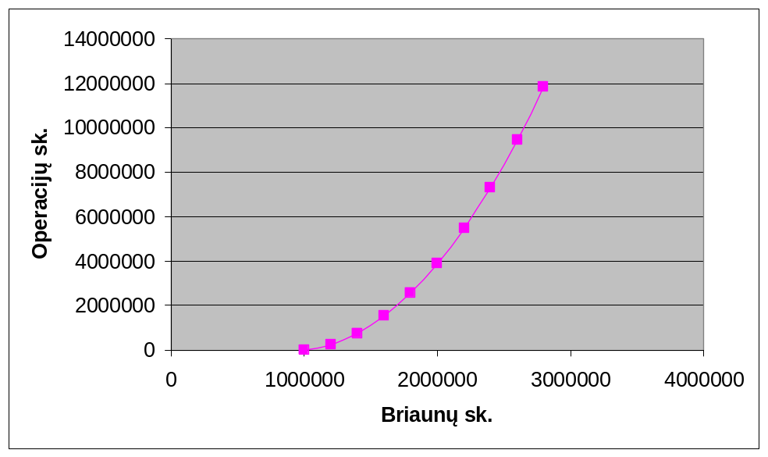
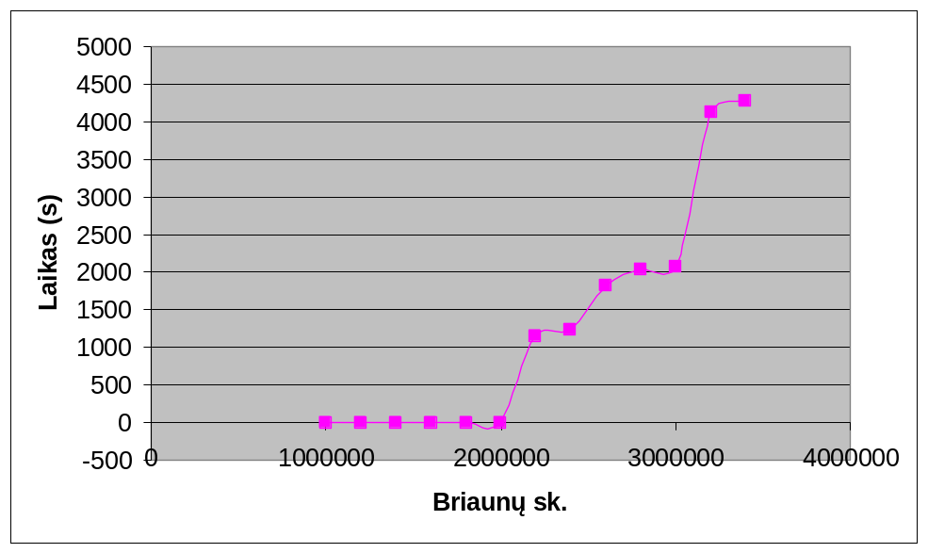
Algoritmas yra rekursinis, todėl labai reiklus steko dydžiui. Mano sistemoje su 3GB RAM neužteko atminties didesniems grafams ir rekursyviam vykdymui, todėl maksimalus algoritmo laikas yra ~4s.

Išvados
Nors ir antrojo algoritmo grafikai nėra tiesiniai, tačiau tai gali įtakoti pakankamai maži duomenų ruožai. Pirmasis algoritmas veikia taip, kaip priklauso.

