Algoritmų sudarymas ir analizė
Laboratorinis darbas nr. 1 (22 var.)
Atliko: IFF-6 gr. studentas
Artūras Šlajus
Data: 2009-03-29
Dėstytojas: Valdas Astrovas
Turinys

1 Užduotis 3
2 Algoritmų analizė 3
2.1 Hash funkcija 3
2.2 Rezultatai 4
3 Išvados 4
4 Programų išeities tekstai 4
4.1 JAVA 4
4.2 C++ 9

Užduotis
Rikiavimo uždavinys.
Palyginkite tris rūšiavimo algoritmus, kai rūšiavimas atliekamas masyve ir dinaminiame sąraše.
- Rūšiavimas „suliejimu“.
- Rūšiavimas „piramide“.
- Rūšiavimo algoritmas „Counting sort“

Algoritmų analizė

Rūšiavimas „suliejimu“
Masyvas rekursyviai skaidomas per puse, kol belieka po vieną elementą. Tada gauti masyvai rūšiuojant sujungiami atgal. Pagrindinė įdėją – mažesni sąrašai surūšiuojami greičiau negu dideli.
Algoritmo veikimo pavyzdys:
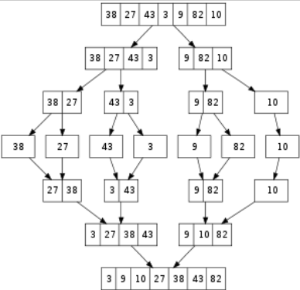

Teorinis algoritmo sudėtingumas: Θ(nlogn)

Rūšiavimas „piramide“
Algoritmo esmė – sudaryti piramidę (heap) iš nesurūšiuotos masyvo dalies. Algoritmas vykdomas iteracijomis, kiekvienos iteracijos metu nerūšiuota masyvo dalis sumažinama vienetu, o iš nesurūšiuotos sudaroma nauja piramidė.
Teorinis algoritmo sudėtingumas: Θ(nlogn)

Rūšiavimas „Counting sort“
Esmė – žinant min ir max reikšmes masyve sudaryti dar vieną masyvą (dydžio max - min), kurio nariai reikštų kiek kartų šis duomuo pasikartojo duomenų masyve. Tai vienas iš greičiausių rūšiavimo algoritmų, tačiau jis netinka, kai duomenų ruožas yra labai didelis.
Teorinis algoritmo sudėtingumas: Θ (n + k)

Rezultatai
Algortmai realizuoti dvejomis kalbomis: JAVA ir C++.
Žemiau pateikiami grafikai.
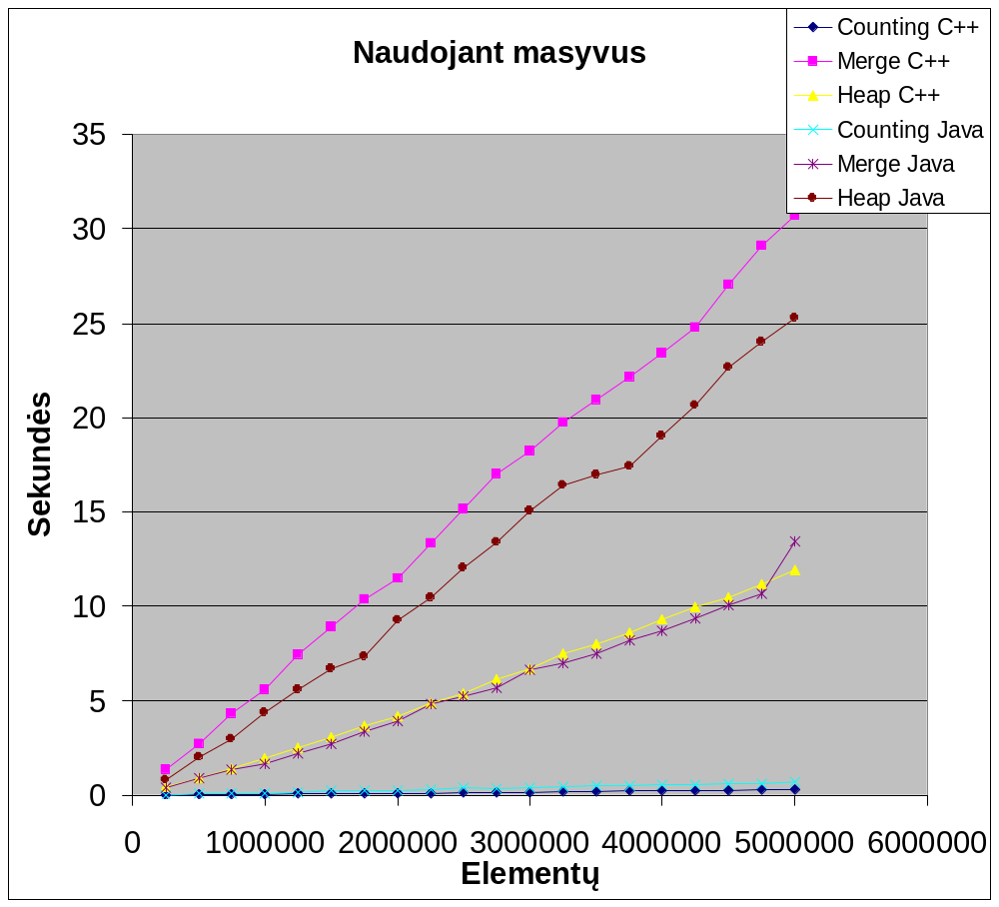
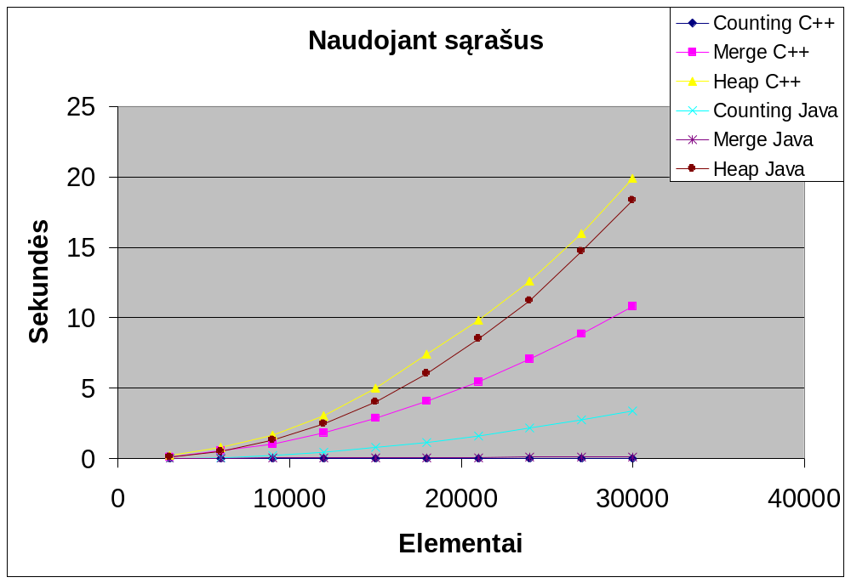
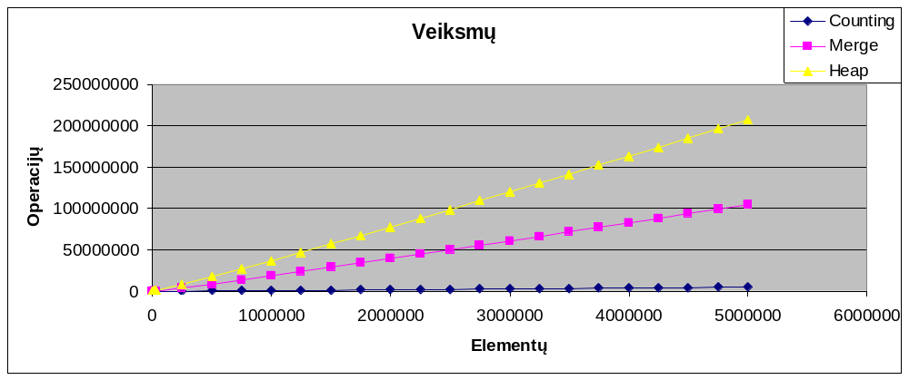

Išvados
Kaip matome naudojant sąrašus telpant į tą patį laiką elementų galima apdoroti 100 kartų mažiau. Tai ko gero paaiškinama tuom, jog kreiptis į bet kurią masyvo vietą užtrunka vienodai (const).
Be to nors „heap“ ir „merge“ algoritmų teorinis sudėtingumas yra O(n*log(n)), bet iš grafiko matome, jog su masyvais tai panašiau į tiesę, tad sudėtingumo klasę O(n). Su sąrašais algoritmo laikas kinta pagal eksponentinį dėsnį.
„Counting sort“ nors ir nesimato grafike, tačiau jo suskaičiuotas sudėtingumas yra O(n+k), t.y. prilygsta teoriniam sudėtingumui.
Be to – nors ir manoma, jog Java yra letesnė, tačiau keliuose algoritmuose ji veikė greičiau. Ko gero tai priklauso ir nuo kodo ir kompiliatoriaus optimizacijų.

Programų išeities tekstai

JAVA

Counting sort
/// countingSort - sort an array of values.
///
/// For best results the range of values to be sorted
/// should not be significantly larger than the number of
/// elements in the array.
static LinkedList<Integer> list_counting_sort(LinkedList<Integer> source) {
LinkedList<Integer> nums = new LinkedList<Integer>(source);
int size = nums.size();
// search for the minimum and maximum values in the input
int i, min = nums.get(0), max = min;
for (i = 1; i < size; ++i) {
if (nums.get(i) < min) {
min = nums.get(i);
} else if (nums.get(i) > max) {
max = nums.get(i);
}
}

// create a counting array, counts, with a member for
// each possible discrete value in the input.
// request compiler to value-initialize all counts to 0.
int distinct_element_count = max - min + 1;
int[] counts = new int[distinct_element_count];

// accumulate the counts -
// each index in the counts array represents the value
// of an element in the input nums array, so the result
// of incrementing the sum at the index in the
// counts array reflects the number of times the element
// appears in the input array and therefore
// must be copied to the sorted output.
for (i = 0; i < size; ++i) {
counts[nums.get(i) - min] += 1;
}

// store back into the input array the sorted value as
// represented by the respective index in the counts array.
// repeat for each additional occurrence of the value
// found in the original array, as recorded by the
// counts array.
int j = 0;
for (i = min; i <= max; i++) {
number_of_operations++;
for (int z = 0; z < counts[i - min]; z++) {
number_of_operations++;
nums.set(j++, i);
}
}

return nums;
}
/// countingSort - sort an array of values.
///
/// For best results the range of values to be sorted
/// should not be significantly larger than the number of
/// elements in the array.
static ArrayList<Integer> vector_counting_sort(ArrayList<Integer> source) {
ArrayList<Integer> nums = new ArrayList<Integer>(source);
int size = nums.size();
// search for the minimum and maximum values in the input
int i, min = nums.get(0), max = min;
for (i = 1; i < size; ++i) {
if (nums.get(i) < min) {
min = nums.get(i);
} else if (nums.get(i) > max) {
max = nums.get(i);
}
}

// create a counting array, counts, with a member for
// each possible discrete value in the input.
// request compiler to value-initialize all counts to 0.
int distinct_element_count = max - min + 1;
int[] counts = new int[distinct_element_count];

// accumulate the counts -
// each index in the counts array represents the value
// of an element in the input nums array, so the result
// of incrementing the sum at the index in the
// counts array reflects the number of times the element
// appears in the input array and therefore
// must be copied to the sorted output.
for (i = 0; i < size; ++i) {
counts[nums.get(i) - min] += 1;
}

// store back into the input array the sorted value as
// represented by the respective index in the counts array.
// repeat for each additional occurrence of the value
// found in the original array, as recorded by the
// counts array.
int j = 0;
for (i = min; i <= max; i++) {
number_of_operations++;
for (int z = 0; z < counts[i - min]; z++) {
nums.set(j++, i);
number_of_operations++;
}
}

return nums;
}

Heap sort
static void list_sift_down(LinkedList<Integer> source, int start, int end) {
// end represents the limit of how far down the heap to sift.

int root = start;
// While the root has at least one child
while (root * 2 + 1 <= end) {
// root*2+1 points to the left child
int child = root * 2 + 1;

// If the child has a sibling and the child's value is less than its sibling's...
number_of_operations++;
if (child + 1 <= end && source.get(child) < source.get(child + 1)) {
// ... then point to the right child instead
child++;
}

// out of max-heap order
number_of_operations++;
if (source.get(root) < source.get(child)) {
swap(source, root, child);
// repeat to continue sifting down the child now
root = child;
} else {
return;
}
}
}

static void list_heapify(LinkedList<Integer> source) {
// start is assigned the index in a of the last parent node
int start = (source.size() - 2) / 2;

while (start >= 0) {
// sift down the node at index start to the proper place such that all nodes below
// the start index are in heap order)
list_sift_down(source, start, source.size() - 1);
start--;
// after sifting down the root all nodes/elements are in heap order
}
}

static LinkedList<Integer> list_heap_sort(LinkedList<Integer> source) {
LinkedList<Integer> result = new LinkedList<Integer>(source);
list_heapify(result);

int end = result.size() - 1;
while (end > 0) {
// swap the root(maximum value) of the heap with the last element of the heap
swap(result, 0, end);
// decrease the size of the heap by one so that the previous max value will
// stay in its proper placement
end--;
// put the heap back in max-heap order
list_sift_down(result, 0, end);
}
return result;
}

static void vector_sift_down(ArrayList<Integer> source, int start, int end) {
// end represents the limit of how far down the heap to sift.

int root = start;
// While the root has at least one child
while (root * 2 + 1 <= end) {
// root*2+1 points to the left child
int child = root * 2 + 1;
// If the child has a sibling and the child's value is less than its sibling's...
number_of_operations++;
if (child + 1 <= end && source.get(child) < source.get(child + 1)) {
// ... then point to the right child instead
child++;
}
// out of max-heap order
number_of_operations++;
if (source.get(root) < source.get(child)) {
swap(source, root, child);
// repeat to continue sifting down the child now
root = child;
} else {
return;
}
}
}

static void vector_heapify(ArrayList<Integer> source) {
// start is assigned the index in a of the last parent node
int start = (source.size() - 2) / 2;

while (start >= 0) {
// sift down the node at index start to the proper place such that all nodes below
// the start index are in heap order)
vector_sift_down(source, start, source.size() - 1);
start--;
// after sifting down the root all nodes/elements are in heap order
}
}

static ArrayList<Integer> vector_heap_sort(ArrayList<Integer> source) {
ArrayList<Integer> result = new ArrayList<Integer>(source);
vector_heapify(result);

int end = result.size() - 1;
while (end > 0) {
// swap the root(maximum value) of the heap with the last element of the heap
swap(result, 0, end);
// decrease the size of the heap by one so that the previous max value will
// stay in its proper placement
end--;
// put the heap back in max-heap order
vector_sift_down(result, 0, end);
}
return result;
}

static void swap(List<Integer> source, int indexA, int indexB) {
int temp = source.get(indexA);
source.set(indexA, source.get(indexB));
source.set(indexB, temp);
}

Merge sort
static LinkedList<Integer> list_merge(LinkedList<Integer> left, LinkedList<Integer> right) {
LinkedList<Integer> result = new LinkedList<Integer>();
while (left.size() > 0 && right.size() > 0) {
if (left.getFirst() <= right.getFirst()) {
result.add(left.pop());
} else {
result.add(right.pop());
}
number_of_operations++;
}

result.addAll(left);
result.addAll(right);

return result;
}

static LinkedList<Integer> list_merge_sort(LinkedList<Integer> source) {
LinkedList<Integer> work = new LinkedList<Integer>(source);
int length = work.size();
if (length <= 1) {
return work;
}

int middle = length / 2 - 1;
LinkedList<Integer> left = new LinkedList<Integer>();
LinkedList<Integer> right = new LinkedList<Integer>();

for (int i = 0; i <= middle; i++) {
left.add(work.pop());
}
for (int i = middle + 1; i < length; i++) {
right.add(work.pop());
}

left = list_merge_sort(left);
right = list_merge_sort(right);
return list_merge(left, right);
}

static ArrayList<Integer> vector_merge(ArrayList<Integer> left, ArrayList<Integer> right) {
ArrayList<Integer> result = new ArrayList<Integer>(left.size() + right.size());
int leftIndex = 0, rightIndex = 0;
while (leftIndex < left.size() && rightIndex < right.size()) {
if (left.get(leftIndex) <= right.get(rightIndex)) {
result.add(left.get(leftIndex));
leftIndex++;
} else {
result.add(right.get(rightIndex));
rightIndex++;
}
number_of_operations++;
}

for (int i = leftIndex; i < left.size(); i++) {
result.add(left.get(i));
}
for (int i = rightIndex; i < right.size(); i++) {
result.add(right.get(i));
}

return result;
}

static ArrayList<Integer> vector_merge_sort(ArrayList<Integer> source) {
int length = source.size();
if (length <= 1) {
return source;
}

int middle = length / 2 - 1;
ArrayList<Integer> left = new ArrayList<Integer>(middle + 1);
ArrayList<Integer> right = new ArrayList<Integer>(middle + 1);

for (int i = 0; i <= middle; i++) {
left.add(source.get(i));
}
for (int i = middle + 1; i < length; i++) {
right.add(source.get(i));
}

left = vector_merge_sort(left);
right = vector_merge_sort(right);
ArrayList<Integer> result = vector_merge(left, right);
return result;
}

C++

Counting sort
/// countingSort - sort an array of values.
///
/// For best results the range of values to be sorted
/// should not be significantly larger than the number of
/// elements in the array.
list<int> list_counting_sort(list<int> &nums, long &number_of_operations) {
int size = nums.size();
// search for the minimum and maximum values in the input
int i, min = nums.front(), max = min;
for (list<int>::iterator it = nums.begin(); it != nums.end(); it++) {
if (*it < min)
min = *it;
else if (*it > max)
max = *it;
}

// create a counting array, counts, with a member for
// each possible discrete value in the input.
// request compiler to value-initialize all counts to 0.
int distinct_element_count = max - min + 1;
int *counts = new int[distinct_element_count]();

// accumulate the counts -
// each index in the counts array represents the value
// of an element in the input nums array, so the result
// of incrementing the sum at the index in the
// counts array reflects the number of times the element
// appears in the input array and therefore
// must be copied to the sorted output.
for (list<int>::iterator it = nums.begin(); it != nums.end(); it++)
++counts[ *it - min ];

// store back into the input array the sorted value as
// represented by the respective index in the counts array.
// repeat for each additional occurrence of the value
// found in the original array, as recorded by the
// counts array.
list<int> result;
for (i = min; i <= max; i++) {
number_of_operations++;
for (int z = 0; z < counts[i - min]; z++) {
result.push_back(i);
number_of_operations++;
}
}

delete[] counts;

return result;
}

/// countingSort - sort an array of values.
///
/// For best results the range of values to be sorted
/// should not be significantly larger than the number of
/// elements in the array.
vector<int> vector_counting_sort(vector<int> &source, long &number_of_operations) {
vector<int> nums = vector<int>(source);
int size = nums.size();
// search for the minimum and maximum values in the input
int i, min = nums.at(0), max = min;
for (i = 1; i < size; ++i) {
if (nums.at(i) < min)
min = nums.at(i);
else if (nums[i] > max)
max = nums.at(i);
}

// create a counting array, counts, with a member for
// each possible discrete value in the input.
// request compiler to value-initialize all counts to 0.
int distinct_element_count = max - min + 1;
int *counts = new int[distinct_element_count]();

// accumulate the counts -
// each index in the counts array represents the value
// of an element in the input nums array, so the result
// of incrementing the sum at the index in the
// counts array reflects the number of times the element
// appears in the input array and therefore
// must be copied to the sorted output.
for (i = 0; i < size; ++i) {
++counts[ nums[i] - min ];
}

// store back into the input array the sorted value as
// represented by the respective index in the counts array.
// repeat for each additional occurrence of the value
// found in the original array, as recorded by the
// counts array.
int j = 0;
for (i = min; i <= max; i++) {
number_of_operations++;
for (int z = 0; z < counts[i - min]; z++) {
nums.at(j++) = i;
number_of_operations++;
}
}

delete[] counts;

return nums;
}

Heap sort
void list_sift_down(list<int> &source, int start, int end, long &number_of_operations) {
// end represents the limit of how far down the heap to sift.

int root = start;
// While the root has at least one child
while (root * 2 + 1 <= end) {
// root*2+1 points to the left child
int child = root * 2 + 1;

// If the child has a sibling and the child's value is less than its sibling's...
list<int>::iterator it = source.begin();
advance(it, child);
if (child + 1 <= end) {
list<int>::iterator it1 = it;
it1++;

number_of_operations++;
if (*it < *it1) {
// ... then point to the right child instead
child++;
it = it1;
}
}

// out of max-heap order
list<int>::iterator root_it = source.begin();
advance(root_it, root);

number_of_operations++;
if (*root_it < *it) {
list_swap(source, root_it, source, it);
// repeat to continue sifting down the child now
root = child;
} else {
return;
}
}
}

void list_heapify(list<int> &source, long &number_of_operations) {
// start is assigned the index in a of the last parent node
int start = (source.size() - 2) / 2;

while (start >= 0) {
// sift down the node at index start to the proper place such that all nodes below
// the start index are in heap order)
list_sift_down(source, start, source.size() - 1, number_of_operations);
start--;
// after sifting down the root all nodes/elements are in heap order
}
}

list<int> list_heap_sort(list<int> &source, long &number_of_operations) {
list<int> result = list<int>(source);
list_heapify(result, number_of_operations);

int end = result.size() - 1;
while (end > 0) {
// swap the root(maximum value) of the heap with the last element of the heap
list<int>::iterator end_it = result.begin();
advance(end_it, end);
list_swap(result, result.begin(), result, end_it);
// decrease the size of the heap by one so that the previous max value will
// stay in its proper placement
end--;
// put the heap back in max-heap order
list_sift_down(result, 0, end, number_of_operations);
}
return result;
}

void list_swap(list<int> &l1, list<int>::iterator it1,
list<int> &l2, list<int>::iterator it2) {
l1.insert(it1, *it2);
l2.insert(it2, *it1);
l1.erase(it1);
l2.erase(it2);
}

void vector_sift_down(vector<int> &source, int start, int end, long &number_of_operations) {
// end represents the limit of how far down the heap to sift.

int root = start;
// While the root has at least one child
while (root * 2 + 1 <= end) {
// root*2+1 points to the left child
int child = root * 2 + 1;
// If the child has a sibling and the child's value is less than its sibling's...
number_of_operations++;
if (child + 1 <= end && source.at(child) < source.at(child + 1)) {
// ... then point to the right child instead
child++;
}
// out of max-heap order
number_of_operations++;
if (source.at(root) < source.at(child)) {
swap(source.at(root), source.at(child));
// repeat to continue sifting down the child now
root = child;
} else {
return;
}
}
}

void vector_heapify(vector<int> &source, long &number_of_operations) {
// start is assigned the index in a of the last parent node
int start = (source.size() - 2) / 2;

while (start >= 0) {
// sift down the node at index start to the proper place such that all nodes below
// the start index are in heap order)
vector_sift_down(source, start, source.size() - 1, number_of_operations);
start--;
// after sifting down the root all nodes/elements are in heap order
}
}

vector<int> vector_heap_sort(vector<int> &source, long &number_of_operations) {
vector<int> result = vector<int>(source);
vector_heapify(result, number_of_operations);

int end = result.size() - 1;
while (end > 0) {
// swap the root(maximum value) of the heap with the last element of the heap
swap(result.at(0), result.at(end));
// decrease the size of the heap by one so that the previous max value will
// stay in its proper placement
end--;
// put the heap back in max-heap order
vector_sift_down(result, 0, end, number_of_operations);
}
return result;
}

void swap(int &a, int &b) {
int temp = a;
a = b;
b = temp;
}

Merge sort
list<int> list_merge(list<int> &left, list<int> &right, long &number_of_operations) {
list<int> result;
while (left.size() > 0 && right.size() > 0) {
if (left.front() <= right.front()) {
result.push_back(left.front());
left.pop_front();
} else {
result.push_back(right.front());
right.pop_front();
}

number_of_operations++;
}

result.splice(result.end(), left);
result.splice(result.end(), right);

return result;
}

list<int> list_merge_sort(list<int> source, long &number_of_operations) {
int length = source.size();
if (length <= 1) {
return source;
}

int middle = length / 2 - 1;
list<int> left, right;

list<int>::iterator it = source.begin();
for (int i = 0; i <= middle; i++) {
left.push_back(*it);
it++;
}
for (int i = middle + 1; i < length; i++) {
right.push_back(*it);
it++;
}

left = list_merge_sort(left, number_of_operations);
right = list_merge_sort(right, number_of_operations);
list<int> result = list_merge(left, right, number_of_operations);
return result;
}

vector<int> vector_merge(vector<int> &left, vector<int> &right, long &number_of_operations) {
vector<int> result;
int leftIndex = 0, rightIndex = 0;
while (leftIndex < left.size() && rightIndex < right.size()) {
if (left.at(leftIndex) <= right.at(rightIndex)) {
result.push_back(left.at(leftIndex));
leftIndex++;
} else {
result.push_back(right.at(rightIndex));
rightIndex++;
}
number_of_operations++;
}

for (int i = leftIndex; i < left.size(); i++) {
result.push_back(left.at(i));
}
for (int i = rightIndex; i < right.size(); i++) {
result.push_back(right.at(i));
}

return result;
}

vector<int> vector_merge_sort(vector<int> &source, long &number_of_operations) {
int length = source.size();
if (length <= 1) {
return source;
}

int middle = length / 2 - 1;
vector<int> left, right;
left.reserve(middle + 1);
right.reserve(middle + 1);

for (int i = 0; i <= middle; i++) {
left.push_back(source.at(i));
}
for (int i = middle + 1; i < length; i++) {
right.push_back(source.at(i));
}

left = vector_merge_sort(left, number_of_operations);
right = vector_merge_sort(right, number_of_operations);
vector<int> result = vector_merge(left, right, number_of_operations);
return result;
}

